

POSITIVE RELATIONSHIPS & BEHAVIOUR POLICY
Ready, Respectful, Safe
September 2026
Policy History
Date | Version | Update | Prepared by
April 2014 | 1.0 | Policy reviewed | C. Beddows
Sept 2015 | 2.0 | Updated and shared with Govs Teaching and Learning Committee | C. Beddows
Sept 2016 | 3.0 | Updated, waiting for Governor approval | C. Beddows
Sept 2017 | 4.0 | Updated, approved by Headteacher and staff | J. Malone
Jan 2019 | 5.0 | Updated, approved by Headteacher and staff | P. Cope
Jan 2020 | 6.0 | Updated, approved by Headteacher and staff; waiting for and Governor approval. COVID measures put into policy | P. Cope
Jan 2021 | 7.0 | Updated, approved by Headteacher and staff; waiting for and Governor approval. COVID measures put into policy | P. Cope
Jan 2022 | 8.0 | Updated, approved by Headteacher and staff; waiting for and Governor approval. | P. Cope
Jan 2023 | 9.0 | Change of name to positive relationship policy, updated with new aims. Guidance gathered from staff, parents and children. | P. Cope
Sept 2023 | 10.0 | Changes to the policy from the Paul Dix reading and INSET delivered to staff | P.Cope
Feb 2024 | 10.1 | Checked for any amendments to share with the governors. | P.Cope
Sept 2024 | 10.2 | Amendments following the poverty proofing audit. | P.Cope
Jan 2025 | 10.3 | Suspension and exclusion included in the policy following the guidance from August 2024 | P.Cope
Sept 2025 | 10.4 | Changes made to star of the week jumper instead of badge | P.Cope
Sept 2026 | 11 | Numerous changes – ready, respectful, safe | S Kelly

Our aims are:
- To ensure that all children are Ready, Respectful and Safe in school.
- To ensure that the Core Values and Bee Rules are embedded and followed within school.
- To have consistent and fair systems in place.
- To ensure children feel that they are listened to, supported and that they are valued.
- To form and maintain positive relationships within the school community, where a sense of shared responsibility for behaviour is taken.
- To create a culture of acceptance and tolerance for all members of the school community, within clear boundaries of behaviours that are acceptable and unacceptable in respect of maintaining a culture that is conducive to learning and the welfare of all.
- To include, value and respect all members of the school community.
The policy outlines the rationale and practicalities of our relational approach to learning and behaviour. Relational and behaviourist approaches are sometimes seen as in conflict which can be a concern for some staff and parents. This policy sets out how we use relational and restorative practice to ensure clear expectations and boundaries and consistent and persistent responses from adults, in an effort to make school predictable and safe. How and why children respond to these clear messages is important. We want children to behave well because they care about themselves and others, not because they want to earn a reward or avoid a sanction. Children need both clear boundaries and a safe person to go to when they need more help, as they move from co-regulation with adults, to self-regulation as adults themselves.

Myth busting – in relational practice, do we have?
High standards and expectations? YES, and a high level of support for all children to achieve them.
Support systems in place for the most vulnerable? YES, and a relational approach, which builds the safety and confidence ALL members of our school community need to take on learning challenges. A relationally inclusive approach benefits all of our children.
Consequences? YES, children who do not complete work that could have reasonably been expected of them will be given time during playtimes to complete it and children who lose control of their temper will be given time to help them self-regulate, reflect and repair, not for punishment, but for learning and to ensure they are calmer and safer and to give time away from those who may need this.
Rewards? YES, via relationships in which we notice what we want children to do more of. Stickers, Dojos, positive recognition boards etc. are symbols of positive regard, rather than part of a ‘token economy.’
Clear rules and boundaries? YES, e.g., to help us to be ready, respectful and safe, rather than with compliance as an end in itself.
Calm and orderly? YES, with adults modelling self-regulation, and providing calming and solution focused support to enable children to do the same and as part of enabling ‘optimal brain states for learning.’
Persistent and consistent? YES, we ‘persistently and consistently meet the relational and developmental needs of our children’, so we are firm, fair and adjust our approach to what works for the child, taking account of and making reasonable adjustments for SEND and SEMH (Social, Emotional and Mental Health) needs.
Suspension and exclusion? YES, but, given that we believe that ‘all behaviour is a form of communication’, we will always focus on understanding and meeting the need communicated, as we would with an ongoing medical problem. Suspension or exclusion is rare and is always the very last resort, when all other possible options have been explored. Keeping everyone safe is key when making these difficult decisions. Any suspension is an admission that current practice for that child has been insufficient to meet their needs and a short, focused period of time is necessary for them to recover and re-set and for school to re-plan how to best challenge and support them.

The following are our guiding principles to relationally inclusive practice:
- We believe that if a child could do better, they would.
- Relationships are at the heart of everything.
- We accept all emotions, but not all behaviours.
- We identify and address the cause of the behaviour, not the symptoms.
- We foster a culture of compassion and repair. Social and behavioural mistakes are part of learning and need fixing in the same way as academic mistakes.
- We recognise that a trauma-informed, attachment aware and low arousal approach isn’t just about behaviour management – it is about equity, inclusion and responsive pedagogy. It is also an approach that benefits ALL pupils.
Our approach is based on helping everyone to be and feel safe, building relationships, understanding individual needs, and supporting the development of self-regulation skills (through the Zones of Regulation framework) so that everyone can achieve their potential in school. The policy applies to all adults and children in our school, and we ask parents, carers, our community and other adults involved to support it.
At the heart of our community are the people and the relationships they build. To make our community work, we expect everyone to treat each other with respect, kindness and compassion. We recognise the importance of relationships and the power of connection. Therefore, we strongly believe in ‘connection before correction’, reminding educators of the importance of adults developing connections, and once the connection is there, they are more likely to be able to correct behaviour successfully without the need for rewards or sanctions.
We know that meeting these expectations can be challenging. To help, we build a culture in which people can talk about how they feel, ask for help, learn from mistakes, put things right and get the support they need to achieve their potential, manage their mental health, well-being, feelings and behaviours, so that they become confident, self-regulated adults and positive members of their community, who show tolerance, respect and support for others.

At Etchells Primary School, we strongly believe that we must teach our children how to regulate, how to respond appropriately, how to be kind and how to repair… just as we do any other subject in the curriculum.

All Behaviour is Communication
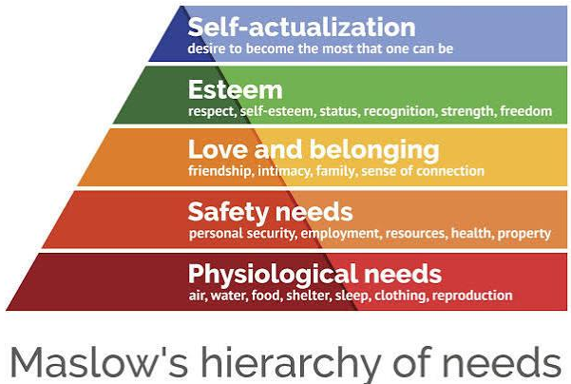 | Behaviour that is not conducive to learning and everyone’s wellbeing is communicating a need in the individual that it is not being met.  At Etchells we are determined to know and understand the children and families as best we can so we can determine quickly if a key need is not being met and take steps to address this first.

Calm is the goal. Calm people, including children, behave well.

 | Comfort  Challenge  Stress | When comfortable, relaxed, feeling safe and calm, we all behave well. But school is a place of learning and that requires some challenge, moving out of your comfort zone, risking getting things wrong. At Etchells, we try to manage this through consistent routines and modelling the learning through a process of ‘I do-we do-you do’ to minimise the risks of children feeling overwhelmed.  However, through academic, social, emotional or other pressures, inevitably, children will sometimes feel overwhelmed and tip into their stress zone. At such times it is not reasonable or realistic that they return immediately to learning challenge. They must be supported to first feel comfortable again. The getting calm work then becomes their priority and the priority of those supporting them.
Should any child need help to calm (co-regulation), a range of help is available from the adults in school.  The deal is that we will help you to calm, we will understand that you are too stressed for work or difficult conversations just yet, we will connect with you rather than looking to correct your behaviour (at this stage) and we are here to help. The expectation for the child at such times is that they accept the help; they choose or accept direction to try one of the helpful co-regulation activities from those listed here and they do this work. Once calm, there may be something to fix first or they may be ready to return to learning.  In EYFS, missed play instead means missed time in provision (thinking time) which is of an age-appropriate length. |  | 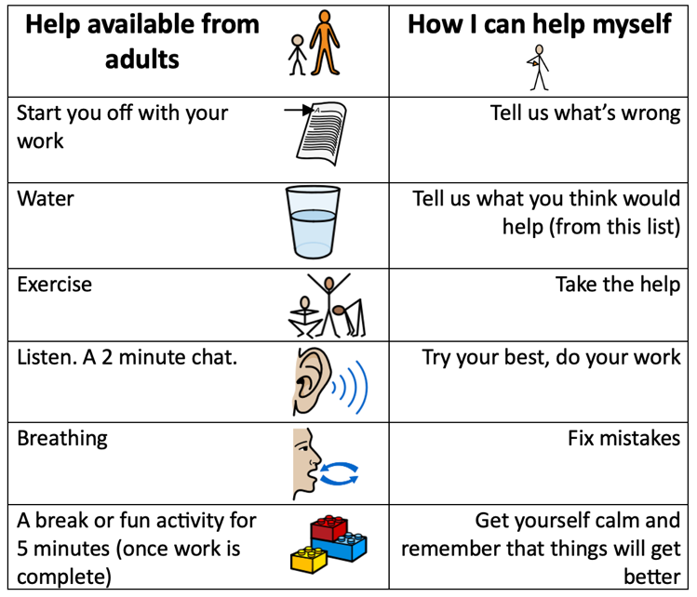
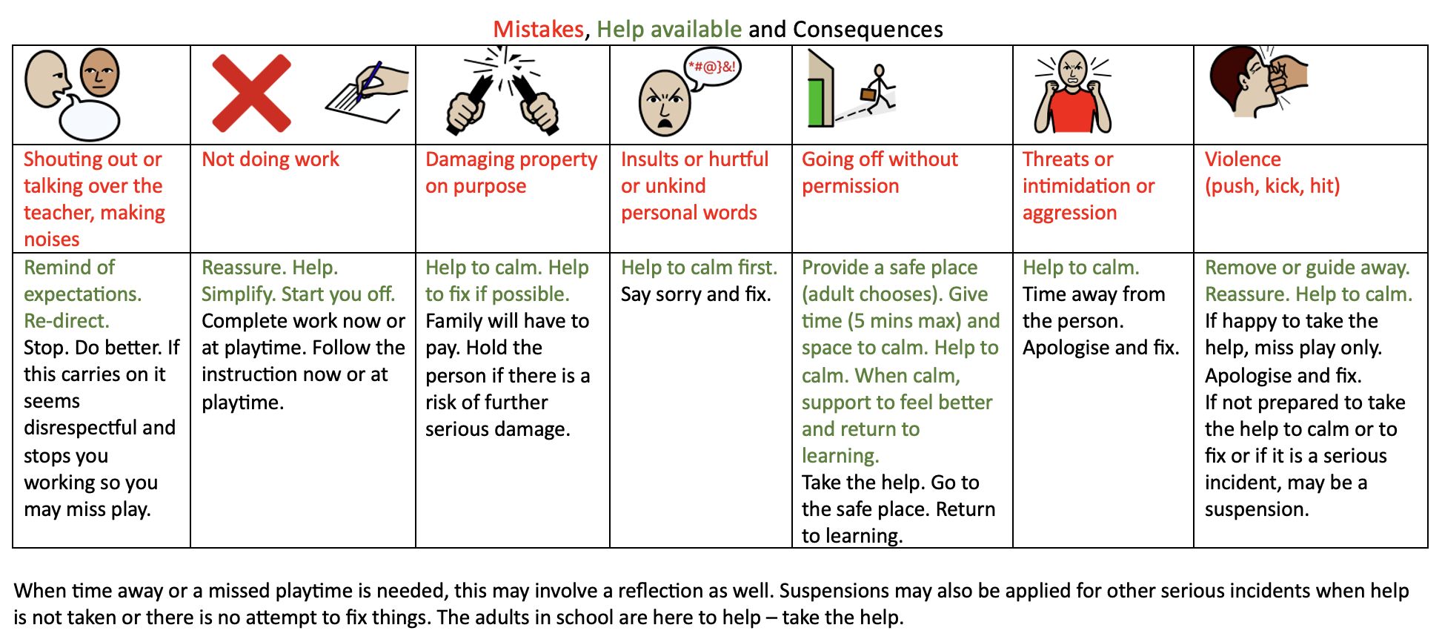

What you will see day to day:
- The children receiving Dojos for following the Bee Rules and demonstrating a quality from our Core Values. This will be consistent for each class.  - Regular reminders to staff and children of the behaviour expectations at school.  - Annual review of the Bee Rules by all members of the school community.  - The Bee Rules to be present in all classrooms and in key areas across the school.  - The training and induction of staff to ensure that a consistent approach is used across the school, including the sharing of the Positive Relationship Policy.  - Monitoring of the effectiveness of the Positive Relationship Policy, reviewing Reflection time and Dojo awards that are given, success in particular areas and any incidences of poor behaviour that has serious consequences. | 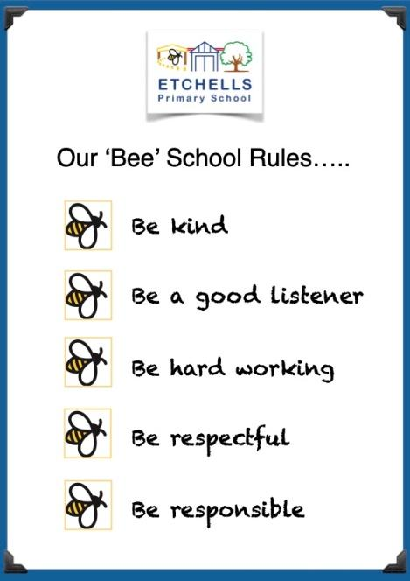
It is vital that all staff ensure that the children feel happy, safe and secure at school; this will form the best foundation for the children to be successful with their learning. At Etchells, we achieve this by ensuring that we develop strong and respectful relationships with the children. Our adults promote the values and expectations and implement a defined and consistent reward system. At Break and Lunchtimes, children are encouraged and helped with play, involving adults to model positive behaviour during games.
When behaviour expectations, the child will be encouraged using positive reinforcement. The child will also have it explained to them in a clear and concise manner which behaviours we would not expect to see. For some children it would be appropriate to implement a bespoke My Plan. This is completed in conjunction with parents and with input from the SENCo and/or Headteacher.
A log of incidents that require reflection is kept by the Headteacher. These are shared with parents in order for there to be continuity between home and school. This is analysed every term to form a better understanding of how behaviour looks across the school and is reported to Governors. Reflection sheets are a log of what was done to fix things and repair harm.
Core Values
Enjoyment, Challenge, Independence, Creativity, Resilience, Aspiration, Community
Underpinning all that we do at Etchells are our Core Values. These are drivers for behaviour in school and the children are encouraged to demonstrate these values throughout the school day. Dojo awards and specific praise are given to children who exemplify these values.
Praise
Positive reinforcement is at the heart of all work at Etchells. Adults who work with the children focus on the positives and this behaviour is rewarded. These are all age and developmentally appropriate for the children with each key phase having specific rewards in place. Alongside rewards, we praise positive behaviour in the classroom and will recognise this when it is demonstrated. Every week, a member of each class will receive the ‘Above and Beyond’ award for demonstrating positive behaviour for learning. This will be posted on Dojo by the class teacher.
EYFS Phase
- Verbal praise
- Stickers and stamps
- VIB (very important bee!) chosen each day, badge worn for the day
- Star of the week - children given a star of the week badge to wear for the week and certificate presented in EYFS assembly on Fridays.
- 2 core value certificates awarded per class each week presented in EYFS assembly on Fridays.
- Children move their name onto the star for 'star of the week' or onto 'VIB' each day.
- Prize box
- Challenge stamp awarded onto individual children's challenge chart for each provision area challenge completed, prize when chart is completed.
KS1
- Class Dojos
- Stickers and stamps
- Verbal praise
- Star of the week presented in Fridays assembly (Badge)
- Table Dojos
KS2
- Class Dojos
- Verbal Praise
- Stickers and stamps
- Star of the week presented in Fridays assembly (Badge)
If a child’s behaviour has been exceptional or they have completed a piece of work which has impressed the teacher then they may be brought to a member of the Senior Leadership Team to receive a special award.
Dojos will be awarded to all children for demonstrating one of the Core Values or following the ‘Bee’ Rules. This will be for the children who are going ‘above and beyond’ the normal expectations in the classroom. We have high expectations of consistently good behaviour and behaviours for learning.
Communication with Parents
All parents are invited to sign up to Class Dojo. On Class Dojo, direct notifications are sent to parents when a child receives a dojo. The children are awarded a Dojo for either demonstrating the Core Values or Following the ‘Bee Rules.’ We communicate behaviour success and mistakes with parents. Parents will be sent written details of any reflections so they know how their child has taken steps to make amends.
Safeguarding
The school recognises that changes in behaviour may be an indicator that a pupil is in need of help or protection. We will consider whether a pupil’s misbehaviour may be linked to them suffering, or being likely to suffer, significant harm. Where this may be the case, we will follow our Child Protection and Safeguarding Policy, and consider whether pastoral support, an early help intervention or a referral to children’s social care is appropriate. In such cases, we always liaise with parents first.
Reasonable force
All members of staff are aware of the regulations regarding the use of force by teachers, as set out in the DfE Circular 10/98, relating to section 550A of the Education Act 1996: The Use of Force to Control and Restrain Pupils. The actions we take are in line with the government guidelines on the restraint of children. All staff have received training in safe handling of pupils. Reasonable force covers a range of interventions that involve physical contact with pupils. All members of staff have a duty to use reasonable force, in the following circumstances, to prevent a pupil from:
Causing disorder
Hurting themselves or others
Damaging property
Committing an offence
Incidents of reasonable force must:
Always be used as a last resort
Be applied using the minimum amount of force and for the minimum amount of time possible
Be used in a way that maintains the safety and dignity of all concerned
Never be used as a form of punishment
Be recorded and reported to parents
Be reasonable, proportionate and necessary
When considering using reasonable force, staff should, in considering the risks, carefully recognise any specific vulnerabilities of the pupil, including SEND, mental health needs or medical conditions. Please see government guidance on use of reasonable force.

Behaviour expectations
A key message that we deliver at Etchells is: ‘That is how we do it here,’ to reinforce the positive behaviour that the children are demonstrating. This is a reminder to the children of the high expectations that we have of behaviour here at Etchells. If behaviour is not up to that high standard, the children are reminded with the statement: ‘That is not how we do it here.’ If this reminder does not change the behaviour, the child may be given a warning and their name placed in the class clipboard, see Appendix 1 for our reminder system. The children will receive three warnings: a reminder, a caution and a final chance. If the behaviour has not changed at that point then they will have a time in with phase leaders.
If there are any serious incidents of poor behaviour (see Appendix 1, under reflection), this will result in a reflection time being completed by one of our Senior Leaders (See Appendix 2.) These will be sent home so that the parents/guardians can see the words that the children have used to explain the situation. There is a clear system in place for what happens after each reflection and a table that explains the next steps (see appendix 3). At Etchells, we strive to maintain a culture that understands all perspectives, feelings, emotions and people but does not tolerate hateful prejudice or discrimination. All people are valued (more than just tolerated) but all behaviours are not. We understand that the culture of any organisation can only be as good as the worst behaviour tolerated.
What teachers, TAs and all adult members of the school community should model
Consistent use of the Team Stop signal to gain attention.
Connect before correct.
Minimise shouting.
Good manners.
Do not talk over others, give positive, focused attention including body language.
Levity, lightness, calm - a sense that all will be ok, the assumption that mistakes can be fixed and problems can be solved. We are here to make molehills out of mountains, to de-escalate. We acknowledge and validate scary feelings without colluding in and encouraging children’s worst fears.
Humility - we get things wrong and this is ok. Apologise, admit to mistakes and model this as normal and part of continual learning.
Lack of ego - even when things seem very personal, we endeavour to not take it personally.
Focus on calm over compliance.
Use of scripts (see below).
Honesty and integrity. In particular, honesty about our own emotions and modelling both seeking and accepting help. As colleagues we model offering and accepting help for one another, including SLT.
We praise the behaviour we want to see.
We see the best in everyone and strive to form and maintain positive relationships with everyone, especially when this is tricky.
Scripts
Particularly at times of stress or in situations when emotions are heightened, we rely on scripts to keep us focused on calm, de-escalation, welfare and a return to a state of ready, respectful and safe. Examples below.
You seem ____ (state emotion); I can see that you are ____ (state emotion).
How can I help? What do you need?
Stop. I need you to _____. Thank you.
I care about you too much to let you (get out of control, get yourself in a mess, get more upset etc).
I am here to help.
That must feel rubbish. Don’t worry, I can help you feel better.
I am going to help you feel better. Calm feels better than angry.

Stages of a crisis
All of the above is vital if we are to a) avoid children going into crisis and b) support them through the stages of a crisis if prevention is not possible.
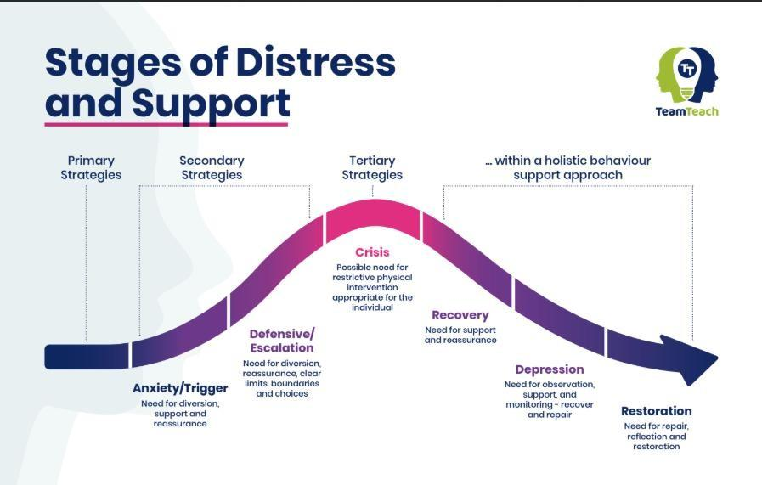
This policy is focused primarily on supporting pupils to be calm (primary and secondary stages). More detailed scripts for supporting pupils through crisis are in school. Should a child need to be supported through multiple crises, beyond age-appropriate tantrums in early years, we would typically co-produce a My Plan with parents to reduce the likelihood of further crises and to ensure that all staff working with that child know how to best support them. Other adaptations including Catch Me cards will be put in place for children requiring regular additional support.

Removal from Class
We reserve the right to remove pupils from their lessons when absolutely necessary whilst acknowledging the scope for damage to the teacher-child relationship inherent in this action. Children behave well for people they trust, respect and like. Any action that undermines relationships between the teacher and the children in their care is therefore only to be undertaken when the alternative is worse and even then, with great caution.
Where children are removed from their class, the following must be in place:
An adult comes with them at the earliest opportunity to co-regulate and ensure a prompt return to a state of calm and readiness to learn. This would typically involve the kind of help stipulated on page 4.
or
They remain in the eye-line of the teacher, just outside the class and it is judged that all they need is a quieter space for a strictly limited time (10mins max). They understand this as help not punishment.
or
They work in another class for up to 15 minutes with work which they clearly understand and can complete without support. The receiving class teacher receives them in a neutral, non-judgmental manner.
Upon or before returning to the class, they have the unacceptable behaviour (mistake) explained clearly, are reminded of recent times when they have done better and are told what is expected of them henceforth. If their earlier mistake needs a practical action to fix it, they are to do this promptly.
Circumstances when it may be appropriate for a pupil to be removed from class may include times when they are so disregulated or upset that they cannot stay appropriately calm or quiet, are throwing items, are being persistently disruptive and not responding to direction to do otherwise or are presenting a real emotional or physical threat to others.
Lost playtime
Lesson time is for learning. Where learning time is lost, it must be re-gained. If work is not completed or completed without sufficient care and effort, in cases where all reasonable support was available and the work was not too challenging or too much, the pupil will have to complete the work to the required standard at playtime. This is not a punishment, just the natural consequence of failing to complete the work at the designated time.
Playtimes or partial playtimes may also be lost if some harm has been caused that needs time to repair. This reparative work (apologising, listening, fixing something broken etc) may have to take place at playtime if it would eat into too much learning time.
Any violence or threat of violence means that school cannot be satisfied that the person responsible is safe in the less structured forum of breaktimes. In such circumstances, even if a reflection is not required, an assessment of presenting risk may mean that a child has to stay in and be supervised. The child’s emotional presentation would determine whether this was a requirement based on managing risk or whether even though there was no obvious risk as the child was now completely calm, a reflection was required as an opportunity to learn from an earlier mistake and to give time to those who may need time away to again feel safe. In either case, this is not a punishment. If it is presented as such, the harm done to the adult-child relationship is likely to escalate risk rather than diminish it. The result (lost playtime) is the same, but the time in need not be spent in contemplative silence.
Suspension and Permanent Exclusion
At Etchells Primary School, we follow the statutory suspension and permanent exclusion guidance issued by the Department for Education (DfE) when making decisions regarding suspension from school and carrying out the permanent exclusion process.
The headteacher will use their professional judgement based on the individual circumstances of the case when considering whether to exclude or suspend a pupil. The parents will receive a letter detailing the information of the suspension. The reasons below are examples of the types of circumstances that may warrant a suspension or permanent exclusion:
• Physical assault against a pupil
• Physical assault against an adult
• Verbal abuse or threatening behaviour against a pupil
• Verbal abuse or threatening behaviour against an adult
• Use, or threat of use, of an offensive weapon or prohibited item that has been prohibited by a school’s behaviour policy
• Bullying
• Racist abuse
• Abuse against sexual orientation or gender reassignment
• Abuse relating to disability
This list is not exhaustive and is intended to offer examples rather than be definitive. Equally, incidents such as those listed above may occur without a suspension necessarily following depending on a variety of contextual factors.

Child on Child Abuse
This form of abuse is when there is any kind of physical, sexual, emotional or financial abuse or coercive control exercised between children/young people both on and offline. At Etchells, all staff understand the importance of challenging inappropriate behaviours between children/young people. Downplaying certain behaviours, for example dismissing sexual harassment as “just banter”, “just having a laugh”, “part of growing up” or “boys being boys”; or not recognising that emotional bullying can sometimes be more damaging than physical harm and should be taken equally seriously. Stopping harm and ensuring immediate safety is Etchells first priority. All emotions and feelings are acceptable; all behaviours are not.
From this point, we prioritise calm and understanding. Once all parties are calm, reparative work can and must be undertaken. Children’s willingness, once calm, to take steps to repair harm and to make different decisions in future will determine the amount of time at play that is missed. Where children are quickly ready to concede they made a mistake and take steps to fix and harm caused, and where the child(ren) upset by the previous behaviour are happy with this outcome, lost playtime may be limited. In other instances, it may take more time to teach children of the consequences of their actions, leading to further lost playtime.
Restorative Approach
Restorative Approaches/Practice describes a way of being. It promotes active thinking about how we build our relationships, how we work to keep them healthy and how we can repair them when there has been conflict.
Restorative Practice supports us to connect with each other as fellow human beings, guiding us with our interactions. It can help us to consider how our actions and responses affect our relationships, whether these are relationships at work or at home.
When reflecting on how our actions impact others, we use the Restorative Triangle. This shows that thoughts, emotions and behaviour are drivers for each other. Our thoughts can affect how we feel and how we act to those around us. Our feelings can affect how we think and what we do. Our actions can affect how we think and how we feel.
It is important that the children realise that all actions have an impact on those around them. At Etchells, we equip the children with strategies to repair relationships after conflict.

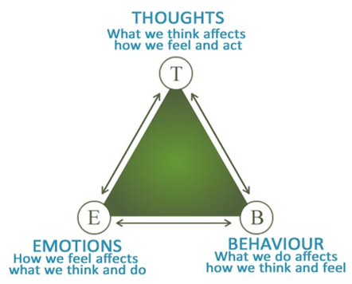

Vitally, what Restorative Practice is not is some kind of woolly, soft-touch avoidance of responsibility and accountability. Genuine restorative practice involves high challenge and high support. High challenge ensures that we hold our pupils and ourselves accountable for the highest standards of behaviour and we never tolerate behaviours that prevent or limit learning or that cause social, emotional or physical harm. All mistakes must be fixed. High support means that we understand that we are all human, that mistakes are inevitable and part of learning and that children particularly will need support so that they maintain calm or regain feelings of calm quickly and easily, are not overwhelmed by the challenges of school, know that there are trusted adults on hand to help them and are not required to do things that are unreasonable.

This policy should be read alongside the following documents.
Etchells Teaching Model (the primary way we ensure great behaviour is through excellent first teaching which is predictable, planned, focused on foundational knowledge (ie not too hard so as to overwhelm), rich in modelling, scaffolding and support, active and allows learners to feel safe and engaged.)
Keeping Children Safe in Education
Etchells Safeguarding Policy
Etchells SEND policy
SEND Code of Practice
Etchells Anti-Bullying policy
Use of Reasonable Force
Suspensions and Exclusions policy
Appendix 1- Reminder system
Steps | Behaviours shown | Who is responsible?
Reminder | Not completing work, calling out, rudeness to staff, throwing small equipment, continual off-task talking, refusal to follow instructions. | Class teacher  Class teacher may at any stage, if behaviour justifies, tell a pupil that they will have to miss playtime so long as they are given the opportunity to win this time back by addressing previous behaviour, behaving better and/or repairing harm promptly and effectively.
Final Chance
Time in | Failure to adequately address early behaviours  Leaving the classroom,  Refusal to come in from  playground | Class Teacher supported by Phase Leader
Reflection sheet to be completed | Deliberate violence towards a  child or adult  Racist or prejudicial hate incidents  Upturning furniture  Swearing directly at an adult  Significant loss of temper | Member of SLT

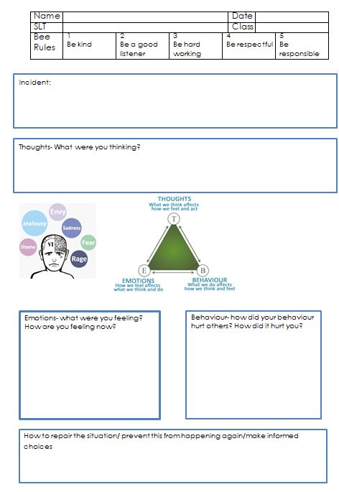
Appendix 2- Reflection Sheet

Appendix 3- KS2 Behaviour ladder
Step 1 | Verbal reminder of expectations
Step 2 | Further reminder of expectations and reminder of times when they have done and shown much better. Their name is ticked inside the clipboard.
Step 3 | The child is given a final chance. The class teacher will speak to the child about their behaviour and what the next steps are if it continues.
Step 4 | Time in. Missed play during which time the work that was not completed to the required standard can be completed and / or any harm done can be repaired.
Step 5 | Reflection with member of the Senior Leadership Team issued at lunchtime or in the afternoon to reflect on their behaviour. In the case of children who have a school dinner, their wrist band will be collected and the meal reserved. A Reflection sheet identifying mistakes made and action taken to repair will be completed and these forms will be kept by the Headteacher. The reflection sheet is shared with parents, detailing mistakes made and steps taken to redress.
Step 6 | Suspension. Any suspension is an admission that current practice for that child has been insufficient to meet their needs and a short, focused period of time is necessary for them to recover and re-set and for school to re-plan how to best challenge and support them. Suspensions can be issued for individual serious incidents, typically involving violence or the threat of violence, or for a cumulation of lesser incidents of poor behaviour where it is clear that there is a pattern of support being offered and not taken or effective. See Suspensions and Exclusions policy.
Step 7 | Permanent Exclusion. The Headteacher, with the support of the Governors, reserves the right to permanently exclude pupils in line with the suspensions and exclusions policy where negative behaviour is so serious and/or regular to jeopardise the safety and wellbeing of others. This is exceptionally rare and subject to a range of contextual factors.

