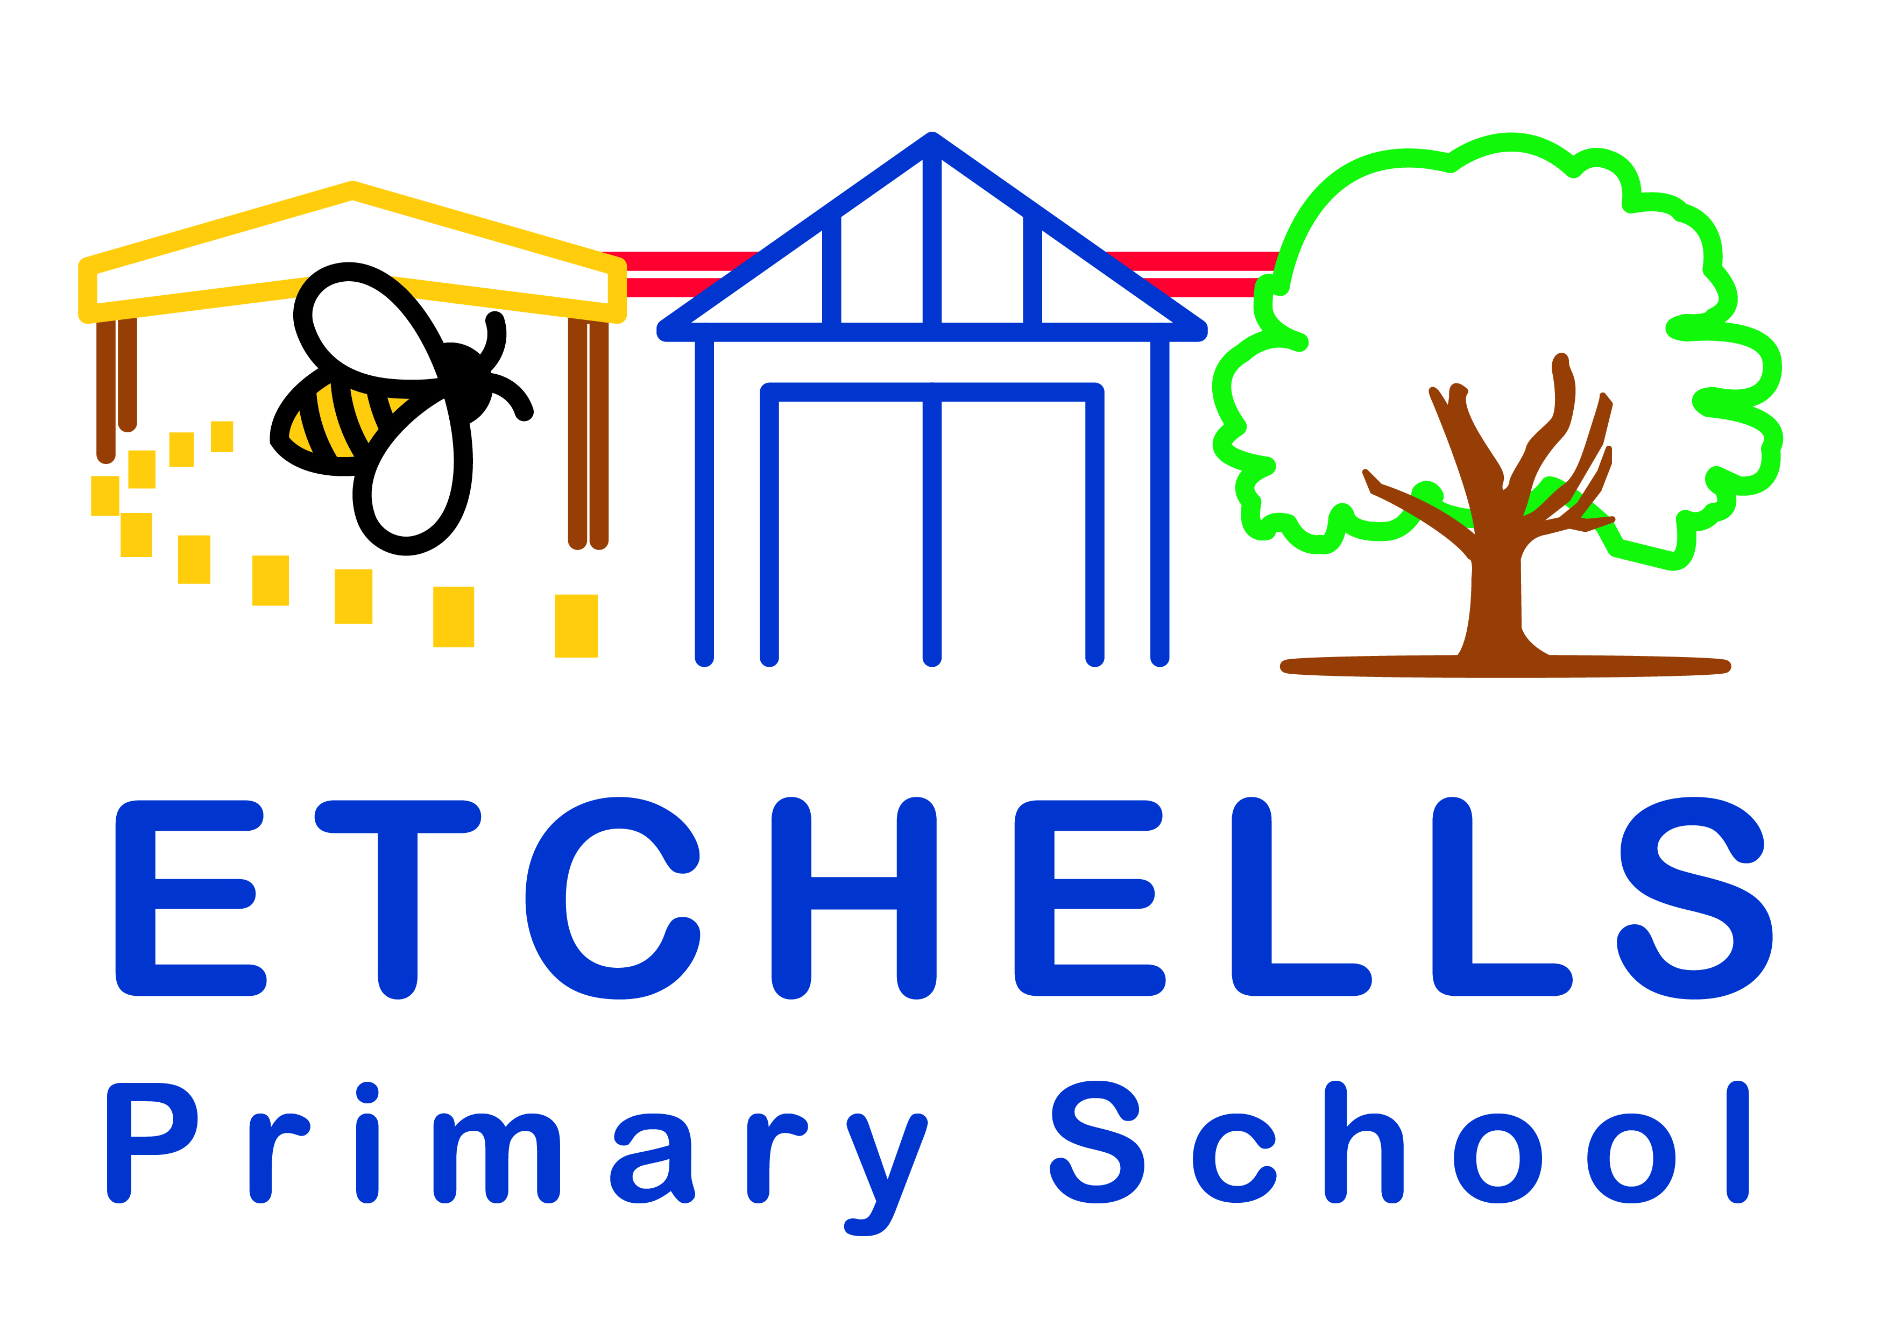

School Uniform Policy

March 2025
Policy History
Date | Version | Update | Prepared by
April 22 | 1.0 | Policy prepared for September 22 | J. Mallinson
March 2025 | 2.0 | Updated policy in line with latest guidance and shared with staff, parents and Governors. Ensured that it was inline with the Equality Act 2010. | P.Cope

Aims:
At Etchells Primary School, we have high expectations and standards which is reflected in the pride we take in our school uniform and the feeling of belonging that it creates. It is Etchells policy that all children wear school uniform when attending school or when participating in a school-organised event. This policy is based on the notion that school uniform:
- Promotes a pride for the school and upholds the principles, values and ethos of the school.
- Allows for a sense of community, identify and belonging to Etchells.
- Allows us to identify children with Etchells.
- Promotes a sense of equality in terms of appearance and removes peer pressure to dress in ‘designer’ fashions.
- Respects variations if they are directly related to established religious or cultural traditions.
- Represents suitable wear for school and good value for money.
- Designed to support safeguarding, health and safety.
What is the recommended School Uniform?
A gender-neutral policy is applied at Etchells Primary School. For example, girls may prefer to wear shorts in Summer. The school recognises the impact that school uniform may have on: equality, those who share the protected characteristics and parental financial restraints, whilst considering key aspects such as: safeguarding requirements and the health and safety of our pupils.
The following are approved uniform items:
Winter/Spring Term | Summer Term | Early Years | Swimming | Physical Education | Forest School
Royal Blue sweatshirt or cardigan  White polo shirt/t-shirt  Grey trousers, shorts and skirts  Black shoes or trainers  Plain grey tights  Plain headscarves | Royal Blue sweatshirt or cardigan  Leavers Hoodies (Royal Blue) for Year 6  Blue and white checked dresses.  White polo shirt/t-shirt  Grey trousers, shorts and skirts  Black shoes or trainers | Royal Blue sweatshirt or cardigan  White polo shirt/t-shirt  Grey/Black joggers/leggings  Black shoes or trainers | One piece swimming costume.  Shorts, not baggy.  Swim caps for longer hair. | Royal Blue sweatshirt or cardigan  Plain or Branded white t-shirt  Plain black shorts  Plain black jogging bottoms  Black trainers  No football kits  Long hair must be tied back | Plain joggers/tracksuit/  Leggings  Plain coloured long sleeve t-shirt  Plain old jumper/sweatshirt  Wellington boots/old trainers  Gloves or sunhat depending on the season.

Generic school uniform can be purchased from any number of local stores, such as Tesco, Asda, Marks and Spencer or online. If you wish to purchase a sweatshirt or cardigan with the school logo, these can be purchased through school via ParentPay.
Headscarves worn for religious reasons should be plain in any colour. Nail polish, make up and jewellery is not to be worn. The wearing of earrings poses a health and safety risk during all physical activities e.g. playtime, PE sessions, dinnertime etc. Children should not wear earrings in school. However, we are aware that many families elect to pierce their children’s ears and, though we strongly discourage ear piercing for primary school aged-children, we will work with families in the following ways.
Children unable to remove earrings for the first six weeks of a new piercing will have to have PE and other potentially dangerous activities modified to mitigate and limit risk. This will mean less than full participation in some lessons and activities but ensuring children are safe is paramount. They must be able to remove them after the six weeks has lapsed, in line with Stockport and national policy. If they cannot, restrictions will continue but we will work with families to support safer options including parental removal of earrings on PE days or support in teaching the child to remove their own where appropriate.
Children may wear small, discreet watches which must be removed for PE. Smart watches with the ability to take pictures/receive messages are not permitted at any time.
Purchasing School Uniform
Generic school uniform can be purchased from any number of local stores, such as Tesco, Asda or online. If you wish to purchase a sweatshirt or cardigan with the school logo, these can be purchased through school via ParentPay. Please note that our Parent Teacher Association also runs a number of pre-loved uniform events throughout the course of the year. Parents can also collect pre-loved items of uniform during parents evening at no cost.
Equal Opportunities
All children have equal access to wearing school uniform regardless of their culture, race, religion, gender, disability or ability. We ensure that the set uniform respects other policies and allows for individual sets of circumstances of all groups and individuals. Etchells Primary School is committed to creating a positive climate that will enable everyone to work free from racial intimidation and harassment and to achieve their full potential.
Optional items
- A small book bag for carrying homework diary, reading books, letters etc
- A drawstring PE kit bag for swimming/ Forest School. No large bags please
Please make sure all items of clothing are clearly named
Sun Protection
We are very keen to promote a healthy exposure to the sun. Caps should be worn in sunny weather.

