Maths Vocabulary Jargon Buster
Following feedback from our Maths Open Evening this is a guide to some of the more complex terms we may use in maths. If you feel we have missed anything out, please let us know and we will be happy to amend the details.
Key vocabulary | Definition | Example
abstract (– follows on from concrete and pictorial) | A child who is working in an abstract way is using the ability to calculate without having to draw images or to hold objects. (mental and calculator methods completed without additional support). This is the stage when they are working most confidently in mathematics
addend | The name we give to the 2 or more parts we combine or add to make a total | 3 + 4 =7 (3 and 4 are addends)
aggregation | This is when a child puts two or more sets of objects together and then counts all of them | 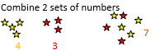
algebraic | When a symbol or picture is used to represent different numbers | 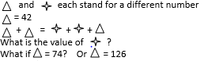
algorithm | An algorithm is a formula or set of steps for solving a particular problem. | To find the area of a rectangle we multiply the length by the width
arrays | Images set out in a pattern which help children to ‘see’ multiplication and division facts. | 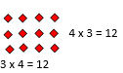
augmentation | Counting on from the largest number. This is the step after augmentation, as children now know that they don’t have to start from one every time they add on. | 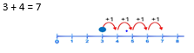
balanced equation | A number sentence in which both sides have the same answer. | 3 + 4 = 5 + 2
Bead strings | A counting tool used in KS1 | 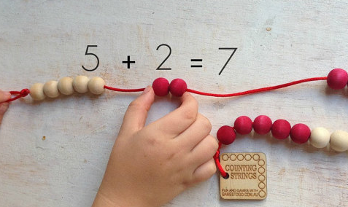
chunking | Used in division, this is a way of taking away known ‘groups’ or ‘chunks’ of a number because we teach division as repeated subtraction of the same number. | 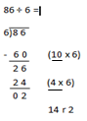
columnar | The process of writing numbers one above the other and then calculating each column in turn. | 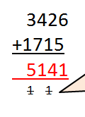
combine | Put two or more sets of objects together to create a larger total | 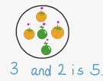
commutative | In addition or multiplication, numbers may be added or multiplied together in any order. | 2 x 3 = 3 x 2  4 + 5 = 5 + 4
compact method | Formal method of adding, subtracting and multiplying. | 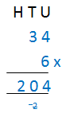
Composite number | A number that is not a prime. A whole number that can be divided evenly by numbers other than 1 or itself. | 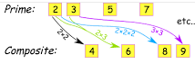
Complements | Give a number (for example 10) whenever the sum of any two numbers equals the given number, the two numbers are said to be complementary. So 4 is the complement to 6 when we want to make 10. These are also known as ‘number bonds’ | 50 + 50 are complements to 100
complimentary addition | Commonly known as the jump strategy. Useful for helping children visualise that subtraction is finding the difference between two numbers. | 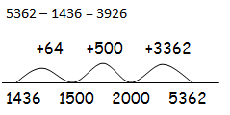
concept of equality | Children need to know that it doesn’t matter where the equal symbol is, the calculations on either side of it need to match one another. This concept is reinforced by providing children with missing number calculations so they ‘have’ to think about making the 2 sides balance. Scales are used in KS1 to show pupils that the 2 sides ‘weight’ the same if cubes or numicon are used. | 2 + 3 = 5  is the same as 5 = 2 + 3  what needs to go on the other side if  3 x 4 = 2 x __
concrete | This method of calculating is the first stage in learning about number and involves the pupils in holding and moving objects to represent numbers | 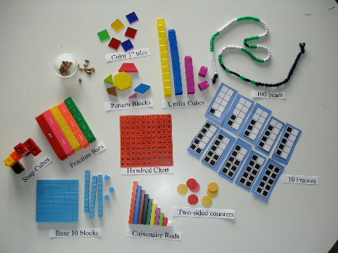
Deins | A set of plastic blocks that are used to model numbers. They come in ones, tens, hundreds and thousands blocks. | 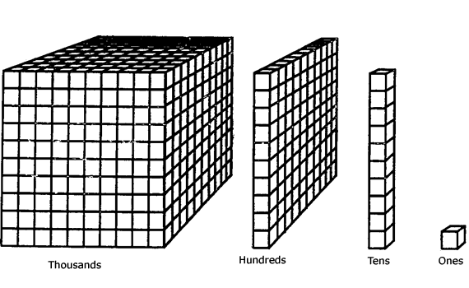
digits | Another word for individual numbers that are used to make a larger number. | 1 2 3 4
divisor | A number which is used to divide up another number without a remainder. | In the calculation 24 ÷ 4 = 6  the divisor is 4.
dividend | This is the number you want to divide up. | In the calculation 24 ÷ 4 = 6 the dividend is 24
efficiency | The fastest and most accurate way to complete a calculation. | It is okay to do  4 + 4 + 4 + 4 + 4 + 4 = 24  But it is more efficient to write  6 sets of 4 = 24  Or even faster to write  6 x 4 = 24
equation | An equation says that two things are equal. It will have an equals sign. | 7 + 2 = 10 – 1
estimating | Trying to work out a rough answer to a question first in order to check if a final answer is correct.  This often involves making numbers simpler by ‘rounding’ them. | 234 + 456 =  ‘roughly’ 200 + 500 = 700
exchange | To swap digits of one value (see place value) for another value in order to borrow or to add. | 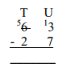  in this case there were not enough ones for us to take 7 away so we exchanged one of the tens to give us 13 ones.
expanded method | A way of writing numbers to show place value. | 224  +148  12  60  300  372
factors | The numbers which can divide into another without any remainder. | The factors of 12 are 1, 2, 3, 4, 6 and 12 because  12 ÷ 1 = 12  12 ÷ 2 = 6  12 ÷ 3 = 4  12 ÷ 4 = 3  12 ÷ 6 = 2  But 5 is not a factor because there will be a remainder  12 ÷ 5 = 2 r 2
fluency | The ability to recall the answers to basic maths facts automatically and without hesitation. A child who is still using fingers or taking a long time to think out an answer is not yet fluent.
grid method | It is a written method. It involves partitioning numbers into tens and units before they are multiplied. | 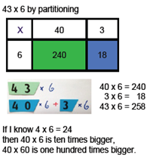
integers | A positive number, a negative number or zero but not a fraction or a decimal. | 1, 3, 5, -4 are all integers but ½ 0.25 or ¼ are not integers
inverse calculation | Opposite, reverse operations. | Addition and subtraction are inverse operations  Multiplication and division are inverse operations
manipulatives | Objects that are used to support the learning of maths – such as numicon, counters and Cuisenaire rods | 
mixed operations | Calculations or number sentences that involve more than one type of operation. | 23 + 7 = 40 - ___
multiples | All numbers that are in a particular times table. | Multiples of 3 include 3, 6, 9, 12, 15, 18…
multistep problems | Calculations or problems that require a child to work out one part and then another…  The higher up the school pupils are the more steps there may be in a problem. | If lollies cost 20p each how much change would I get from £1 if I bought three lollies. Here the child needs to work out first how much 3 x 20 is and then calculate what £1 – 60p would be.
not commutative | A calculation in which the numbers on one side of the equals symbol can’t be reversed. Subtraction and division are NOT commutative. | 23 – 4 = 19  but 4 – 23 is not 19  12 ÷ 4 = 3  But 4 ÷ 12 is not 3
number bonds | Pairs of numbers that make another number. By the end of Year 1 pupils should know all of the number bonds that make every number up to 10 by heart. These number bonds are used in every subsequent year group and need to be recalled instantly for children to make effective use of them higher up the school. | 1 + 2 = 3 1 + 3 = 4  2 + 1 = 3 2 + 2 = 4  3 + 0 = 3 3 + 1 = 4  0 + 3 = 3 4 + 0 = 4  0 + 4 = 4
number line | This can be numbered or blank and is a line that pupils use to count on or backwards. | 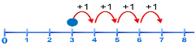
numicon | A set of frames and pegs that are used to model numbers and to practise number skills particularly within key stage one and with pupils who are having more difficulty. | 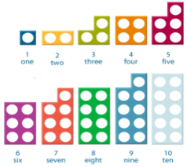
operations / 4 rules of number | These are addition, subtraction, multiplication and division and all of the vocabulary associated with each.
partition | To split a number into parts. In its simplest form it is usually split into tens and ones such as 23 partitions into a 20 and a 3 however ANY splitting of the number can be classed as partitioning for example 23 can also be split into 18 and 5 if this helps with a calculation | 34 can be split into 30 and 4  20 and 14  24 and 10…
pictorial representations | Drawing or looking at pictures to help children to understand a question or problem. | 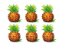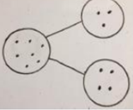
place value | How much each digit within a number is worth. | In the number 247  The 2 is worth 200  The 4 is worth 40 and the 7 is worth just 7
prime | A number positive whole number that has no factors other than itself or 1. (2 is the only even prime number.) | 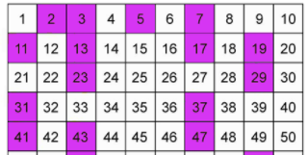
product | Product is the result after we multiply | The product of 2 and 3 is 6 because 2 x 3 = 6
quotient | The answer after you divide one number by another. dividend ÷ divisor = quotient. | 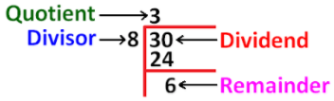
reasoning | This involves pupils in giving a ‘reason’ why something has or will happen. | If a child has added 30 and 80 and given the answer as 110, can they explain that they know that this calculation is the same as saying 3 tens add 8 tens makes 11 tens. Equally it would be possible to ‘reason’ that 80 add 20 is 100 so 80 + 30 must be ten more than 110.
rounding | Making a number simpler but keeping its value close to what it was. | 38 rounded to nearest 10 = 40  123 rounded to nearest 100 = 100
symbols | + - x ÷ £ % are all examples of symbols. | + - x ÷ £ %
variety of contexts (variation) | Problems which are set in lots of different ways. For example addition could be completed for money, when finding out about fruit, number of animals, number of rockets going into space…Teachers will often devise problems that are linked to the current topic to make the learning relevant. The more contexts children meet the more confident they become in using their skills.
visualisation | When a child draws or uses marks to help them to ‘see’ what a problem means.

