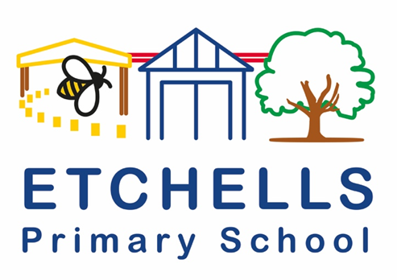

Teaching and Learning
POLICY

September 2024
Version History
February 2016 | 1.0 | Rewritten for the new National Curriculum | J. Mallinson
 |  | Presented to Governors Spring 2016
 |  | Policy agreed Spring 2016
January 2019 | 1.1 | Revised to compliment new Curriculum Policy | J. Mallinson
 |  | Presented to Teaching &Learning Governors Committee Spring 2019
May 2023 | 1.2 |  | P.Cope
September 2024 | 2.0 | Revised Policy reflecting the Kagan strategies, Rosenshine Principles and Alex Bedford work. | C.Wilson

Aims:
This policy aims to explain how we will create an environment at our school of high expectations where students develop a life-long love of learning and make continued and accelerated progress. It summarises the expectations we have as a school to make sure all staff have a clear understanding about what excellent teaching and learning looks like across the school. It ensures that all members of school community recognise the importance of excellent Teaching and Learning and that a robust curriculum is our most powerful tool to achieve excellent inclusion and equality across the school. Finally, it is here to monitor that all staff have the skills and knowledge to identify gaps in students’ learning and to address this through their teaching.

At Etchells Primary School:
We are a vibrant, happy, welcoming school and provide a stimulating and inclusive environment for learning. We have an experienced, highly skilled and innovative team who work together to plan exciting and stimulating learning opportunities for our pupils, delivering a curriculum which is built around 'Knowledge, Exploration and Communication'. We take pride in responding to the learner's interests and ensure that lessons challenge and support our pupils. We fervently believe that teaching and learning underpins all elements of Etchells school life.

The six core values underpin all teaching and learning at Etchells:
Enjoyment, creativity, resilience, independence, challenge and aspiration.

Furthermore, through our ‘Bee Rule’ we establish impeccable behaviour for learning and ensure that this is maintained though consistent use of these rules:
- Be kind,
- Be a good listener,
- Be hard-working,
- Be respectful,
- Be responsible.

At Etchells we believe children learn best when they:
- Are interested and motivated by the curriculum
- Feel successful
- Receive feedback about their performance
- Are clear about expectations in their work and behaviour
- Are given appropriate tasks
- Are challenged and stimulated
- Work alongside the local community and their families
- Feel happy, safe, value and secure
- Are proud of their learning environment
- Enjoy coming to school

We believe teachers teach best when:
- Work is planned to meet the needs of the children
- There is a stimulating, positive and happy environment within the classroom
- The classroom is well-managed and organised
- There is good communication and teamwork among all teaching and support staff
- Staff feel supported
- There are regular opportunities for CPD

As such, this policy should be read in conjunction with our Positive Relationships policy, Pupil Premium Strategy, EAL policy and our curriculum policies.
KEY PRINCIPLES
At Etchells we believe that Teaching and Learning is underpinned by 4 areas:
- Planning
- Assessment
- Feedback
- Questioning
- Planning
- At Etchells, learning activities are well planned to ensure complete coverage of knowledge, skills and curriculum content based from the National Curriculum. Each curriculum area has its own skills and progression document outlining the expectations in each year group. This gives staff the opportunity to support the progression in each subject area whilst also checking for prior learning.
- All planning is differentiated to meet the needs of our diverse school community, with many children speaking English as an Additional Language, having SEND needs or being pupil premium. A broad range of strategies are in place to support this, including substitution grids in written lessons, scaffolds and the chilli challenges.
- The chilli challenges (Appendix A) are an embedded part of our school curriculum, giving children the opportunity to recall prior learning, support, stretch and challenge learners.
- Active learning is an integral part of the culture at Etchells with opportunities planned in daily and weekly for children to actively engage in their learning. Active learning should be fun and engaging so children can get the most out of their educational experience.
- In writing, Jane Considine’s Write Stuff is used to plan writing units, following a very clear format which included sentences stacking. This is used in every phase of school, with teachers writing a follow up unit based on the end of year grammar objectives.
- Maths planning follows White Rose, with supplementary resources selected to engage in active maths.
- Success criteria building are built with the children and provided where necessary.
- Kagan structures are used in lessons to promote paired and group work and structures discussion.
- whenever possible planning is cross-curricular, recognising connections between areas of learning and taking into account the role teaching has in promoting the children’s spiritual, moral, social and cultural development.
- Assessment
- At Etchells, assessment informs teaching so that there is provision for support and extension of learning for each child.
- Assessment is split into two strands: formative (takes place on a day-to-day basis during teaching and learning, allowing teachers and pupils to assess attainment and progress more frequently) and summative (sums up what a pupil has achieved at the end of a period of time, relative to the learning aims and the relevant national standards).
- Formative:
- Alongside Kagan structures, talk partners are an integral part of the Etchells classroom. Children are concisely offered the opportunity to share their thoughts with a partner prior to feeding back to an adult.
- Recall strategies are used at the start of lessons to recap previous learning.
- Cognitive load is reduced by ensuring that coverage of the curriculum is clear and concise.
- Metacognition and self-regulation strategies are deployed across school to support pupils to think about their own learning more explicitly, often by teaching them specific strategies for planning, monitoring, and evaluating their learning.
- Summative:
- In years 2-5 children are assessed termly using Test Base papers are used to assess pupils progress in Reading, Maths and SPaG.
- In year 6, children are assessed half termly using SATs papers from previous years.
- Teachers track children’s progress in writing and reading using the Etchells Primary School Writing and Reading progression documents. These documents are stuck in the front of children’s writing and reading books. Teachers will tick off the standard that the child has met. In writing these are ticked off after each final piece of independent writing has been completed.
- In writing, this assessment is then used to inform the next steps in planning for writing lessons.
- Writing is internally assessed termly with year group moderation and cross phase moderation. In both meetings, teachers have the opportunity to discuss children’s work and their progress.
- In phonics, as well as ongoing formative assessments during lessons; end of phase assessments, TELL diagnostic tool and phonics screening checks are used to track children’s progress, inform planning, identify children who need further consolidation and organise groupings.
- At the end of Year 1 all children take the Phonics Screening test. Year 2 children who did not achieve the pass mark in the previous year re-take the Screening test at the same point in time.

- Feedback
- At Etchells we have a clear ‘feedback policy’ that focusses on in the moment marking and feedback for all pupils. As a consequence of this, teachers are not expected to make written comments on all pieces of work. In order to keep feedback manageable and meaningful, these guidelines are followed:
- Marking with pupils during the lesson in green pen is encouraged as this gives immediate feedback.
- Pupils not working directly with a teacher or TA may be completing practical work, large paper tasks, iPad supported tasks etc. This work is not expected to be marked and does not always need to be photographed for books. A photographic record may be kept on the class website page or ClassDojo.
- Time is planned during allocated English and Maths lessons for feedback to be followed up and corrections, responses or editing flaps to be made (not during other curriculum lessons) This principle should be applied across the curriculum where relevant
- Peer marking and self-assessment should be taught and modelled. Check lists and use of success criteria can be used to support this, keeping the process effective and focussed
- Where 'Teacher chat', 'verbal feedback' or '1-1 supported re-visit' is used, it is useful to see evidence of purple pen corrections, improvements or reflection, though further comments are not needed.
- Staff are encouraged to be innovative in their feedback strategies. Good examples have included whole class feedback sheets with self-selection targets; printed hot questions/next steps; marking ladders; pupil reflection and reasoning comments in purple pen, sharing of good example.
- Questioning
- All school staff have been trained in Rosenshein’s principles. As such, as a school, we follow the attitude that the best teachers ask the most questions and ask students questions about how they got to their answer
- Following discussion time, we follow a ‘no hands up’ approach to questioning, where tools such as lolly pop sticks and random name generators are used to ensure that all children are engaged and included in all learning.
- Key questions are planned into lesson slides prior to the lesson.
- Blooms taxonomy questioning techniques are used extensively in KS2. Bloom's taxonomy is used by teachers to ask questions that are closely related to the learning objectives at each stage of the process. Multiple-choice questions, for example, can help determine a student's basic understanding and how well they remember the topic, whereas asking them to come up with an analogy indicates that they are ready to proceed to the application or analytical stage.
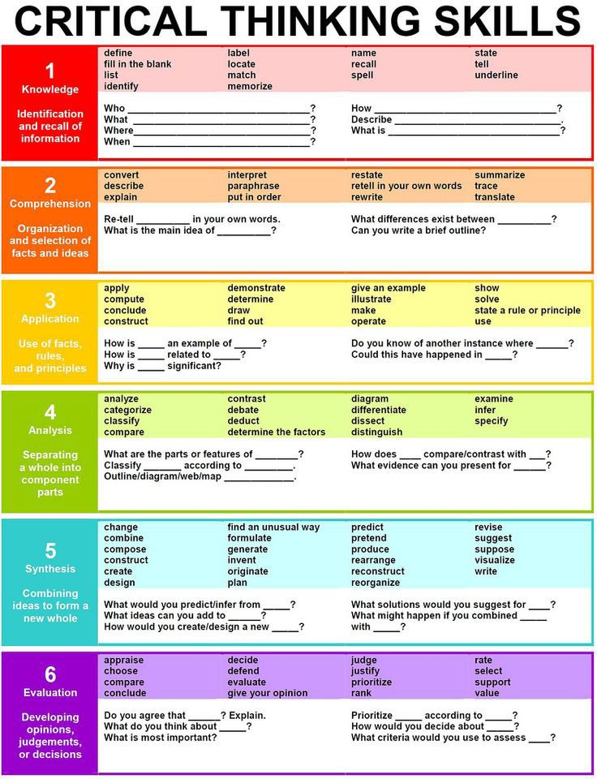

- Blank’s level questions are used in EYFS and throughout school where appropriate (INA’S, Speech and language support) to help develop oral language comprehension skills.

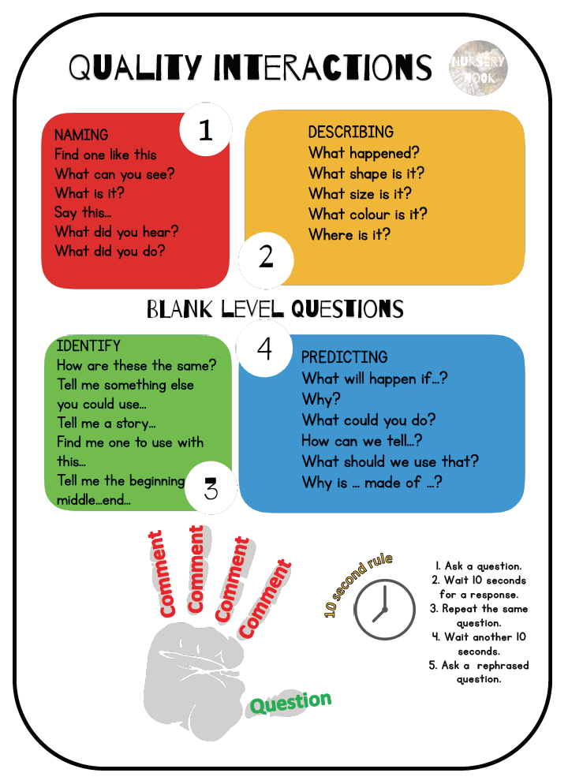

- Question stems are used throughout such as:
- Are you sure?
- How do you know?
- What do you notice?
- What’s the same and what’s different?
- Can you convince me?
- Is there another way?
- Is it always, sometimes, or never true?
- Can you imagine?
- Questioning strategies are used to support feedback in lessons, such as:
- No opt out
- Cold calling
- Say it again better
- Probing question
- ABC questioning
- Pose pause pounce bounce

Appendix A- Examples of Chilli Challenges
Year 5 Example
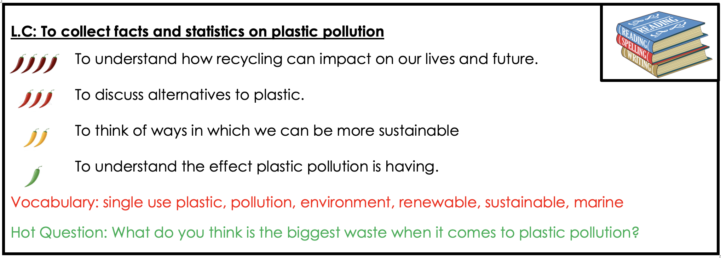
Year 3/4 Example
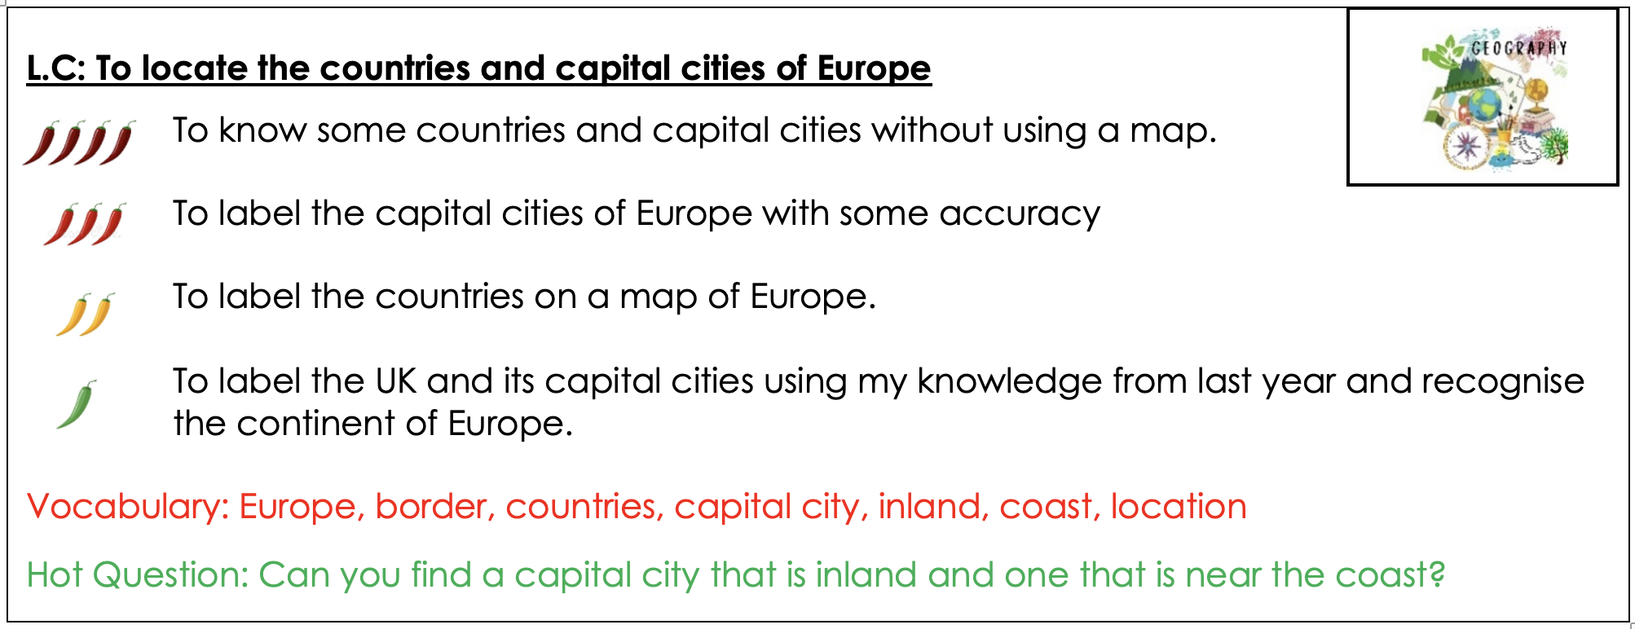


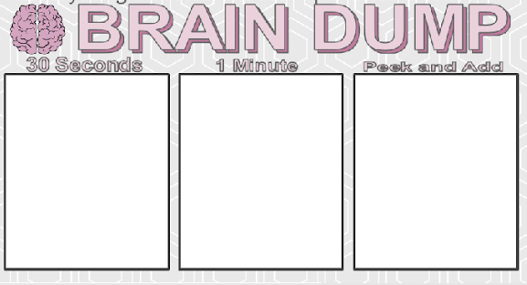
Appendix B- Recall Strategies at Etchells
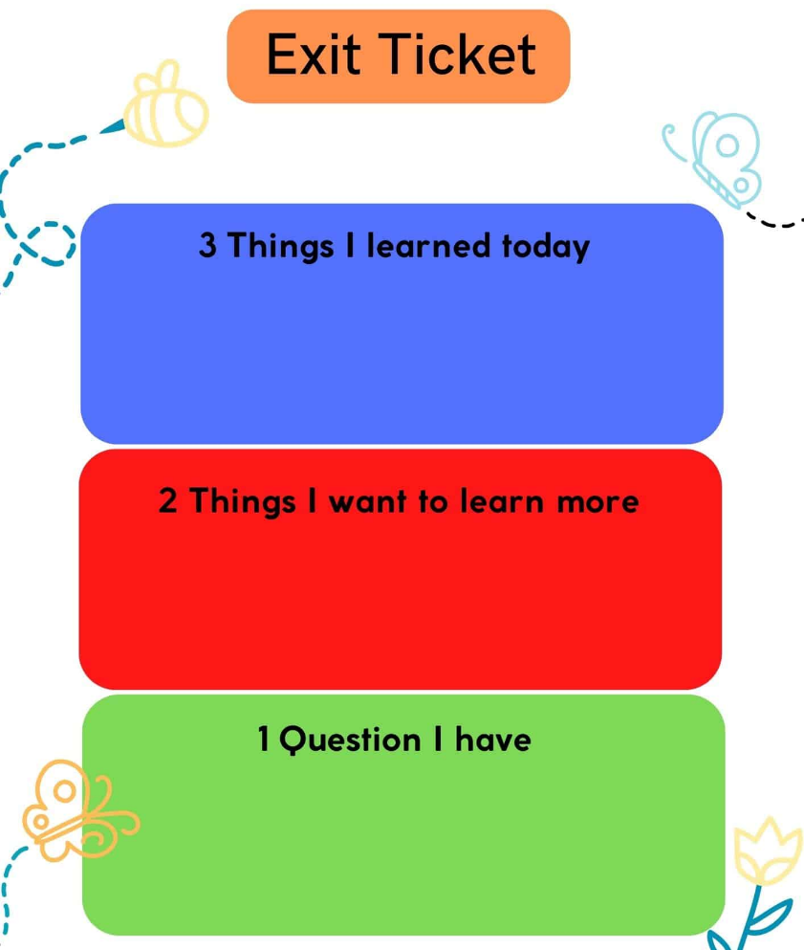
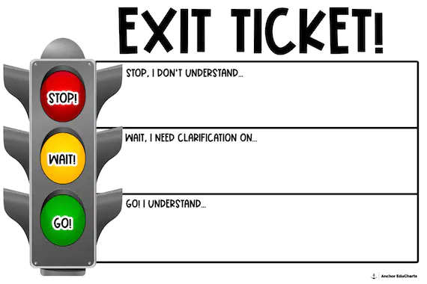
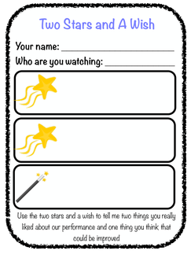
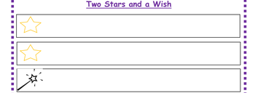
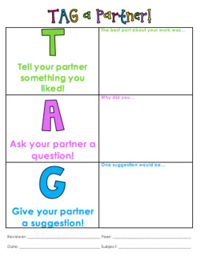
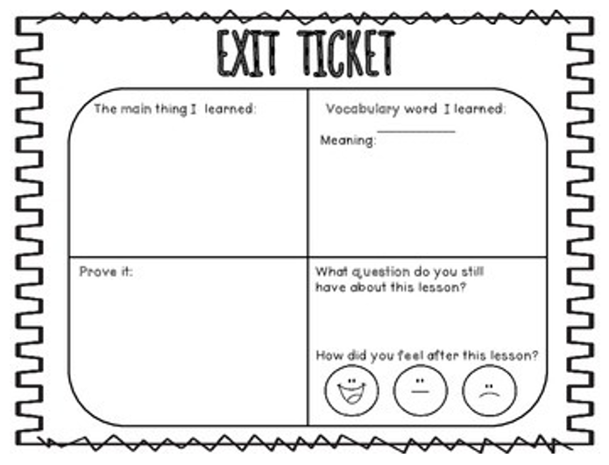

Appendix C- One page teaching strategy
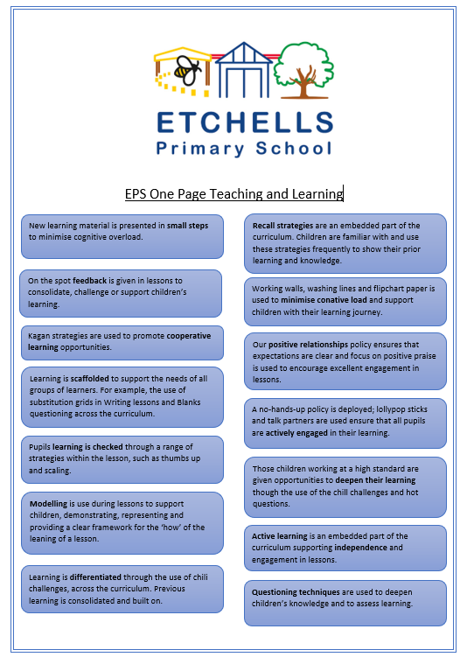
Appendix D- One-page questioning strategies
