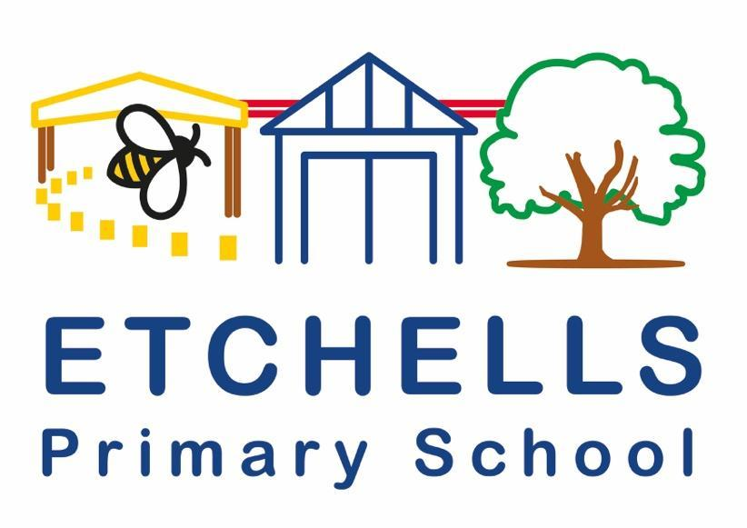

HOME LEARNING POLICY

January 2025
Policy History
Date | Version | Update | Prepared by
Jan 2025 | 2 | January 2028 | Claire Wilson

- Aims
The main aims of this policy are to lay out the processes and procedures in place for home learning in the event that school is closed or partially closed for any reason. This is to ensure that learning is consistent for all pupils and that progress of the children is monitored, even through periods of lockdown, self-isolation or any other event of closure. This policy does not refer to homework. Homework is discussed at length in the Etchells Homework policy.

This policy details the home learning provision that is provided by school in the vents of the following closures:
- School is closed or partially closed due to unforced circumstances, including lack of water or heating, limitations of food or toilet provision, snow and ice.
- During times of infectious disease control (such as Covid 19), and following guidance from Public Health England on isolation, a pupil needs to isolate as someone in their household has either tested positive or is currently waiting for results back from a COVID test or similar infectious disease.
- As outlined above, following guidance, a group of children have been told that they need to be isolated as there has been close contact with a person who has Covid 19 (or similar infectious disease).
- As outlined above, following guidance, a whole bubble has to self-isolate as there is a case of Covid 19 (or similar infectious disease) in the bubble.

This policy fully complies with the expectations outlined in the DFE document: Guidance for Full Opening of Schools.

- Parental responsibility
During any periods of self-isolation or lockdown, parents and carers must understand the importance of the home learning that is being provided by school and that the work is compulsory. If work is not being completed or there is a lack of engagement from home, teachers may complete a welfare phone call to discuss the lack of engagement, discussing strategies that could be used to move forward and increase the amount of work that is being completed. However, if a child is too ill to engage in the home learning then it is the responsibility of the parent/carer to share this information with the school as soon as possible. This should be done via the school office or on class Dojo.

- Online platforms
As a school, it is our responsibility to ensure that the children are receiving a wide and varied curriculum, even during periods of self-isolation or lockdown, that are in line with our Etchells Curriculum Skills. The teachers will aim to cater for all abilities but if a child is particularly struggling with the work being set then a message should be sent to the teacher via Class Dojo. Families of children in the Resource Base can also access the Tapestry app to share messages and learning.
The work that is provided for the children will be uploaded daily on the school website and on Class Dojo. It is recommended that when the children complete the work that it is sent to the teacher so that they can see what work has been completed for the day. Work can be uploaded directly onto class Dojo, where the teacher can access this and give feedback where appropriate. The reward system will still be active during home learning periods and Dojos’ awarded for high levels of engagement. The Class Story page will also offer a chance for the teachers to celebrate good work.
In line with Local Authority advice, live, online lessons will not take place. This is to enable all our pupils to have an equal opportunity to access the lessons. We recognise that technology challenges can lead to children only being able to access the online resources at certain times of the day due to working commitments of parents and the sharing of IT equipment with siblings. IN the event of whole class closure, teacher will endeavour to post videos/links to videos that can be watched at home at an appropriate time.
Where there is no available IT equipment in the home, the school will endeavour to support with this. Any families unable to access a laptop or tablet should let the school know. A phone is not considered to be a suitable form of equipment to access home learning.

- Communication
During self-isolation or isolation periods, the best way to contact school is through the class teacher on Class Dojo. If the message is more urgent then please don’t hesitate to contact our phase leaders on the following emails:
Sally Revill (EYFS Lead)- EYFS@etchells.stockport.sch.uk
(KS1 Lead)- KS1@etchells.stockport.sch.uk
Rachel Collins (Year 3/4 Lead)- LKS2@etchells.stockport.sch.uk
Claire Wilson (Year 5/6 Lead)- UKS2@etchells.stockport.sch.uk
The headteacher can also be contacted at: headteacher@etchells.stockport.sch.uk
Please contact the head regarding any concerns and always in the event of a positive case in the family household.
- Implementation

In the event of the closure of a bubble or local/national lockdown, home learning will be provided in the following ways:
- Ongoing support provided for all children
- The children will have access to both the school website and parent/carers to the Class Dojo App.
- Work will be uploaded daily for the children. This will consist of at least one Maths, one English and another activity for the children to complete. This will be a variety of practical activities and written challenges.
- Once work is completed, this should be uploaded to the school website, the portfolio section of Class Dojo or a picture taken of the work and sent to the teacher via messages on Class Dojo.
- After the work has been submitted, it will be accessed and reviewed by the class teacher. The teacher then may choose to offer advice on how to improve the work and may offer a form of reward for their efforts.
- During the day, the teachers will be available for any questions that you have. This could be help with the work that is being set or how to complete a particular type of method. The teacher may direct you to online clips that can help with particular methods or upload pictures/videos of themselves explaining how to complete the work.
- If a task has a specific outcome or is challenging, the teacher will either write a detailed explanation of what is expected of the children or they may upload a video explaining what to do. Sometimes it is helpful for the teacher to record audio clips on the Powerpoint uploaded to guide the children through the task.
- If a child does not have access to home learning, paper-based packs can be provided by the teacher for children to work on. This work will eb available via the school office and should eb returned to the office for class teachers to look at. These will have detailed explanations of what is expected of the children and may be followed up by the teacher via a phone call.
- If you are struggling to get your child to engage in the home learning activities, communication is vital. Contact your class teacher and they can send encouraging messages or complete a phone call in order to increase the amount of engagement from the child.

- Ongoing support for SEN/Vulnerable children
- Adapted work will be provided for these children, this could be through the online platforms or paper copies.
- Phone calls will be made to these parents/carers to review the home learning tasks set and discuss any possible improvements that can be made to make the activities more meaningful.
- If the child does not engage, the SENCO or class teacher will phone the parent/carer to discuss how best to support the child. If engagement does not happen after the first phone call, an additional one will be made by a member of the Senior Leadership Team.
- It is recommended for our vulnerable children that if a case of Coronavirus occurs in their bubble then they should get a test, if showing symptoms.
- Specific intervention work may be provided for the children to complete at home such as speech and language programmes or physio work.

- Impact
At Etchells Primary School, we aim to always provide a stimulating and varied curriculum for the children, focusing on the enjoyment of learning and progress towards specific targets that the children have. We will continue to provide home learning tasks which meet the age appropriate skills required.

- Resources used by each Year group for home learning tasks

Nursery | Daily uploaded videos by teacher with teacher led activities for the children to complete  Practical activities planned  Play dough given to the children for weekly ‘dough discos’  Story Reading
Reception | 3 tasks a day- Literacy, Numeracy and Phonics  Each task has 3 levels of challenge for the children  Ey2P Phonics Games  Mr Thorne does Phonics- Youtube for each daily phoneme  Alphablocks for Phonics  Phonics Play Website  Jack Hartman  Numberblocks  Links to stories for writing
Year 1 | White Rose Hub Maths  Numbots  Nessy  Phonics Play  MCFC Home learning Pack
Year 2 | Teacher based Maths powerpoint based on White Rose Hub  Powerpoint with spelling, phonic task, SPAG task and a writing task  Twinkl- SPAG and Maths Mats  Stories read on Class Dojo
Year 3 | White Rose Hub  Oxford Owl  Read Theory  Nessy  123 Maths  Pobble  TT Rockstars  Talk for writing booklets
Year 4 | Whiterose Hub  Classroom Secrets  Kahoot  Youtube Clips  Hamilton Trust  TT Rockstars  Nessy
Year 5 | Twinkl (Geography, reading comprehension, Science)  Literacy Shed  Easyteaching.net  TT Rockstars  Youtube clips (PE and Mindfulness)  BBC Bitesize Clips  IXL  Popuk.org  Sigma Science  Nessy
Year 6 | White Rose Hub  Levelled SATS questions- TES  Audio Clips attached to Powerpoints  Youtube Clips for enrichment activities  Online video clips linked to the curriculum  Daily uploaded Videos explaining tasks  Jane Constantine Sentence Stacking  TT Rockstars  Nessy

