

Parent and Visitors Respect Policy

September 2025

Policy Version
Date | Version | Update | Author
May 2019 | 1.0 | Presented to Governors 30.4.19 | Stockport Local Authority
April 2024 | 1.1 | Prepared for new parents booklet and to be shared with governors. | Stockport Local Authority  P.Cope
October 2024 | 1.2 | Shared with governors with new guidance document attached from SMBC | SMBC  P.Cope
September 2025 | 1.3 | Section added for consequences of unacceptable behaviour, term homophobic behaviour changed to LGBTphobic, section included on where to find policies | P.Cope

Rationale:
At Etchells Primary School we believe staff, parents and children are entitled to a safe and protective environment in which to learn and work. We strive to ensure that our school offers a warm and nurturing environment. All members of the school community and visitors should demonstrate mutual respect. To work and grow together we use restorative approaches as the foundation of our practice. Any behaviour that may lead to feelings of harassment, alarm or distress to members of our community, will not be tolerated and action will be taken.
Aims:
- To facilitate a whole school community ethos of respect
- To promote dignity in the work place for our staff
- To promote resilience through restorative approaches

Expectations:
- That all adults (staff, governors, parents, carers and volunteers) set a good example to children at all times, showing them how to get along with all members of the school and the wider community.
- All members of the school community follow the Etchells Respect Charter (Appendix 2)
- That no one - staff, governors, parents, carers, volunteers or children be subjected to abusive behaviour or any form of threats from visitors on the school premises.
- That physical attacks and threatening behaviour, abusive or insulting language verbal or written (including on social media), to staff, governors, parents, carers, volunteers, children and other users of the school premises will not be tolerated and may result in a ban from school premises and/or police action.

Access to school grounds
School premises are private property and therefore schools can decide who may access the grounds. Parents and carers by their connection to the school have been granted permission to be on school premises. This however can be rescinded if action or behaviour warrants such response. Under section 576 of the Education Act 1996, “parent” includes a child’s natural parents, anyone with Parental Responsibility for the child or anyone who is caring for a child. The public has no automatic right of entry onto school premises. All visitors must seek permission to be on school premises by appointment.
If an individual displays or engages in concerning, threatening or abusive behaviours towards staff, pupils or other parents, school may seek to ban those individuals from entering school grounds or premises.
It is an offence under section 547 of the Education Act 1996 for any person (including a parent) to cause a nuisance or disturbance on school premises, such as trespass, public order and criminal damage.
Under section 547 school staff have a right to make a report to the police and request their assistance under such circumstances.
Should parents or carers be banned, the responsibility to make alternative arrangements for bringing children to school is that of the parent/ carer.
Guidelines:
Types of behaviour that are considered serious and unacceptable and will not be tolerated towards any member of the school community:
- Shouting, either in person or over the telephone
- Speaking in an aggressive/threatening tone
- Physically intimidating , e.g. standing very close
- Emotional intimidation and unreasonable demands
- The use of aggressive hand gestures/exaggerated movements
- Physical threats
- Shaking or holding a fist towards another person
- Swearing and name calling
- Pushing
- Slapping, punching, hitting or kicking
- Racist, LGBTphobic or other hateful behaviours
- Sexist comments or sexual innuendo
- Disrespecting religion or belief
- Inappropriate posting on social networking sites which could bring the school into disrepute or be deemed as bullying or a hate related comment
This is not an exhaustive list but seeks to provide illustrations of such behaviour.
Consequences of Unacceptable Behaviour
- Bans from School Premises: Schools have the right to ban individuals from school property if their behaviour warrants it.
- Police Action: Abusive or threatening behaviour may lead to police intervention.
- Rescinding Permission: The permission for parents and carers to be on school grounds can be withdrawn if their actions are inappropriate.

Inappropriate use of social networking sites:
Etchells Primary School has a comprehensive social media use policy, which all staff, governors and volunteers must adhere to.
Social media websites are being used increasingly to fuel campaigns and complaints against schools, Headteachers, school staff, and in some cases, other parents/pupils.
The governors and senior leaders at Etchells Primary School consider such use of social media in this way as unacceptable and we believe that this can never be in the best interest of the children or the broader school community.
Any concerns you may have must be made through the appropriate channels by speaking to the class teacher, Senior Leader, the Headteacher or the Chair of Governors, so they can be dealt with fairly, appropriately and effectively for all concerned. Please note, discussions about individual children can only be held with those who have parental responsibility and/or in line with General Data Protection Regulation.
In the event that any pupil or parent/carer of a child/ren being educated in our school is found to be posting libellous or defamatory comments on Facebook or other social media sites, they will be reported to the appropriate 'report abuse' section of the site. The school will also request that the individual responsible removes the offensive content immediately.
In serious cases the school (and the Local Authority) will also consider its legal options to deal with any such misuse of social networking and other sites. This includes any other defamatory or libellous behaviours.
Cyberbullying is the use of technology to harass, threaten, embarrass, or target another person. By definition, it occurs among young people. When an adult is involved, it may meet the definition of cyber-harassment or cyber-stalking, a crime that can have legal consequences. This will be dealt with as a serious incidence of school bullying and/or may be a matter for the police.
Responsibilities:
It is the responsibility of the governing board to monitor and review this policy annually.
Where to Find Specific Policies

School Websites:
Each school in Stockport will have its own specific parent and visitor behaviour policy or a "respect charter" on its website. You can find these by searching for a specific school's name along with terms like "parent policy" or "visitor conduct".

Contact the School Directly:

If you need to understand the exact policy or have specific questions, you should contact the school administration directly.

Appendix 1- Procedure to address inappropriate behaviour by adults in our school community
At Etchells Primary School we operate a ‘zero tolerance’ of inappropriate behaviour anywhere on the school site or via social media.
**Inappropriate behaviour means disrespectful conduct towards people or property within the school site or via social media.

We expect:
- That adults set a good example to children at all times, showing them how to get along with all members of the school and the wider community
- That no members of staff, parents or children are the victims of abusive behaviour or threats from other adults on the school premises or via social media.

All staff and governors agree that any adult found to be using inappropriate behaviour towards other adults or children should be dealt with using the following steps:

An adult approaches  a child | The adult will be spoken to immediately and the issue investigated by a school leader. This will be reported to the Headteacher and recorded. The adult will receive a warning letter.
A parent/ adult approaches another parent. | The parent should report this to a member of staff or a school leader. The offending parent/s will be spoken to as soon as possible after the incident and reminded that we have a zero tolerance of inappropriate behaviour. A letter will be given to the parent/s. This warns a parent that if there is a reoccurrence of such behaviour, that the school will seek that they be banned from the school site under section 547 of the Education Act 1996.
A parent/adult approaches a  member of staff | This should be reported immediately to a member of the Senior Leadership Team. This will be investigated as soon as possible and the member of staff will be informed of the action taken.  The parent/adult will be spoken to and given a warning letter. This warns a parent/s that if there is a reoccurrence of such behaviour, that the school will seek they be banned from the school site under section 547 of the Education Act 1996.
Recurring inappropriate  behaviour | If a parent/s (or other adult) continues to use inappropriate behaviour, they will be reminded or and referred to the Parent and Visitor Behaviour Policy. This indicates how anti-social behaviour, when not corrected, can lead to interventions from the Headteacher and/or Governors.  This can then lead to a ban from the school site under section 547 of the Education Act 1996.  School may also consult with the police and Local Authority at any time for further advice and support.
Appendix 2- Etchells Respect Charter
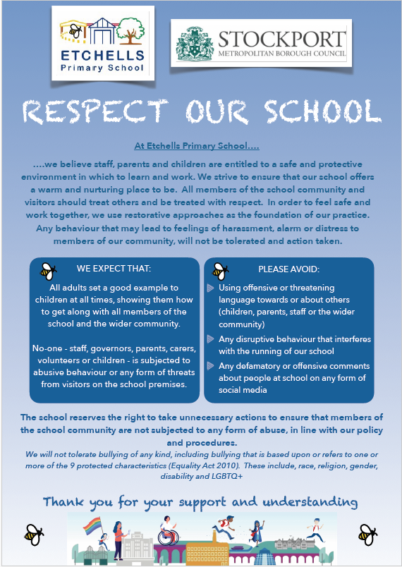

Appendix 3- Guidance for volunteers and visitors with trips
Guidance for parents & carers who support on school trips and visits
We are very grateful to parents/ carers who support Etchells Primary School when attending trips and events outside of school and without this support the visits would be unlikely to go ahead. Parents, carers and other helpers are a valuable asset to us in ensuring that our children take an active part in learning outside the classroom activities, and we appreciate the time and energy you give in supporting school staff to ensure children are kept safe.
Whilst your help and support is much appreciated it is very important that the adults supporting the trip have a clear understanding of their respective roles and responsibilities so that no one is placed at unnecessary risk. As a result there are certain procedures that must be adhered to for the safety and protection of children, parents and staff. The following must be maintained in the interest of all.
- Mobile phones must be switched off and not used at any period during the time with the children.
- No photographs or videos of children should be taken by a parent, carer or other helper unless specifically requested by a member of the school staff team. As a rule photos should only be taken using a school camera and be checked by the Headteacher before they are published on the school’s website, or sent home if this is required.
- Parents, carers or other helpers must not escort any child or children to the toilet.
- Parents, carers or other helpers must not be left solely in charge of a group without a member of the school staff being present.
- Parents, carers or other helpers must not administer any medicines or first aid. This is the responsibility of the school team. All helpers will know who the first aiders are in an event of an accident.
- Parents, carers and other helpers may become aware of confidential information relating to children and other adults during the visit. Confidentiality is therefore to be maintained at all times. This extends to the use of social media before, during and after a school trip. Any concerns about the event should be brought to the immediate attention of the visit leader or headteacher at the earliest opportunity.

In the event of an emergency

The visit / team leader will have sole responsibility for contacting the appropriate emergency services, the school and/ or parents. So as to avoid confusion and ensure a coordinated response to any incident, all mobile phones should remain switched off until directed by the visit leader who will act to promote the safety of all children and adults.
In the event of a serious accident any and all approaches by the media will be dealt with by the school and / or local Authority. Parents, carers and other helpers should direct any media enquiries to the appropriate member of school staff. The school will seek advice from the Local Authority as appropriate. Additionally, advice may be sought from the Police. This is to safeguard and protect all those involved.

Before the visit

A short meeting will be held to explain to all helpers the following:

- Purpose of the visit including proposed learning outcomes
- Role and responsibility of supporting adults
- Any particular needs of individual children or group of children
- Difficulties or possible problems that may arise as highlighted from the risk assessment
- Notification of who the team leader, first aiders and road crossers are
- Notification of appropriate clothing to be worn (as appropriate)
- Expectations with regard to confidentiality
- Access to information related to specific needs of individual children and/or staff
- Expected level of behaviour and an awareness of Professional Codes of Conduct
- Expectations about the use of social media

Supporting with school trips

Name of helper ………………………………………………………………………………………………………….

Trip supporting …………………………………………………………………………………………………………..

Date ………………………………………………………….

I have received information regarding my role and responsibility and understand the procedures I need to take if there is an accident

Signed …………………………………………………………………………………………………………………………..
CHILD PROTECTION SUMMARY

This summary sheet is for volunteers who work in the school to support our children. Ensuring such staff and adult helpers read this sheet contributes to the school’s commitment to safeguarding and promoting the welfare of pupils.

As an adult working in this school you have a duty of care towards all pupils. This means you should act at all times in a way that is consistent with their safety and welfare.

If you have a concern about a child, particularly if you think s/he may be suffering or at risk of suffering harm, it is your responsibility to share the information promptly with the Designated Senior Lead for Child Protection (DSL), Stuart Kelly or the deputy DSLs who are Pete Cope, Claire Wilson, Becky Kind, Rachel Collins and Sally Revill.

The following is not an exhaustive list but you might become concerned as a result of
- seeing a physical injury which you believe to be non-accidental
- observing something in the appearance of a pupil which leads you to think his/her needs are being neglected
- witnessing behaviour which gives rise to concern
- a pupil telling you that s/he has been subjected to some form of abuse

In any of these circumstances you should write down what you observed or heard, date and sign the account and give it to the DSL or deputy.

If a pupil talks to you about (discloses) abuse you should
- listen carefully without interruption, particularly if s/he is freely recalling significant events
- only ask sufficient questions to clarify what you have heard. You might not need to ask anything but, if you do, you must not ‘lead’ the pupil in any way so should only ask ‘open’ questions
- make it clear you are obliged to pass the information on, but only to those who need to know
- tell the DSL or deputy DSL without delay
- write an account of the conversation as soon as you are able (definitely the same day), date and sign it and give it to the DSL.

Do not ask the pupil to repeat the disclosure to anyone else in school, ask him/her or any other pupil to write a ‘statement’, or inform parents. You are not expected to make a judgement about whether the child is telling the truth.

If the behaviour of another adult in the school gives rise to concern you should report it to the Headteacher.
Remember – share any concerns, don’t keep them to yourself

This school has a safeguarding policy and more detailed procedures on child protection which are available from the DSL.

These procedures were revised in September 2025.
A review of these procedures is due in September 2026 unless deemed necessary by the Headteacher before this date.

