

To make play dough you will need:

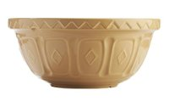

- large mixing bowl
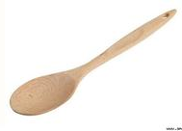

- wooden spoon
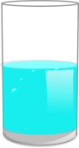

- half a cup of cold water to the blue line (1/2 cup)

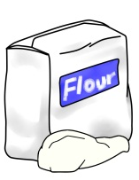
- 2 full cups 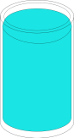 of plain flour
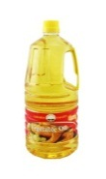
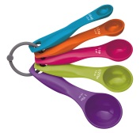

- 2 tablespoons of cooking oil

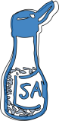
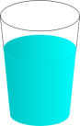
- Fill the cup with salt up to the red line (3/4 cup)



- Food colouring one drop at a time! 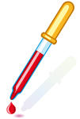

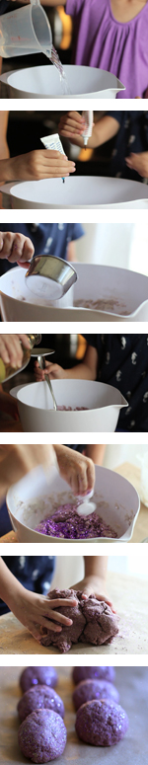
Instructions

  - Pour water into a large mixing bowl.

  - Next add food colouring. Once you add the food colouring to the water, stir it well.

  - Add the dry ingredients (flour and salt) to the mix. You can stir a little at this point to begin blending the ingredients.

  - Next add 2 tablespoons of oil. You can add more oil later if the mix seems to dry. Oil is the secret to keeping this "no cooking required" recipe soft! If you don't add enough oil, the mix will be very crumbly.

  - Mix everything together.

  - Knead the ingredients together until soft dough is formed.

You could try adding:

- glitter
- flavouring or fragrance

