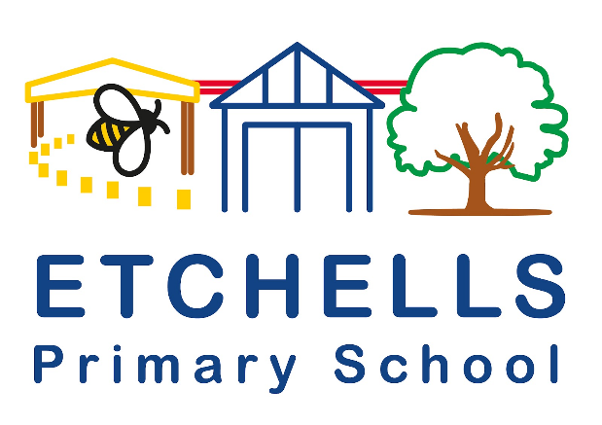

Etchells Primary School Language of the half term:
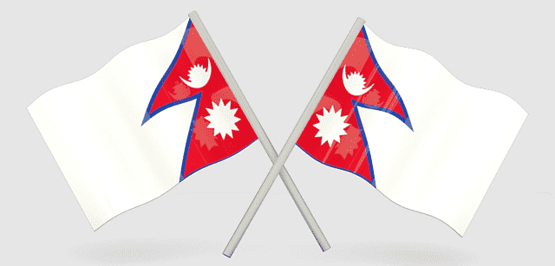
Nepali
Nepali is spoken by more than 17 million people, mostly in Nepal and neighbouring parts of India. Smaller speech communities exist in Bhutan, Brunei, and Myanmar.

English | Translation
Hello | नमस्कार  Namaskāra
Thank you | धन्यवाद  Dhan'yavāda
How are you? | कस्तो छ ?  Kastō cha?
Excuse me | मलाई माफ गर्नुहोस्  Malā'ī māpha garnuhōs
Nice to meet you | तिमीलाई भेटेर खुशी लाग्यो  Timīlā'ī bhēṭēra khuśī lāgyō

At Etchells we have 2 children who speak or hear Nepali being spoken at home.

