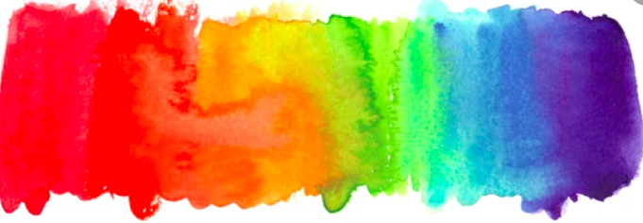

EYFS
- Set and work towards simple goals, being able to wait for what they want.

My PSHE Learning Journey –
Transition and Identity

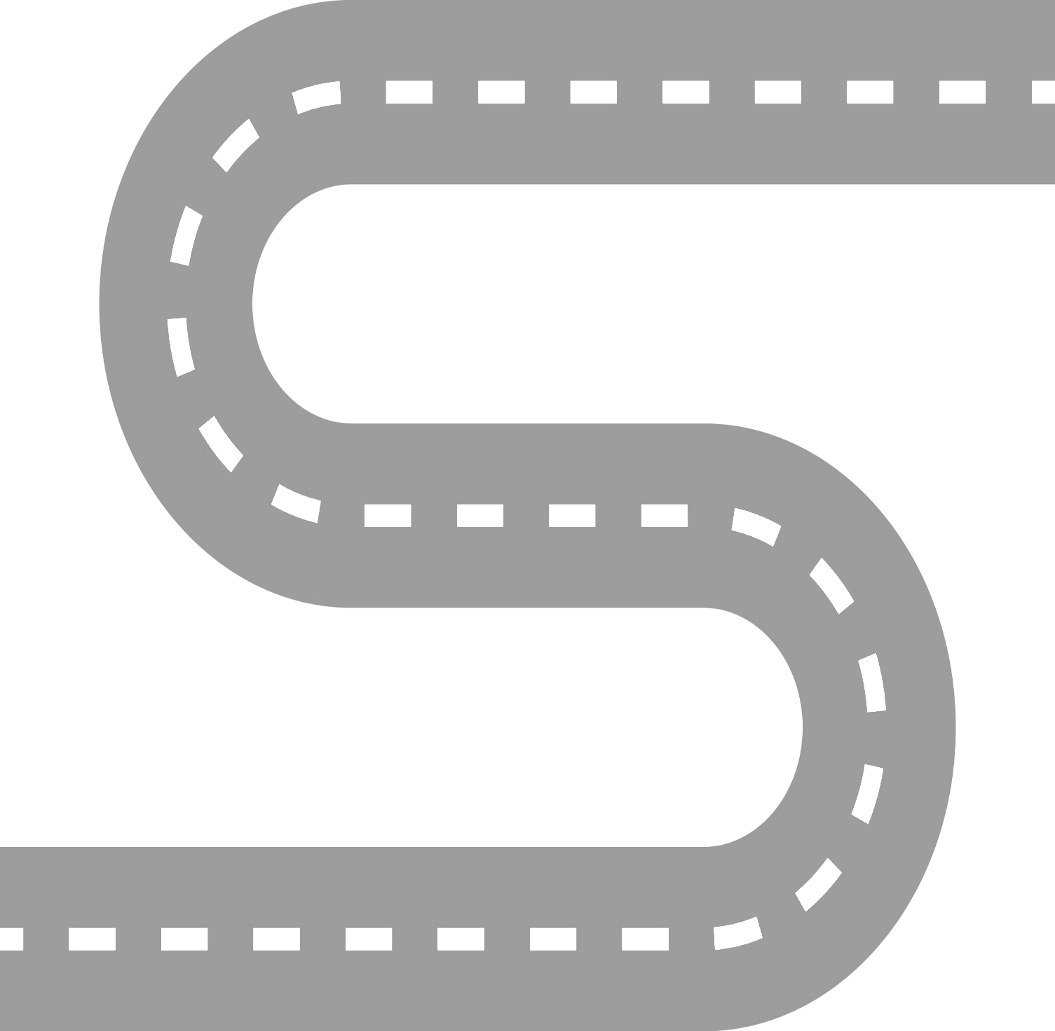
YEAR 6 – Identity
- To know that identity is the way we see ourselves and also how other people see us.
YEAR 5
- To know the skills needed for roles in school.
YEAR 6
- To know that a big change can bring opportunities but also worries.

YEAR 4
- To know that setting goals can help us to achieve what we want.
YEAR 3
- To know that change often brings about more opportunities and responsibilities.
YEAR 2
- To know that change is part of life..
YEAR 1
- To know that changes can be both positive and negative.

