
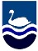
YEAR 1
- To know some of the ways children may receive money.
- To know it is wrong to steal money.
- To know that banks are places we can store our money.

EYFS
- To be able to wait for what they want and control their immediate impulses.

My PSHE Learning Journey –
Economic Wellbeing

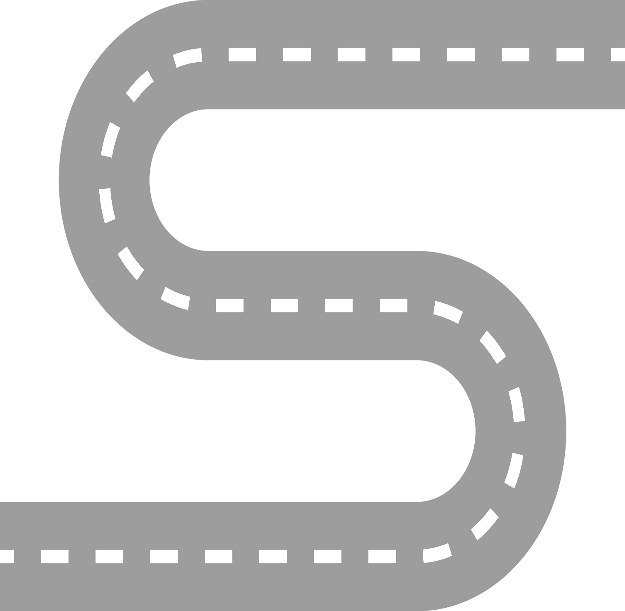
YEAR 6
- To understand that there are certain rules to follow to keep money safe in bank accounts.
- To know that gambling is a risk where money, or something else, is swapped in the hope of winning something better or more money.
- To understand that different jobs have different routes into them.
- To understand that people change jobs for a number of reasons.

YEAR 5
- To know that when money is borrowed it needs to be paid back, usually with interest.
- To know that it is important to prioritise spending.
- To know that the income is the amount of money received and expenditure is the amount of money spent.
- To know some ways that people lose money.
YEAR 4
- To know that money can be lost in a variety of ways.
- To understand the importance of tracking money.
- To know that people will have more than one job or career in their lifetimes.
YEAR 3
- To know that there are different ways to pay for things.
- To know that budgeting money is important.
- To know that there are a range of jobs available.
YEAR 2
- To know some of the ways in which adults get money.
- To know the difference between ‘need’ and ‘want’.

