

YEAR 1
- To know the rules in school.
- To know how to look after a pet.
- To know that voting is a fair way to make a decision..
EYFS
- To know the reasons for rules.

My PSHE Learning Journey –
Citizenship

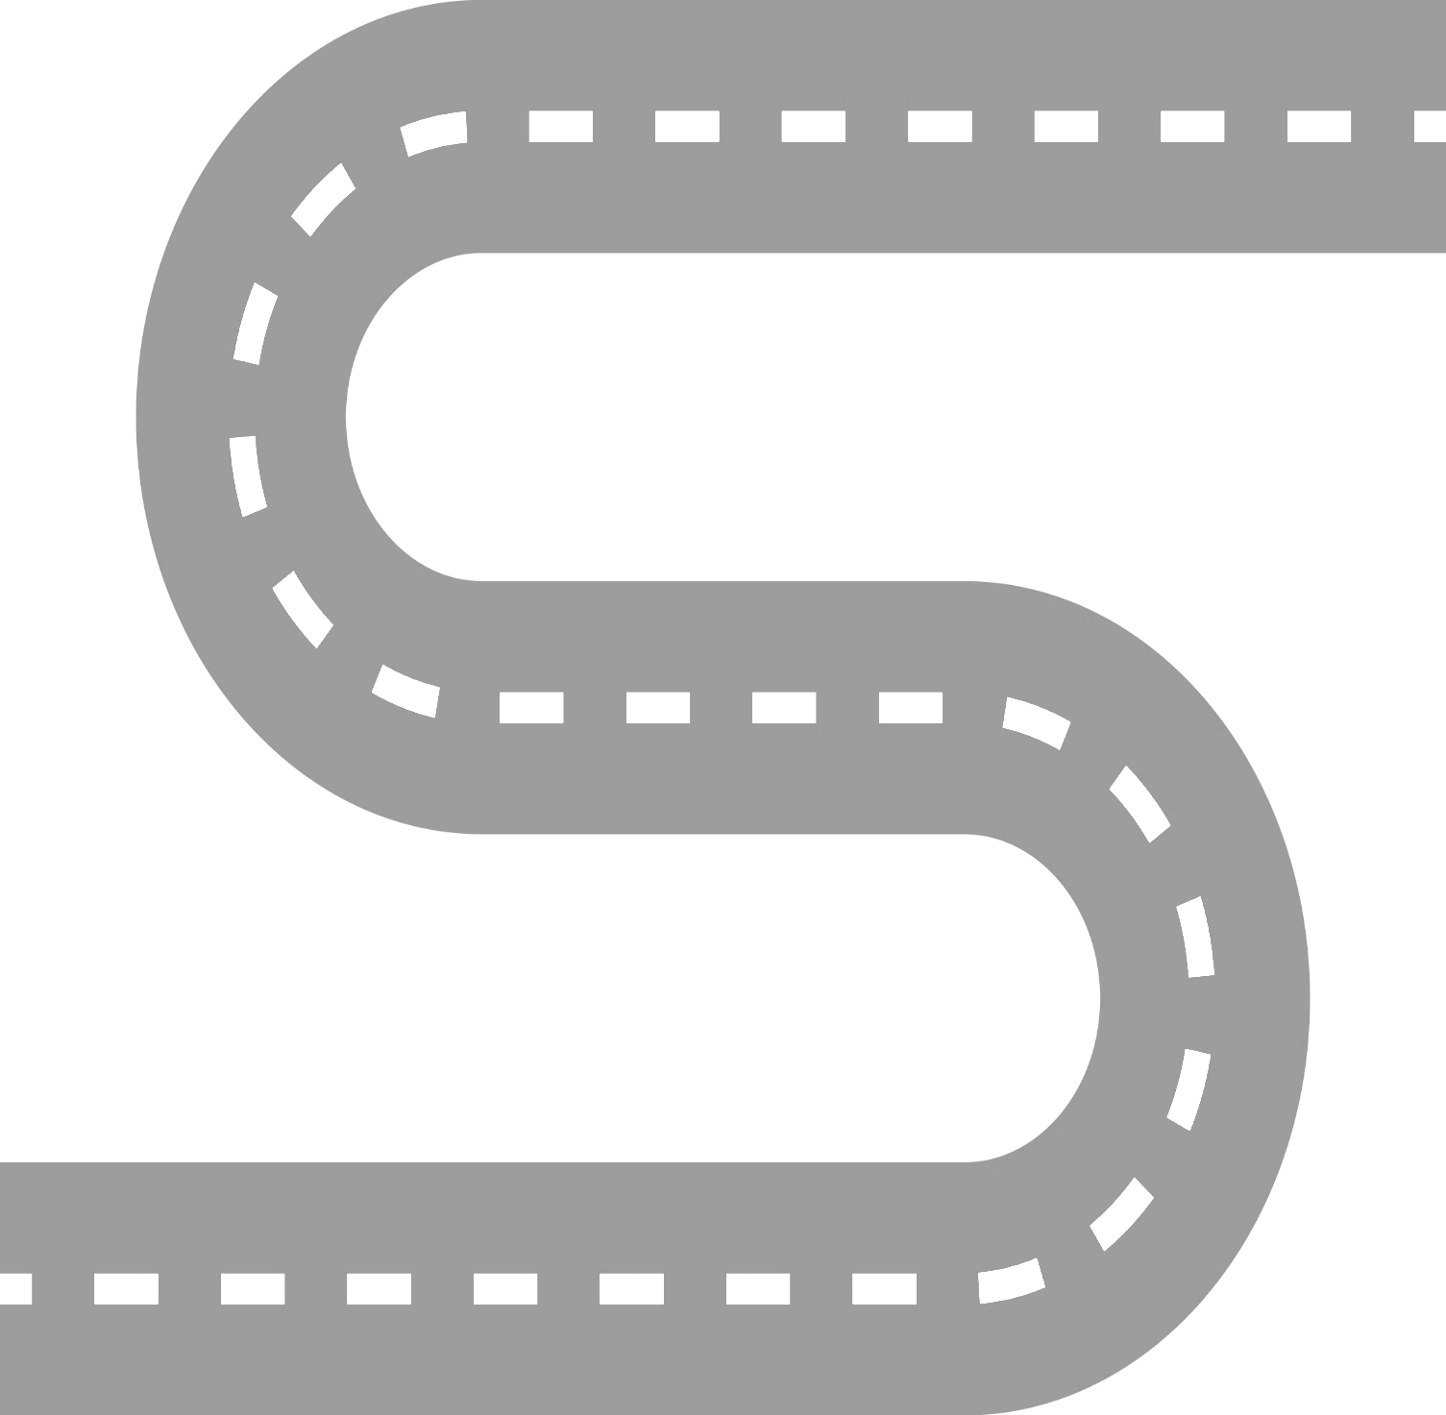
YEAR 6
- To know that education is an important human right.
- To know that our food choices can affect the environment.
- To know that the prime minister appoints “ministers” who have responsibility for different areas such as healthcare and education.
- To know that prejudice is making assumptions about someone based on certain information.
- To know that discrimination is treating someone differently because of certain factors.

YEAR 5
- To know what happens when someone breaks the law.
- To know that parliament is made up of the House of Commons, the house of lords and the Monarch.
- To know that parliament is where MPs debate issues, propose laws and challenge the governments’ work.
YEAR 4
- To know that human rights are specific rights that apply to all people.
- To know some of the people who protect our human rights such as police, judges and politicians.
- To know that reusing items is of benefit to the environment.
- To know that there are a number of groups which make up the local community.
YEAR 3
- To know that recycling can have a positive impact on the environment.
- To know that elections are held where adults can vote for local councilors.
- To know some of the consequences of breaking rules.
- To know the role of charities in the community.
YEAR 2
- To know that some rules are made to be followed by everyone and are known as ‘laws’.
- To know how democracy works in school through the school council.
- To know how to help look after the school environment.

