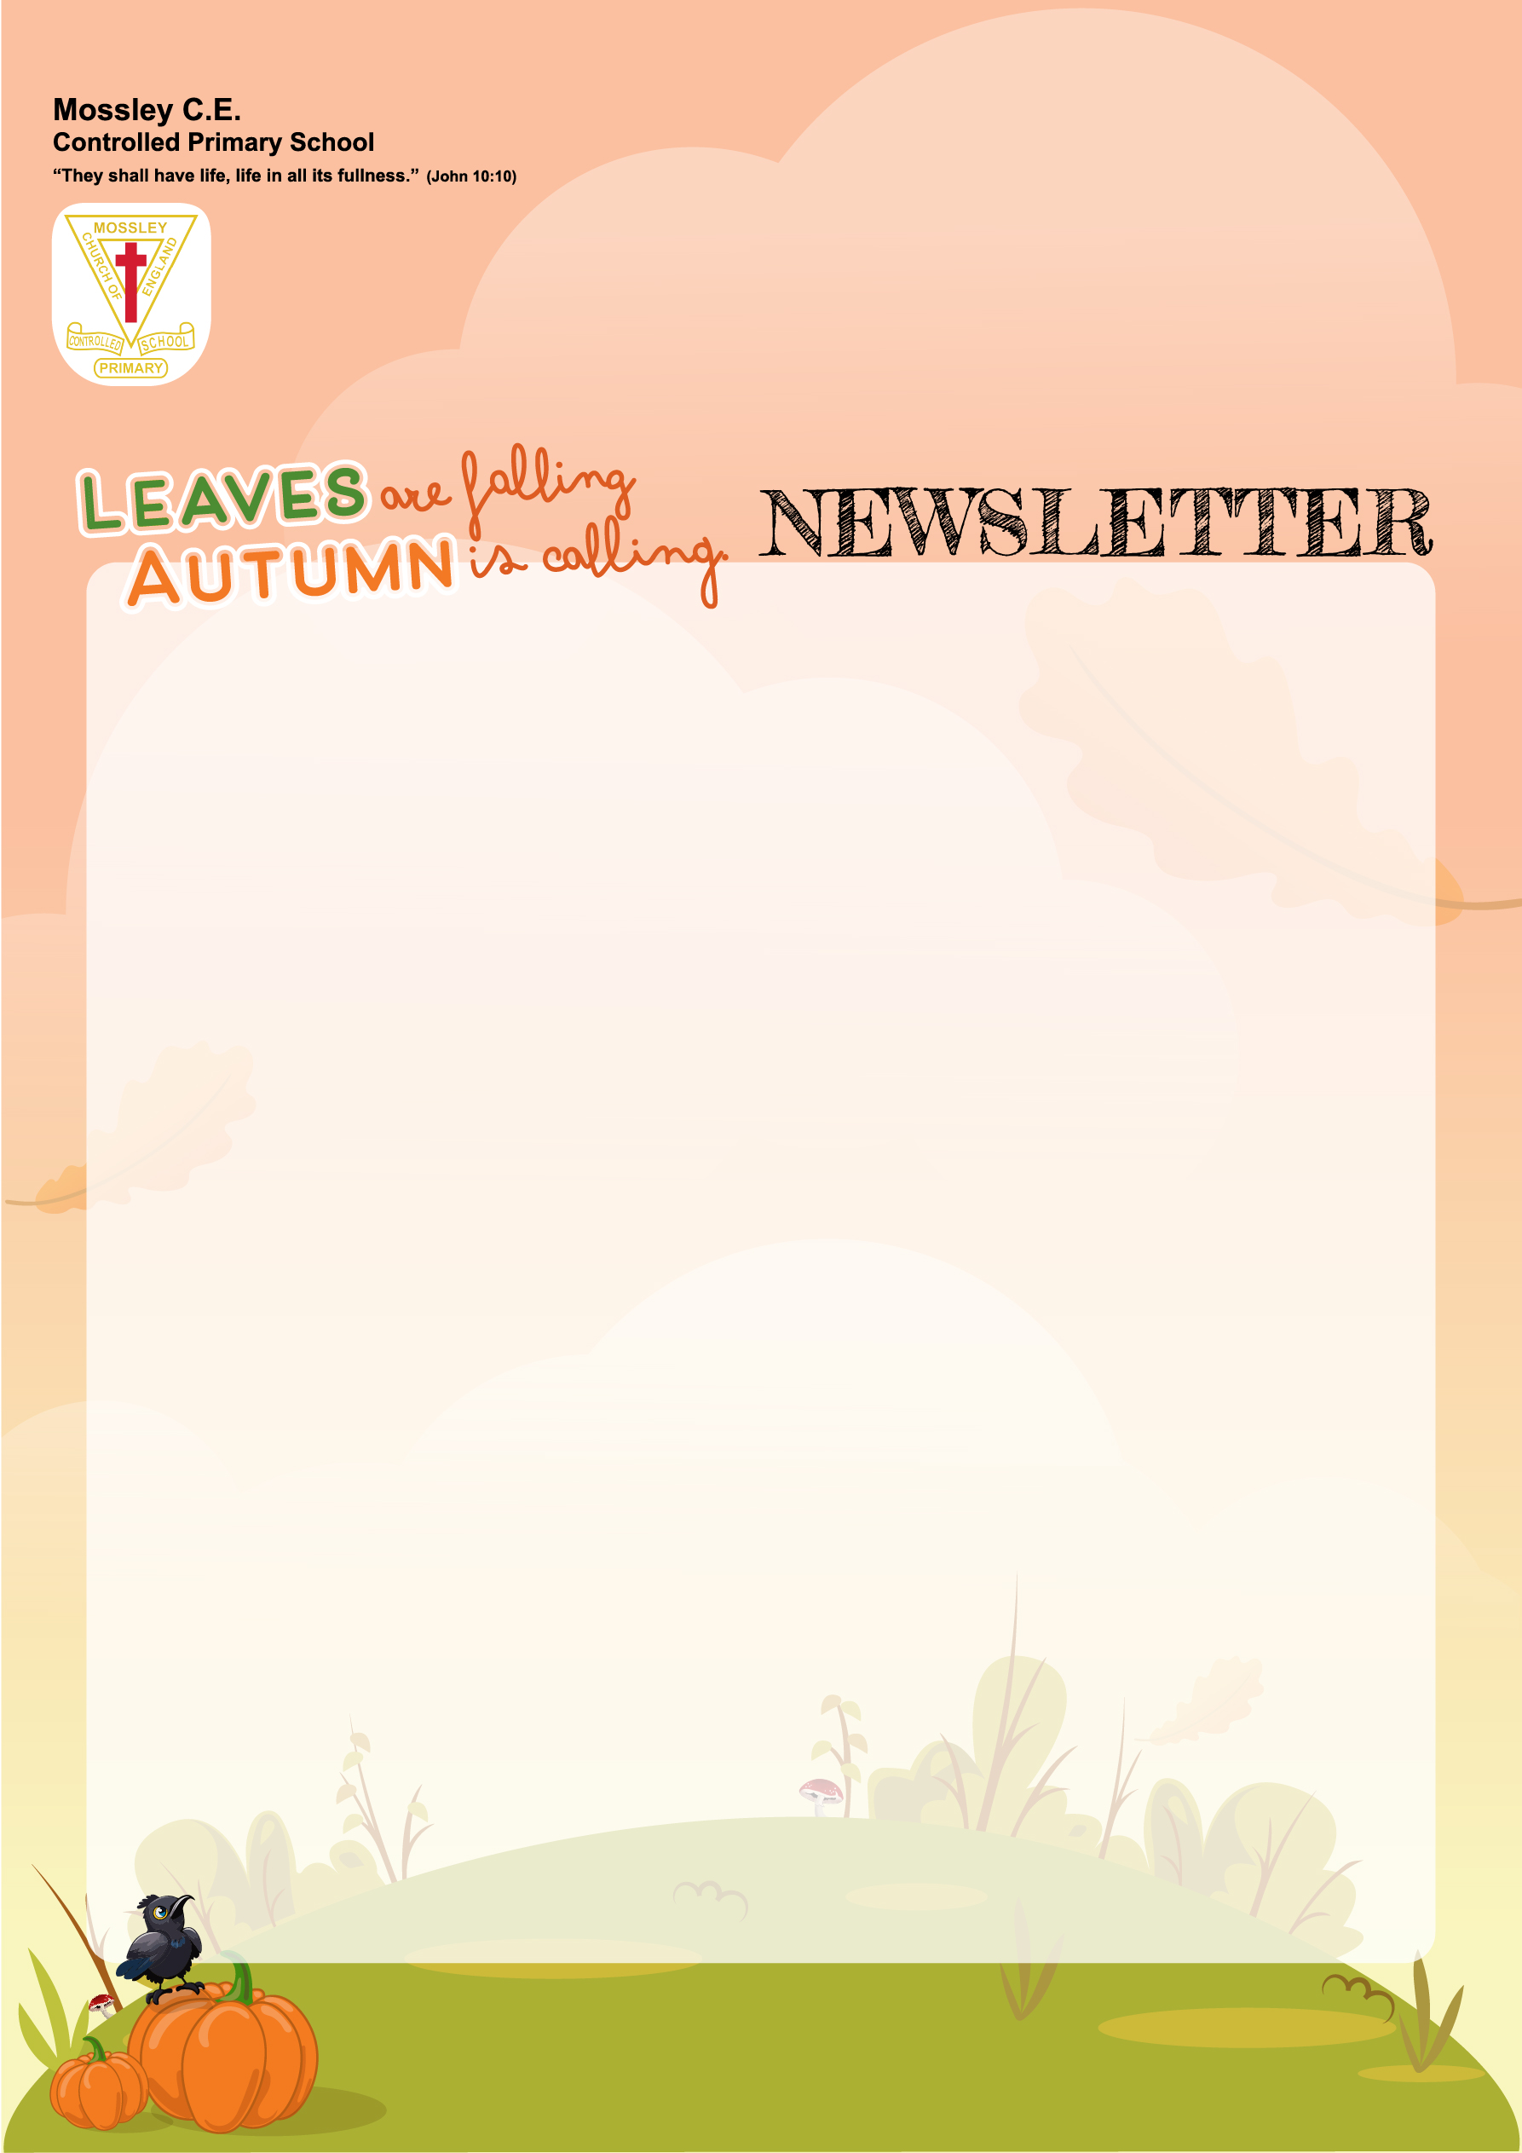

🌟 Mossley School Newsletter – January 2026
Dear Families,
Welcome Back
Welcome back to all our families. I hope you had a restful break and that the children have returned refreshed and ready for learning. As we begin this half term, our focus is on creating a calm, positive and productive environment where every child can thrive. It has been wonderful to see how quickly pupils have settled back into routines and demonstrated our school values in and out of the classroom.
The first two weeks have already given us so much to celebrate, particularly in sport, where our older pupils have represented the school with enthusiasm, teamwork and determination.

Year 5/6 Basketball
Our Year 5 and 6 basketball team made an excellent start to the half term, showing great skill, resilience and sportsmanship. The pupils worked superbly as a team and should be very proud of their performance and commitment. The team finished as overall winners and will represent the school in the Cheshire Finals! Well done all and thank you to Mr. Casserley for managing the team.

Year 5/6 Indoor Athletics
The Year 5/6 indoor athletics competition was another highlight. Pupils demonstrated speed, strength and perseverance across a range of events. Their positive attitudes and encouragement of one another truly reflected the spirit of our school. The team finished runners up and have qualified for the Cheshire Finals! Thank you to Mr. Heades for managing the team.



Boys Football -Cheshire Finals
Our boys’ football team represented the school brilliantly at the Cheshire Finals. They played with determination and teamwork, showing respect to opponents and officials throughout. Reaching this stage is a fantastic achievement and a credit to everyone involved.
Girls Football -Cheshire Finals
Good luck to our girls’ football team who are competing in the Cheshire Finals today.
Parking and waiting
A polite reminder to all families to park considerately at drop-off and pick-up times. Please avoid blocking driveways, entrances or waiting in restricted areas. Your cooperation helps keep all our children and families safe and supports our local community.

Christian Values – Hope
Since returning to school last week, we have been thinking about our new value of ‘hope.’ Hope is all about having a positive attitude, mindset and having a wish in your heart to change things for the better. This time of year, as begin our journey into 2026, it can mean making a fresh start, changing behaviour for the better, leaving past mistakes behind, making positive changes or simply taking a new direction.
Many people use the start of a New Year to ‘turn over a new leaf’’ or make New Years Resolutions.
Here are some of children’s and staff’s wishes and aims for 2026...
Year 6-Jack G
‘During 2026, I want to ride on at least 25 different rollercoasters!’
Year 5-Rowena
‘I want to try and drink more water.’
Year 3-Bobby C
‘To get better at being in defence at football’
Year 2- Tristan
‘I really hope I can be better at the egg and spoon race on Sports Day.’

Year 1- Emily L
‘I really hope I can score at least 10 goals this year in football and may be even score a hat-trick!’
Mrs Statham
‘My hope is that I will become a more confident driver and be able to drive on the motorway!’
Miss Munro
‘My hope this year is to become a stronger runner. I’m going to challenge myself to run 5k at least twice a week!’
Mrs Greeves
'I aim to take one day at a time and try not to worry as much about what the next day/ week etc may bring.’
As Christ says in Matthew 6.34 Take therefore no thought for the morrow: for the morrow shall take thought for the things of itself. Sufficient unto the day is the evil thereof.

Dates for diaries –
Wk./C 19th January Year 5 Friends and Family Lunch
Tuesday 20th January- Year 5/ 6 X-Country @EBA
Wk./C 26th January Year 4 Friends and Family Lunch
Tuesday 27th January – Year 3 /4 X-Country @EBA
Wednesday 28th January – Year 5/6 Indoor Athletics Indoor Athletics Finals

Our priority is to support every child. Class teachers are available via Dojo, and I’m always happy to hear from you directly at head@mossleyce.cheshire.sch.uk
Yours sincerely,
Mrs. Helen Harrison

Little Eco Steps, Big Impact
💧 Save Water – Turn off the tap while brushing; you could save 6,000 litres a year!

