 DAVENHAM C OF E PRIMARY SCHOOL 
Charles Avenue, Davenham, Northwich, Cheshire, CW9 8JW
Telephone 01606 42551
Mobile (for emergencies) * 07985 725859
www.davenhamcofeprimary.com
@davenhamcofe

WEEKLY NEWSLETTER
3 September 2025

‘A friend loves at all times.’
Proverbs 17:17

The format of the Newsletter is as follows:

Section 1 | Individual Class Dates for the following week. Any actions you need to take will be in red font.  Whole school events for the following week.  FODS and Parent Council dates for this half term.
Section 2 | News Items (general school information)
Section 3 | Other News – parents are welcome to contribute to this section. Please send any items to Mrs Hyslop
Section 4 | Standing Items (always in blue font)  Useful reference information.

WELCOME BACK!
A VERY warm welcome back to everyone and especially to our new families who are joining the reception classes or other classes in school. We are sure that the children will settle quickly and soon begin to feel part of our Davenham family.
This Newsletter is sent out every Wednesday. There is a diary sheet which lists events that are taking place the following week. This week’s Newsletter is longer than normal as it contains lots of back-to-school information.

GOOGLE CLASSROOM
Please ensure that you log onto Google Classroom using the code provided in your Welcome Back letter. This is where teachers post class information and homework.

TIMINGS AND PICK UP ARRANGEMENTS
Please ensure that your child’s current teacher knows the arrangements for pick up. Please do not expect your child’s former teacher to pass this information on. For safeguarding reasons, we WILL NOT allow children to walk home or be collected by anyone else unless we have permission from parents / carers. If your child is allowed to walk home, please let you child’s current class teacher know – an email will suffice. If someone else is collecting your child, please call the office and let us know. Thank you!
Please note the school day begins at 8.50am and ends at 3.20pm. The gate opens at 8.30am.

CHRISTIAN VALUE
Our Christian Value for this half term is Friendship - what a perfect one to start this year with! The theology behind the value of Friendship can be found on our school website.

God is a wonderfully friendly caring and eternal family of three –the Father, the Son and the Holy Spirit. The Father sent His son so that we could belong to Him. Jesus wants us to be our friend and God wants us to be friends with others.

Our chosen Bible stories for friendship are Luke 19:1-10 (Zacchaeus) and Mark 10:13-16.

SECTION 1 DATES
TABLE 1 CLASS EVENTS
8 - 12 September

Class | Activity | Date
Oaks and Jack R
Firthfields Y1
Eaton Y1/2
Fountain Y2
Pavilions Y3
Mere Y3 and 4
Mount Pleasant Y4
Green Y5
London Y5/6
Hartford Y6 | Come Join Us 2.15pm and FS 2.45pm | Fri 12 Sep

TABLE 2
WHOLE SCHOOL EVENTS NEXT WEEK 8- 12 September

Monday
Tuesday
Wednesday
Thursday
Friday

TABLE 3
FODS AND PARENTS COUNCIL MEETINGS

FODS | AGM 15 September 7.00pm
PARENT COUNCIL | AGM 23 September 7.30pm

FODS
We would like to express a huge thank you to FODS for all their efforts last year. The money they raise makes a huge difference to the children and staff in school.

FODS AGM Monday 15th September @7.00pm AT SCHOOL – PLEASE USE STAFF ROOM DOOR
A recap of the last 12 months fundraising and expenditure will be given, and election of the committee officers will also take place. Minutes will be available to everyone via the school website after the event. We would welcome any new members of FODS – you can be involved in so many ways to support school so please do pop along to the AGM.

SECTION 2 NEWS
THANK YOU
The staff would like to thank parents / carers for the lovely messages, cards and gifts sent at the end of the academic year.

STAFF EMAIL ADRESSES
Emails are a very quick and effective means of communication between teacher and parent / carers. All staff have a school email address which is made up of the initial of their Christian name and surname followed by @davenhamce.cheshire.sch.uk. Please do not expect that staff will reply to emails out of working hours, during holidays or at the weekend. In the event of an out of hours emergency, please contact head@davenhamce.cheshire.sch.uk.

Here is a list of all useful staff email addresses.

SENIOR LEADERSHIP TEAM
Mrs Hyslop  (Headteacher) | head@davenhamce.cheshire.sch.uk
Miss Sutton  (Deputy Headteacher M – Th) | deputy@...
Miss Phillips  (Acting Deputy Headteacher F) | kphillips@...
Mrs Ollier (T, W, Th ) SENDCO | senco@...
School Business Manager (Mrs Colloby) | bursar@...
EYFS STAFF
Miss Rigby (M, T, W and F) | hrigby@
Miss Pucill (M, T and Th) | jpucill@...
Mrs Clewes (W, Th and F) | mclewes@...
KS1 STAFF
Mrs Campbell-Hayes (M, T, W) | jcampbellhayes@...
Mrs Torrie (alternate Wpm, Th, F) | ltorrie@...
Miss Beard | cbeard@
Miss Phillips | kphillips@...
LKS2 STAFF
Mrs Broadbere | abroadbere@...
Mrs Ozturk | sozturk@...
Mr Ashworth | cashworth@...
UKS2 STAFF
Mr Roberts | troberts@...
Mrs Nixon | jnixon@...
Mrs Boyde | eboyde@...

Please note that Mrs Ollier will reduce her working days to Tuesday, Wednesday and Thursday from September.

MEDICAL INFORMATION
Please ensure that we have any necessary medical information about your child and if they use an inhaler, please check that they have one in school and that it is in date.
Please also ensure that we are aware of any allergies.

SCHOOL LUNCHES
Lunches are payable for all junior pupils (Y3 – Y6) except those eligible for benefits related Free School Meals. Please note that the Universal Infant Free School Meals (UIFSM) system ceases after Year 2. If you believe your child may be eligible for Free School Meals, please apply online through the Cheshire West and Chester Council website. Please contact Mrs Colloby for any information around school meals. The current price for school meal is £3.15.

PE KITS
These are the days that each class will need to wear PE Kits this next academic year.
EYFS and Key Stage One children do not need to wear a different PE kit as their uniform is suitable for PE.

 | INDOOR SESSION | OUTDOOR SESSION
Mon | Firthfields, Eaton and Fountain (no change of kits needed) | Green, London and Hartford
Tues | Pavilions, Mere and Mount Pleasant
Weds | Green. Hartford and London
Thurs
Fri | Firthfields, Eaton and Fountain (no change of kits needed) | Pavilions, Mere and Mount Pleasant

DROPPING ITEMS OFF
Please try to avoid dropping items off at the office unless it is a genuine emergency. If children forget water bottles, we will provide them with a drink.

UNIFORM
Please ensure that your child wears the correct uniform, school PE kit and suitable school shoes. We were noticing that children were not adhering to this towards the end of the year.

Some reminders…
- Only stud earrings are allowed.
- Jewellery, other than stud earring is not permitted in school. This includes friendship bracelets etc.
- Children may wear a watch if they wish but not a smartwatch of any description. Watches must be removed for PE.
- Large hair adornments are not allowed - a simple bobble or hairband in school colours is preferred.
- Long hair should be tied up.
- Nail varnish / make up is not permitted in school.

RUCK SACKS KS2 ONLY
We ask that these are not fashion items but plain black or navy. Thank you to those parents / carers who have followed this rule!

COATS
Please ensure that children have a coat. Children will go out to play in fine drizzle and so always need a coat.

MOBILE PHONES
For safeguarding reasons, we have strict rules about children having mobile phones / devices in school. Children should ONLY have a mobile phone if they are walking home alone. In this event, we need written permission from parents and children must hand phones in to their class teacher and collect them at the end of the day. Phones must not be used on the school premises by children.

BIRTHDAY DRESS UP DAY
We have an optional wear your own clothes on your birthday day.

- For those children who have a birthday over the weekend they can wear their own clothes on the Friday before or the Monday after.
- If a birthday falls during half term, they can wear their own clothes on the last day of the half term OR any day of the week following half term.
- If their birthday is in the summer holidays, they can wear their own clothes any day of the first week back in September.

THE FOUR STEPS
As the children start a new school year, they will be agreeing a set of class rules. Teachers will have talked to children about why rules are helpful and necessary.
Playtimes and lunchtimes can be difficult for some children and there will be inevitable disagreements from time to time.
To encourage the children to deal with low level conflict or disagreements we teach them the 4 steps. These are:

- Ignore the problem. Lots of small problems go away if you ignore them.
- Walk Away. Walk away or go and play with someone else, or somewhere else. Leave the problem behind.
- Ask the person to stop. It’s fine to do this. They might not realise they are annoying you.
- Tell a grown up. If you have tried steps 1,2,3 and 4 then you are not telling tales!

When possible, we want children to be able to deal with minor disagreements themselves but to also know that sometimes Step 4 will be necessary and that is when adults are there to help. Please talk to your child about these steps.

PARENT COUNCIL
If you are interested in becoming a Parent Council Rep for your child’s class, please email Mrs Hyslop at head@davenhamce.cheshire.sch.uk. The group meets several times throughout the year to discuss and represent parent / carer’s views. There can be a minimum of 7 members and a maximum of 12 reps – ideally 1 rep per class. This is not an onerous job but one which can really help to support school. Any candidates wanting to re-stand are welcome to do so but should email Mrs Hyslop

PARENT COUNCIL Tuesday 23rd September @7.30pm IN SCHOOL. PLEASE USE STAFF ROOM DOOR
If you are interested in joining Parent Council, please ensure that you attend the AGM, which will take place in school on Tuesday 23rd September at 7.30pm. New Parent Reps and Committee members will be appointed at the AGM.

EDUCATION SUNDAY
Our annual Education Sunday service will take place on Sunday 23 September at St Wilfrid’s at 10.00am. All families are welcome. This is a joint school and church service. We will present our new EYFS children with a Bible during the service.

SPORTS NEWS
CELEBRATE | These events are for children who do not attend sporting activities or have additional needs and would benefit from taking part in an event.
ASPIRE | These events are for children developing sporting skills in a semi-competitive environment. These events are for children who do not play for a club / an A team.
INSPIRE | These are competitive events leading to finals.

CHARITY FUNDRAISING 2024 – 2025

Detail | Charity | Amount Raised
Hello Yellow | Young Minds | £221.00
Harvest Festival | Mid Cheshire Food Bank | £215.00
Poppy Sale | British Legion | £300.89
Uniform Sale (pupil led) | UKS2 charities to be selected | £98.50
Children in Need | Children in Need | £255.00
Christingle | The Children’s Society | £172.00
Dosh for Downs | Downs Syndrome | £225.00
Little Princess Trust | Cancer Charity for Children | £275.00

FODS FUNDRAISING UPDATE 2024-2025

Event | Amount Raised
Wreathmaking | £413.68
Disco | £1509.23
Stikins | £94.62
Teatowels | £133.19
Funfest | £2978.35
Christmas Cards | £464.54
Bingo | £796.53
Easter Raffle | £365.80
Sports Day Refreshments | £75.56
Total | £6831.50

OUR GOOD SAMARITAN AWARDS (child led courageous advocacy)

- September 2024 The Ethos Group raised £1180.24 at the Summer Fair. This was donated to a range of charities of their choice.
- October 2024 IM in UKS2 donated her hair for a wig for children suffering with cancer.
- November 20204 Year 5 and 6 nominated Mary’s Meals as the charity to receive the money collected from the sale of pre-loved school uniform.
- December 2024 MH in KS1 made cards for Alder Hey Children’s Hospital while she was off poorly.
- December 2024 OW LKS2 raised money by making loom bands for Alder Hey Children’s Hospital
- December 2024 CHM LKS2 and THM KS1 from Davenham Football Club who donated kits to our partner school in Kenya (letter received from school March 25)
- January 2025 EL in Y3 raised £10 for Alder Hey selling loom bands
- January 2025 Group of Y3 children made posters to highlight importance of looking after the environment
- February 2025 Ethos Group led the service at St Wilfrid’s Church – sharing with the church family all the work they do to raise awareness of good causes.
- February 2025 IM and CN made posters to encourage litter picking
- February 2025 Group of Y3 pupils who made posters about looking after environment went to litter pick at local park after school.
- February 2025 MP Y1 cut off hair for Little Princess Trust
- World Book Day KS1 children went to local park to litter pick.
- March 2025 Immy Y4 cut off hair for Little Princess Trust
- March 2025 TW Y1 went to litter pick at local park (following Ks1 litter pick) and donated toys to charity
- March 2025 group of Ethos children awarded Archbishop of York award for Young Leaders
- March 2025 Whole School Funky Hair Friday – child-initiated CN and IM Y4
- March 2025 IT Y3 litter picking in local area
- April 2025 MT Climbing Snowdon and raising over £1600 for Alder Hey hospital
- May – JH Y1 raising money for Cancer Research Run for Life - £511
- May – AH Y4 raising money for Cancer Research Run for Life
- May 2025 PW rescuing a hedgehog
- June 2025 EW raising over £1000 for Little Princess Trust by cutting off her hair
- June 2025 Y3 children completing local park tidy
GK Y5 twinned his second toilet by swimming 140 lengths over 7 days starting on July 4th

2025 – 2026
- TW Y1 looked after a lost cat by providing some food and water.

FORTHCOMING VISITS AND COSTINGS

Visit, Year Group and Date of Visit | Instalment Date and Amount
Year 6 London 2026 | First deposit £65 25 June 2025  Second deposit £65 15 July 2025  Balance £200 5 March 2026  Total £330

SECTION 3 OTHER NEWS

PLEASE NOTE THAT WE ARE NOT AFFILIATED WITH ANY COMPANIES WHO ASK TO PLACE AN ADVERT IN OUR NEWSLETTER

At St Wilfrid’s, Davenham, we have two Sunday morning services:
We have a 9.00am – 9.45am all age service with a difference – it is modern, with interaction
and crafts for younger people and is particularly suitable for families and younger people. All
are very welcome. We also have a classic service at 10.00am.
Please see our Church Website for any updates - davenhamparish.net

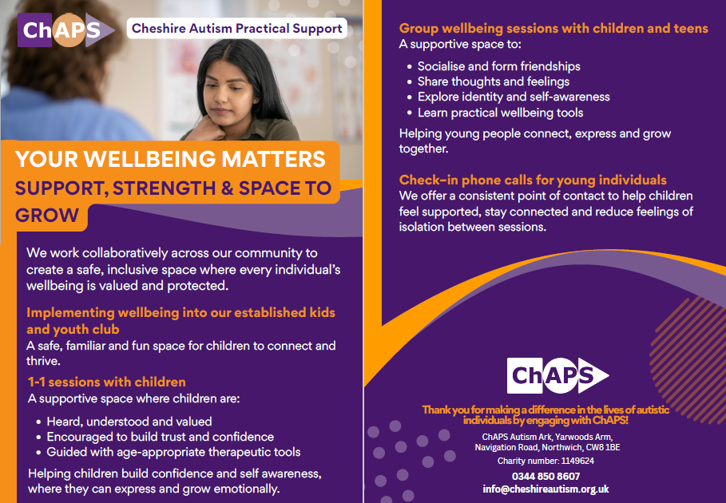

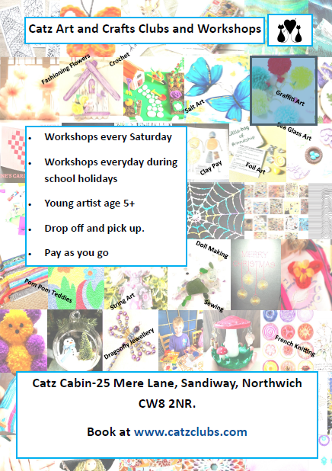

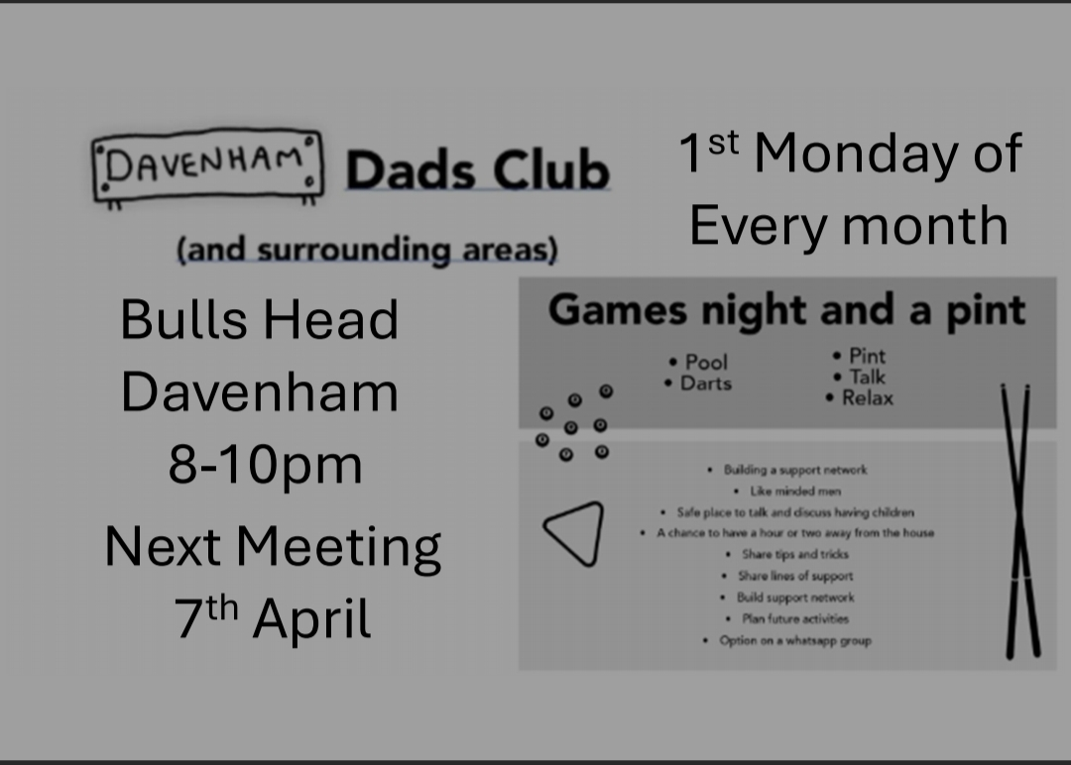







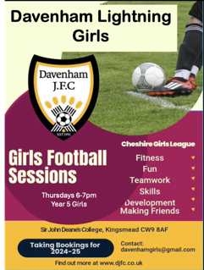

PARENT SUPPORT HUB
https://www.facebook.com/115801448114488/posts/pfbid02GgkvaSqwpQQZupuoDB ibFgiyoZTZU3L9e691rjg5uQc1hH167EeJQSn4BFaddFWHl/?sfnsn=scwspmo

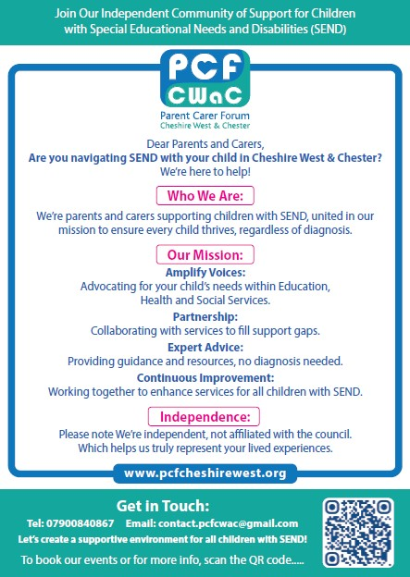



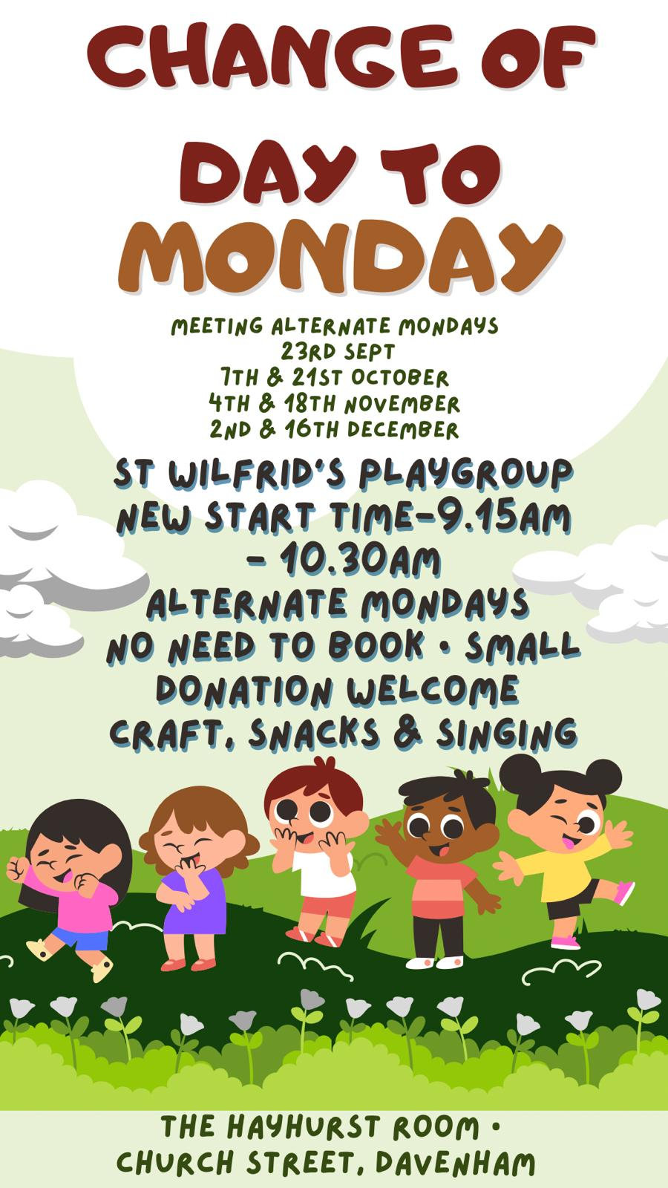


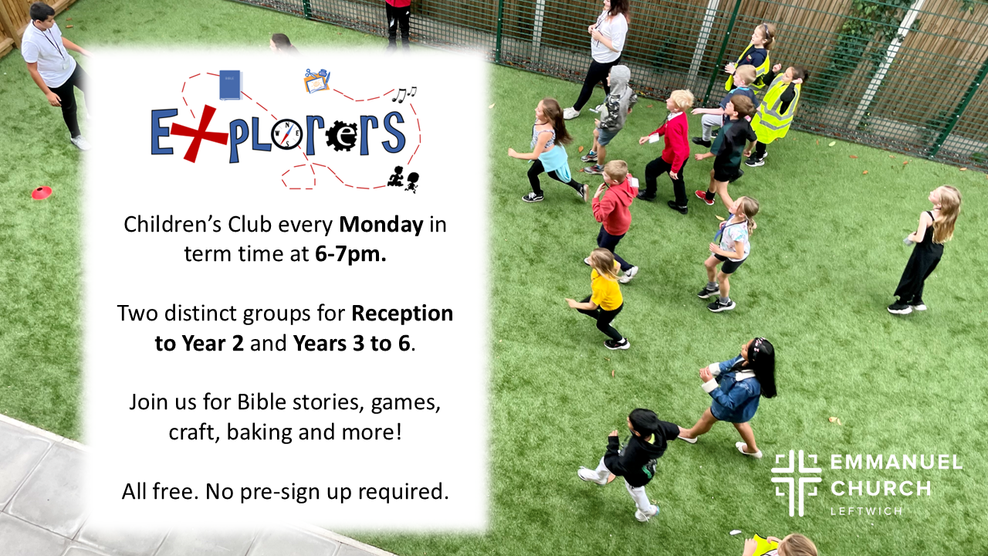


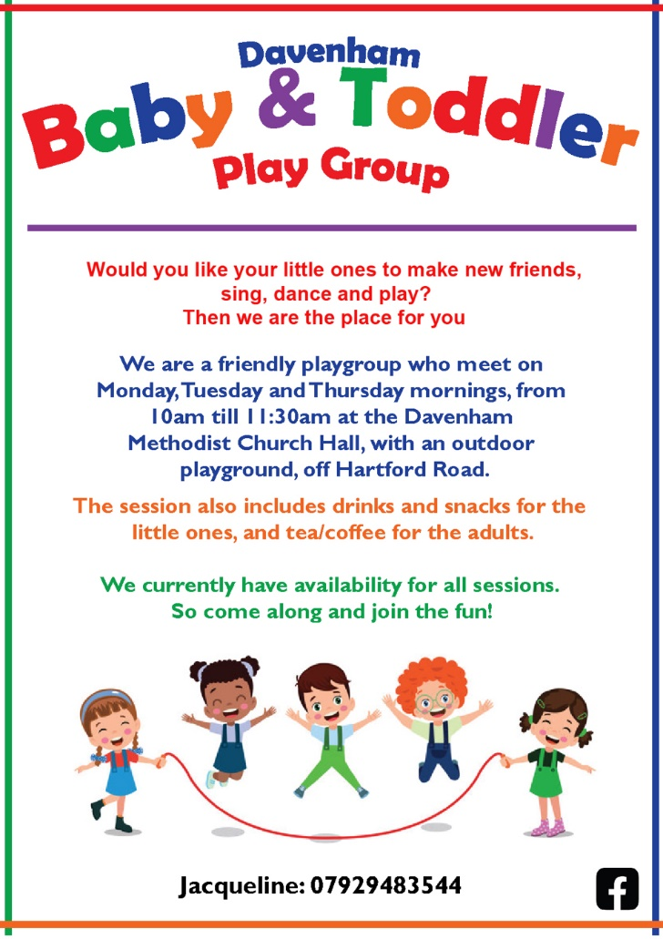

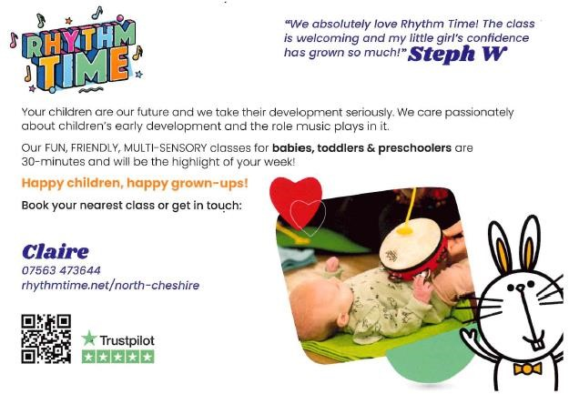

Please remember to ask for the Gardens for Schools Vouchers if you shop at Winnington Garden Centre.

SECTION 4 STANDING ITEMS (appear in blue)

FIXED PENALTY NOTICES
A Fixed Penalty Notice can be issued in cases of unauthorised absences of at least 10 consecutive school sessions (five school days). At Davenham, all requests for holidays in term time will be unauthorised unless in exceptional circumstances. Such circumstances include the wedding of a close family member or the funeral of a close family member.
REPLY SLIPS
All communication is now via GOOGLE CLASSROOM. If parents find it difficult to print out, a reply slip, then please write a return on a slip of paper or come into the school office.

APPLICATIONS FOR CHILDREN STARTING PRIMARY SCHOOL SEPTEMBER 2026

Please take careful note of the following dates. Failure to apply by the closing dates may result in your child not being offered the place you want.

1 Sep 2025 | Application process starts - online application facility open,
15 January 2026 | Closing date for applications forms to be returned to the Council
16 April 2026 | Online applicants can view the school place offered by logging into their online account
18 May 2026 | Closing date for appeal applications

APPLICATIONS FOR CHILDREN STARTING SECONDARY SCHOOL SEPTEMBER 2025

1 Sep 2025 | Application process starts - online application facility open,
31 Oct 2025 | Closing date for applications forms to be returned to the Council
2 March 2026 | Online applicants can view the school place offered by logging into their online account
30 March 2026 | Closing date for appeal applications

Our School Prayer


Dear Father God
Bless Davenham School
That working together and playing together.
We may learn to serve you and to serve others.
Amen

Remember to …

“…encourage one another and build each other up…”
1 Thessalonians 5:11.

Items for the Newsletter
If you have any items you would like to put in the Newsletter such as information about local events or clubs, please email me at head@davenhamce.cheshire.sch.uk
As always, should you have any concerns or questions, please come into school. Problems can often be dealt with very quickly- when we know about them!

Mrs J M Hyslop Headteacher

