JUSTICE AND RESPONSIBILITY
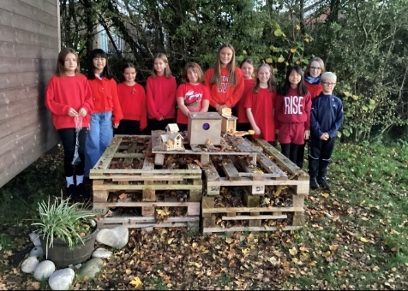
At Davenham, we encourage all our adults and pupils to believe that they can function as agents of change. They know that they have the power to create a fairer world for us all to live in. They recognise this can be at a local, national or a wider global level.
Our Christian vision and associated values of friendship, thankfulness, trust, forgiveness, compassion and koinonia all remind us of the importance of positive relationships and the power of a community working together. We also aim to teach our pupils the importance of respect – respect for themselves, for one another and for those who face challenges in their lives.
Through our curriculum and collective worship, we encourage pupils to discuss and debate life’s big questions and to challenge injustice. Pupils learn about a diverse range of people who have made a difference. These include people from the past and the modern day.
Our school community recognises the power of fund raising to support others and are actively involved throughout the year in a range of projects that are close to our hearts.
In recent years, we have conducted fundraising to raise awareness and support charities such as
- The Royal British Legion
- Macmillan Nurses
- Alder Hey Children’s Hospital
- The Children’s Society
- The Princess Trust

Furthermore, we recognise the need to care for the world God created for us. We have a gardening club, care for our two hens Taylor and Swift and conduct activities such a litter picking to improve the environment. We have strong links with local care homes and our local church. Our Year 5 Min Police Officers challenge parking issues and speeding in the community.
Our School Council work closely with pupils from other local schools to support projects in the wider community.
Our Ethos Group have completed the Archbishop of York Award which includes completing projects within the local community.

COURAGEOUS ADVOCACY

Courageous advocacy is defined by the Church of England as ‘the act of speaking out against an issue of injustice, often on behalf of those whose voice is not heard.’
We recognise that it can be difficult to challenge things and make a stand against what you believe to be wrong or unfair. This takes courage and perseverance.
Adults and pupils at Davenham regularly engage in activities that challenge injustice or bring about change. These not only include our pupil leadership groups, such as the Mini Police, Ethos and Eco Groups but also individual adults and pupils.
When pupils act independently as agents of change, we recognise and celebrate these acts of genuine kindness. Examples include making cards or jewellery and donating the funds to a chosen charity, sending football kits to our partner school in Kenya and raising funds for toilet twinning.
We share a list of both fund raising and courageous advocacy work in our school Newsletter. This allows us to celebrate with our wider school community the fact that we have made a difference – no matter how small that difference may be.

‘We encourage one another and build each other up.’
1 Thessalonians 5:11


We are people of the day, people of the light.

