

Davenham Church of England Primary School

“Working Together, Playing Together, Serving God and Serving Others”
“…encourage one another and build each other up…”
1 Thessalonians 5:11.

POLICY FOR ADMISSIONS 2025 – 2026
Parents should be aware before applying that in this school RE, Collective Worship and our whole ethos are based on the teachings of the Church of England.

Making an application
Applications for admission to the school should be made on the common application form enclosed with the Local Authority’s brochure. Applications may also be made electronically. The school's Supplementary Information Form for criteria numbers 2 and 3 will also need to be completed. The Common Application Form and Supplementary Information Form should be completed and returned by 15th January.
It is not normally possible to change the order of your preferences for schools after the closing date.

Letters or emails informing parents of whether or not their child has been allocated a place will be sent out by the Local Authority on 16th April or the next working day. Parents of children not admitted will be informed of the reason, offered an alternative place by the Authority and be made aware of their right to appeal.

Admission procedures
The number of places available for admission to the Reception class will be a maximum of 45. No restrictions will be placed on admissions unless the number of children for whom admission is sought exceeds this number. By law, no infant class may contain more than thirty children.

Places are allocated according to the criteria, with each application treated equally regardless of where the school sits within the preferences expressed. All children with an Education Health and Care Plan in which the school is named will be admitted. In the event that there are more applicants than places remaining, the Governing Board will allocate these places using the following criteria, which are listed in order of priority:

- A 'looked after child' or a child who was previously looked after but immediately after being looked after became subject to an adoption, child arrangements, or special guardianship order including those who appear to the admission authority to have been in state care outside of England and ceased to be in state care as a result of being adopted. A looked after child is a child who is (a) in the care of a local authority, or (b) being provided with accommodation by a local authority in the exercise of their social services functions (see the definition in Section 22(1) of the Children Act 1989). A child is regarded as having been in state care outside of England if they were in the care of or were accommodated by a public authority, a religious organisation or any other provider of care whose sole main purpose is to benefit society.

- Children with special medical or social circumstances affecting the child where these needs can only be met at this school. Professional supporting evidence from e.g. a doctor, psychologist, social worker, is required that sets out the particular reasons why the school in question is the most suitable school and the difficulties which would be caused if the child had to attend another school. The Supplementary Information Form should be completed if applying through this criterion.

- Children whose parent/s or carer/s are faithful and regular worshippers at the parish church of St Wilfrid’s.

‘Faithful and regular’ is taken to mean attendance at a minimum of twenty four public worship services in the previous year prior to the closing date for applications. In the event that during the period specified for attendance at worship the church has been closed for public worship and has not provided alternative premises for that worship, the requirements of these admissions arrangements in relation to attendance will only apply to the period when the church or alternative premises have been available for public worship.
A parent / carer is any person who has parental responsibility or care of the child. Where admission arrangements refer to ‘parent’s attendance at church’, it is sufficient for just one parent to attend. It is the responsibility of the parent / carers to formally record attendance at services with the church (not just attending without being formally recorded) for the year in advance of the closing date of applications. Please speak to the Church/ School Admissions Coordinator at St. Wilfrid’s for more information.
The Supplementary Information Form should be completed if applying through this criterion.

- Children with a sibling attending the school at the time of application who will still be attending the school in the following year. Sibling is defined in these arrangements as children who live as brother or sister in the same house, including natural brothers or sisters, adopted siblings, stepbrothers or sisters and foster brothers and sisters.

- Children resident within the Admission Priority catchment area of the school

The Admission Priority catchment area of the school lies to the south of the A556 Northwich Bypass and to the north of the Moulton School catchment area. This area can be viewed through the Cheshire West and Chester Admissions website via
https://www.cheshirewestandchester.gov.uk/residents/education-and-learning/school-admissions/catchment-areas/primary-school-catchment-areas
A map is also available from the school office.

- Children resident within the Ecclesiastical Parish of Davenham – St. Wilfrid’s.

The Parish of Davenham, Leftwich, Kingsmead and Gadbrook is situated in mid Cheshire, in the centre of the Diocese of Chester. It is a large parish, stretching five miles from north to south, and five miles from east to west. To the north, the parish extends to the railway viaduct across London Road. The western boundary is the River Weaver from the Viaduct Bridge to the Vale Royal Locks. The southern and eastern areas of the parish are almost entirely rural and farming land. The eastern boundary is King Street (old Roman Road) and Bostock Hall lies almost on the southern boundary. Davenham Village lies at the centre of the parish.

The map below identifies the parish boundaries. A copy is available from the school office. Parish maps can also be found on www.achurchnearyou.com

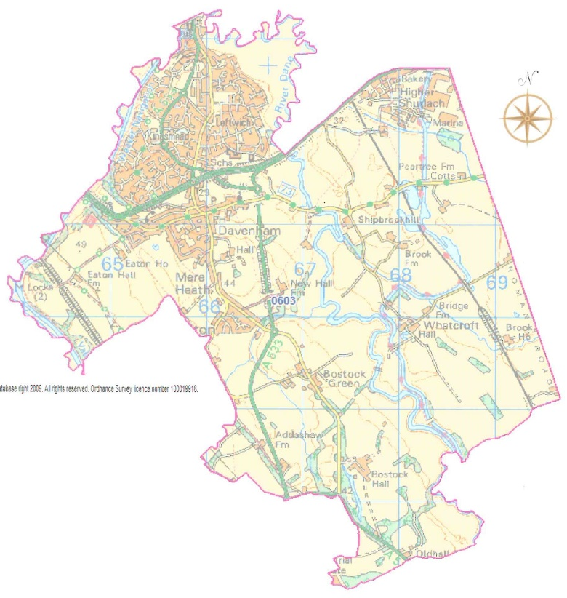

- Other children by distance from the school, with priority for admission given to children who live nearest to the school. Distances are measured using Ordnance Survey mapping in conjunction with Local Land and Property Gazetteer (LLPG) to identify each property and each school. A straight-line measurement in miles is taken from the place of residence to the preferred school to calculate the distance.

Random allocation will be used as a tie-break in the final category above to decide who has highest priority for admission if the distance between two children’s homes and the school is the same. This process will be independently verified. If a tie-break is required in earlier categories to decide who has priority for admission between two children, distance from the school will be used to decide as measured above.

Children of multiple births

In relation to children of multiple births, exceptionally it may be necessary to offer places over the published admission number. This is to ensure that, as far as possible, siblings (twins, triplets or children from other multiple births) can attend the same school.

Waiting list

Where we have more applications than places, the admissions criteria will be used. Children who are not admitted will have their name placed on a waiting list. The names on this waiting list will be in the order resulting from the application of the admissions criteria. Since the date of application cannot be a criterion for the order of names on the waiting list, late applicants for the school will be slotted into the order according to the extent to which they meet the criteria. Thus it is possible that a child who moves into the area later to have a higher priority than one who has been on the waiting list for some time. If a place becomes available within the admission number, the child whose name is at the top of the list will be offered a place.
This is not dependent on whether an appeal has been submitted.
This waiting list will operate until the 31st December of the year of admission.

Late applications for admission

Where the Local Authority accepts that there are extenuating circumstances for an application being received after the last date for applications, and it is before the list of pupils to be admitted has been established then it will be considered alongside all the others.
Otherwise, applications which are received after the last date will be considered after all the others, and where applicable, placed on the waiting list in order according to the criteria.

Address of pupil

The address used on the school’s admission form must be the current one at the time of application. If the address changes subsequently, the parents should notify the school. Where the parents live at different addresses, the current-at-the-time-of-application, normal address of the child will be the one used. This will normally be the one where the child wakes up for the majority of Monday to Friday mornings. Parents may be asked to show evidence of the claim that is being made for the address, e.g. utility bills of various sorts showing the child’s address as the one claimed. For children of UK Service personnel and other Crown Servants returning to the area proof of the posting is all that is required.

In-year admissions

It sometimes happens that a child needs to change school other than at the “normal” time; such admissions are known as non-routine admissions or in-year admissions. Please contact school in the first instance to enquire about available places in the appropriate year and to arrange a visit to school.
Further Information about In-year admissions can be found on the CWAC website with the relevant procedure and application forms. Any oversubscription will result in the application of admission criteria.

Please note that you cannot re-apply for a place at a school within the same school year unless there has been relevant, significant and material change in the family circumstances.

Excepted children outside the normal admissions round may include:

Children of UK Service Personnel:
Places will be allocated in advance of the family arriving in the area for children of UK service personnel and veterans, if accompanied by an official government letter which declares a relocation date and a Unit postal address or quartering area address for considering the application against Davenham C of E School’s oversubscription criteria. In addition the School Admissions Code (December 2014) allows the admittance of a forces child as a permitted exception in relation to infant class size legislation.

Children who move in to the area outside the normal admissions round for whom there is no other available school within reasonable distance.

Appeals

Where the governors are unable to offer a place because the school is oversubscribed, parents have the right to appeal to an independent admission appeal panel. Parents should request an Appeal Form from the school, complete and return it to Chair Of Governors at Davenham CE Primary School within 20 days of receiving the letter refusing the place. Parents will have the opportunity to submit their case to the panel in writing and also to attend in order to present their case. You will normally receive 14 days’ notice of the place and time of the hearing.

If your child was refused a place in Reception or Key Stage 1 because of Government limits on Infant class sizes, the grounds on which your appeal could be successful are limited. You would have to show that the decision was one which in the circumstances no reasonable governing body would have made, or that your child would have been offered a place if the governors’ admissions arrangements had been properly implemented.
Please note that this right of appeal against the governors’ decision does not prevent you from making an appeal in respect of any other school.

Closure of places of worship

In the event that during the period specified for attendance at worship the church has been closed for public worship and has not provided alternative premises for that worship, the requirements of these admissions arrangements in relation to attendance will only apply to the period when the church or alternative premises have been available for public worship

Fraudulent applications

Where the Governing/Trust Board discovers that a child has been awarded a place as the result of an intentionally misleading application from a parent (for example a false claim to residence in the catchment area or of involvement in a place of worship) which effectively denies a place to a child with a stronger claim, then the Governing/Trust Board is required to withdraw the offer of the place. The application will be considered afresh and a right of appeal offered if a place is refused.

Deferred admission

Children are eligible for a reception place from the beginning of the school year in which they become 5 years old. However they do not become of compulsory school age until the start of the term after their fifth birthday. After a place has been allocated and accepted parents may defer the school place until later in the school year and if they do this the place will be held for the child. They cannot however defer entry beyond the beginning of the term after the child’s fifth birthday, nor beyond the summer term. Parents can also request that their child attends on a part time basis until the child reaches compulsory school age.

Children educated outside of their normal age group

Parents who wish to delay entry until the following year due to specific circumstances, such as ill health, specific circumstances which mean they are not ready to start school or summer born children (those between 1st April and 31st August), must speak to the school and Local Authority as soon as possible as this this would involve either an in-year application for year 1 or a new application for reception in the following year. The decision as to which year group the child will enter will be made taking into account information from the parents and headteacher and should be in the best interests of the child. Information that parents could include in their request may include details of medical conditions or reports from professionals to support their request.
Parents of summer born children should be aware that agreement by the school to allow a child to enter reception in the following year does not guarantee a place in the class. Parents must apply to the school in the normal co-ordinated round and the application will be considered in the normal manner following the oversubscription criteria. Parents may also choose to apply in-year for admittance to year 1 and the child’s normal age group.
Similarly if the parents of a gifted and talented child wish to apply for a place outside of their child’s normal age group they should speak to the school and the Local Authority. Any application will be considered to ensure any decision is in the best interests of the child and parents informed of the outcome.

Special Educational Needs

Where a child has an education, health and care plan (EHCP) which names the School, then that child will be admitted to the School and the number of available places in the PAN will reduce correspondingly. Admission of children with an EHCP is dealt with by the home Local Authority (LA) (which is where you reside).

Supplementary Information Form for Davenham CE Primary School

Name of child:
Surname |  |  |  | first names
Date of birth
Name of parent/guardian
Address

Place of worship parent/ guardian regularly attends (Criteria 3) must be:
Name of place of worship |  |  | St. Wilfrid’s Parish Church
Address | 57 Church Street  Davenham  Northwich  CW9 8NF
Name of vicar or church minister/officer |  |  |  | Rev. Rob. Iveson
Telephone  email |  | Rev Rob Iveson 01606 42450 / Church Office 01606 42963  rob.iveson@btinternet.com / davenhamchurch@btinternet.com

Worship attendance (Criteria 3):
It is the responsibility of the parent / carers to formally record attendance at services with the church (not just attending without being formally recorded).Please tick here if you have attended a minimum of 24 public worship services in the previous year prior to the closing date for applications

Church Vicar or Minister Confirmation of worship attendance

Name of Vicar or Minister …………………………………………………………..

Signature / date …………………….………………………..……………………...

Please note:
In the event that during the period specified for attendance at worship the church has been closed for public worship and has not provided alternative premises for that worship, the requirements of these admissions arrangements in relation to attendance will only apply to the period when the church or alternative premises have been available for public worship.

Special medical or social circumstances (Criteria 2):

Tick here if you are applying under this criterion

Give details of professional evidence submitted:

Please return completed SIF to:
The Headteacher, Davenham CE Primary School, Charles Avenue, Davenham, Northwich, Cheshire, CW9 8JW

