
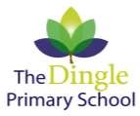

OUR SCHOOL

The Dingle Primary School was opened in January 1971 for pupils aged 4 to 11. The school site is surrounded by playing fields, trees and country views.

The whole school has undergone progressive refurbishment over the last couple of years and provides a pleasant learning environment for all. Each class has access to practical areas for Art, DT, Cookery and Science, and there is an abundance of IT equipment to support learners.

OUR AIMS

Primary education is constantly undergoing complex changes reflecting the diversity of our British Society and the wider World. The school therefore provides exciting opportunities for children in preparation for the next stage in their lives.

We follow the National Curriculum and provide a wide range of engaging, balanced learning opportunities within a caring environment to develop knowledge, natural talents, skills and follow pupils’ interests.

The school rightly attaches a high priority to the acquisition and development of basic skills in numeracy and literacy, and we strive to develop these skills through all areas of the curriculum.

Finally, there is the "hidden curriculum" where the children are expected to work and behave to high standards, and to develop as caring, responsible members of the school community.

The overall aims of the school are:
- To provide each child with a broad and balanced education commensurate with their ability.
- To recognise each child as an individual and to cater for their needs socially, academically, aesthetically, emotionally, spiritually and physically.
- To encourage self-awareness, self-respect and self-discipline, both in work and behavior.
- To foster a diligent attitude to work and learning.
- To foster good manners and respect for others and for property.
- To develop links between home, school and community.
- To develop the values required of a British citizen.

SCHOOL ADMISSIONS AND TRANSFER

Children enter school in September if their birthday is between 1st September and 31st August of that year.

All applications from parents must be made on the Cheshire East Council online application form via the Local Authority. The closing date for all applications is usually mid-January in the school year prior to admission of primary school. Application forms will be available online from Cheshire East from late September in the year preceding the admission year.

All catchment applications usually secure a place at the school. Parents who live outside the school’s catchment area are usually offered a place and are very welcome to apply if they wish their child to attend The Dingle Primary School.

Most children from The Dingle transfer to Sandbach School (boys) and Sandbach High School (girls), although all parents have the right to apply to other secondary schools if they wish. Children have recently transferred to Alsager, Holmes Chapel, Sir William Stanier and Ruskin High School as their chosen high school.

VISITING THE SCHOOL

Parents are welcome and encouraged to contact the school if advice is required. Prospective parents are invited to contact the Head Teacher for an introductory visit. Each year the school holds an Open Evening in early October, led by the Headteacher, to introduce the school to parents with preschool children.

For those who then accept a place, a meeting is held in the summer term before the child's entry to school, which includes an address by the Headteacher and an opportunity for the staff to be introduced to you. Parents will also be able to meet their child's class teacher enabling a mutual exchange of information.

Parent evenings are held in the autumn and spring terms to discuss the children’s progress. Further interviews can be arranged on request.

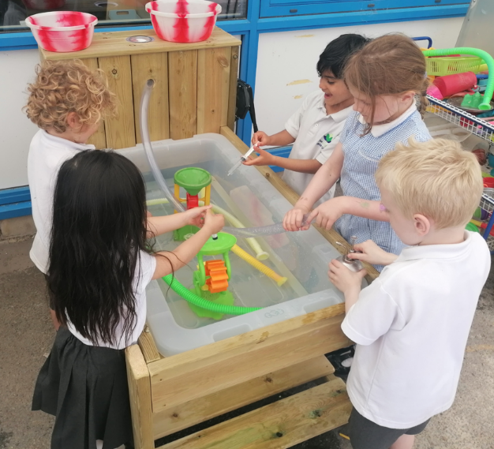

SCHOOL ORGANISATION

Currently there are eighteen teachers, plus the Headteacher, Mr. Cox. The class organisation is:

2 x Reception classes
2 x Year 1 classes
2 x Year 2 classes
2 x Year 3 classes
2 x Year 4 classes
2 x Year 5 classes
2 x Year 6 classes

This could change slightly each September, according to the number of children in each age group, and any budget constraints.

Senior Leadership Team

Mr B Cox – Headteacher / Designated Safeguarding Lead
Mr M Griffiths – Deputy Headteacher / KS2 Co-ordinator
Miss Hadzik – Assistant Headteacher
Miss Clark – School Business Manager
Miss Henry – Special Educational Needs Co-ordinator

Teachers – 20
Teaching Assistant – 11
Pastoral Support -1
School Administration Staff - 2
Mid-day Assistant – 8
Kitchen Staff – 4

WHO ARE THE GOVERNORS?

Governors are like a voluntary board of directors and make decisions about how the school is run. They meet at least once a term at school.

Governors are appointed to help:

- Decide what is taught.
- Set standards of behaviour.
- Interview and select staff.
- Decide how the school budget is spent.
- Evaluate the practice and successes of the school and plan for its future development.

School Governors have legal duties, powers and responsibilities. They can only act together, they cannot act individually.

School Governors are:
- Parents | Parent Governors have a child in the school; are elected by parents of the school; serve for 4 years.
- Teachers at the school
- Local council representative
- Community representatives
- Businessmen and women

Why are parents on the Governing Body?

Parent Governors bring the views of parents to the Governing Body, but they speak and act as individuals. They should not be thought of as delegates, or "mouthpieces" of the parents, they do not vote for all parents in general. They have equal status in the work of the Governing Body and have voting rights. The minutes of the Governors’ meetings are in the school office for anyone to read.

You, as a parent, elect 4 Parent Governors for a four-year period.

PARENT GOVERNORS (3) | Mrs R Smith - Chair
 | Mr M Ireland
Mrs A Wheatley
Mrs N McCann
Mrs N Spurrier
LA REPRESENTATIVE (1) | Vacant
CO-OPTED (5)  STAFF GOVERNOR  ASSOCIATE GOVERNORS | Mrs G Reynolds  Mr I Raisbeck  Mrs J Griffith  Ms C Lambert – Vice Chair  Mr E Flood  Mrs H Austin  Ms C Clark (SBM)  Mr M Griffiths (Deputy)
HEAD TEACHER | Mr B Cox

SCHOOL LINKS WITH PARENTS

For Parents we offer:

Autumn |  | An evening to discuss how well your child has settled into their new class.
Spring |  | An evening to discuss your child’s progress.
Summer |  | Open Afternoon for Parents and Grandparents to join their children at their work. This is also an opportunity for the children to take their parents to other classes.  Written reports sent home.

Parents are always welcome to see their child's class teacher or the Headteacher at a convenient time.

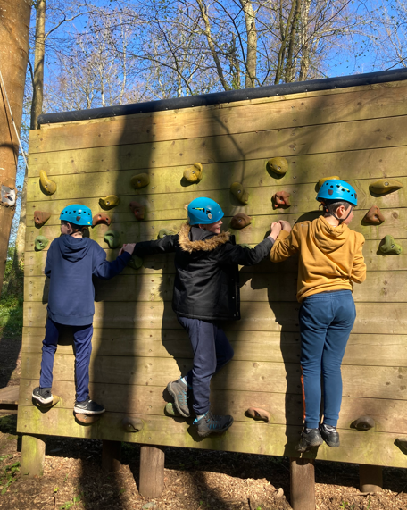
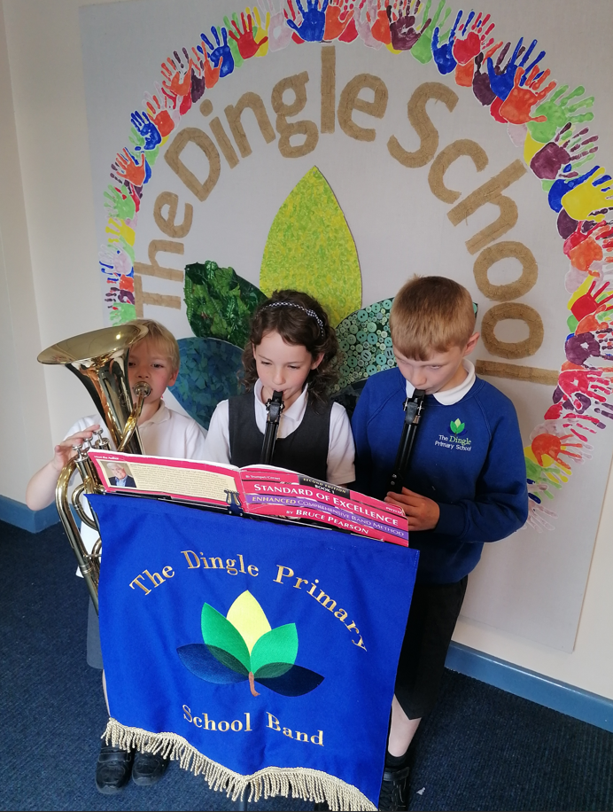

We also invite parents to view school concerts, musical performances, and ad hoc class activities.

The ‘Friends of the Dingle’ is an informal group of parents, friends and staff who meet at regular intervals and organise both, fund raising and social events.

Parents are welcome to help in school in various activities e.g. cooking, sewing, craft work, reading stories, talking to children and assisting with educational visits, once Safeguarding checks have been carried out.

Please contact the school for further information.

THE SCHOOL CURRICULUM

The National Curriculum is taught in all maintained state schools and consists of:

5 CORE SUBJECTS FOUNDATION SUBJECTS

- English  - Maths  - Science  - Computing  - RE | - Geography  - History  - Design & Technology  - Physical Education  - Music  - French

Our curriculum also covers Relationship Sex and Health Education, British Values and the personal development of every child.

The curriculum is organised between 3 stages at Primary level.

- FOUNDATION STAGE - ages 4-5 (Infants)

- KEY STAGE 1 ages 5 – 7 (Infants)

- KEY STAGE 2 - ages 7-11 (Juniors)

All classes are of mixed ability and some will be of mixed age, although Numeracy and Literacy classes maybe taught in ability target sets at Key Stage 2. Children will work in a variety of ways: individually, in pairs and in co-operative learning groups.

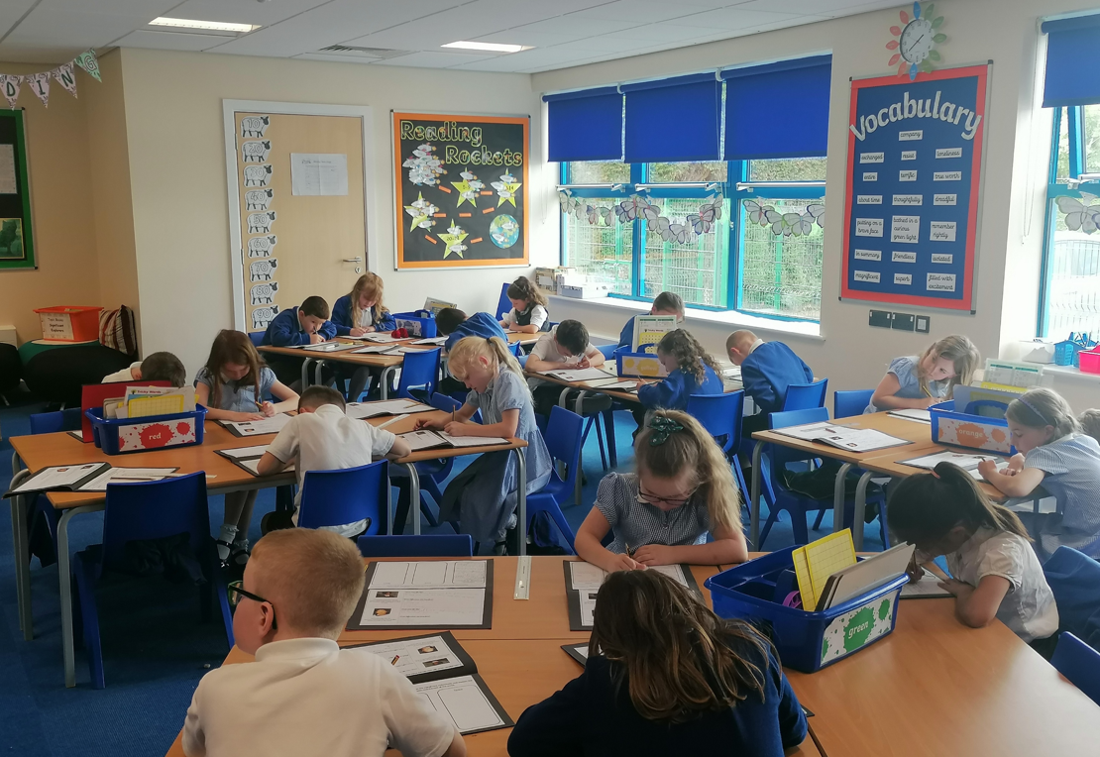

RELIGIOUS EDUCATION

Religious Education is taught in accordance with the Cheshire Agreed Syllabus, and school assemblies are held on a regular basis. Although assemblies are non-denominational, the delivery is broadly Christian in its content. However, account is taken of some of the world's major faiths. Parents have the right to have their children withdrawn from such instruction and school assemblies.

ASSESSMENT AND REPORTING

It is a legal requirement that schools keep records containing basic information about their pupils. The school fulfils all the statutory requirements regarding recording and assessment. Assessments are made continuously, with statutory assessments made as follows (table over page).

PUPIL PROGRESS REPORTS

Written reports are prepared by the teachers which are sent to parents at the end of each summer term.

School Assessment Tests
EYFS |  | Early Years Baseline | Ongoing
KEY STAGE 1 | Year 1 | Statutory Phonics Check | Summer
 | Year 2 | Internal curriculum tests (SATS) – English and Maths | Summer
KEY STAGE 2 | Year 3 | Internal tests – Maths, reading, writing, grammar, punctuation and spelling. | Ongoing
 | Year 4 | Internal tests - Maths, reading, writing, grammar, punctuation and spelling.  Multiplication Tables Check | Ongoing  Summer
 | Year 5 | Internal tests - Maths, reading, writing, grammar, punctuation and spelling. | Ongoing
 | Year 6 | Statutory curriculum tests (SATS) – English and Maths  Teacher Assessment in Science | Summer

OTHER ACTIVITES

MUSIC
All pupils are taught music including being introduced to a variety of instruments however private music tuition is available for KS2 pupils who want to learn a specific instrument to a greater depth. This is paid for by parents through the Music for Schools Foundation. Instruments include, Clarinet, Cornet, Flute, Trombone and Trumpet.

There is a charge made to parents for the hire or sale of instruments. The school has a very well-regarded school band & choir that plays at functions in school and at community events.

EXTRA CURRICULAR CLUBS
The school offers a number of enrichment opportunities through clubs. Recently they have included cookery, sewing, construction, sports clubs, drama club and concerts.

RESIDENTIAL STAY
The school offers a Residential visit for Year 5 pupils which focuses on outdoor adventurous activities.

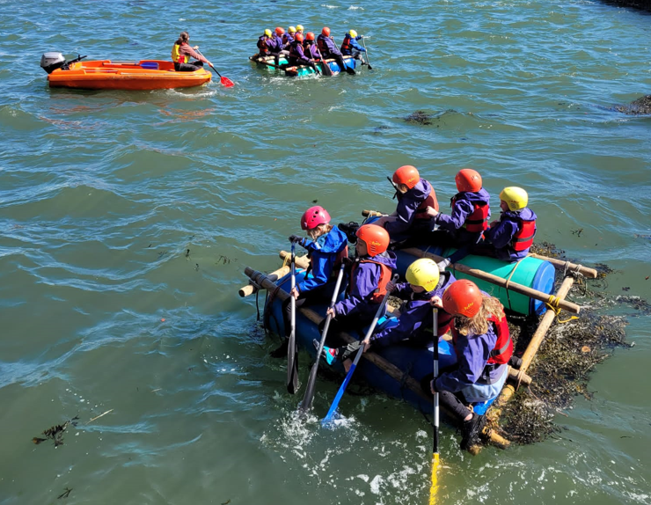
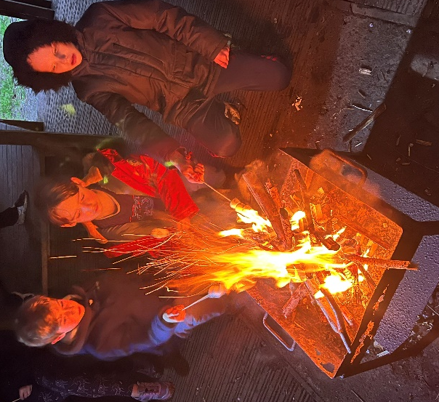

SCHOOL TRIPS
During your child’s time at The Dingle, they will be invited to take part in a number of school trips.

In accordance with the 1988 Education Reform Act, the school policy is that when educational visits take place during school hours, parents may be asked to make a voluntary contribution towards the cost. Whilst no child will be placed at a disadvantage because of a parent's unwillingness or inability to pay, if voluntary contributions do not meet the cost of the visit, it may be cancelled. We find that parents fully support us in these valuable activities.
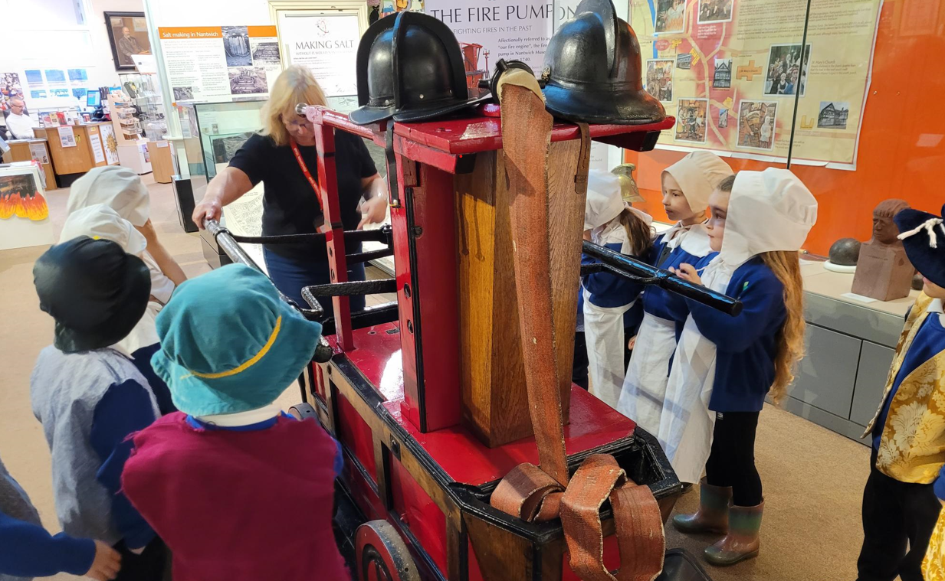

SPORTS
We take part in numerous sports both for enjoyment and competitively. A selection of the clubs available to pupils include:
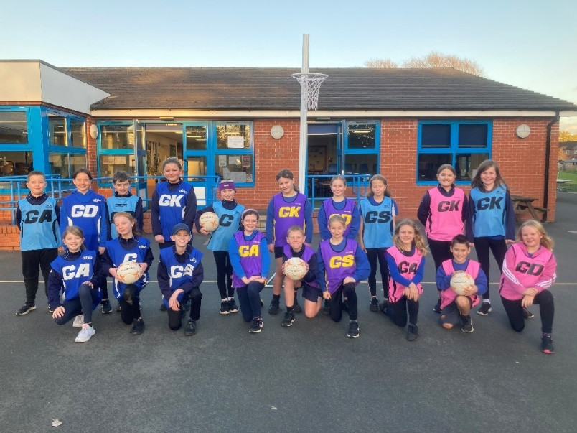
- Athletics
- Cricket
- Hockey
- Football
- Netball
- Rugby
- Rounders
- Tennis
- Dance
- Cross Country Running

Some of the activities outlined above take place outside of normal school hours and have a small charge. The school participates in Football, Netball, Cricket, Hockey, Athletics, Rugby, Cross Country and Rounders competitions

HOMEWORK
There is an expectation that all pupils read regularly to an adult at home.

Other homework may be set in a number of different ways. Initially we may ask children to undertake extensions to school work usually in the form of activities related to reading at home and learning basic numbers and number facts. Naturally, we encourage parents to show an active and positive approach towards their children's learning.

As the children reach Key Stage 2, they will all be expected to read and to learn their times tables, taking spellings and times tables home on a weekly basis. Other more detailed work such as tasks to enrich learning in school may be encouraged by the class teacher.

SPECIAL EDUCATIONAL NEEDS

The school aims to fulfil all children’s entitlement to learning and their access to the National Curriculum (including the National strategies for Literacy and Numeracy), by enabling them to participate in the life and work of the school to the best of their abilities, whatever their needs.

A register of all children with special educational needs is maintained and held by the Special Needs Co-Ordinator (SENCO). It is updated as required, but at least on a half-termly basis.

The school has full wheelchair access and a disabled toilet.

HEALTH EDUCATION

Children are encouraged to make sensible decisions about their lifestyle, using the skills and acquisition of knowledge gained in areas like personal hygiene, exercise, diet and oral hygiene. We encourage healthy snacks at break time and do not allow sweets, chocolate, fizzy drinks or other high sugar-based foods.

Sex and relationship education (SRE) is a sensitive part of our broad health programme. SRE is taught through individual lessons and science topics. Whilst all teachers have a responsibility to respond to questions as they arise, answers will be matched to the maturity of the children involved.

PASTORAL CARE

The school fully appreciates that it shares the care and responsibility of the children with their parents. Care of the child is primarily with the class teacher, who is fully supported by the Headteacher. The school rules are:
- work hard,
- be kind,
- be sensible,
- show respect to others and their property.

We expect all children to make every effort to abide by these rules. Children respond to an ordered and secure way of life, and the staff endeavor to create this with a kind, yet firm understanding and approach

Bullying - Any incident described as bullying is first reported to the class teacher. Children are encouraged at all times to discuss with their class teacher or the Headteacher any fears or concerns that they may have concerning behavior towards themselves by other pupils. Appropriate measures are then taken.

This is our school Code of Conduct as agreed with the children.

- Treat others with respect and kindness.
- Respect other people’s property.
- Listen to advice, especially regarding safety, from people in authority.
- Respect our environment.
- Always be tidy and dispose of litter properly.
- Always dress appropriately.
- Do not waste resources.
- Always be punctual.

BEFORE AND AFTER SCHOOL CARE

The school provides a breakfast club from 7.45 am at a cost of £4.00 including a breakfast of toast and cereals, and an after-school club from the end of school until 6pm. This has a cost of £10.50 for a full session from after school until 6 p.m. and £5.00 from the end of school until 4.00 p.m. A snack is included.

ABSENCES

If a child is unable to come to school, please telephone the school office by 9.10 am. If we do not receive a phone call we will endeavor to contact you to ascertain the reason for the absence. If a child is absent for several days, a letter outlining the reason for the absence is required upon their return.

All holidays will be unauthorised unless there are exceptional circumstances. Any unauthorised holidays taken may result in a Fixed Penalty fine for both parents imposed by the Local Authority. Currently this is £60 per parent per child.

The Local Authority is able to give a Fixed Penalty Notice and fine to parents of children with continuous unauthorised absence.

MEDICINE

Staff can administer medicines. Please ask for a medication request form at the office. Antibiotics will only be given if the child is required to take the dose 4 times daily or is attending after school club.

MOBILE PHONES
Pupils are strongly discouraged from bringing mobile phones to school and should only be brought to school if absolutely necessary, e.g. if the child is being collected by another adult. All phones brought to school will be collected by the class teacher at the start of the day and returned on departure. Pupils will not have access to the phone during school times.
Main School Information

School Times

Morning Registration |  | 8.45 am -8.55 am
Morning Session |  | 9.00 am - 12.00 noon
Afternoon Session |  | 12.50 pm - 3.15 pm - EYFS
12.50 pm - 3.20 pm –year 1/2
1.10 pm - 3.25 pm - year 3/4
1.10 pm - 3.30 pm – year 5/6

There are break times of 15 minutes mid-morning and mid-afternoon. Children should arrive at school no earlier than 8.50 am, as the school cannot be responsible for their welfare before this time.

SCHOOL UNIFORM

- Royal Blue sweatshirt or cardigan
- White blouse/shirt or polo shirt
- Grey skirt, pinafore dress or trousers
- Pale Blue & White gingham dress or grey shorts (summer wear)
- White, black or grey socks

All uniform is currently supplied by Badged, our school uniform supplier. Fleece, sweatshirts, cardigans, PE shirts, and white polo shirts are all embroidered with the school motif.

BAGS
- Early Years and KS1 pupils – Book Bag only.
- KS2 – small rucksack if necessary.

PE KIT IS ESSENTIAL FOR PE LESSONS

INDOOR PE KIT
T-shirt | Royal Blue Drywear T-shirt
Shorts | Blue
Trainers | Black/predominantly black
OUTDOOR PE KIT
PE Jackets or sweatshirt (outside use only) | Royal Blue
Joggers (outside use only) or  school tracksuit | Black  Navy/Royal Blue
Recognised sports trainers | No fashion trainers in bright colours or thick soles please.
Football boots/ Astro turf trainers
Shin pads for football/hockey
Gum shield for hockey (KS2)
Football kits and other recognised sportswear are allowed for games lessons, but not for indoor PE lessons.

SWIMMING KIT (Year 5 and 6 only)
One-piece costume
Tight fit trunks - no baggy long shorts
Towel

Please ensure that all items of property are clearly labelled.

No jewellery is allowed except stud earrings and jewellery that specifically relates to a religious need. Children with pierced ears can only participate in PE and games activities if they are wearing studs covered with a plaster brought from home. If they wear any other earrings, for safety reasons they must be able to remove them without the teachers’ assistance.

All essential equipment such as pens, pencils, books etc., are supplied by the school. However, many children like to bring their own personalised items into school. Whilst the school does not discourage this, it cannot be held responsible for loss or damage to personal items. Please help us to ensure that your child develops a responsible attitude towards looking after property, and that all items of property are clearly labelled. Children should not bring unnecessary items or large bags into school.

CAR PARKING AND ACCESS

We ask all parents who come to school, not to use the school car park, or turn in the gateway. Apart from endangering the pupils’ safety, vehicles, other than those used by employees at the school, are unlikely to be covered by their insurance. It is also worth noting that no one should park on the yellow zigzag markings outside the school gates.

We impress on the children to use only the small side gate and not to walk through the car park and main gate for obvious safety reasons. We ask all parents, especially those in Reception to make a habit of using the side gate and green path and not to access school through the car park at the start and end of the day.

DINNER TIMES

The majority of children elect to stay at school during the dinner time. Children can either bring their own lunch, or have a school meal. If children bring their own lunch, it should be in a proper container e.g. sandwich box. Please, for safety reasons, do not include hot drinks, soup, glass containers or fizzy drinks. All infant pupils currently qualify for a free school meal under the government’s Universal Free School Meal Scheme. KS2 pupils pay for their school lunches at a cost of £2.90 per day unless they are in receipt of low-income tax credits. Parents on such credits can apply for free school meals by contacting 03001235012.

ARBOR

The system works as follows:

Parents of pupil’s are given a user name and password and are asked to set up their own child’s account. Money can be put on to the Arbor system online for lunches, trips, Breakfast and After School Clubs.

An in-app message from Arbor will notify you that your child has had a lunch.
You can pay for lunches daily or if you prefer a lump sum can be put on the account and each time they have a lunch, money will be deducted.

Please note that information emails for trips and school events are sent out via Arbor. It is imperative that you set up an account when instructed to do so.

COMPLAINTS PROCEDURE

It is a statutory requirement that the school prospectus should contain the correct complaints procedure. The initial point of contact is always the class teacher or in some cases the Head Teacher. If necessary this can be taken further to the Chair of Governors and ultimately to the Local Authority. More information can be found on the school website.

FINALLY
All children are different.

They look different.

They behave differently.

They develop at different times and in different ways.

For their sake, don't compare them with other children.

We are delighted to have your family with us.

We hope you will be happy in our school.

USEFUL INFORMATION

School telephone number 01270 918988
Address | The Dingle Primary School
 | The Dingle
 | Haslington
 | Crewe
 | CW1 5SD
Head Teacher | Mr. B Cox
Deputy Head Teacher Assistant Head Teacher | Mr. M Griffiths  Miss.R Hadzik
School Business Manager | Miss. C Clark

