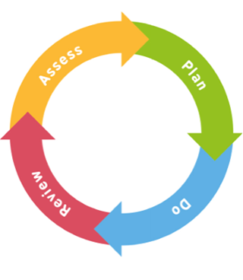

The Graduated Approach


- Concerns may be raised by class teacher or parents.
- Meeting held with class teacher and SENCO.
- SENCO to carry out an observation and to discuss concerns with school staff.
- Screening or Assessments completed.

- Plan interventions and support strategies for the classroom.
- Parents / staff to access training if required.
- Create SEND support plan with a date set for the review.

- Teachers and Parents implement the SEND support plan for a school term.
- Continue with observations and assessments of progress.

- Review the progress that the child has made over the term by completing further observations and assessments against the targets set.
- Teachers, Parents and SENCO agree the next steps for the child and write a new SEND support plan.
- If needed a referral may be made to TESSA to ask for further support – this advice would then be followed in the next cycle.

After two Assess, Plan, Do, Review Cycles if concerns remain a further referral may be made for external agency assessments or support.

