 | Autumn 1 | Autumn 2 | Spring 1 | Spring 2 | Summer 1 | Summer 2
Foundation Stage | See Nursery/Reception Reading Spines
Year 1 | 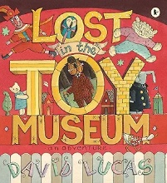  Toys from the past |  | 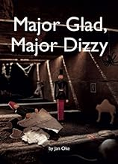  Homes in the past |  | 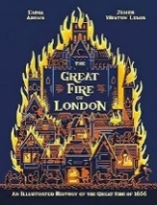  Great Fire of London
Year 2 |  | 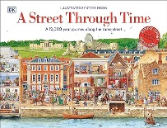  How St Helens has changed |  | 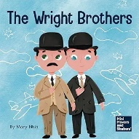  Travel and transport |  | 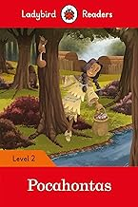  Pocahontas
Year 3 | 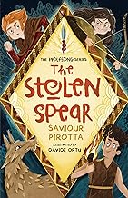  Prehistoric Britain |  | 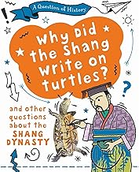  Shang Dynasty |  | 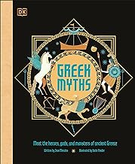  Ancient Greece
Year 4 |  | 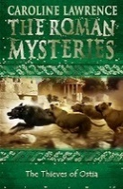  Romans |  | Anglo Saxons |  | 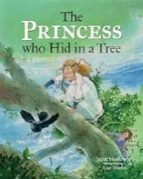  Vikings
Year 5 | 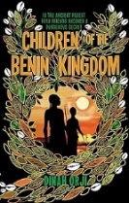  Benin |  | 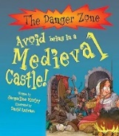  Medieval Monarchs |  | 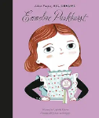  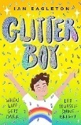  Changing Britain
Year 6 |  | 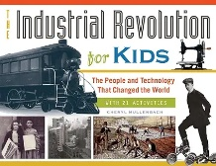  Industrial Revolution |  |   Civil Rights |  | 20th Century Conflict

