 | Autumn 1 | Autumn 2 | Spring 1 | Spring 2 | Summer 1 | Summer 2
Foundation Stage | See Nursery/Reception Reading Spines
Year 1 |  | 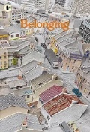  Understanding the World |  | 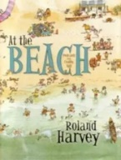  The Seaside |  | 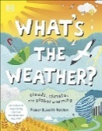  Weather
Year 2 | 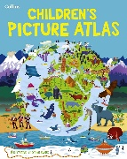  Maps and mapping |  | 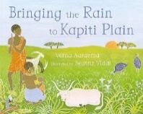  Hot and Cold Places |  | 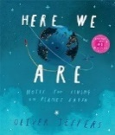  Comparing Countries
Year 3 |  | 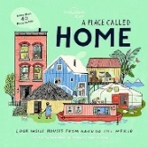  Villages, Towns and Cities |  | 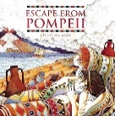  Mountains, Volcanoes and Earthquakes |  | 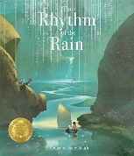  Water and Weather
Year 4 | 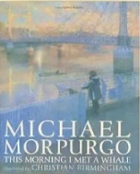  Rivers |  | Migration |  | Natural Resources
Year 5 |  | 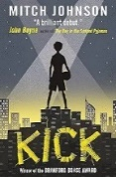  Slums |  | 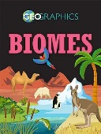  Biomes |  | 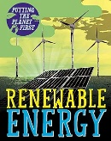  Energy and Sustainability
Year 6 | 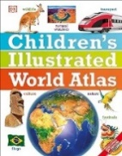  Local Fieldwork |  | 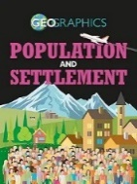  Population |  | Globalisation  