
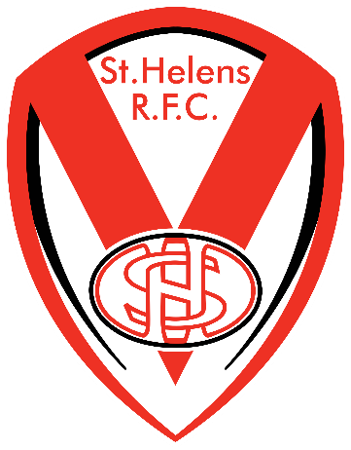
Saints Rugby Coaching
June - July 2021

Throughout the summer term, classes have received 6 weeks of professional rugby coaching sessions delivered by Saints Community Coaches. ‘Saints’ or St Helens RLFC to give them their full name, are our local Rugby League team but whilst they may be local to our children, within the Rugby community, they are renowned around the world.
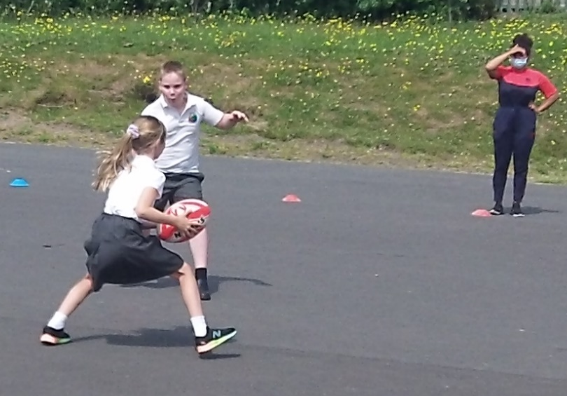
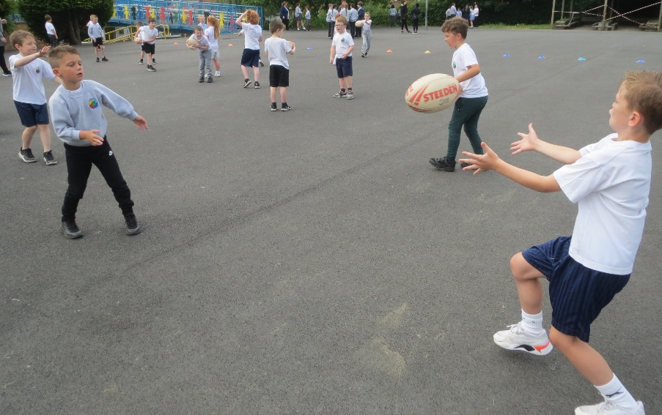
The children were given different coaching sessions each week based on the fundamentals of rugby - passing, movement, playing the ball and 'touch tackling'. The children developed many skills during the sessions as well as having lots of fun.
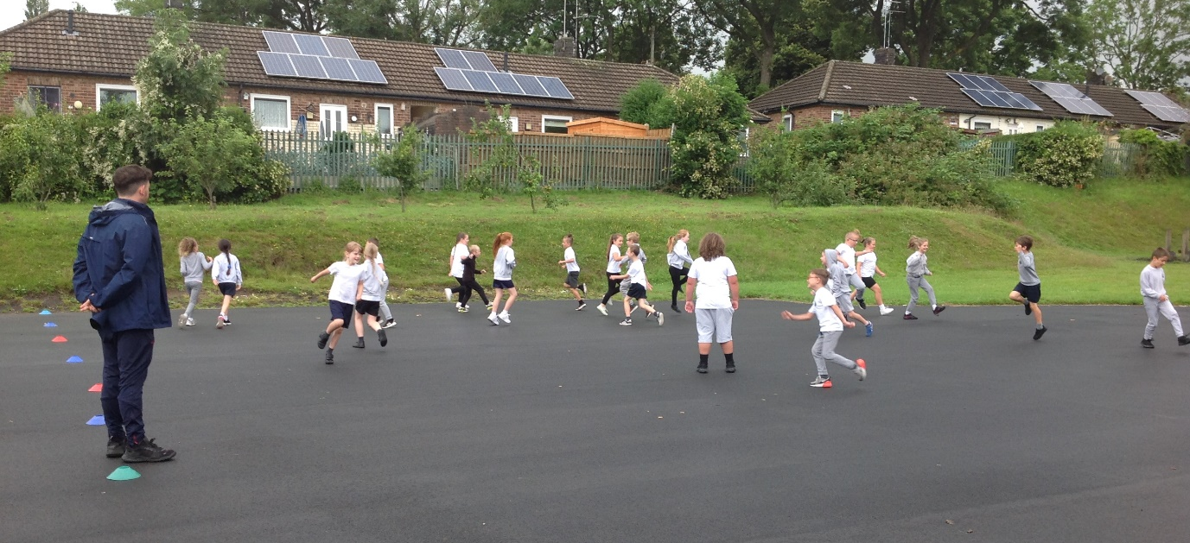

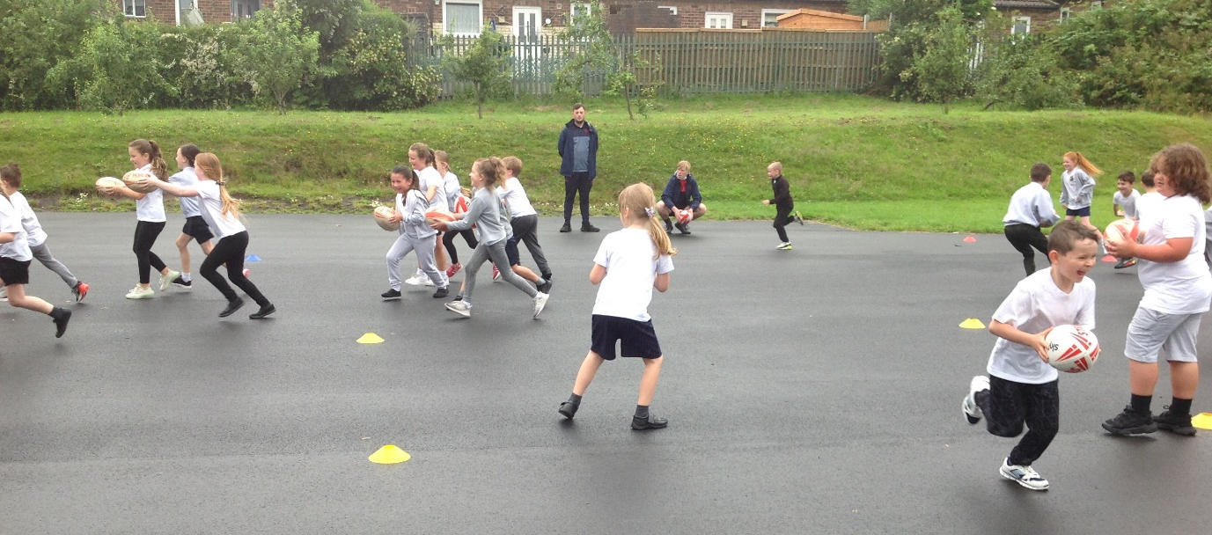
The sessions left the children inspired and dreaming of one day wearing the famous red Vee jersey of their favourite team.
