
Santa Dash

Rivington joined other primary and secondary schools across the country in the School Games Virtual Santa Dash. With many of our usual festive activities not being able to go ahead, it was great to be able to dress up and listen to some festive tunes whilst dashing around the course.
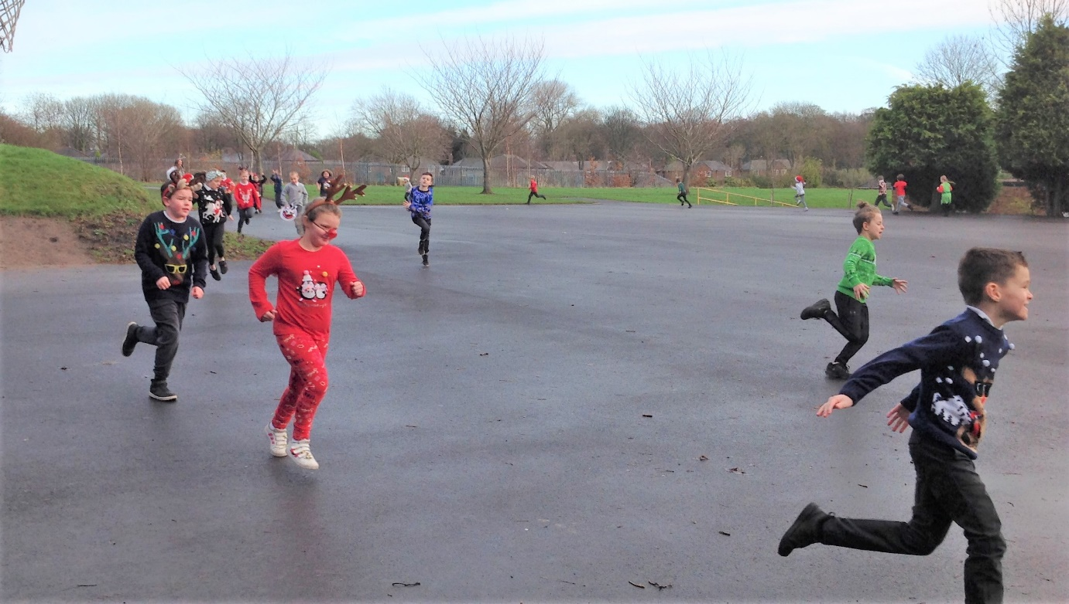
The whole school enthusiastically joined in and came dressed ready for the Santa Dash! There were Santa hats and Christmas jumpers in every class.
