Y6 Rugby Tournament
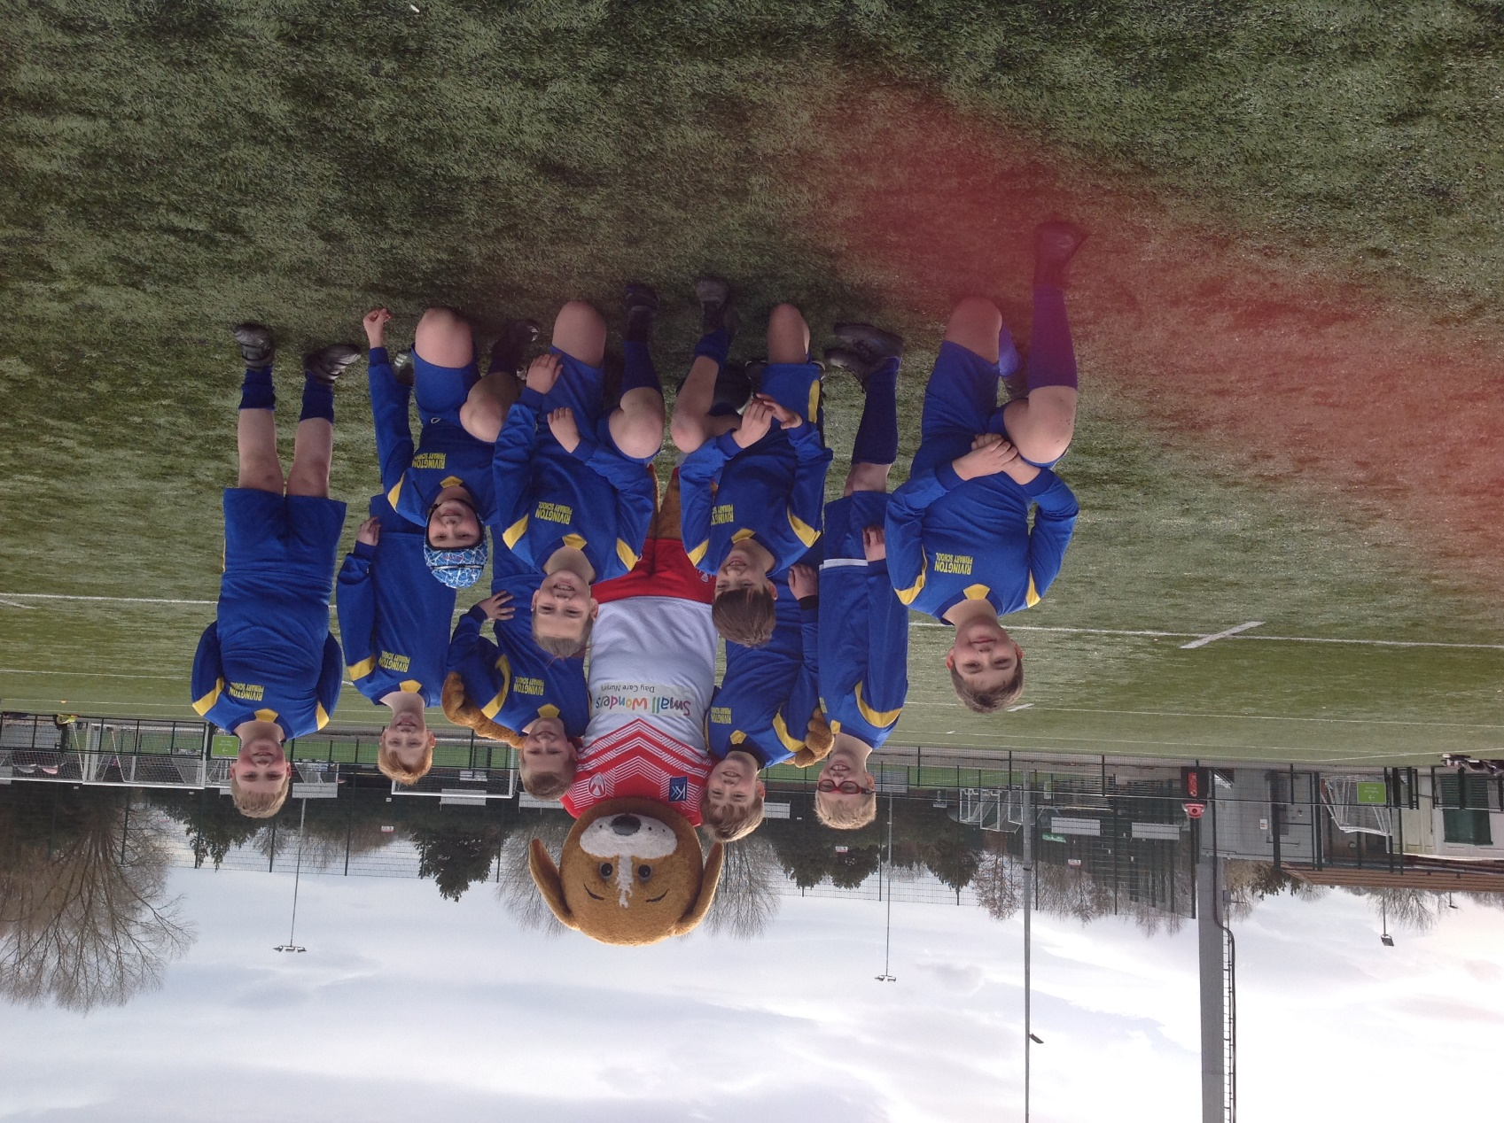
Well done to our Year 6 Rugby team who represented the school at the St Helens Schools’ Rugby Tournament at Ruskin Drive. All of the children were a credit to Rivington and it was so pleasing to see them all working together to tackle the opposition. They worked well as a team throughout the tournament, played with a smile on their faces and showed a real enjoyment of the competition. Altogether, we scored some excellent tries in our games and demonstrated some excellent defending skills, which resulted in us being unbeaten in the competition. It was a fantastic tournament and the children can be very proud of themselves!

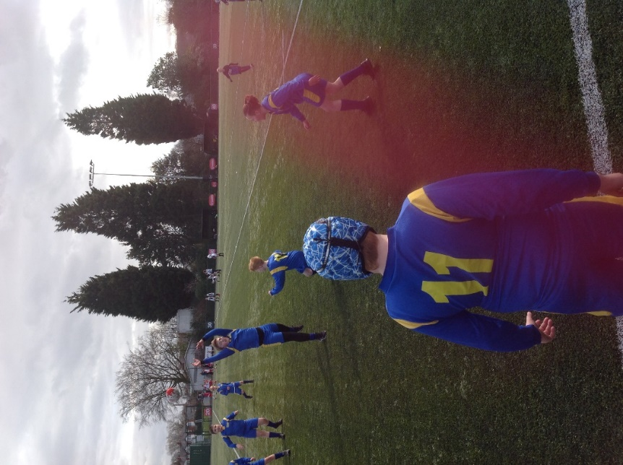
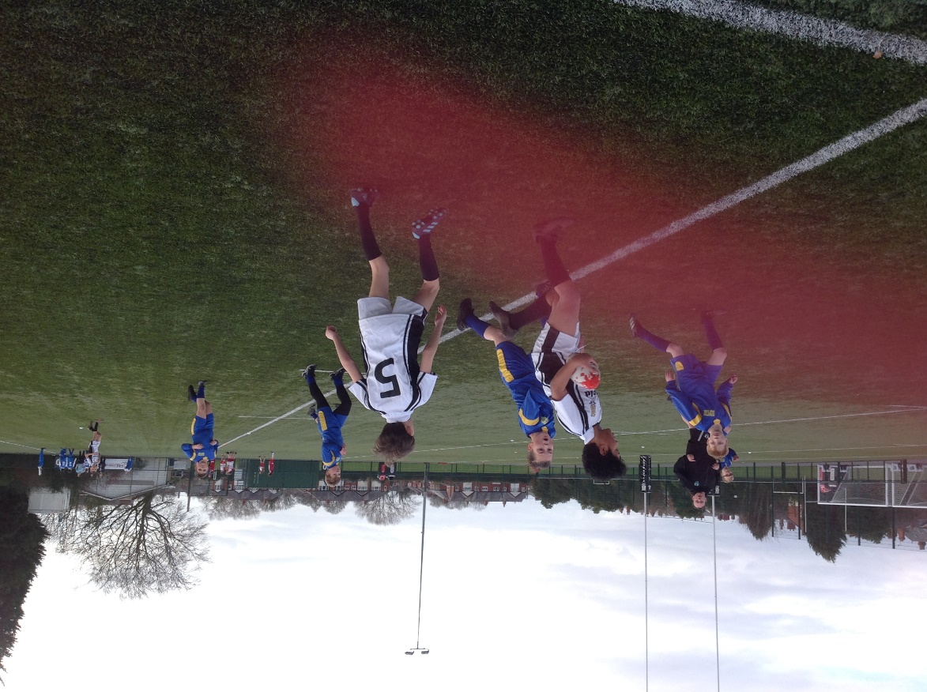
St Annes 0 – Rivington 0 Rivington 0 - St Aidans 0

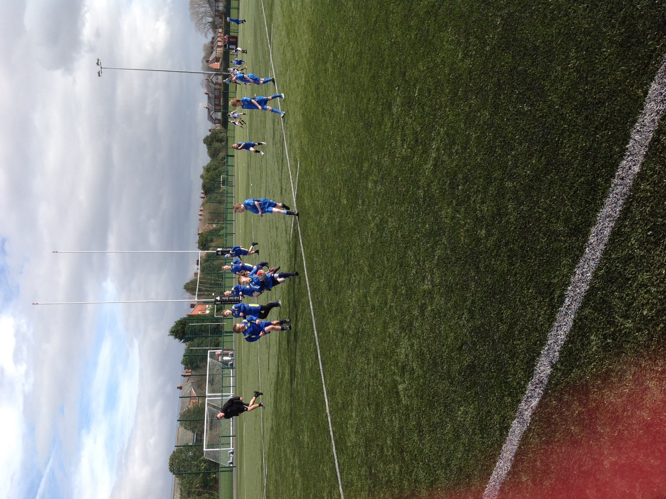

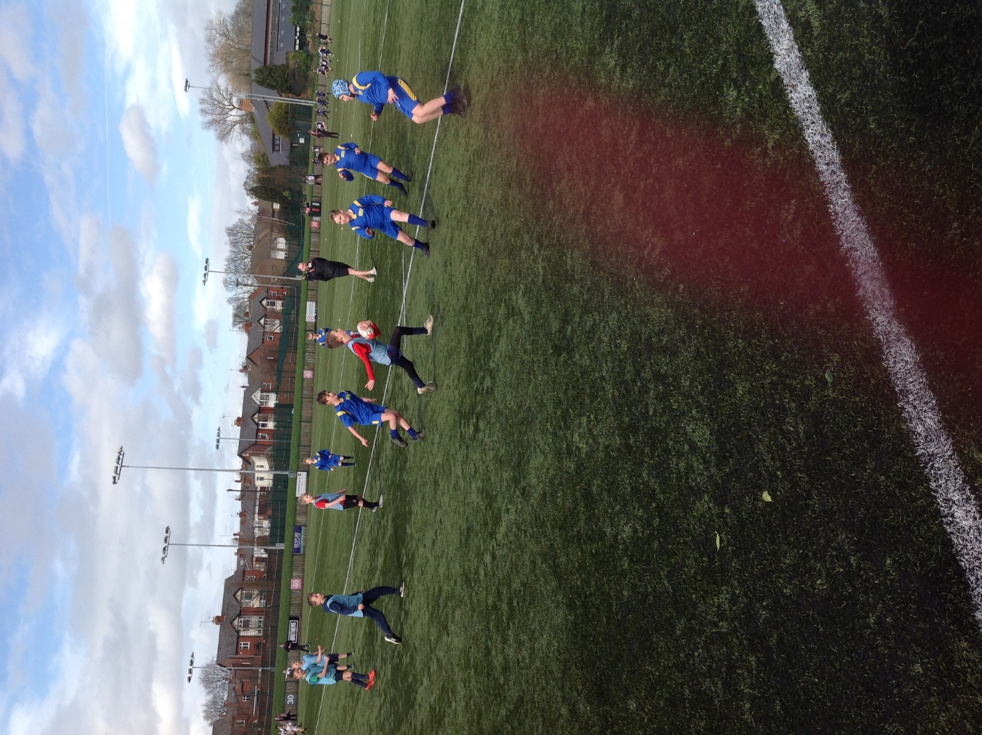

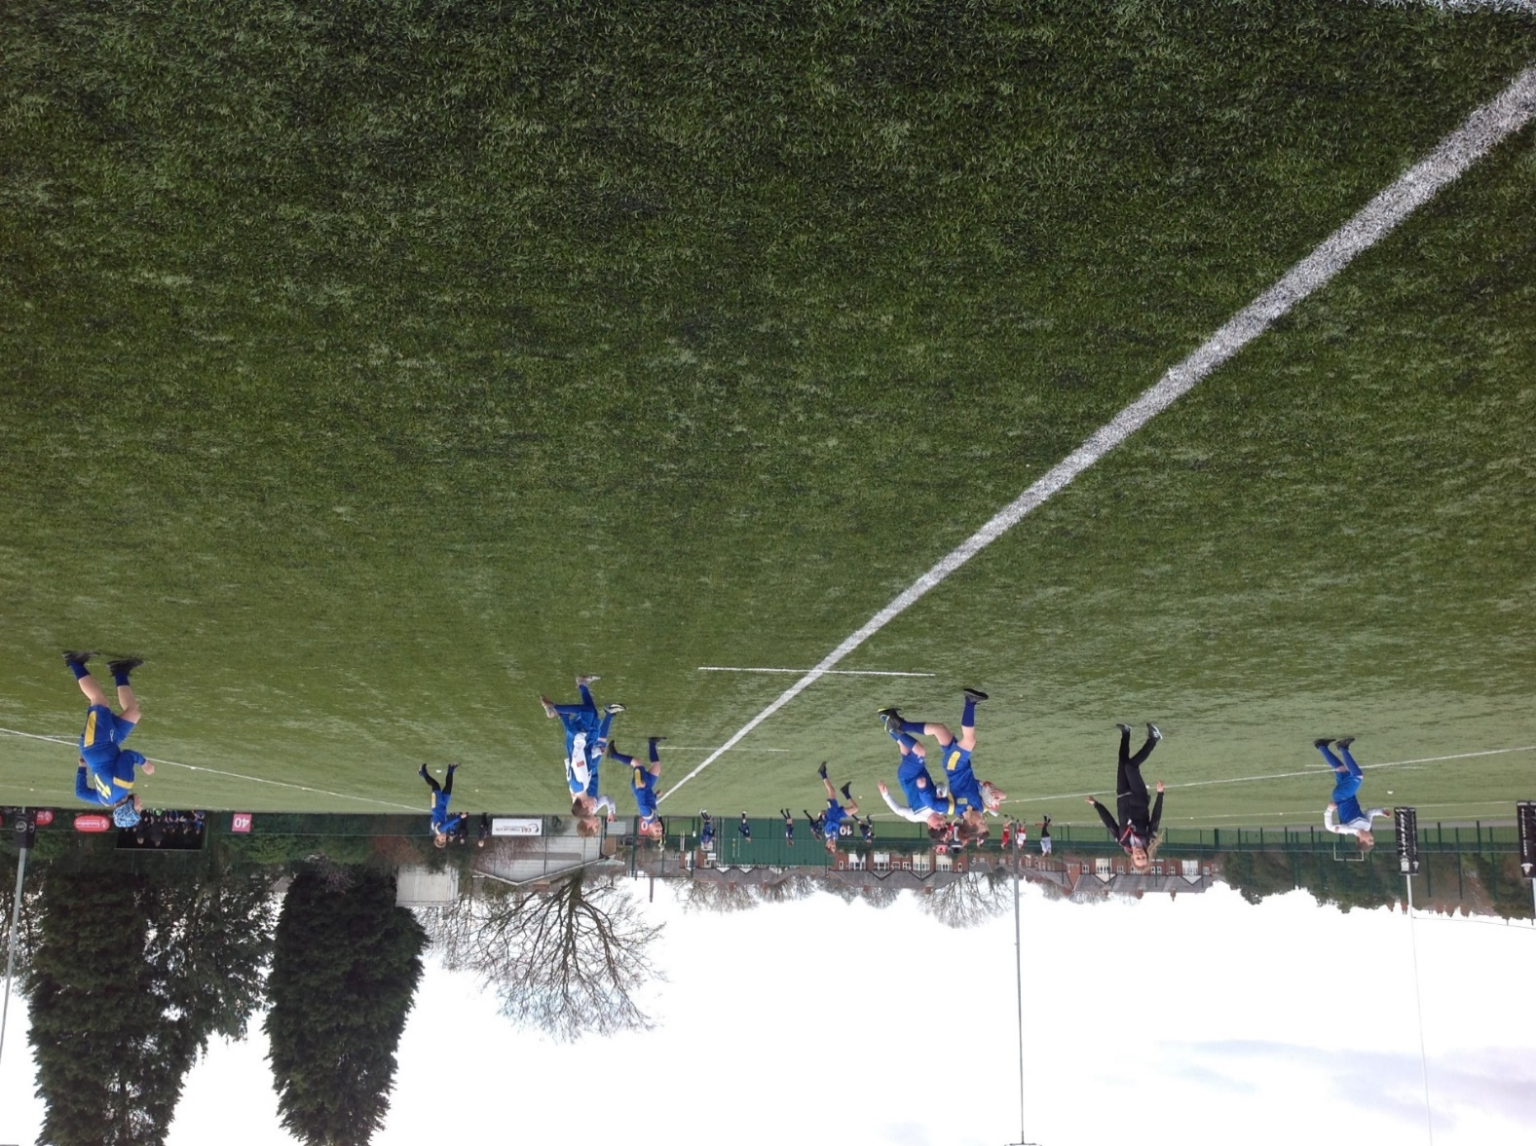
Rivington 3 – Longton Lane 0 Rivington 3 – Wargrave 0

Rivington 1 - St Julies 0

Rivington 3 - Wargrave 0

