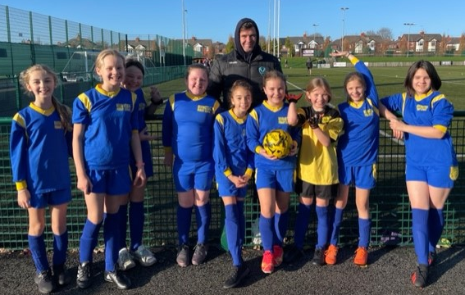
Y5/Y6 Girls’ Football Tournament

Our Y5/Y6 girls’ football team were very excited to participate in their first school tournament of the academic year. The girls’ showed great passion and team work skills, playing against many good teams throughout the afternoon. The team came 2nd in their group, scoring 14 goals in 6 games and only conceding 3! They also won 5 games out of 6, which is an excellent achievement. The highlight of the afternoon for the girls was being congratulated on their football success by one of their local sporting heroes - Paul Wellens the Captain of the Saints Rugby team.
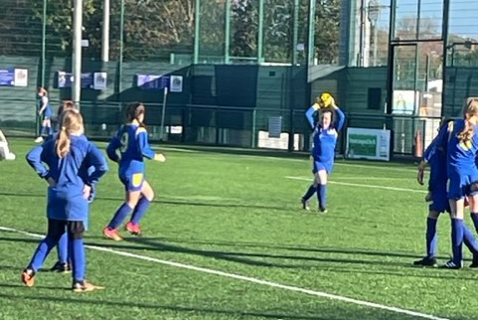
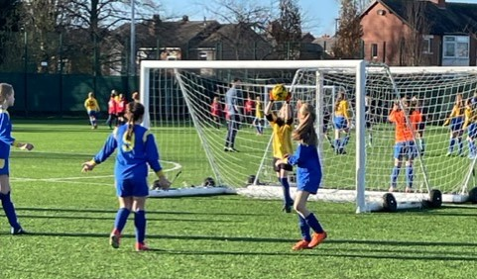
We can't wait to participate in our next girls’ football tournament next term!
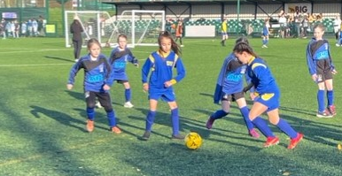
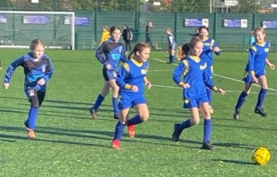

ll

