RIVINGTON PRIMARY SCHOOL
Respect, Protect, Give Thanks, Keep Peace.

Computing Policy



A place where everyone matters!

Revised March 2023
Our vision considers how ICT will contribute towards:
- personalising learning experiences and improving learner engagement
- creating a flexible learning environment so that resources can be accessed whenever and wherever they are needed, including from home
- supporting all staff, through professional development, and providing tools for collaboration, management and administration
- enabling secure and reliable communications between the school and parents, other schools, the local authority and children's services.

Intent

- To teach the children the skills they need to be able to protect themselves when using technology. To know how to report something they feel unhappy or uncomfortable with and what to do if they experience a problem.

- To enable all teaching staff to become confident in the implementation of Computing

- To enable all our children to become confident, competent and enthusiastic users of Computing as they progress through the school.

- To create an environment which is enjoyable, stimulating and challenging, in which the work of children, staff and parents is encouraged and valued.

- To enable our children to appreciate the relevance, usefulness and value of Computing in the world around them.

- To encourage our children to apply their use of Computing to “real life” situations.

- To meet the National Curriculum Requirements as fully as possible and help all children to achieve the highest standard of achievement.

- To encourage the children to make personal choices about when to use Computing to assist with their learning and decide how it could be used appropriately.

- To celebrate success in the use of Computing through display, portfolios and the School Website.

- To track children’s attainment and progress.

Implementation

At Rivington, computing is taught in KS 1 and 2 weekly using the Purple Mash scheme. Within Early Years we recognise the importance of computing and children have the opportunity to develop the skills during child initiated learning time. The scheme maps out progression from Y1-Y6 with detailed plans, assessment resources and pre-recorded CPD, teachers can access before they teach the lesson.

Long Term Plan:
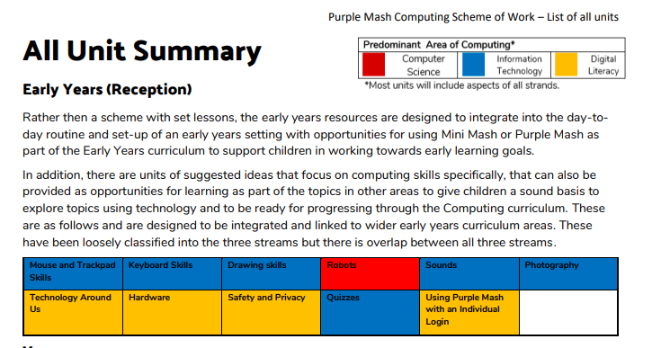
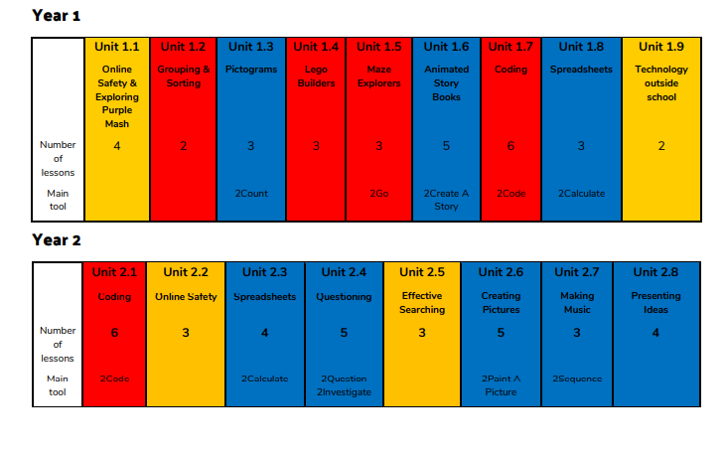
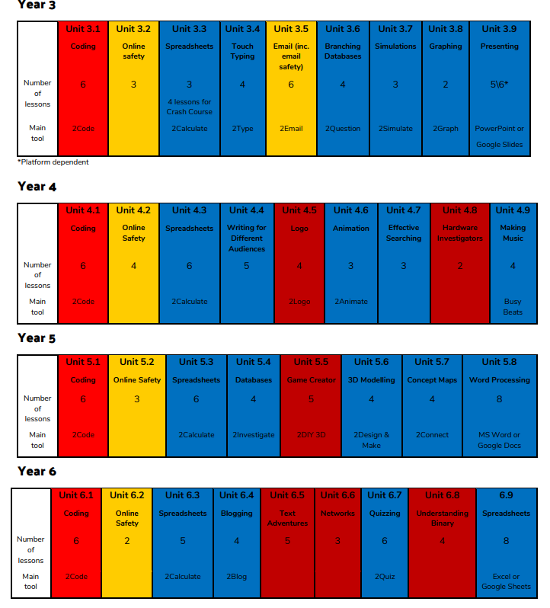
Skills Progression

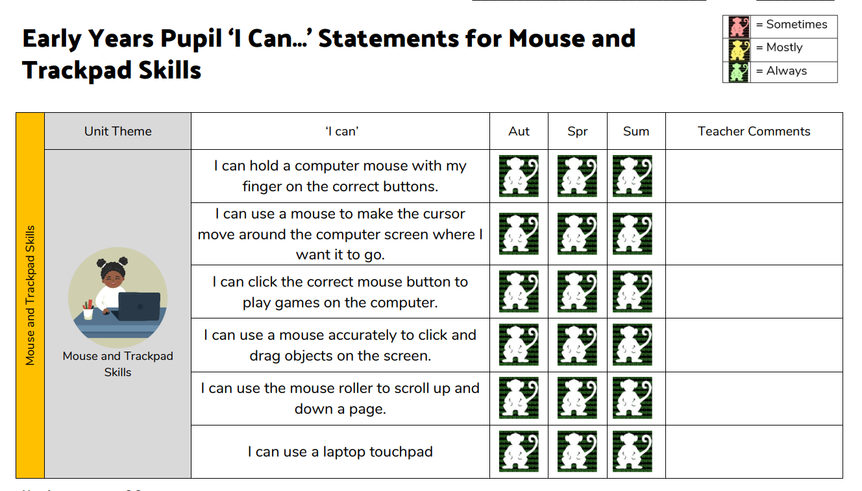
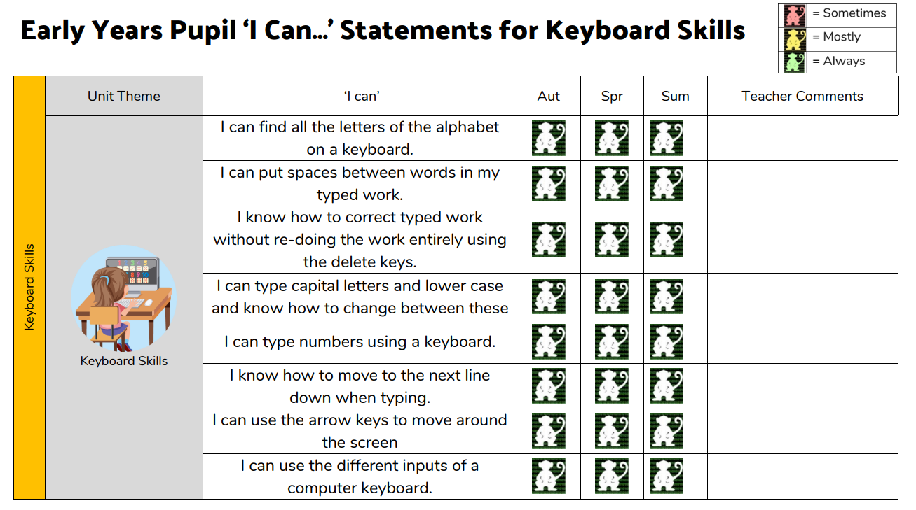
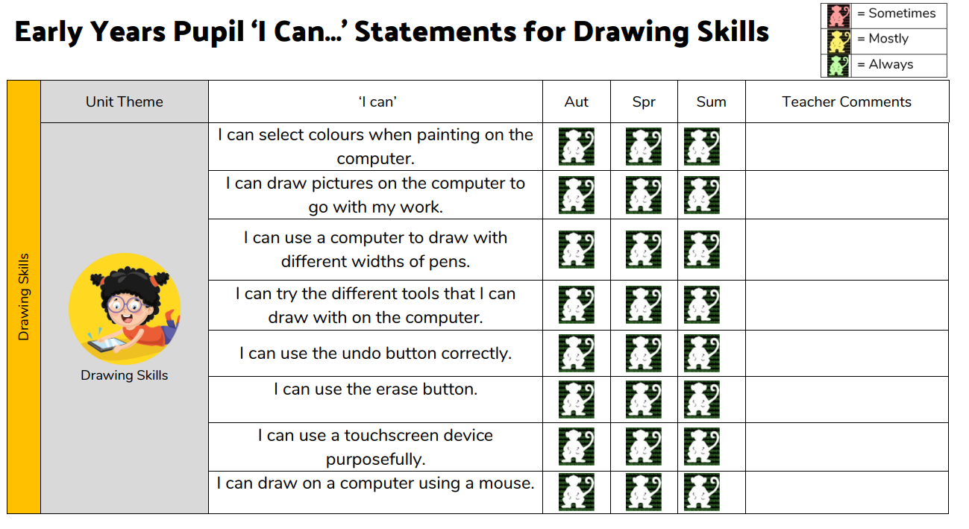
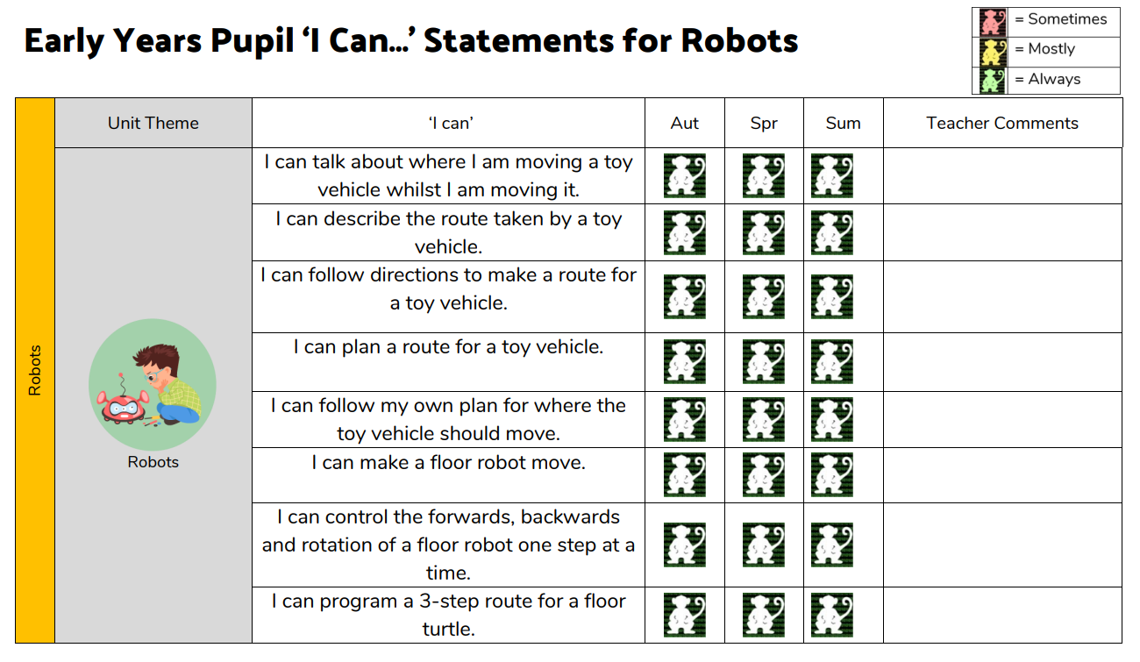
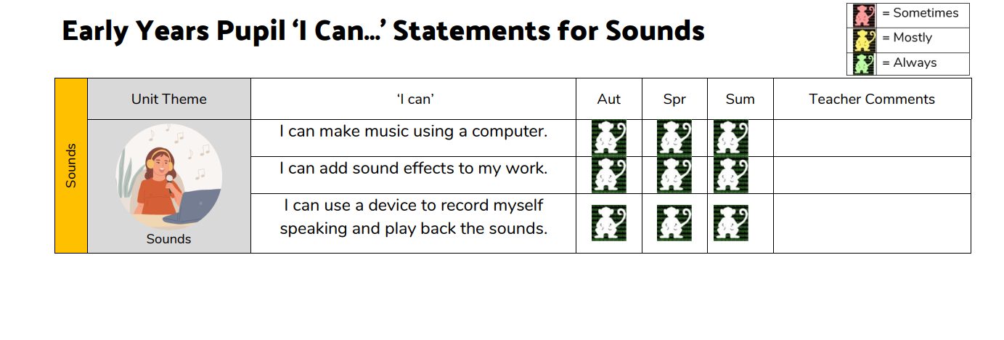
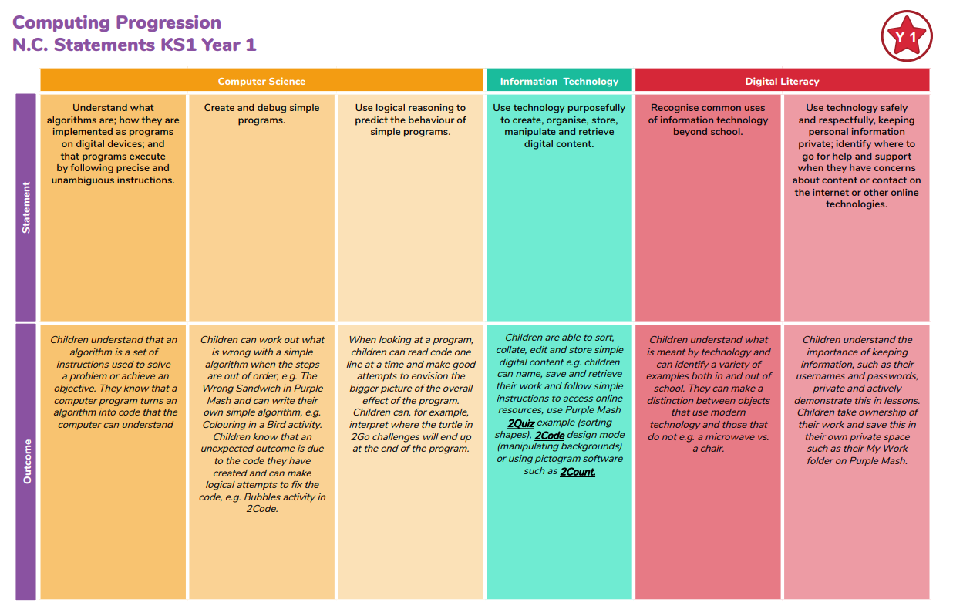

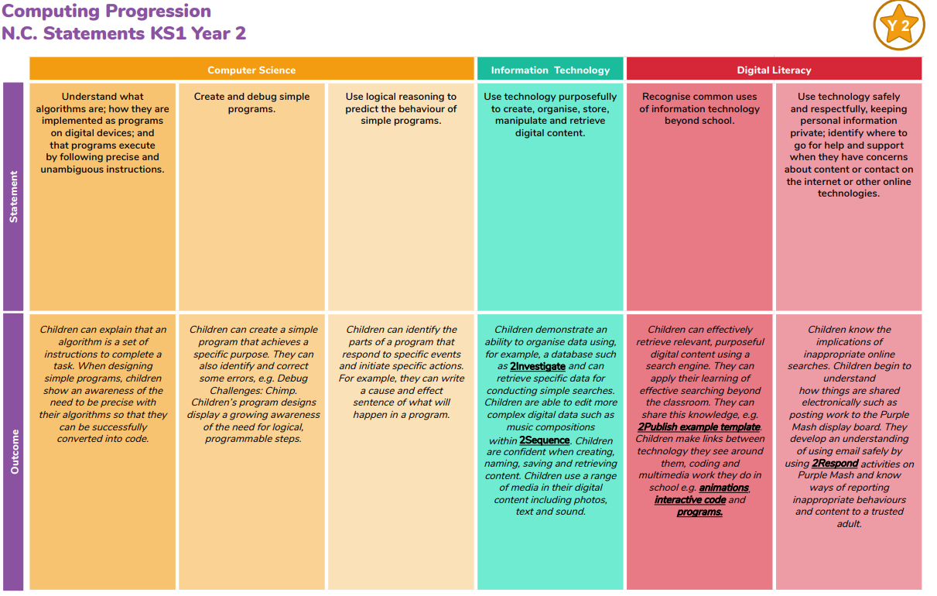

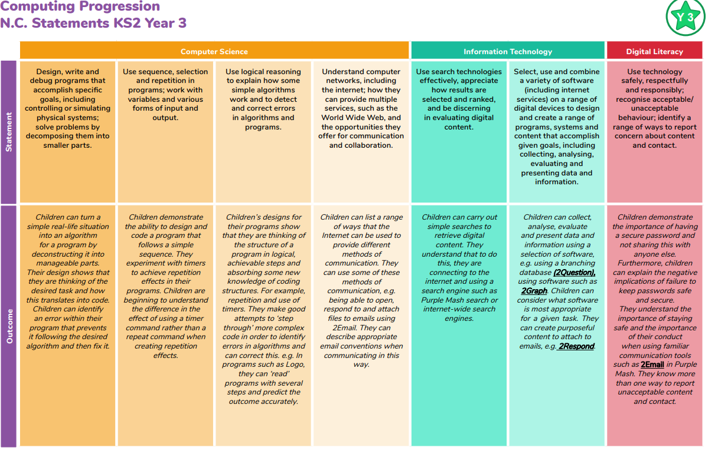
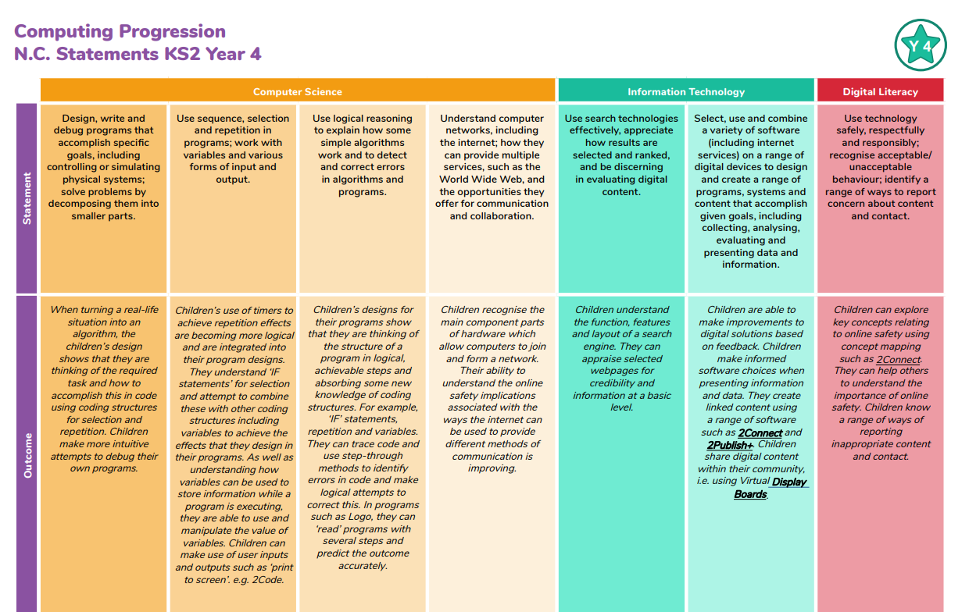

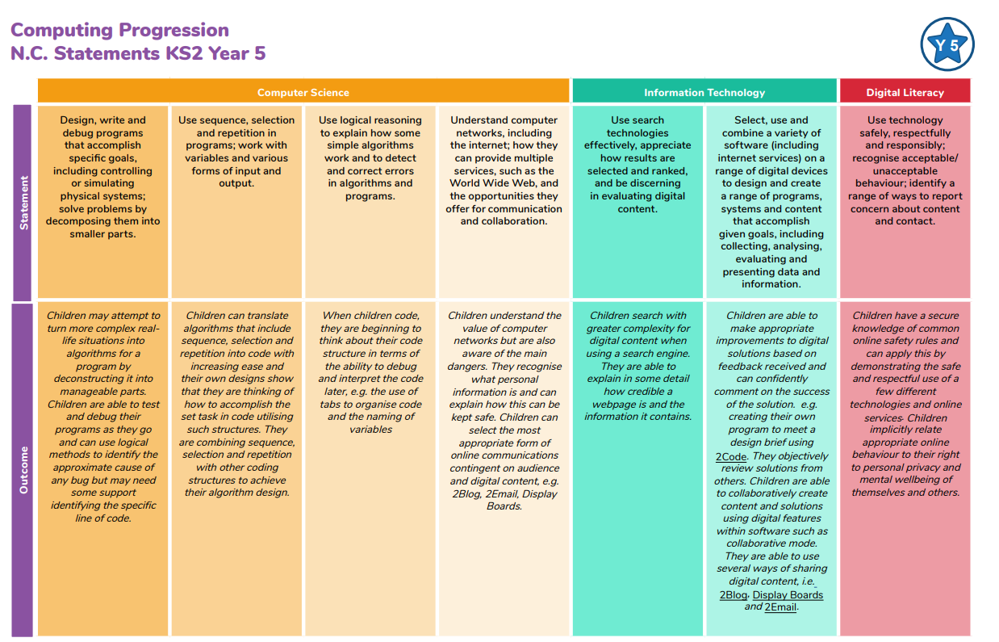

Roles and responsibilities
The governing body
The governing body will approve the Computing policy and hold the Headteacher to account for its implementation.
The Headteacher
The Headteacher is responsible for ensuring that Computing is taught consistently across the school.
Staff
Staff are responsible for:
- Delivering Computing sessions following the Purple Mash scheme.
- Modelling appropriate use of digital technology.
- Monitoring progress
- Responding to the needs of individual children
- Delivering the curriculum without promoting their own personal viewpoint
All teachers are responsible for the teaching of Computing and all teaching assistants are responsible for supporting the teaching of Computing.

Monitoring arrangements
The delivery of Computing is monitored by the Computing Lead, Senior Leadership Team and the governors, through learning walks, pupil interviews and governors meetings. Children’s development in Computing is monitored by class teachers.

Equality
The DfE Guidance 2019 (p. 15) states, “Schools should ensure that the needs of all pupils are appropriately met, and that all pupils understand the importance of equality and respect. Schools must ensure they comply with the relevant provisions of the Equality Act 2010 under which sexual orientation and gender reassignment are amongst the protected characteristics.

SEND
Teachers will plan in different ways and use a variety of teaching strategies to meet the needs of individuals. For some children, particularly those with special educational needs and disabilities, a tailored approach may be necessary to ensure learning outcomes are met – if so, this will be discussed with parents/carers and based upon the individual needs of the pupil.

Resources
We have number of Computing books and dictionaries in school which can be supplemented by loans from the Schools Library Service. There are also a number of role play boxes which contain items that can support learning about Computing through an active learning approach.

