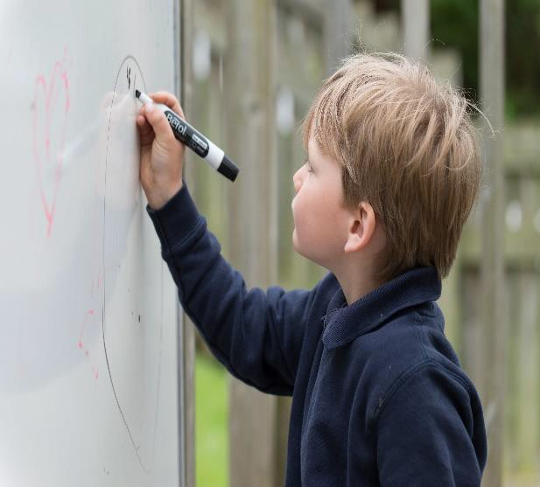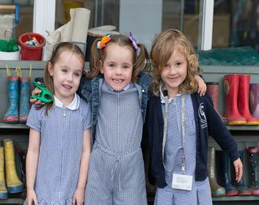EYFS Policy & Philosophy
Rivington Primary School EYFS
This document provides an overview of the policy, philosophy and practice in the EYFS at Rivington Primary School. It outlines our intentions and how we implement this within our provision.
At Rivington Primary School, we are committed to providing a caring and stimulating environment in which every child is valued and can thrive.
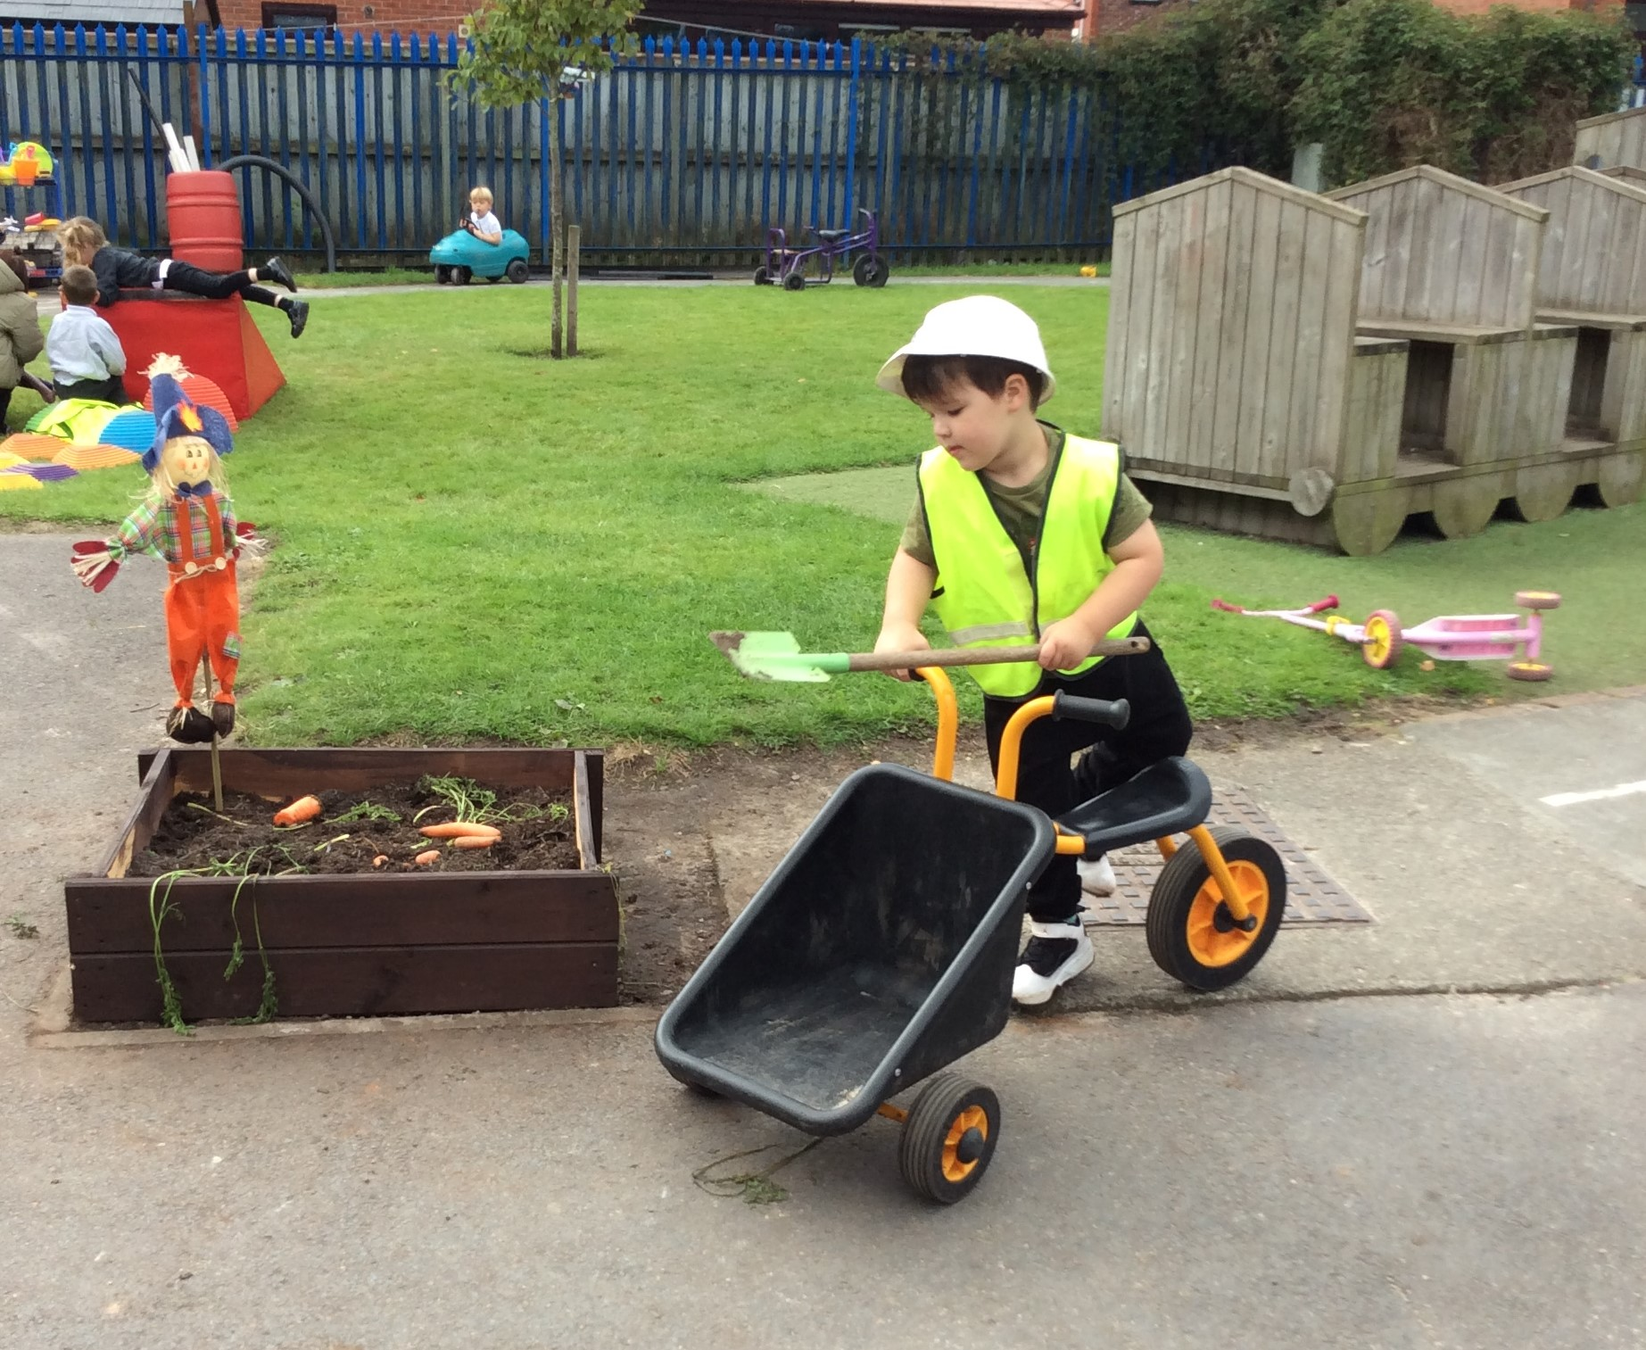
Our philosophy is to nurture every child as an individual, recognising and valuing their unique qualities and abilities, in order to support their learning and exploration at this wonderful stage.

Intent

The intent for our children is to feel safe, happy and eager to learn. At Rivington, we CARE.
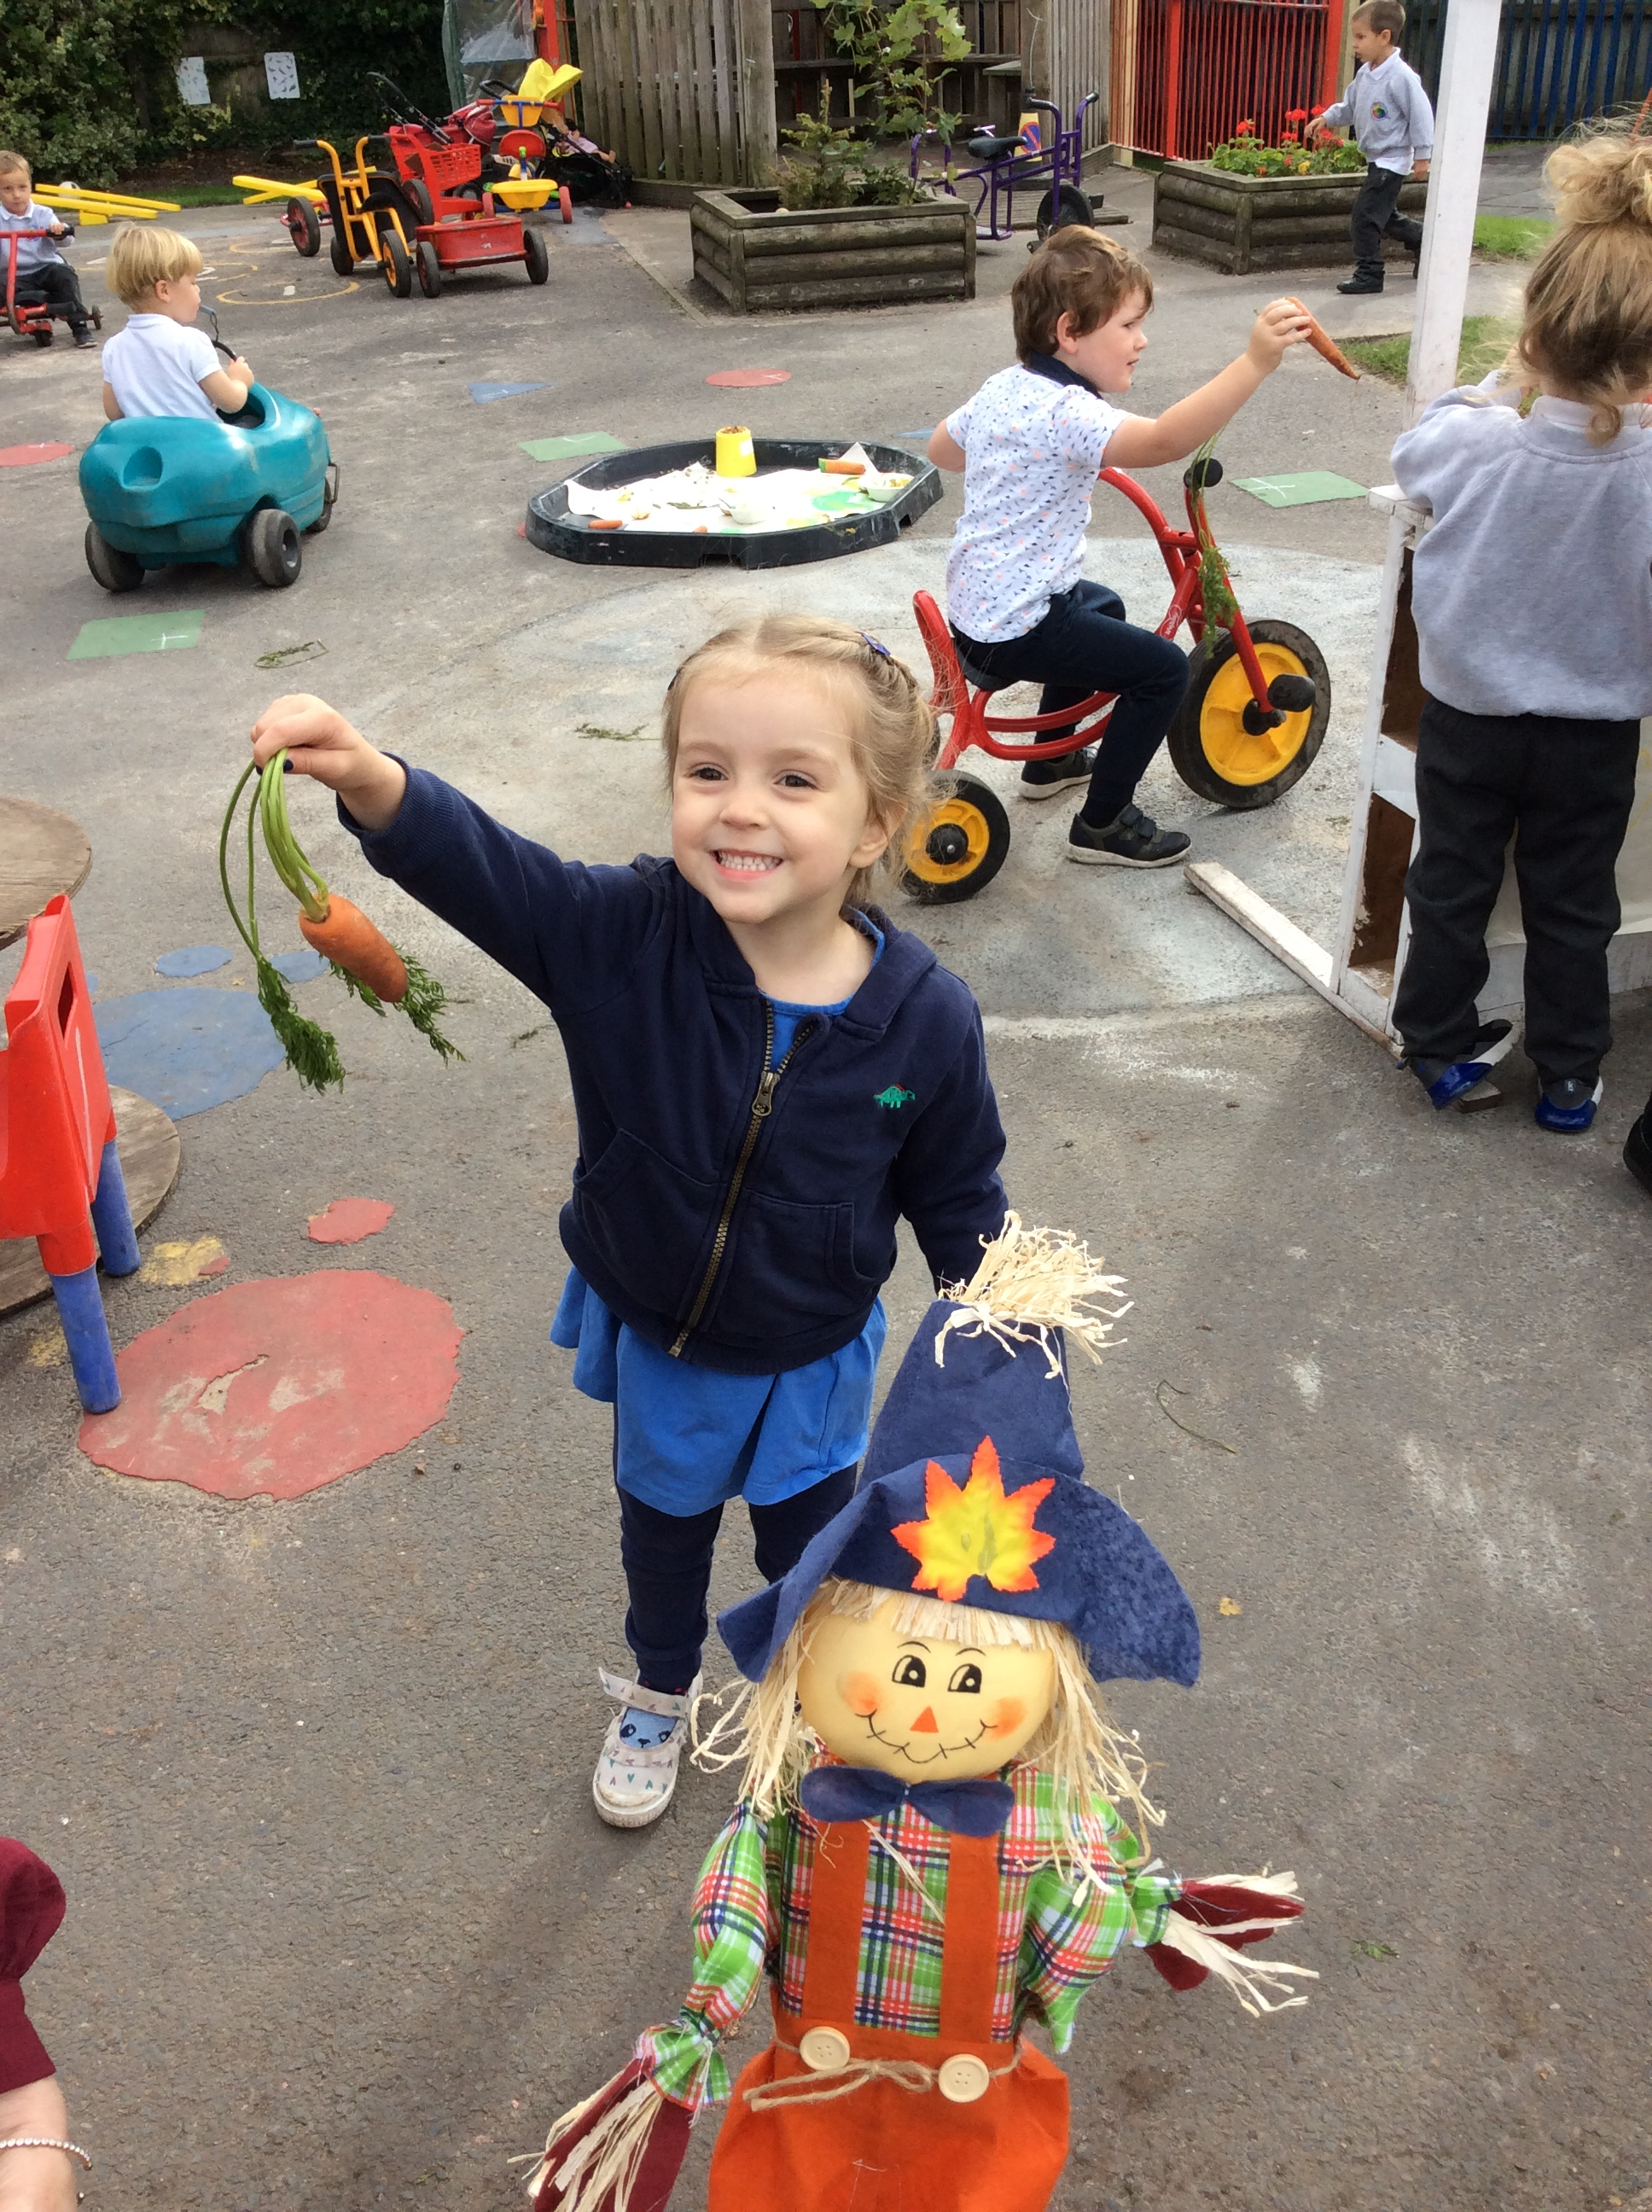
COMMUNICATION – we strive for children to be able to communicate effectively and express themselves with confidence, sharing their thoughts, ideas and feelings with the knowledge that they will be listened to and understood.
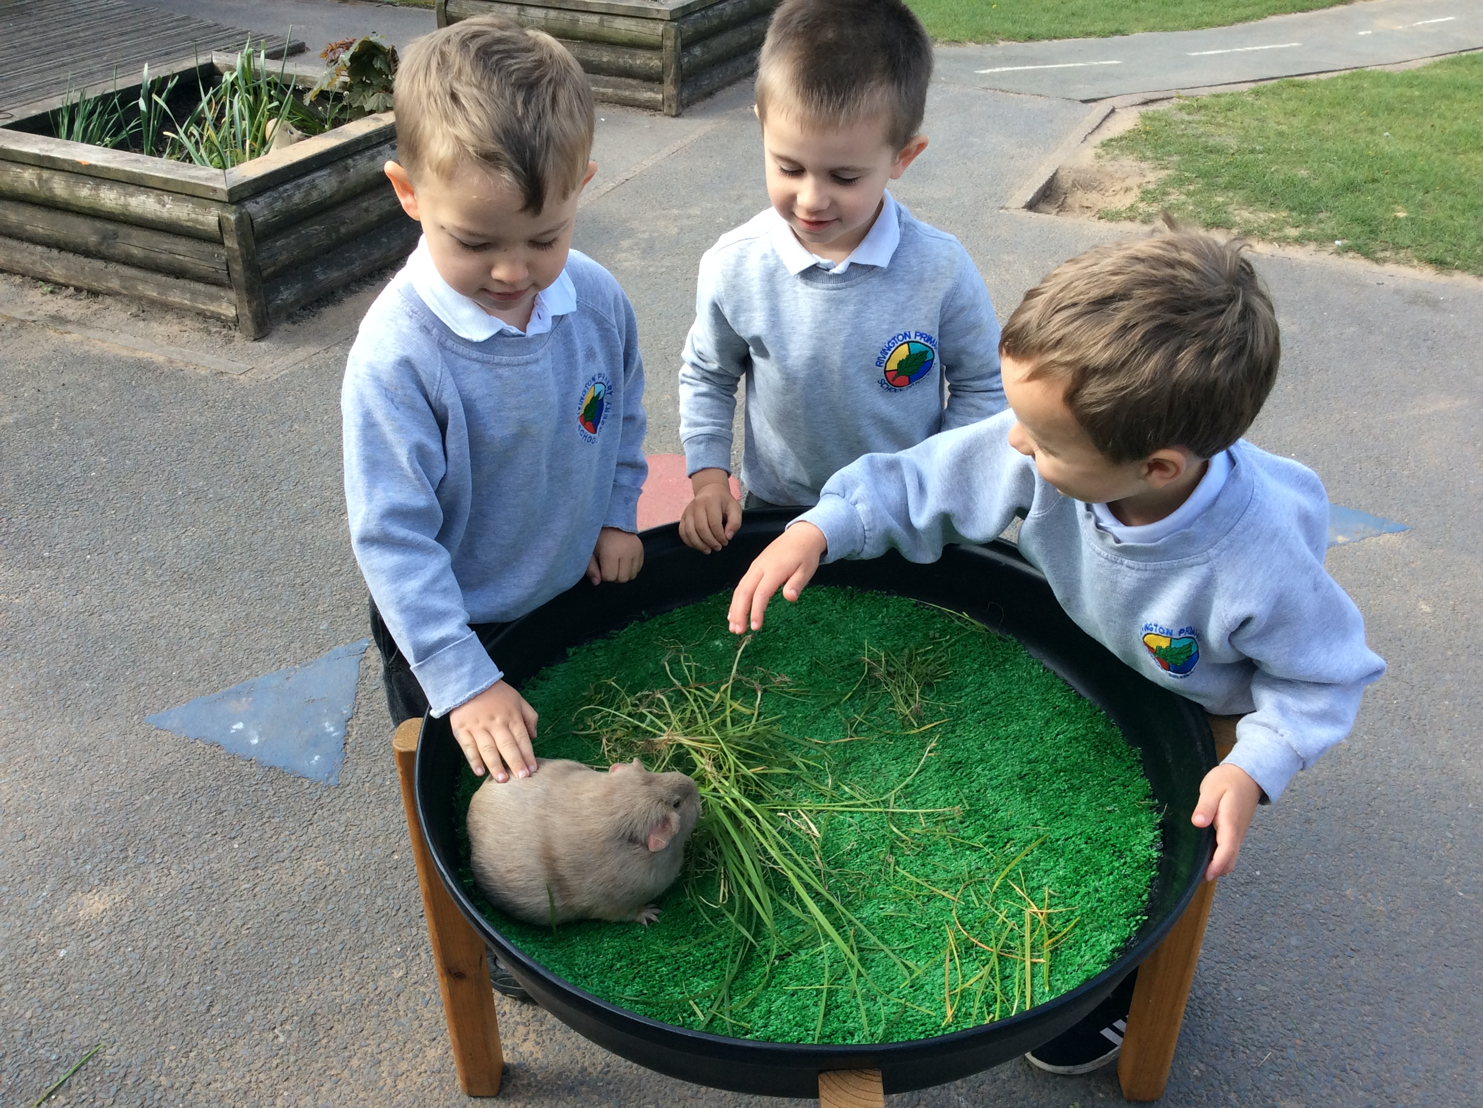
ASPIRATION – developmentally appropriate and ambitious planning, responsive to individuals and group dynamics, and an approach which inspires and challenges children’s inquisitive minds is taken by all adults.
RESPECT – we aim for children and families to feel recognised and valued as individuals and as part of our community. We focus on children’s understanding of what it means to respect – each other and our environment.
“The education of even a very small child does not aim at preparing him for school but for life”
Maria Montessori, 1967
EXPERIENCES – we aim for children to gain first-hand experiences to ignite their curiosity and embed their learning. We encourage children to independently access resources, develop their own play and ask for help, confident in the knowledge that they can co-construct their own learning environment and opportunities.

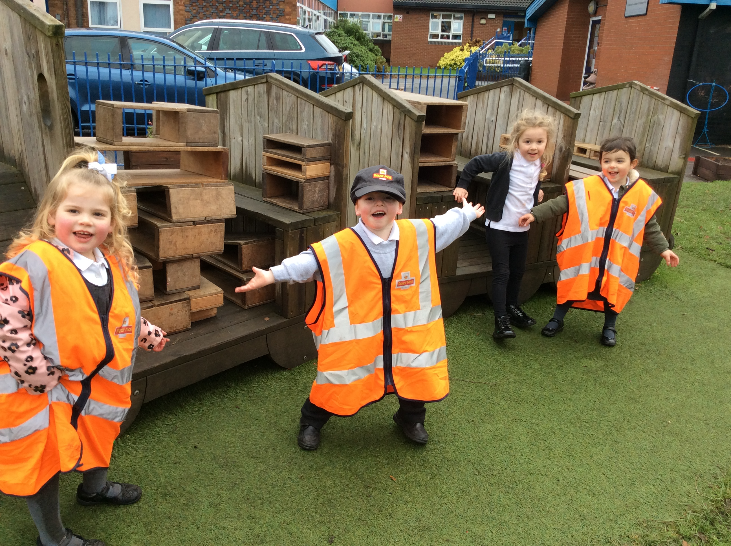

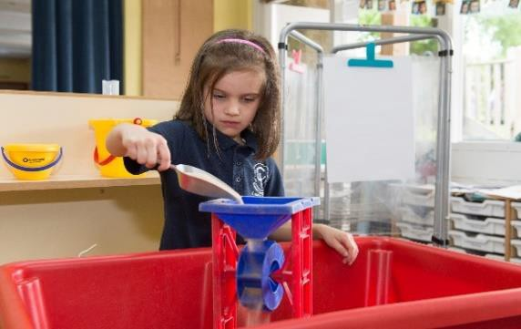Whole Class Input
“Young children learn from those they trust and with those who foster enthusiasm for learning.”
Trevarthen, 2002

Implementation

Our approach is influenced by the work of educationalists, researchers, psychologists and practitioners who have influenced our practice and shaped our perspective on early years education.
At Rivington, our provision is underpinned by a complementary relationship between adult led and child led learning, allowing for flexibility based on the needs of the children and the group.
Our long-term planning is based on an ambitious structure of high quality texts alongside topics which we consider to be essential foundations for our children. The documents ‘Development Matters’ 2021 and ‘Birth to 5 Matters’ inform our medium term plans to ensure developmentally appropriate and challenging opportunities for all.
We engage in a continuous cycle of observation and assessment, planning/teaching, alongside structured and systematic lessons and guided group work.

Short focused activities are planned for reading, writing and mathematics each week. They are planned to meet specific objectives to move children on in their learning and provide individualised support, ensuring that all children receive regular feedback related to these core areas.
Nursery Timetable
AM |  | PM
8:40 | Self-register. Indoor continuous provision. | 12:30
9:30 | Tidy  Literacy | 12:50
9:50 | Free flow continuous provision  Snack bar: 10-11am | 1:10
11:15 | Tidy  Mathematics/Phonics | 3
11:40 | Home time  Lunch time | 3:30

Reception Timetable
8:40 | Self-register. Indoor continuous provision.
9:10 | Phonics
9:40 | Free flow continuous provision
10:20 | Snack
10:40 | Literacy
11 | Literacy groups/continuous provision
11:30 | Whole class singing/poetry/reflection
11:45 | Lunch
1 | Register  Mathematics
1:20 | Free flow continuous provision  Open snack bar
2:50 | Story/reflection
3:20 | Home time

Shared Input
Four times a day as a whole class covering the specific areas of literacy, mathematics and topic-based learning. Singing and poetry occurs at some point in each day and a story session ends every day.

Continuous Provision
Children take an active role in their learning through making choices about where they play and what they want to play. Outdoor and indoor resources are organised to reflect children’s interests and levels of development, as well as including provocations to inspire and motivate children. The areas are planned and reviewed with the aim of developing children’s independent exploration skills and are linked to assessment data.
Continuous provision transcends all areas of learning and provides opportunities for children to develop their characteristics of effective learning. Children are encouraged to be co-constructors of their learning through taking an active role in their play.
Focus Time
Short focused activities are planned to meet specific needs of the group and individual children. For example, ‘Funky Fingers’, yoga, ‘Wake up and Shake up’.

- The Leuven scales
“High-level attainment comes from high-level engagement.”
Alistair Bryce-Clegg, 2015
Alongside the use of observation as an assessment tool we also rely upon the pioneering work of Professor Ferre Laevers (1980s) to understand how focused and comfortable the children are in our
A continuous cycle of observation, assessment and planning is embedded throughout our EYFS provision.

Start here
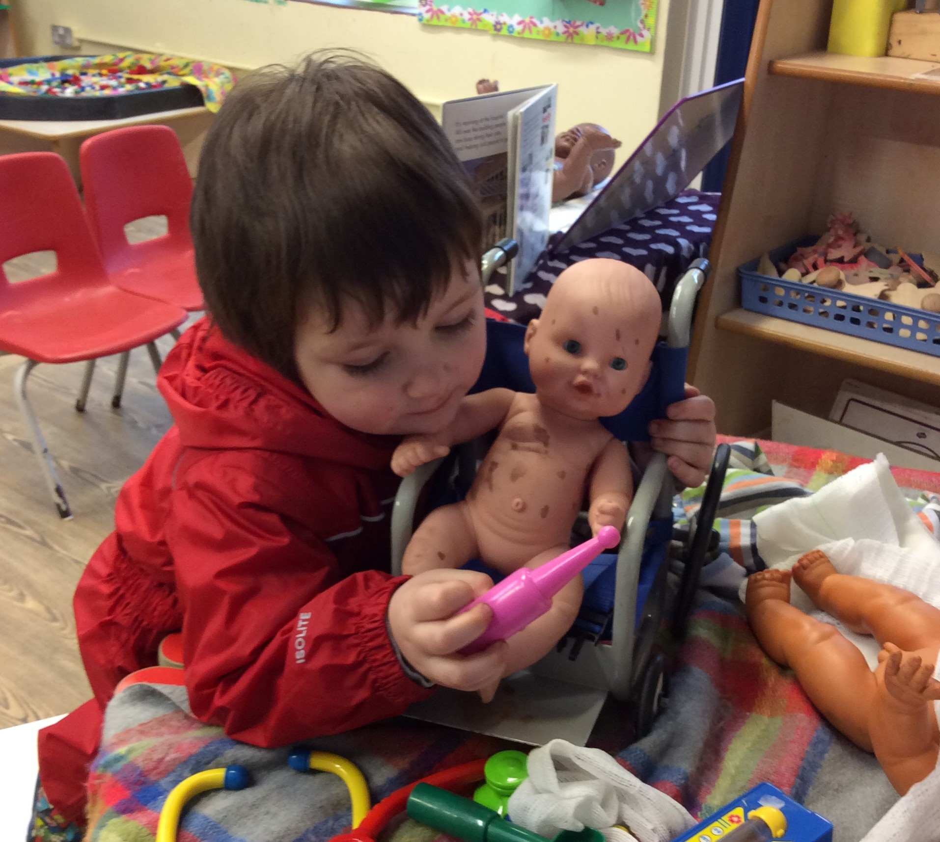

Assessment
Within continuous provision our assessment strategy is 3-fold.

Observation
Throughout ‘continuous provision’ observation forms a fundamental aspect of the pedagogy of EYFS at Rivington Primary School.
“Young children demonstrate language, mathematics, science, creativity, physicality – sometimes all within one activity – and the task of the practitioner is to make sense of what is seen,
to recognise any significant steps in learning that
setting.
The scales of well-being and involvement act as a measure of deep learning and of the effectiveness of the learning environment. This has an empowering impact on our planning and can help to develop the huge potential of the children.

Planning
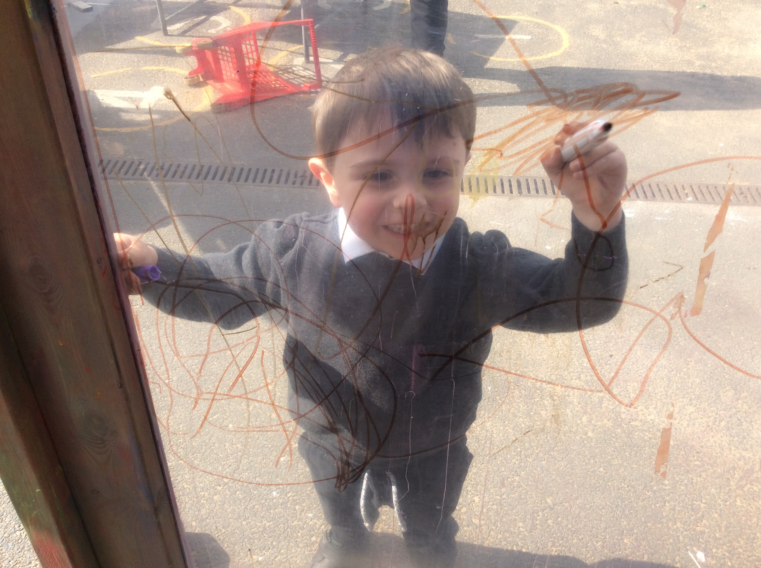
What next? Experiences and opportunities, learning environment, resources, routin practitioner’s role.

Assessment
Analysing observations and deciding what they tell us about children.

Observation
Look, listen and note Describing

es,

may have taken place and to identify where help and support are needed to make further progress” Jan Dubiel, 2014
Observation and responding to children’s thinking inform our planning of experiences and opportunities, how we create our environment for thinking, the strategies the adults use to extend learning (modelling, scaffolding, questioning, discussion, shared sustained thinking) and how we capitalise knowledge of children’s interests to ensure high levels of engagement.
All adults look out for significant moments in a child’s development and contribute to their profile to track their progress.

The 5-point scale measures:
Well Being refers to feeling at ease, being spontaneous and free of emotional tensions and is crucial to good mental health. It is linked to self- confidence, a good degree of self-esteem and resilience.
Involvement refers to being intensely engaged in activities and is a necessary condition for deep level learning and development.

Summative Assessments

In addition to the continuous cycle of observation and formative assessment which informs each child’s next steps, summative assessments are carried out for phonic development and an assessment of each child’s stage of development for each of the 7 areas of learning. These take place termly and informs planning of subsequent teaching and learning.

“The goal of early childhood education should be to activate the child’s own natural desire to learn.” Maria Montessori.

The role of the adult
Research shows that progress will be significantly enhanced by the effective support and role models of adults within a high-quality learning environment.
At Rivington, the role of the adult particularly during continuous provision is crucial.
Within our setting interactions between children and adults will look like this:
  - Tuning in to what is happening or a
child’s thinking.
  - Showing genuine interest.
  - Respecting children’s own decisions
and choices.
  - Inviting children to elaborate.
  - Recapping on what has happened so far.
  - Offering personal experience.
  - Clarifying ideas.
  - Reminding.
    - Using specific praise e.g. that is a good
idea because…
    - Offering an alternative viewpoint.
    - Speculating/ using ‘I wonder if…’
The definition of teaching in the Early Years as stated by OFSTED (2015);
Teaching should not be taken to imply a ‘top down’ or formal way of working. It is a broad term which covers the many ways in which adults help young children learn. It includes their interactions with children during planned and child-initiated play and activities:
communicating and modelling language, showing, explaining, demonstrating, exploring ideas, encouraging, questioning, recalling, providing a narrative for what they are doing, facilitating and setting challenges.
It takes account of the equipment they provide and the attention to the physical environment as well as the structure and routines of the day that establish expectations. Integral to teaching is how practitioners assess what children know, understand and can do as well as take account of their interests and dispositions to learning (characteristics of effective learning), and use this information to plan children’s next steps in learning and monitor their progress.

Interact, don’t interfere.

“A key role of the early childhood educator is to sustain children’s thinking and follow the momentum of their learning.” Julie Fisher, 2016.

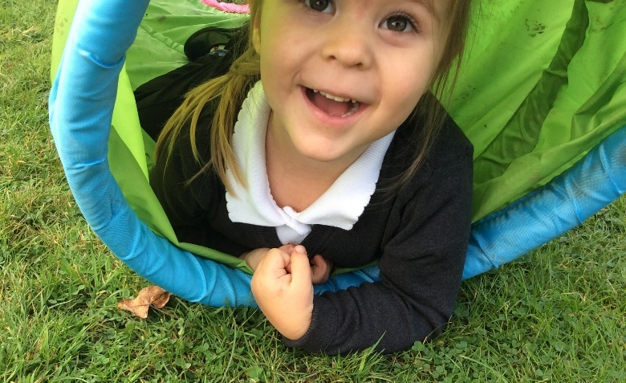

The role of the environment
The importance of each adult to support progression is crucial however, we equally understand that in times when a child is on their own independent learning journey the environment plays a significant role in development.
At Rivington each area of the classroom is informed by assessment. As the needs of the children change, as they grow and develop, so does their learning space.
Using resources that are open ended encourage creativity, imagination and high order thinking skills. For example, the workshop may contain ribbon, lace, pinecones or lolly sticks. Outside role play is deconstructed with access to logs, planks, sheets and tyres. These resources can become anything and have unlimited potential.
Our timetable allows for long uninterrupted periods of continuous provision that allow the children time to reach a deep level of involvement as they engage, play, investigate and talk.

4. Children develop and learn at different rates. The framework covers the education and care of all children in early years provision, including children with special educational needs and disabilities (SEND).
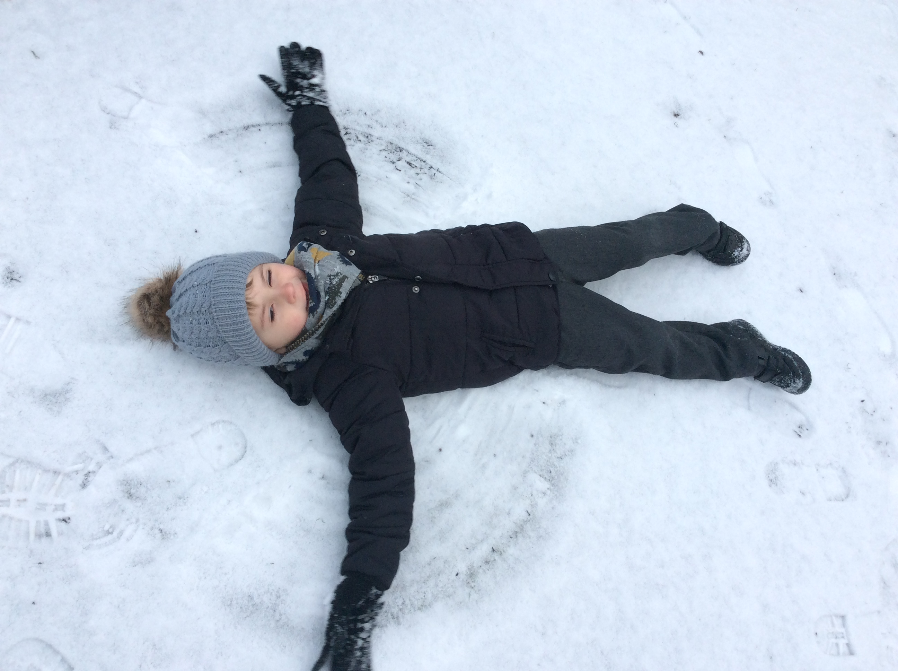
understanding the world
If a child cannot learn the way we teach, we must teach in a way the child can learn.
- expressive arts and design
Throughout their time in our Foundation Stage our children partake in an ambitious curriculum which is designed in a sequential way to ensure progress and challenge. At the end of YR, the children are assessed against statements known as Early Learning Goals (ELGs). The descriptors for these can be found in the appendix.

Early Years Foundation Stage 2021
At Rivington Primary we follow the EYFS statutory framework. Within this framework there are four guiding principles which shape are practice.
These are:
1. Every child is a unique child, who is constantly learning and can be resilient, capable, confident, and self-assured.
2. Children learn to be strong and independent through positive relationships.
3. Children learn and develop well in enabling environments with teaching and support from adults, who respond to their individual interests and needs and help them to build their learning over time. Children benefit from a strong partnership between practitioners and parents and/or carers.

EYFS learning and development requirements
Our curriculum encompasses seven areas of learning and development. All areas of learning and development are important and inter- connected.
Three areas are particularly important for building a foundation for igniting children’s curiosity and enthusiasm for learning, forming relationships, and thriving.
These are called the prime areas:
- communication and language
- physical development
- personal, social, and emotional development.
Four areas help children to strengthen and apply the prime areas.
These are called the specific areas:
- literacy
- mathematics
As previously outlined our curriculum incorporates learning through play, learning by adults modelling, by observing each other and through guided learning and direct teaching. It is also important to highlight that our plans are flexible to allow us to respond quickly to children’s new interests and/or needs.
Weaving throughout the EYFS curriculum at Rivington are three Characteristics of Effective Learning.
  - playing and exploring - children investigate and
experience things, and ‘have a go’
  - active learning - children concentrate and keep on trying if they encounter difficulties, and enjoy achievements
  - creating and thinking critically - children have and develop their own ideas, make links between ideas, and develop strategies for doing things
These elements underpin how we reflect on each child’s development and adjust our practice accordingly. Supporting children in their individual learning behaviour and observing the context of children’s play is essential.

‘What children learn is important, but how children learn is even more important if they are to become learners in today’s society.’ Helen Moylett
How Children Learn, Nancy Stewart (2011

    - 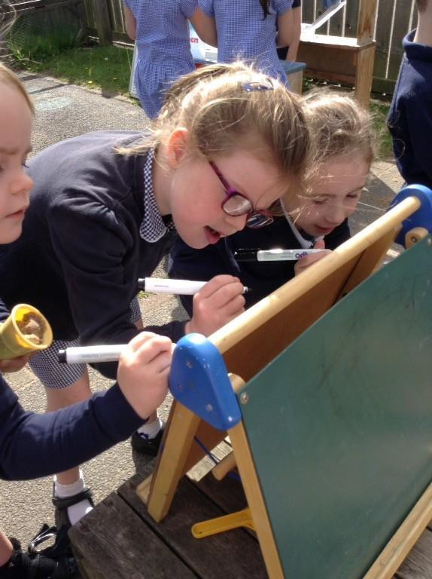Body percussion (e.g. clapping and stamping)
    - Rhythm and rhyme
    - Alliteration
    - Voice sounds
    - Oral blending and segmenting (e.g. hearing that d-o-g makes ‘dog’)

Typical activities for teaching Phase 1 phonics include 'listening' walks, playing and identifying instruments, action songs, learning rhymes and playing games like I Spy. This phase is intended to develop children’s listening, vocabulary and speaking skills.
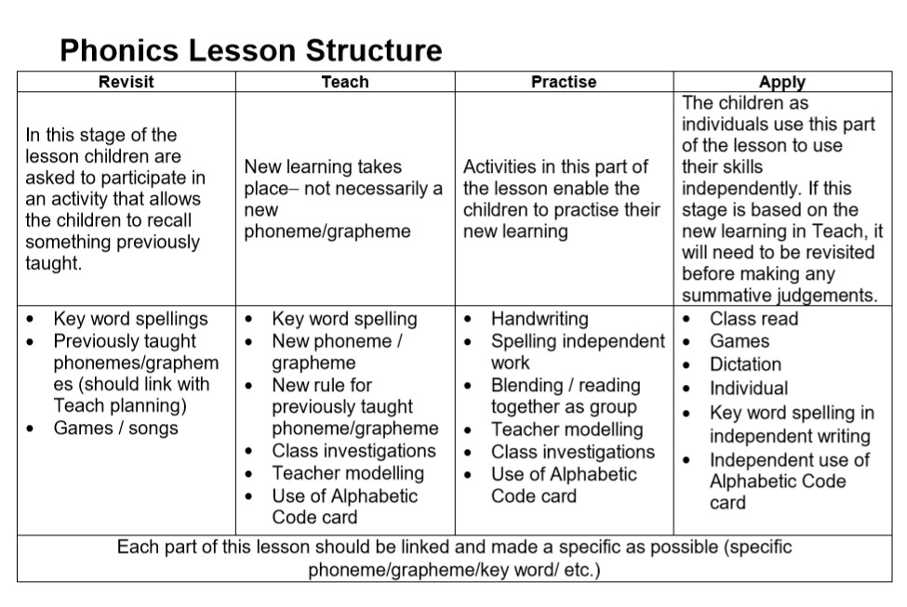Teaching letter-sound correspondences commences in Reception. Every phonics lesson incorporates the reading and writing of common exception and high frequency words.
Beginning in Reception children are taught how to segment words into syllables and then how to segment and blend each syllable using FRED talk (a frog who can only say the sounds in words).
Formative assessment takes place during all phonics lessons, quickly identifying who has and has not understood a new phoneme or grapheme or common exception word, informing future planning. Summative assessment takes place half-termly in Reception for targeted individuals.
Knowledge of each sound is checked, as well as the child being able to apply this when reading words. Pupils who are making slow progress are identified quickly and intervention is immediately put into place, alongside the usual phonics teaching.
Each phonics session is 20 minutes in duration and follows a teaching sequence which is implemented throughout the school ensuring transition to Key Stage 1 is seamless.

Reading at Rivington

Phonics
Systematic synthetic phonics is taught using Read Write inc. Small group phonics sessions are taught in Reception. Phase 1 phonics based on Letters and Sounds is incorporated throughout the Foundation Stage.
In Phase 1 phonics, children are taught about:
- Environmental sounds
- Instrumental sounds

Shared exploration of language
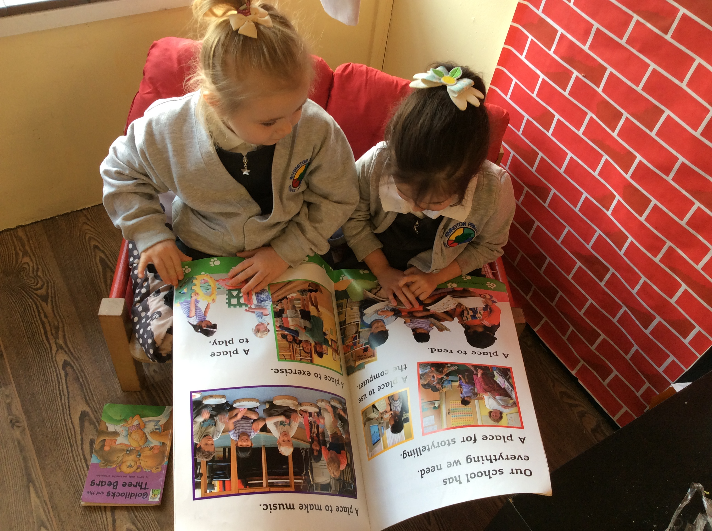
At Rivington, we believe the key to success in reading is communication. Research clearly shows that the level of development in language and communication is the greatest predictor of success in later life.
Within the EYFS communication and language development is a prime area of learning.

The million-word gap

Young children who are read five books a day by the age of 5 have heard about 1.4 million more words than children who were never read to.
Ohio State University, 2019

At school children use language to:
  - Build strong relationships.
  - Communicate their ideas and their feelings.
  - Think creatively and critically.
  - As a tool for learning.
  - Become confident with the written word.
(Julie Fisher, 2016)

The development of a young child’s communication and language comes primarily from tuning in to conversations that are meaningful to the child.
The preparation for all aspects of written language develops through one to one conversation with a responsive adult.
Alongside quality interactions, rich and varied experiences ensure language provides the foundation of thinking and learning.
“it is through others that we develop into ourselves”
Lev Vygotsky, 1981

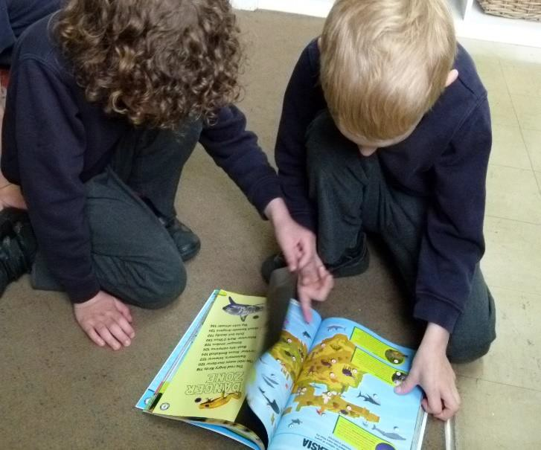Improving young children’s vocabulary is paramount. Exploring and extending pupils’ vocabulary is part of everyday teaching. Lessons are planned to enrich vocabulary and incidental opportunities are exploited. Vocabulary is discussed with the intention of building background knowledge so pupils can comprehend the content of a text.

Shared reading
Texts are shared as a whole class daily. ‘Shared Reading’ is a recognised strategy for teaching reading in which pupils and teacher read a text together with a focus on a specific aspect. Through experiencing a variety of texts, fiction and non- fiction, children will become aware of the range of strategies required when reading for different purposes.

Continuous Provision
At Rivington, we provide books in all areas and model accessing books for a purpose as well as for pleasure, sharing stories throughout the day.
We share books with children for many reasons: enjoying stories together, linking with personal experiences, vocabulary building, developing imagination and language, learning about books. Listening to stories being read and re- read helps children to gain insights into meaning and story structure.

Guided reading
Guided group reading takes place weekly and texts are carefully chosen by staff to match the phonemes pupils are learning or about to learn. Common exception words and high frequency words are introduced and reinforced regularly.

Individual reading
Encouraging reading for pleasure is part of our school vision to create learners for life.
All children have their own individual reading books; one phonetically decodable and one library book. Children select books from a wide range of genres including picture books, non-fiction information books and poetry. If needed, staff will guide pupils towards a suitable selection of a home reading book. Reading progress is monitored through use of Tapestry and class reading challenges are frequently used.

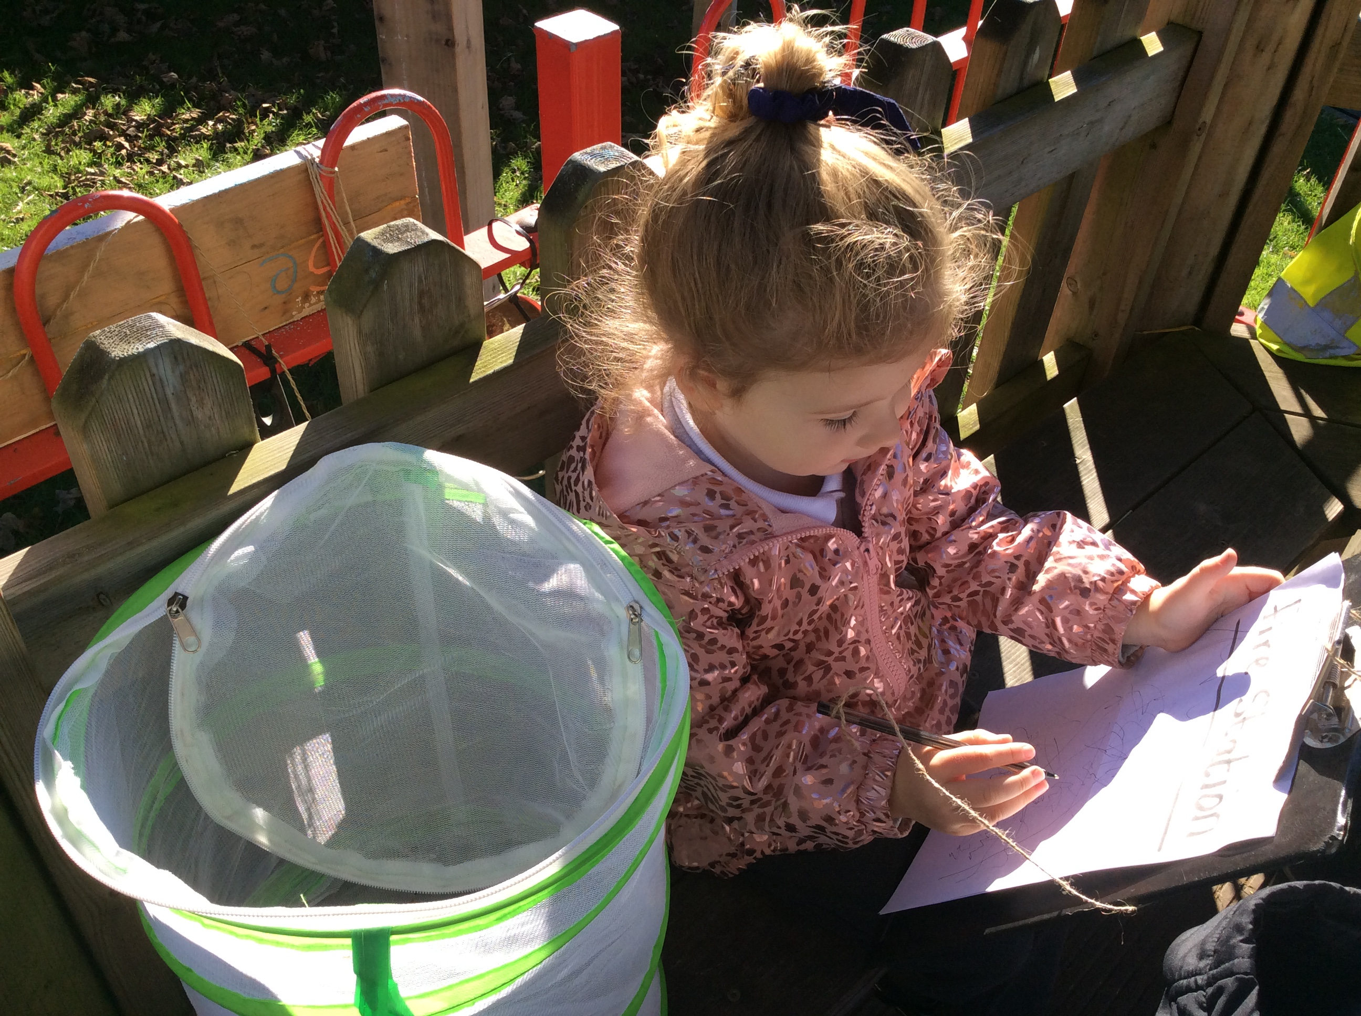
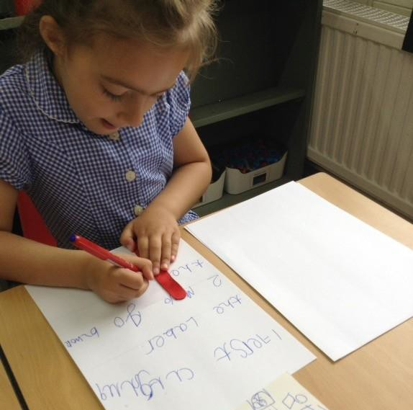

Writing at Rivington

Mark Making
Mark making and speech provide children with powerful tools for thinking, reasoning and problem solving.
Time, space and attention is given to children’s mark making, mathematical graphics, drawing and writing experiences. Throughout each day, children have opportunities for spontaneous mark making, drawing and writing in both the indoor and outdoor environment. Resources are carefully chosen, well organised and attractively presented, so that the children can decide independently how they want to represent their ideas and which medium would best suit their purpose. High value is placed upon imagination, ideas and self-expression demonstrated by the children, these are reflected by the adults and used as starting points for planning.

Story scribing – Continuous provision time
In every classroom there are ‘story tellers, picture makers and paper cutters, watching, listening and sounding forth’ (Paley, 1990) and capturing a child’s story idea is an essential part of becoming a writer.
Children have an innate desire to dictate a story and adults are eager to support their journey to scribing their own ideas.

‘Storytelling is an intrinsically
human thing to do.’
Haven, 2007

On entry to Reception children will often require much support in recording their story ideas. Anna Ephgrave (2011) details the process of story scribing as follows:
- Adults are dictated to by the child, the adult says each word as it is written, pointing out gaps and punctuation. Re-reading and scanning and checking writing.
- The children realise groups of letters make up a word and a group of words make sentences. The children then begin to write the initial sound of a word or a CVC word and the adult continues to write the other parts of the story.
- Next more phonetically correct words are written by child along with common words, such as ‘the’.
- Gradually children take the pen more and more, until eventually they are writing complete phrases.

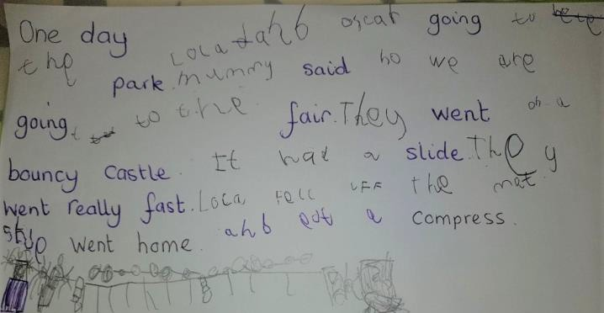

Shared writing time
Our Literacy planning gives a focused and supportive way into writing enabling the children to develop skills needed to become writers.
Each high-quality text is used as a starting point to inspire writing. The planning is split into three distinct phases – imitate, innovate, invent. The teacher models writing opportunities and then guides the children through the process providing support where needed and encouraging the children to use their own phonic knowledge increasingly so, as the year progresses.

Handwriting
Handwriting development in our EYFS includes a wide variety of activities planned to develop the fine motor skills required for the correct pencil grip. Fine motor activities may include threading, using tweezers, dough gym, using Lego and cutting.

The children are taught how to form letters accurately using letter rhymes from the Read Write inc scheme. Pencil control and grip is supported by all adults throughout continuous provision as well as focused sessions.

Concrete – Pictorial – Abstract
“All genuine learning comes through experience.”
John Dewey.
Maths is everywhere!

Maths at Rivington
Children learn about maths through play and their daily experiences. And the more meaningful to them and hands on it is, the better.
Our setting is full of mathematical opportunities for children to explore, sort, compare, count, calculate and describe.
Providing a safe environment to be creative, critical thinkers, problem solvers and to have a go.
Mathematics is identified as one of the specific areas of learning, alongside expressive arts and design, literacy, and understanding the world.
Our objective is to ensure that all children develop firm mathematical foundations in a way that is engaging, and appropriate for their age. This means actively learning using resources and activities provided in the environment.
In addition, maths is explicitly taught daily as short whole class sessions and followed up with small group work within the environment.
Mastery of mathematical concepts in the EYFS takes the following approach:
Concrete – children use concrete objects and manipulatives to help them understand what they are doing.
Pictorial – children build on this concrete approach by using pictorial representations. These representations can then be used to reason and solve problems.
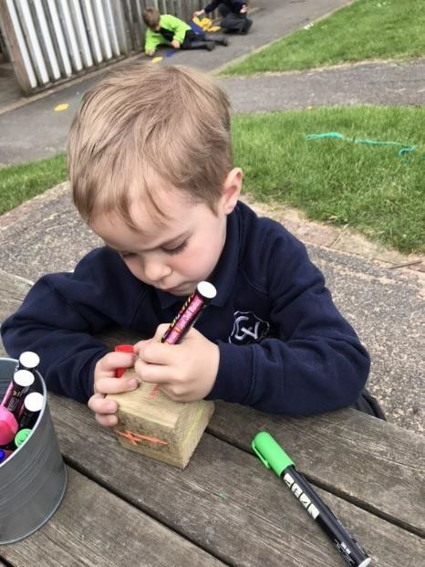Abstract – with the foundations firmly laid, children move to an abstract approach using numbers and key concepts with confidence.
Here are a few examples of how our environment promotes mathematical development:
- Sand & Water can develop mathematical concepts and language, e.g. heavy, light, empty, full, big, little.

- Malleable – dough can develop mathematical language – short, long, fat, thin. Children can make shapes of different dimensions – flat shapes, 3-d shapes.

- Imaginative play - set the table for dinner can develop counting skills. Sorting clothes into different colours, or different types of clothes, e.g. t-shirts and socks will develop knowledge of shapes and colours.

- Physical play can develop fine motor skills e.g. Sorting out a jigsaw, threading beads. Block play or playing with toy cars can help to develop sequencing according to size, colour. Playing with different sized blocks can help to develop an understanding of weight and dimensions. Tidying toys allows children to sort into different sizes and colours. It can also develop mathematical language – first, second, third, how many are blue, which is largest / smallest.

- Outdoors – Children may plant seeds this can develop understanding of time and the life cycle of plants. As the plants grow children use measures and develop mathematical language of size.

- Books & Rhymes - Enjoying stories and rhymes with a mathematical element, e.g. “One-two buckle my shoe” can develop number concepts, knowing direction that the print reads from left to right.

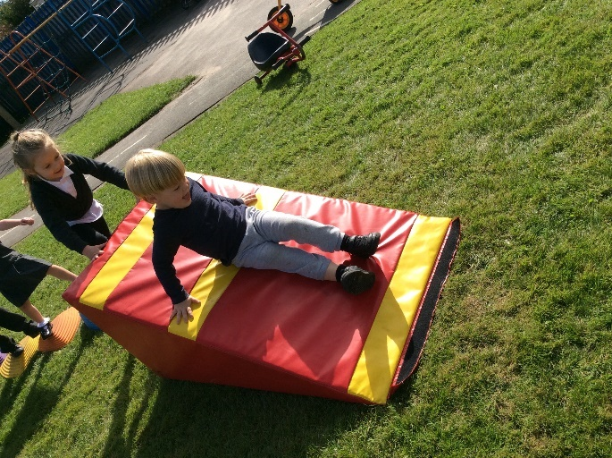

Parent Engagement
Parents are the first and most important influence on their child’s development and future outcomes.
Children have two main educators in their lives – their parents and their teachers.
Therefore, the school and the parents all have crucial roles to play. The impact on a child’s education is greater if parents and schools work in partnership.

At Rivington, parents are invited to be involved in every step of a child’s journey in education. Beginning with a pre-starting school meeting, followed up with home visits and the invitation for their child to attend a settling in session before the Autumn term commences.

We use an online app ‘Class Dojo’ in order to communicate with parents and share class activities and learning.

Throughout the year families are invited to ‘Stay and Learn’ sessions in the EYFS classroom along with
many whole school events e.g. PTA meetings, Easter tombola, summer fayre.

The Early Learning Goal Descriptors
Communication and Language
ELG: Listening, Attention and Understanding
- Listen attentively and respond to what they hear with relevant questions, comments and actions when being read to and during whole class discussions and small group interactions.
- Make comments about what they have heard and ask questions to clarify their understanding.
- Hold conversation when engaged in back- and-forth exchanges with their teacher and peers.
ELG: Speaking
- Participate in small group, class and one-to- one discussions, offering their own ideas, using recently introduced vocabulary.
- Offer explanations for why things might happen, making use of recently introduced vocabulary from stories, non-fiction, rhymes, and poems when appropriate.
-Express their ideas and feelings about their experiences using full sentences, including use of past, present and future tenses and making use of conjunctions, with modelling and support from their teacher.

Personal, Social and Emotional Development
ELG: Self-Regulation
- Show an understanding of their own feelings and those of others and begin to regulate their behaviour accordingly.
- Set and work towards simple goals, being able to wait for what they want and control their immediate impulses when appropriate.
- Give focused attention to what the teacher says, responding appropriately even when engaged in activity, and show an ability to follow instructions involving several ideas or actions.

ELG: Managing Self
- Be confident to try new activities and show independence, resilience, and perseverance in the face of challenge.
- Explain the reasons for rules, know right from wrong and try to behave accordingly.
- Manage their own basic hygiene and personal needs, including dressing, going to the toilet, and understanding the importance of healthy food choices.

ELG: Building Relationships
- Work and play cooperatively and take turns with others.
- Form positive attachments to adults and friendships with peers.
- Show sensitivity to their own and to others’
needs.

Physical Development
ELG: Gross Motor Skills
- Negotiate space and obstacles safely, with consideration for themselves and others.
- Demonstrate strength, balance and coordination when playing; Move energetically, such as running, jumping, dancing, hopping, skipping, and climbing.

ELG: Fine Motor Skills
Children at the expected level of development will:
- Hold a pencil effectively in preparation for fluent writing –
using the tripod grip in almost all cases.
- Use a range of small tools, including scissors, paint brushes and cutlery.
- Begin to show accuracy and care when drawing.

Literacy
ELG: Comprehension
- Demonstrate understanding of what has been read to them by retelling stories and narratives using their own words and recently introduced vocabulary.
- Anticipate – where appropriate – key events in stories.
- Use and understand recently introduced vocabulary during discussions about stories, non-fiction, rhymes, and poems and during role-play.

ELG: Word Reading
- Say a sound for each letter in the alphabet and at least 10 digraphs.
- Read words consistent with their phonic knowledge by sound-blending.
- Read aloud simple sentences and books that are consistent with their phonic knowledge, including some common exception words.

ELG: Writing
- Write recognisable letters, most of which are correctly formed.
- Spell words by identifying sounds in them and representing the sounds with a letter or letters.
- Write simple phrases and sentences that can be read by others.

Mathematics
ELG: Number
- Have a deep understanding of number to 10, including the composition of each number.
- Subitise (recognise quantities without counting) up to 5.
- Automatically recall (without reference to rhymes, counting or other aids) number bonds up to 5 (including subtraction facts) and some number bonds to 10, including double facts.

ELG: Numerical Patterns
- Verbally count beyond 20, recognising the pattern of the counting system.
- Compare quantities up to 10 in different contexts, recognising when one quantity is greater than, less than or the same as the other quantity.
- Explore and represent patterns within numbers up to 10, including evens and odds, double facts and how quantities can be distributed equally.

Understanding the World
ELG: Past and Present
- Talk about the lives of the people around them and their roles in society.
- Know some similarities and differences between things in the past and now, drawing on their experiences and what has been read in class.
- Understand the past through settings, characters and events encountered in books read in class and storytelling.

ELG: People, Culture and Communities
- Describe their immediate environment using knowledge from observation, discussion, stories, non-fiction texts and maps.
- Know some similarities and differences between different religious and cultural communities in this country, drawing on their experiences and what has been read in class.
- Explain some similarities and differences between life in this country and life in other countries, drawing on knowledge from stories, non-fiction texts and –when appropriate – maps.

ELG: The Natural World
- Explore the natural world around them, making observations and drawing pictures of animals and plants.
- Know some similarities and differences between the natural world around them and contrasting environments, drawing on their experiences and what has been read in class.
- Understand some important processes and changes in the natural world around them, including the seasons and changing states of matter.

Expressive Arts and Design

ELG: Creating with Materials
- Safely use and explore a variety of materials, tools, and techniques, experimenting with colour, design, texture, form and function.
- Share their creations, explaining the process they have used.
- Make use of props and materials when role playing characters in narratives and stories.

ELG: Being Imaginative and Expressive
- Invent, adapt, and recount narratives and stories with peers and their teacher.
- Sing a range of well-known nursery rhymes and songs; Perform songs, rhymes, poems, and stories with others, and – when appropriate – try to move in time with music.

