Narrowing the gap; unlocking the potential…

Impact Review of Pupil Premium Expenditure to 2025 – 2026
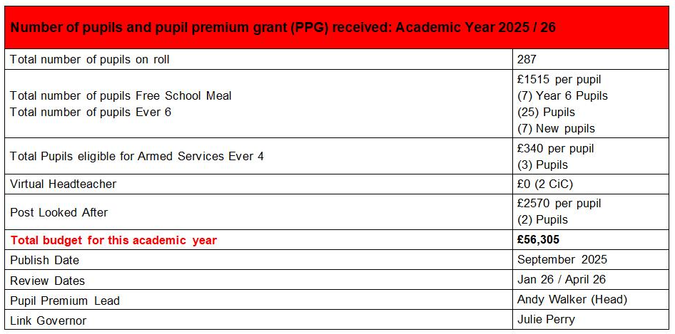
Phonics Year 1 FSM Analysis
 | All Pupils |  | FSM Pupils
% of pupils achieving a pass | 2026  (37) | 2025  (39) | 2026  (3) | 2025  3
% of pupils achieving a pass | 94.6% | 87% | 66% | 100%
Average Score (other) | 35.64 | 34.15 | 33.0 | 36.3
National Figures |  | 2025 |  | 2025
National Figures |  | 80% |  | 67%

Year 2 Reading SATs analysis 2025
All pupils (43 pupils) |  |  | FSM School (6 pupils) |  |  | National  (Historical)
Expected | Depth | Score | Expected | Depth | Score | Expected | Depth | Score
70% | 21% | 101.86 | 83% | 17% | 102.83 | 68% | 19%

Year 2 Writing SATs analysis
All pupils (43 pupils) |  |  | FSM School (6 pupils) |  |  | National  (Historical)
Expected | Depth | Score | Expected | Depth | Score | Expected | Depth | Score
65% | 16% |  | 83% | 17% |  | 72% | 19%

Year 2 Maths SATs analysis
Other pupils (43 pupils) |  |  | FSM School (6 pupils) |  |  | National  (Historical)
Expected | Depth | Score | Expected | Depth | Score | Expected | Depth | Score
70% | 14% | 101.69 | 67% | 0% | 97.83 | 70% | 16%

Year 6 Reading SATs analysis
Other pupils (44 pupils) |  |  | FSM School (10 pupils) |  |  | National
Expected | Depth | Score | Expected | Depth | Score | Expected | Depth | Score
68% | 32% | 104.92 | 40% | 0% | 101.2 | 75% | 33% | 105.0

Year 6 SPAG SATs analysis
Other pupils (-2 pupils below ARE) |  |  | FSM School (7 pupils) |  |  | National  2025
Expected | Depth | Score | Expected | Depth | Score | Expected | Depth | Score
75% | 18% | 105.51 | 40% | 0% | 97.75 | 74% | 23% | 105.0

Year 6 Maths SATs analysis
Other pupils (44 pupils) |  |  | FSM School (10 pupils) |  |  | National  2026
Expected | Depth | Score | Expected | Depth | Score | Expected | Depth | Score
64% | 25% | 104.63 | 40% | 0% | 98.37 | 75% | 26% | 104.0

Year 6 Writing SATs analysis
Other pupils (43 pupils) |  |  | FSM School (10 pupils) |  |  | National  2026
Expected | Depth | Score | Expected | Depth | Score | Expected | Depth | Score
68% | 7% |  | 40% | 0% |  | 73% | 13%

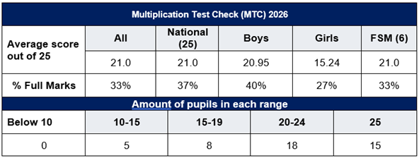
Disadvantaged Review for 2025 - 26
Strengths | Areas to Develop
- Inclusion in Project Based Learning, extra-curricular sports clubs, tris and residentials and Holiday Camps.  - EYFS Writing gap has closed.  - Phonics Intervention: the attainment for Year 1 phonics and Year 2 re-takes.  - Gap closed in majority of Year groups in Reading.  - MTC in Year 4 gap has closed. | - Yr 6 had a large group of 10 pupils. Gap not narrowing in the core subjects.  - EYFS seeing a gap in Word Reading and Maths.  - Gap not closing in Spelling and Spag within the Junior department.  - Gap closing or closed in most classes for Writing; apart from the upper juniors.  - Gap not closing in Maths across most of Key Stage 2.

Quality of Teaching Support for the Academic Year 2025 - 26
Measure |  | Activity | Evaluation and Impact
Priority 1:  £28,000  To continue to deliver a mastery curriculum for the teaching of Mathematics and English through excellent pedagogical approach, formative assessment procedures, and adaptations made so it is accessible to all pupils |  | - Training in what quality modelling looks like.  - Whole school INSET on Rosenshine Principles.  - Training in use of Thinking Frames for Science, History and Geography.  - Established pedagogical approach – 4 cornerstones in learning.  - Focus on reviewing prior learning that link to the “golden threads”  - Training in effective adaptations for pupils in each of the subjects. | 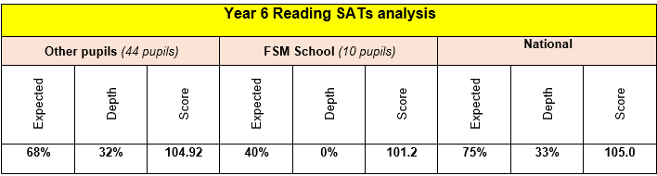  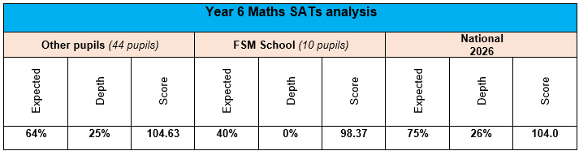  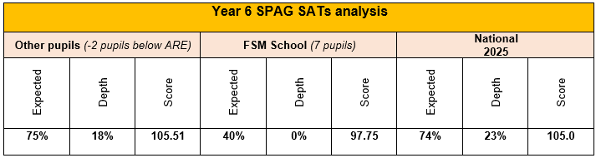  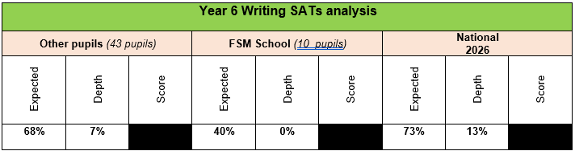
Urgent Improvement
Needs Attention | 
Expected
Strong
Exceptional
Priority 2:  £7000  To implement a curriculum for children who are SEND that supports and evidences their progress at their cognitive level. |  | - Assessments against new PIVATs matched to new curriculum will determine personalised next steps.  - Launched High Quality Teaching evidence base for each class to focus on reasonable adjustments. | - All classes have Zones of Regulation displays in classrooms and have had training in My Happy Mind  - All pupils working well below the age-related curriculum are assessed against PIVATs and with personal targets.  - High Quality and Adaptive teaching sheets completed by each class.  - Each class needs are identified by SLT and SEN lead and provision mapped termly.  - Support groups and interventions are evaluated by TAs via the Pupil Passports.  - OFSTED Parent view: 100% of parents agreed the school gives their SEND child the support they need to succeed.  - OFSTED Jan 2025: “The school has suitable systems in place to identify and assess the additional needs of pupils with SEND. It works closely with families and other professionals to ensure that these pupils have the help and support that they need. Teachers adapt lesson activities skilfully so that all pupils can learn the curriculum alongside their peers.”
Urgent Improvement
Needs Attention
Expected
Strong
Exceptional
Priority 3:  £4500  To improve the quality of teaching in order to close the gap in attainment for Reading and Phonics for all pupils and progress in Reading in line with other pupils nationally |  | - RWI mentoring and CPD support.  - Implemented RWI intervention in KS2.  - Bought Books for bags for EYFS and Year 1 to closely match their phonics.  - Embedded transitional RWI booklets in Year 2 for comprehension, grammar and spelling. | Early Reading and Phonics:  - EYFS Comprehension: 89% achieved expected.  - EYFS Word Reading: 73% achieved expected  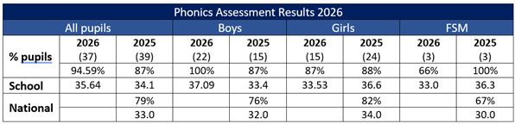  Key Stage 1 Reading Attainment:  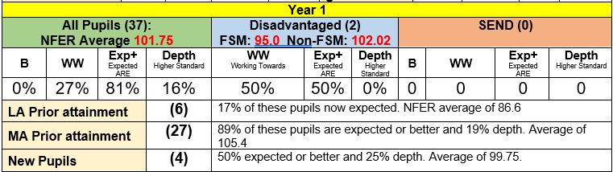  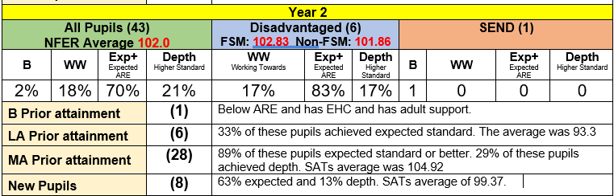
Urgent Improvement
Needs Attention
Expected
Strong
Exceptional
Priority 4:  £1000  To implement and deliver a maths scheme that is aligned to the White Rose medium term planning and has a whole class mastery approach that works for every child. |  | - Embedded new maths scheme in KS2 – Power Maths.  - Staff trained on using Planpannion to supplement the scheme with fluency and reasoning tasks.  - Enhanced learning walls related to the scheme.  - Celebrated mistakes wall.  - Implemented across KS1.  - 1 to 1 mentoring of Year 4 pupils for the MTC. | - EYFS: Number and Number patterns above national at 73% - 2% on national. 1 out of 5 FSM pupils expected (20%)  - Yr1: All pupils 84% expected and 21% depth. FSM pupils (2) 50% achieved expected.  - Yr2: 70% expected and 14% depth. FSM pupils (6), 67% expected.  - Yr3: All pupils 81% expected and 29% depth. FSM pupils (3) 66% expected  - Yr 4: 65% expected and 26% depth. FSM pupils (8). 75% expected and NFER average of 102.37.  - Yr 5: 64% expected and 30% depth. FSM pupils (5) 20% expected and depth.  - Yr 6: Above national 64% expected and 25% depth. FSM (10) 25% expected and 0% depth.  - OFSTED Jan 2025: “A new mathematics curriculum is helping pupils to catch up and gain a secure understanding of this subject.”
Urgent Improvement
Needs Attention
Expected
Strong
Exceptional

Targeted Academic Support for the Current Academic Year
Measure |  | Activity | Evaluation and Impact
Priority 1:  £6,000  In school gap in Maths attainment for Juniors is narrowed and closed when compared to national figures. |  | - Infant TAs trained in delivery of Number Stacks for Infant pupils.  - Outside tutor employed to deliver Number Stacks to Yr2, Yr 3, Yr 4 and Yr 5 pupils.  - After school maths boosters Yr6. | 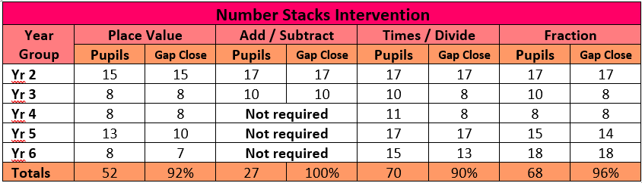  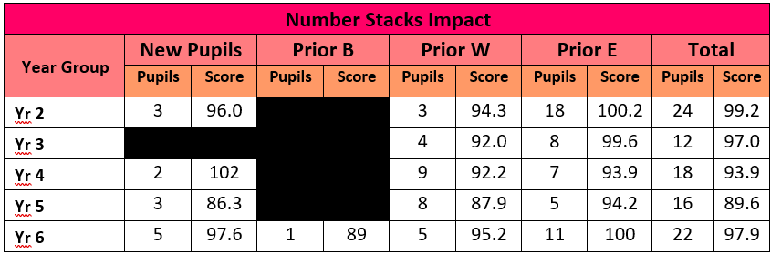
Urgent Improvement
Needs Attention
Expected
Strong
Exceptional
Priority 2:  £6,000  Fine Motor and Writing in EYFS. |  | - Additional adult in Reception to allow for greater provision mapping for targeted children. | Fine Motor Skills  - 93% of EYFS pupils achieved expected in fine motor so above national.  - Boys achieved 87.5% and were 17.2% above Boys nationally.  - 100% of pupils achieved expected in writing with girls well above national.  - 4 / 5 (80%) FSM pupils achieved expected.  Writing  - 81.8% of all pupils expected in writing.  - 70.8% of all boys achieved expected which was slightly above boys nationally.  - 95% of girls achieved expected which is above national.  - 3 / 5 (60%) FSM pupils achieved expected.
Urgent Improvement
Needs Attention
Expected
Strong
Exceptional

Wider Strategies for the Current Academic Year
Measure |  | Activity | Evaluation and Impact
Priority 1:  £3000  To continue to deliver a comprehensive programme of targeted and universal interventions to address the barriers to learning derived from social, emotional and mental health. Achieved through additional Ed Pysch time, Pivatol Practise in behaviour training, ELSA support and Mental Health week. |  | - Used Health Box workshops for 1 to 1 counselling.  - Teacher led nurture groups  - Bought into mindfulness program to be delivered in class.  - SHINE group intervention for vulnerable families.  - Calm to Chaos parental workshops.  - Timid Tiger parental workshops for behavioural management strategies. | - SHINE clubs which involved families and talking therapy for 5 pupils with mental health champion.  - Groups up to 8 children took part in gardening club.  - All classes now have access to mindfulness activities. The use of this needs to be embedded next year.  - 2 pupils had EBSN support for their attendance.  - My Happy Mind embedded across the whole school.
Urgent Attention
Needs Attention
Expected
Strong
Exceptional
Priority 2:  £3000  To give total access to the curriculum and ensure fully inclusive which positively impacts on pupils’ self-esteem. |  | - Identified enrichment opportunities in the form of school clubs.  - Funded Residentials for pupils in Yr4, Yr 5 and Yr 6.  - Bought uniform and PE kit for disadvantaged pupils.  - Offered music lessons via Music for Life for Yr 6 pupils  - Strings in Year 5  - Funded trips for disadvantaged pupils.  - Organised HAF funded Summer Camp over the holidays. | - No disadvantaged pupil missed a residential or school trip.  - Disadvantaged pupils had access to 5 weekly sports clubs throughout the whole academic year.  - Where needed, all disadvantaged pupils were supported with uniform, food banks, Christmas gifts and food vouchers over the holiday periods.  - For every holiday, Holiday camps, including lunch, available to Free School Meal families for free.
Urgent Improvement
Needs Attention
Expected
Strong
Exceptional

