Prospectus 
2026 – 2027
Farndon Primary School

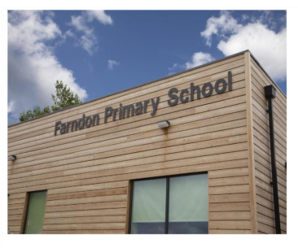
Farndon Primary School
Churton Road Farndon
Telephone: 01244 621124
E-mail Office: admin@farndon.cheshire.sch.uk
School Website: www.farndon.cheshire.sch.uk
Twitter: @farndon_primary

Contents

About Our School
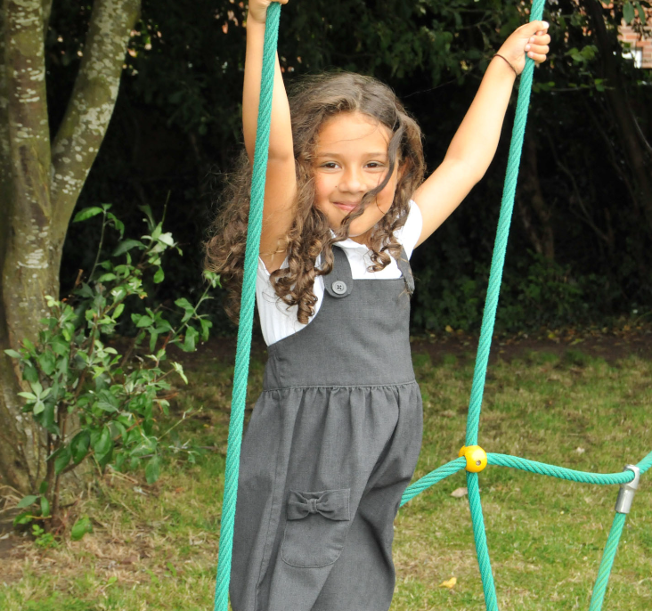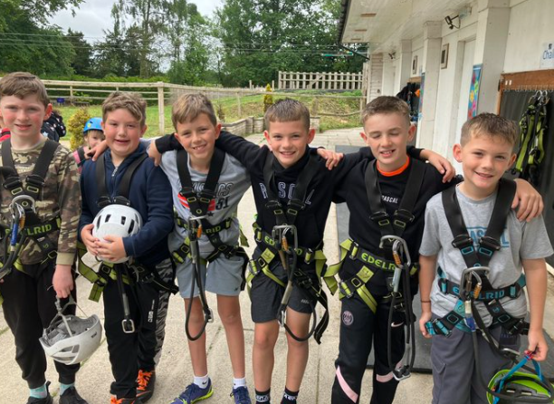
Parents in Partnership
Joining the School
Our Curriculum
Essential Information 2026 – 27
School Achievement 2025 – 26
School Contact Details
School Term Dates
Welcome
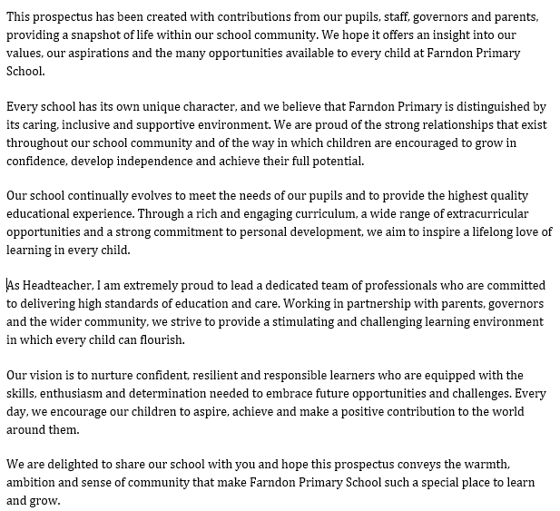
Andrew Walker Michael Rudd
Headteacher Chair of Governors
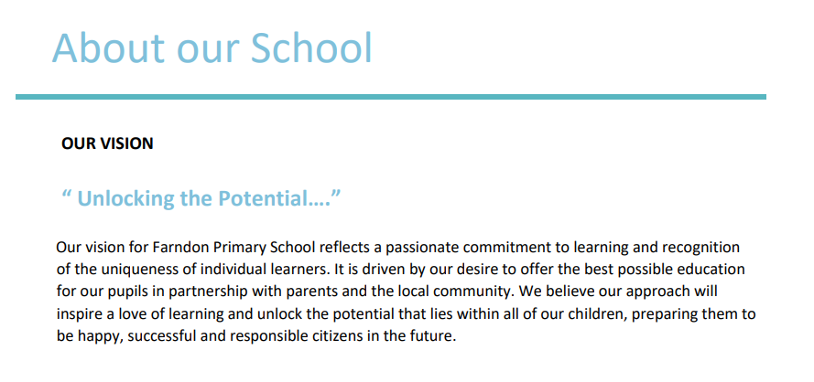
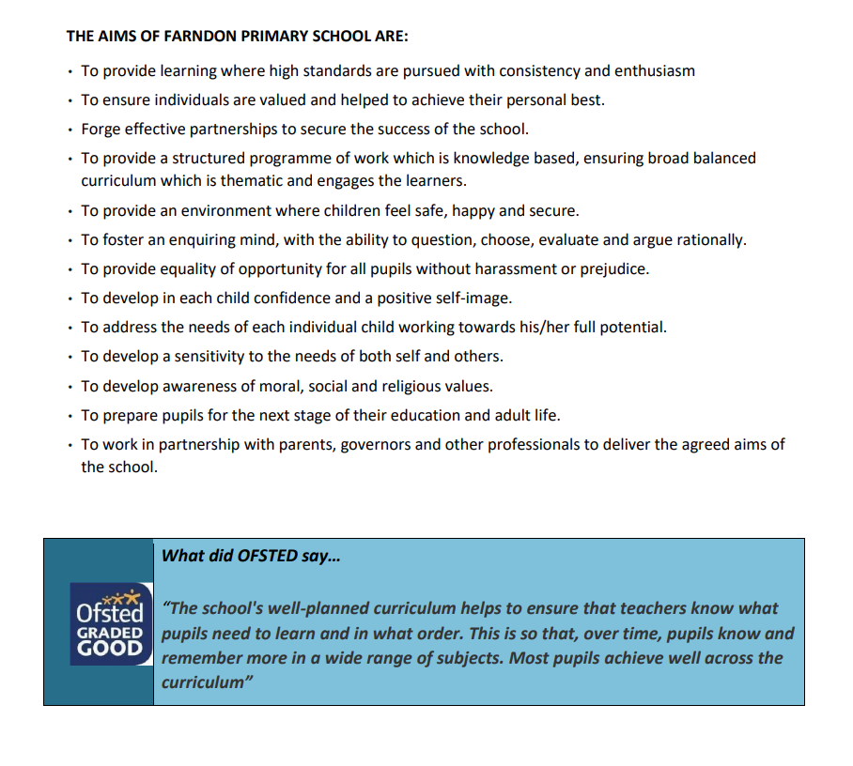
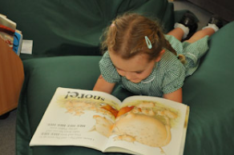
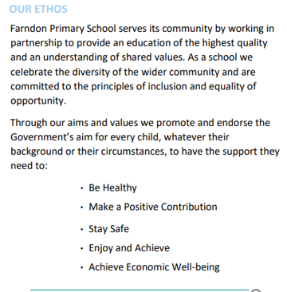
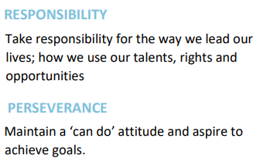
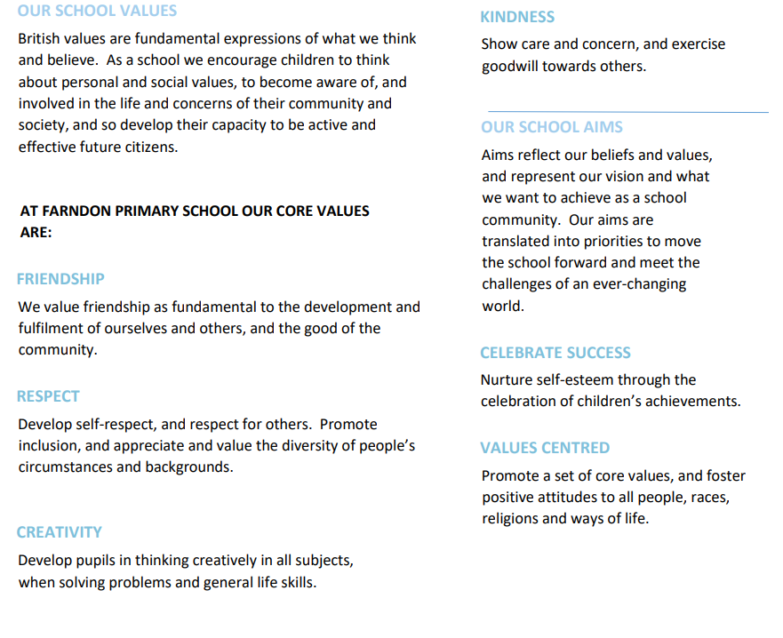
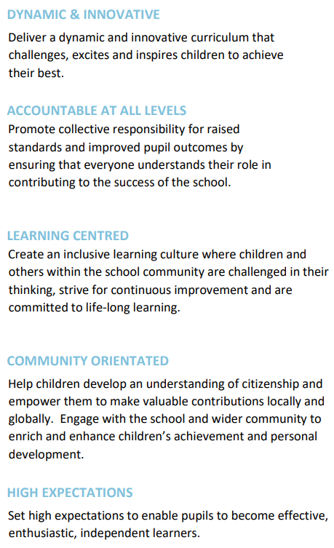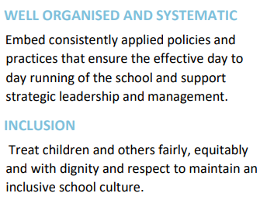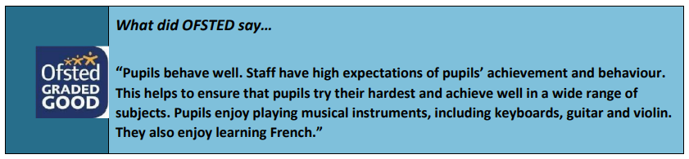
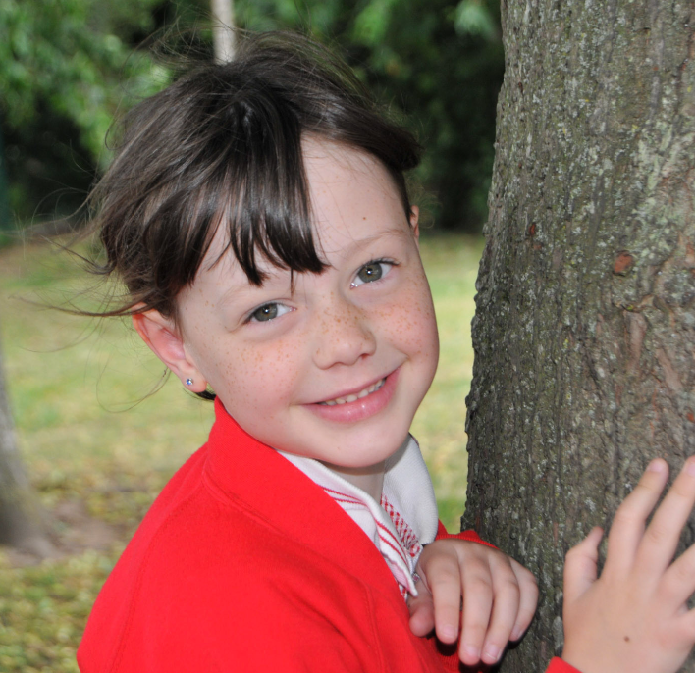

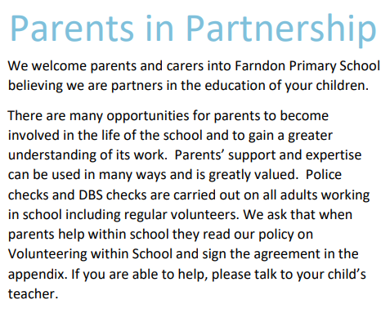
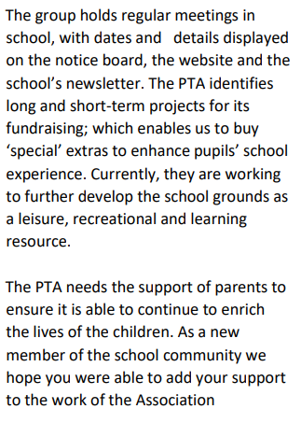
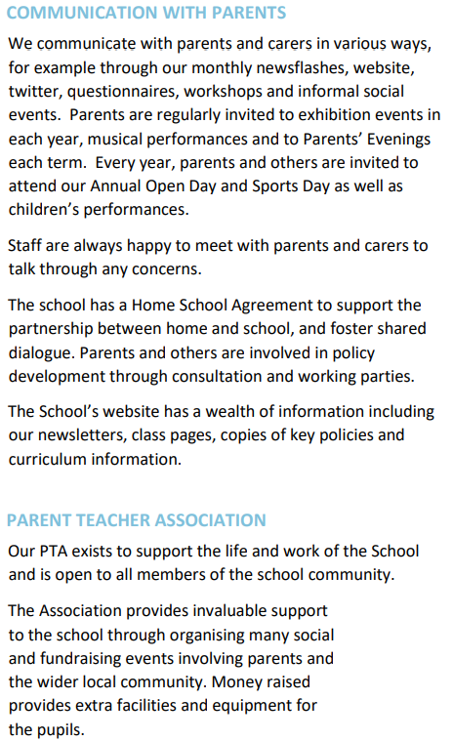
What did our parents say last year…….
In a recent questionnaire, 93% of our parents would recommend our school to another parent, with 30% strongly agreeing.
One Parent said,” Words don’t explain the gratitude felt the school, knowing how well the children are educated, kept safe, and make memories that will last a life time.”

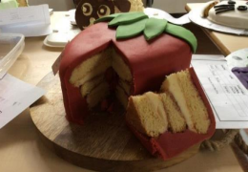

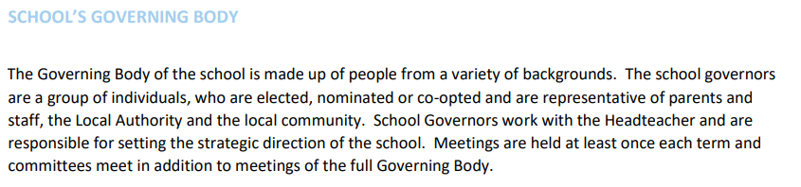

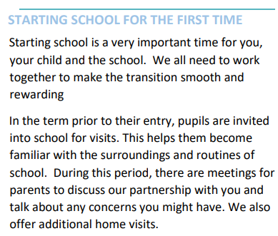
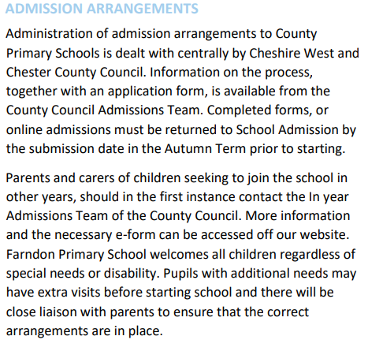
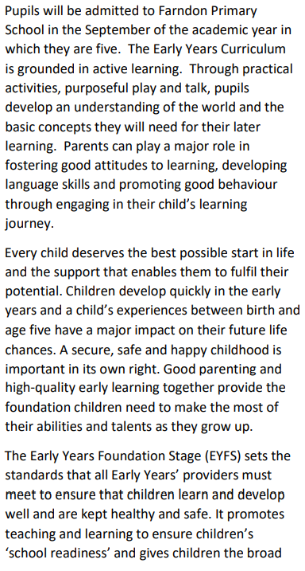
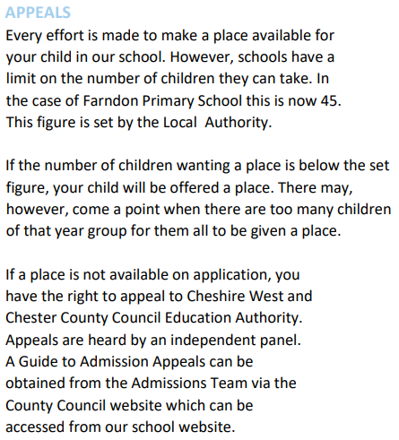

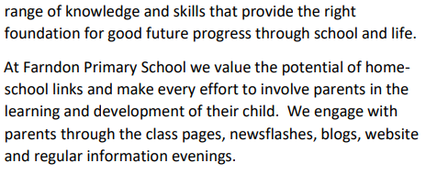
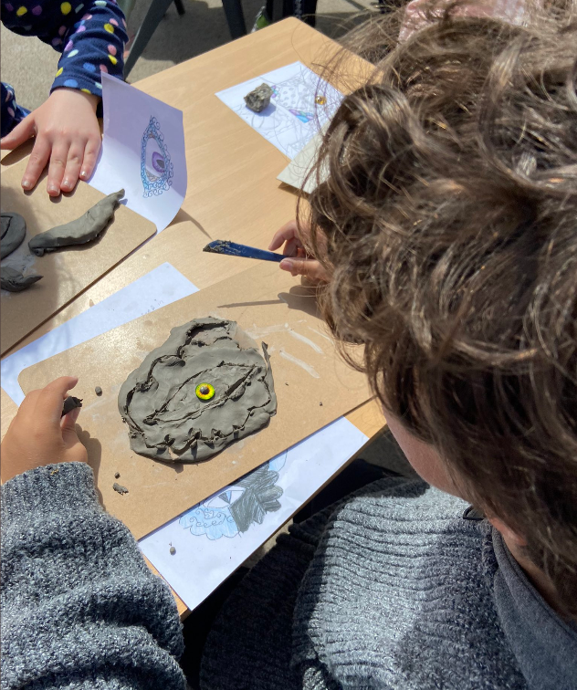

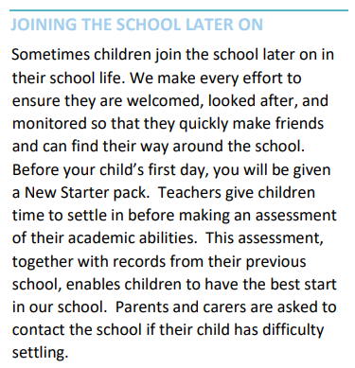
At Farndon Primary School, our curriculum encompasses all the learning opportunities and experiences we provide for our children. Working in close partnership with families and the wider community, we aim to inspire every child to unlock their potential, develop a lifelong love of learning and grow into confident, responsible citizens.
Our curriculum is designed to inspire curiosity and foster creativity. Learning is carefully organised through engaging themes that capture children's interests and imagination, enabling them to make meaningful connections across different areas of the curriculum.
Our thematic approach provides exciting opportunities for children to explore a wide range of subjects through topics such as Raiders and Traders, Out of This World, Endangered, Dungeons and Dragons, Once Upon a Time and Out of Africa. High-quality texts are placed at the heart of each theme, enriching learning experiences and promoting a strong culture of reading throughout the school.
Through a rich and varied curriculum, pupils experience a broad range of subjects and opportunities that nurture academic, creative, technical and sporting talents. We believe every child should have the chance to discover their strengths, pursue their interests and achieve personal success.

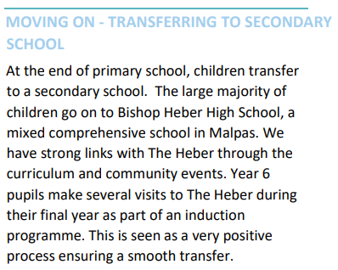
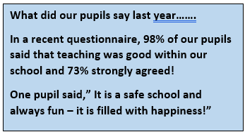
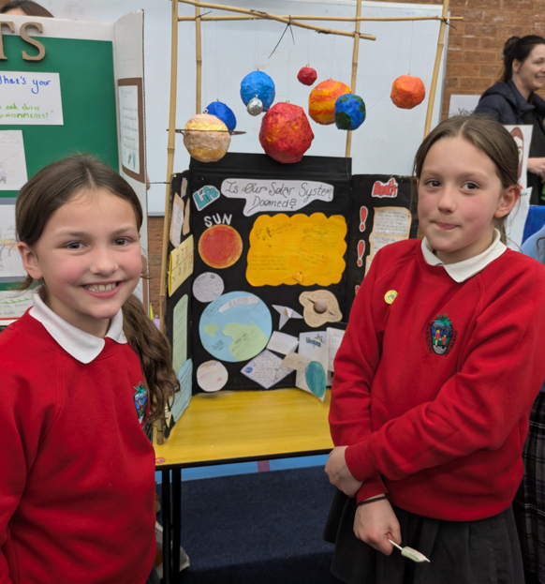
We aim to ensure children do not become spectators but rather are active investigators, applying the research tools, techniques of inquiry and standards of presentation used by professionals in the field.
Visitors have a valuable role to play and can contribute to many aspects of the life and work of the school. They deliver talks, workshops and a wide range of subjects. Visitors to the school have a clear purpose and allows our pupils to be researchers – not spectators. We reach out to a range of experts, who may be professionals from a particular discipline or community members with first-hand knowledge of the project or theme being studied. Often, throughout the class projects, teachers and children maintain an ongoing relationship with experts.

As a school, we offer pupils opportunities to participate in extracurricular activities before and after school. At any time through the year, a wide range of clubs are on offer, which are led by external providers. Clubs include most sports, computing, science, film club, judo and archery.

Our approach to curriculum makes standards come alive for children by connecting learning to real-world issues and needs. Academically robust learning units of work / projects, case studies, field work, and service learning inspire children to think and work as professionals do, contributing high-quality work to authentic audiences beyond the classroom, which in turn, builds character.
Our classrooms are alive with discovery, inquiry, critical thinking, problem solving and collaboration. Teachers talk less; children think more. Lessons have an explicit purpose, guided by learning intentions for which children take ownership and responsibility. In all subject areas, teachers vary and adapt instruction without fixed ability grouping, yet maintain high expectations in order to bring out the best in all children and cultivate a culture of high achievement for everyone.
Our school aims to build a culture of respect, responsibility, courage, and kindness, where children and adults are committed to quality work and citizenship. Our school structures and traditions, exhibitions of children’s work and project-based learning ensure that every child is known and cared for, that children’s leadership is nurtured and that contributions to the school and their community are celebrated. Children and staff are supported to do better work and be better people than they thought possible.

Our school offers many opportunities for fieldwork, work with local experts and the use of primary source material. They are an integral part of the education of children at Farndon Primary. We use the natural and social environments of their communities as sites for purposeful field work and service connected to academic work, and they use professional experts and citizens with first-hand knowledge of events and issues to ensure accuracy, integrity and quality of their work.

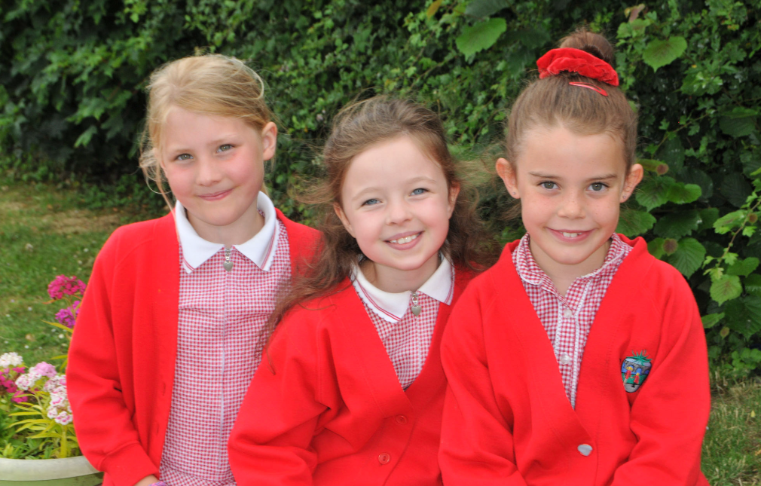
We believe that the arts play a vital role in enriching children's learning, creativity and self-expression. We provide a wide range of musical experiences that inspire pupils to perform, compose, listen and create with confidence. We offer a variety of opportunities both within and beyond the curriculum for children to develop and showcase their musical talents. Performances, concerts and special events give pupils the chance to share their achievements with families and the wider community.
A particular highlight of our music provision is our Year 5 instrumental programme, where every pupil has the opportunity to learn a stringed instrument with a specialist music teacher. This valuable experience develops musical skills, discipline and a lifelong appreciation of music, while ensuring that every child can participate regardless of prior experience.
In May, pupils have the exciting opportunity to perform at the renowned Bridgewater Hall and in April, our Year 4 pupils participate in Young Voices where they perform in the Manchester Co-Op Arena.
Opportunities to participate in drama are available across all year groups through classroom learning, our Film Makers club, key stage productions and special performances. Through our rich and varied arts curriculum, we strive to nurture creativity, celebrate individual talents and provide memorable experiences that enable every child to flourish.



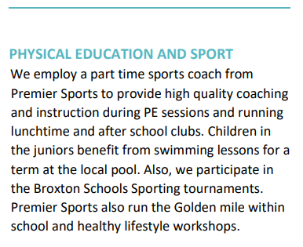
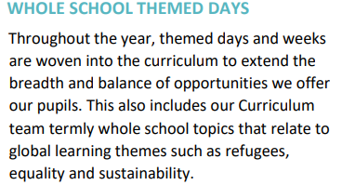
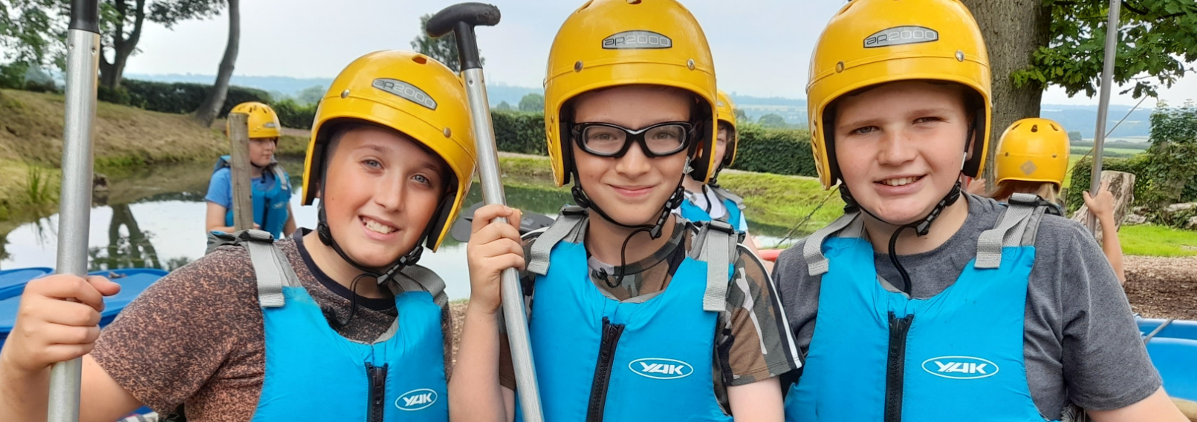
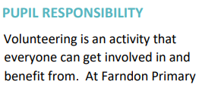
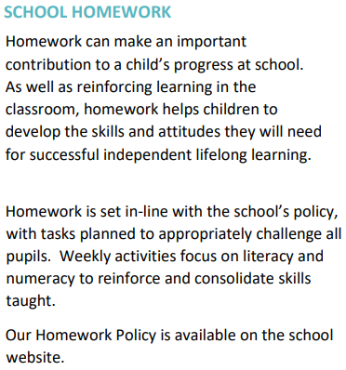
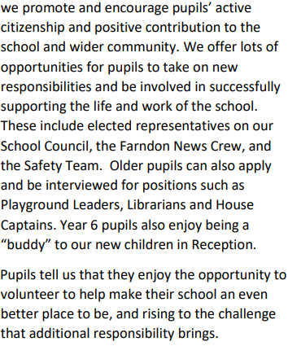
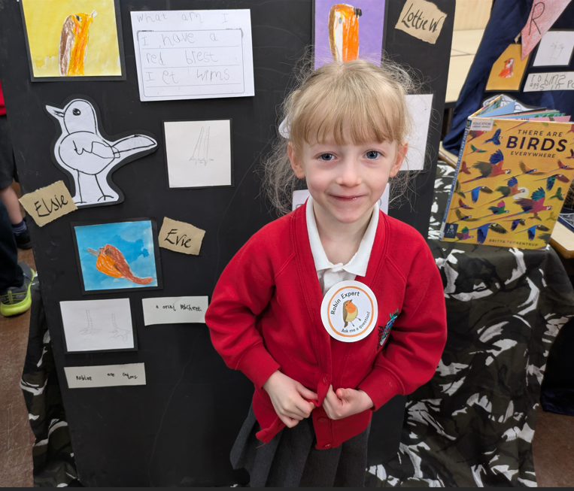
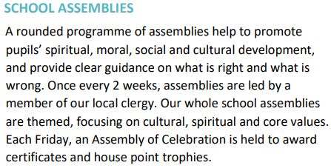

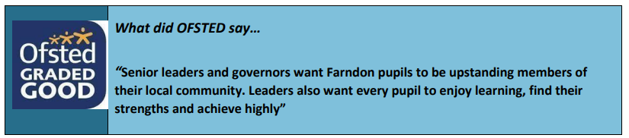

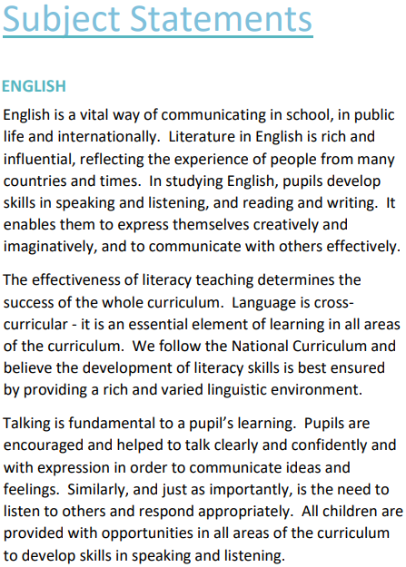
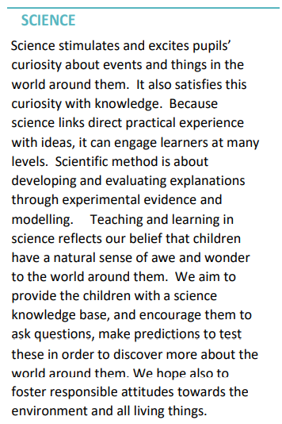
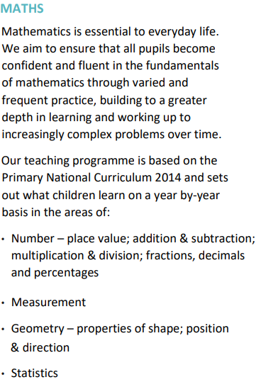
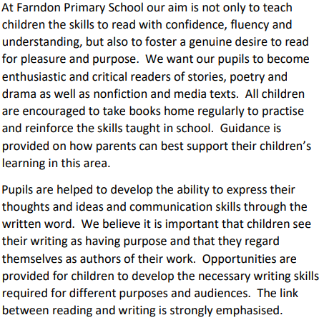

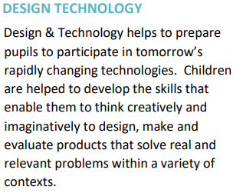
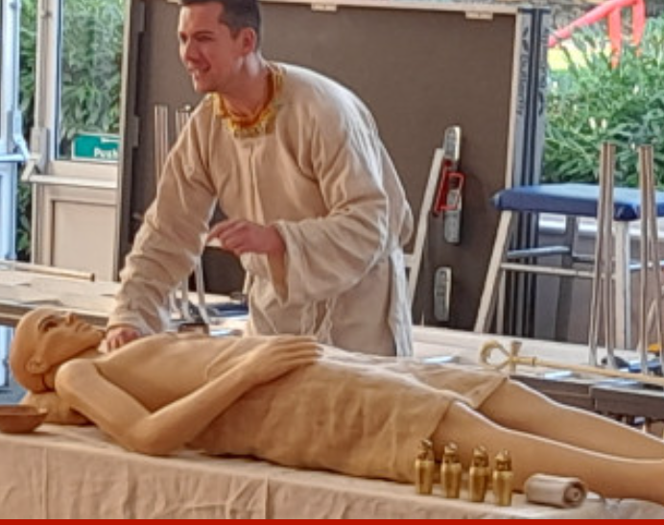

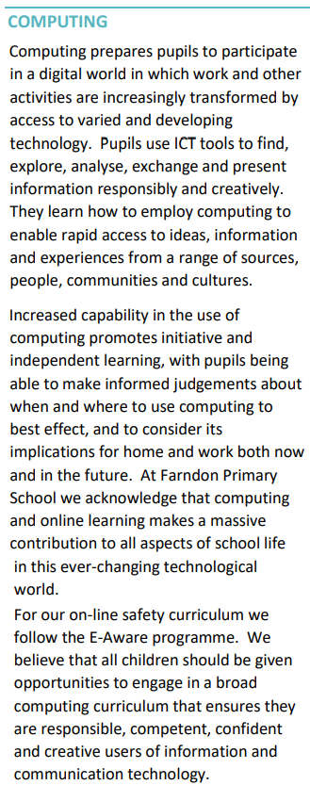
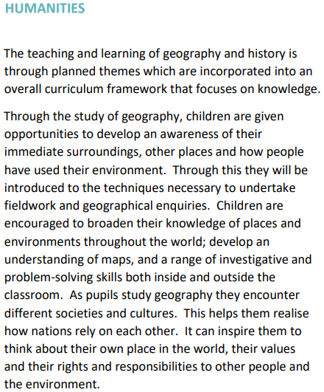
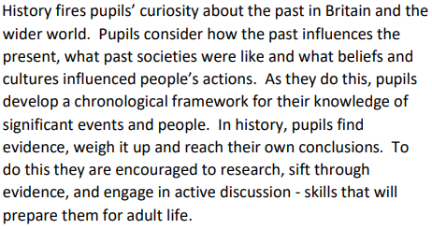
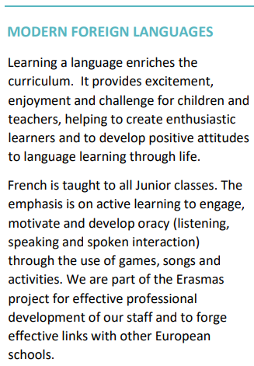
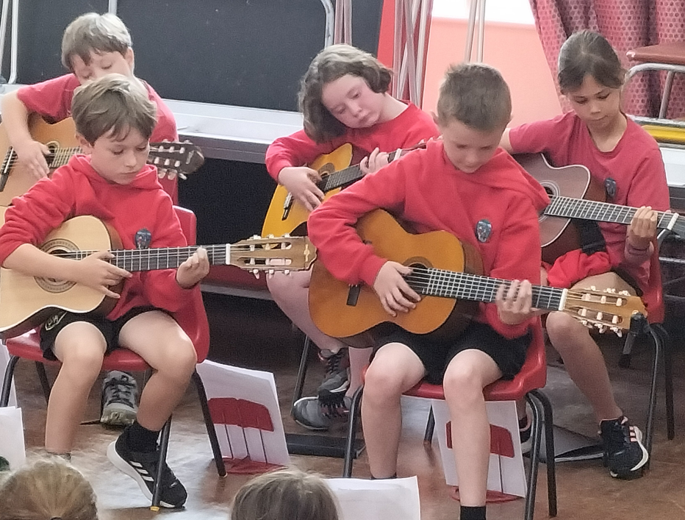

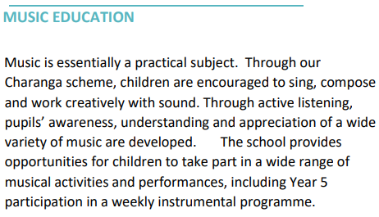
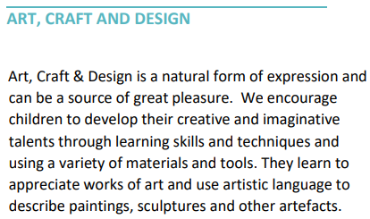
What did our parents say last year…….
In a recent questionnaire, 95% of our parents said their child is taught well, with 32% strongly agreeing.
One Parent said,” My child skips into school and runs into class – this is a credit to his class teacher who makes learning fun and engaging. My child comes home excitedly about their new learning.”

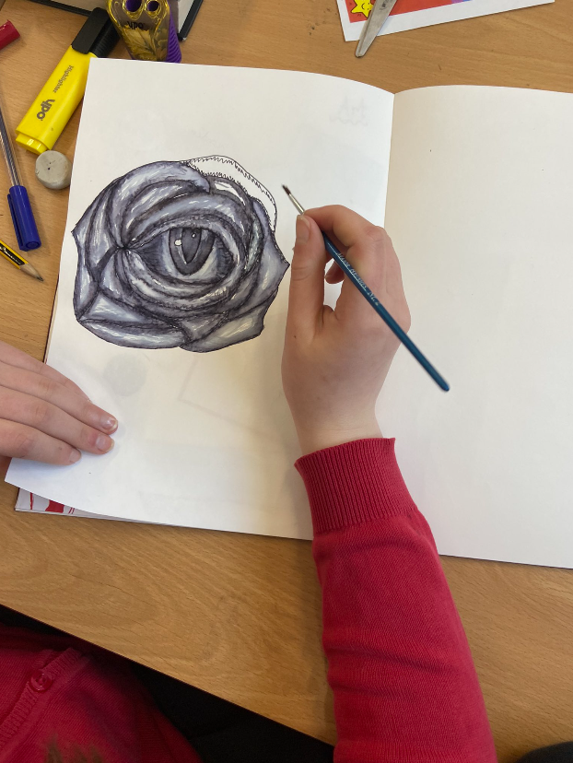

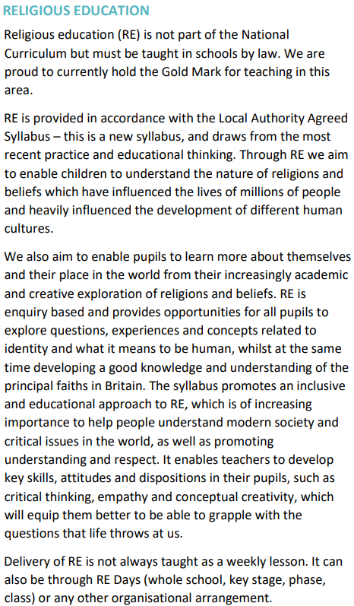
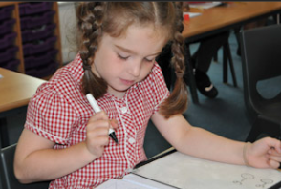
What did our pupils say last year…….
In a recent questionnaire, 91% of our pupils said that lessons are interesting and enjoyable and 47% strongly agreed!
One pupil said,” I enjoy school because it’s fun and enjoyable. I never want to go to a different school!”

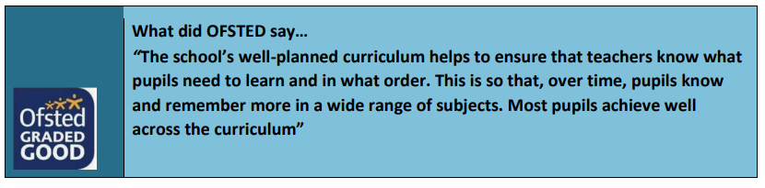

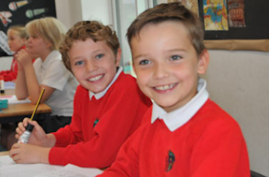
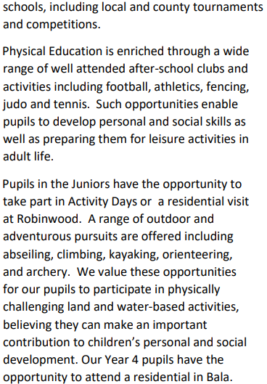


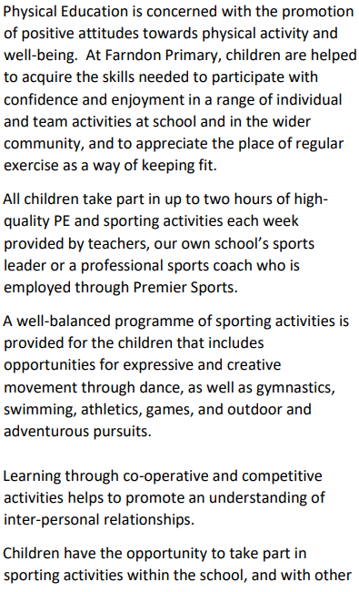
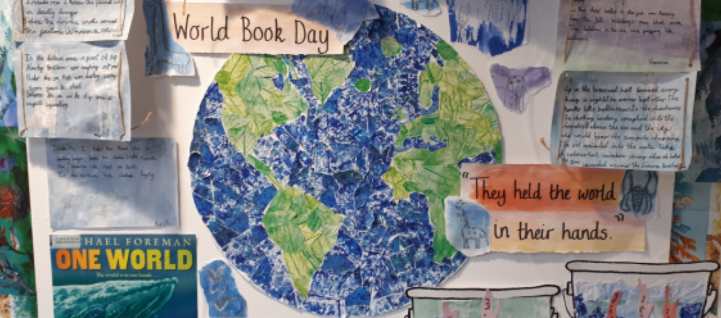
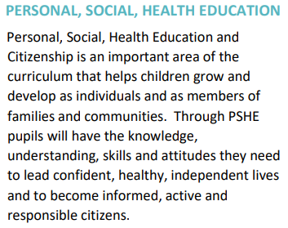

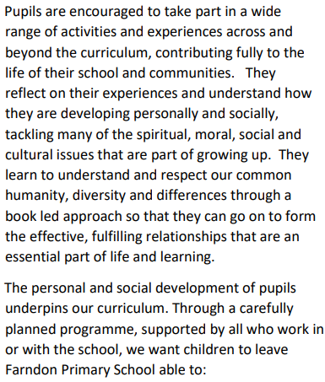
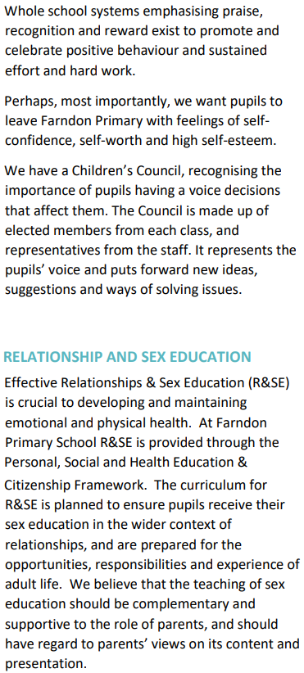
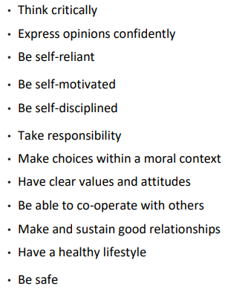

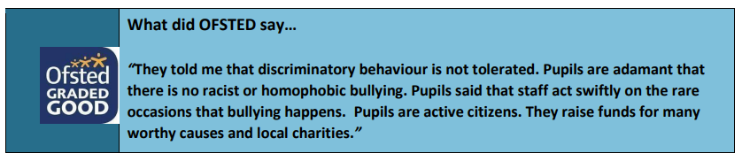
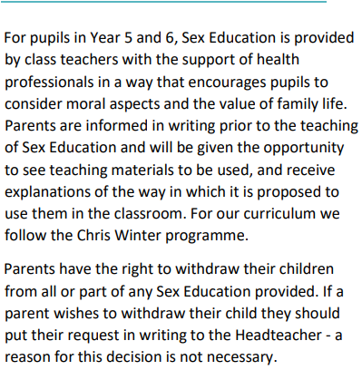
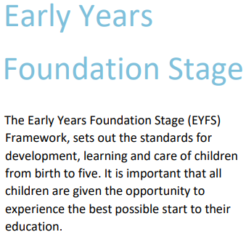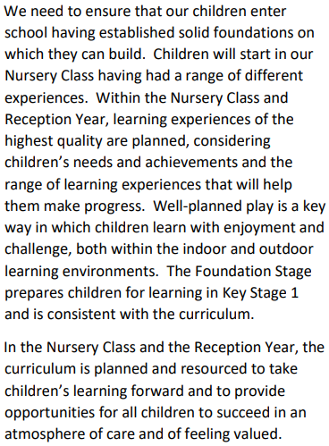
What did our parents say last year…….
In a recent questionnaire, 98% of parents said that their child is well looked after within our school and 64% of these parents strongly agreed.

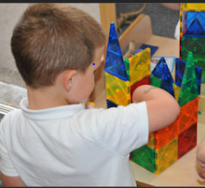

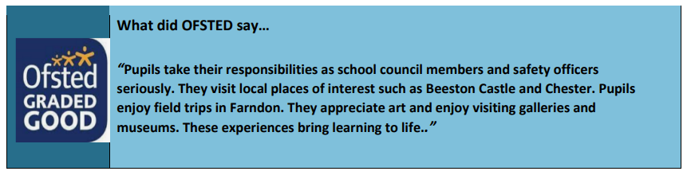
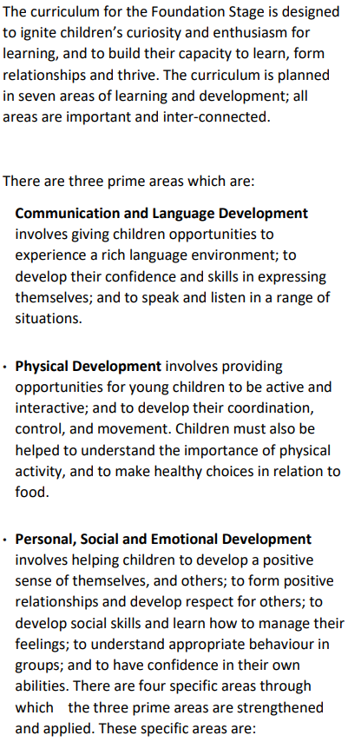

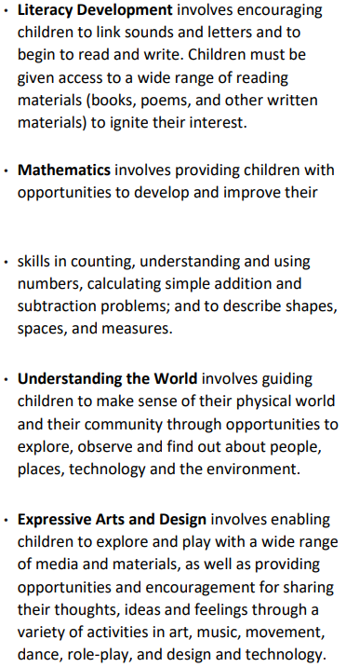
What did our pupils say last year…….
In a recent questionnaire, 94% of our pupils said that they feel safe within school and 55% strongly agreed!
One pupil said,“ Teachers are kind and school trips are fun. Everyday I learn a new thing.”

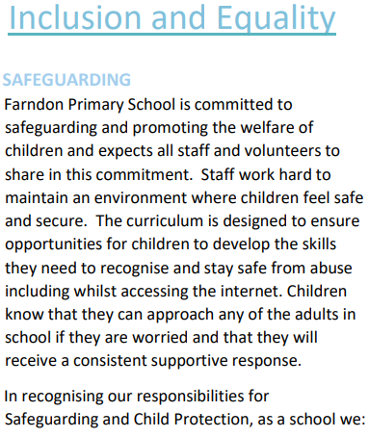
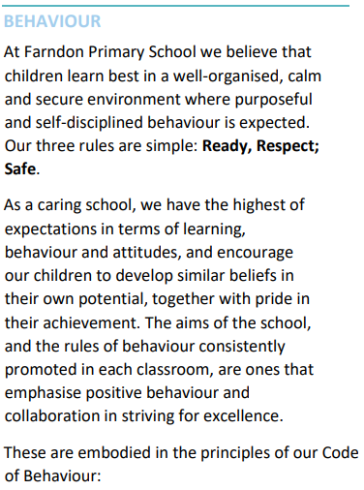
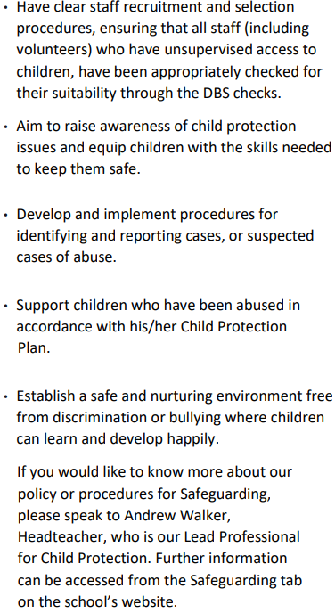
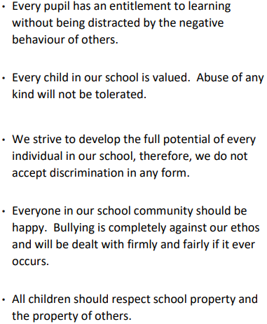
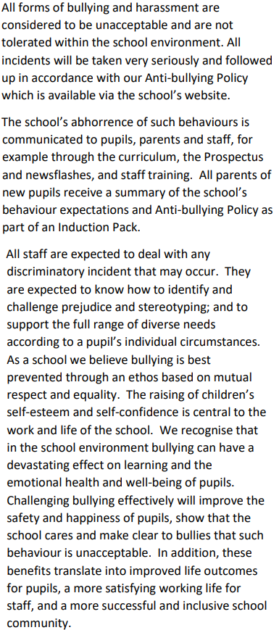
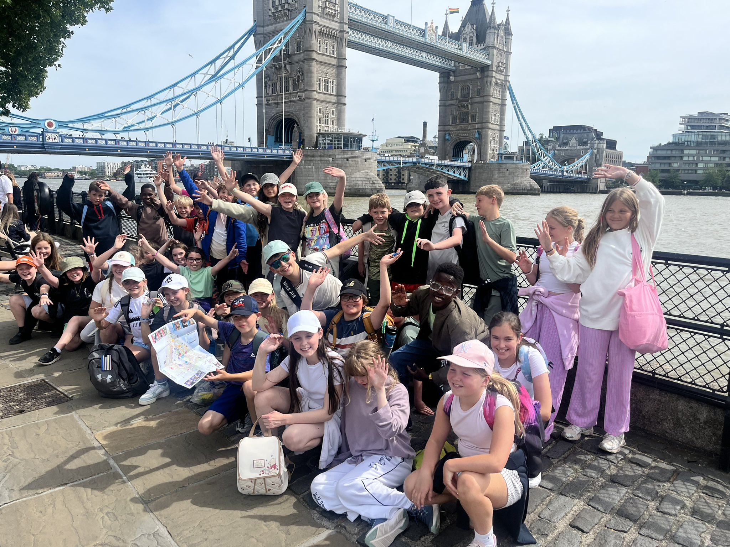
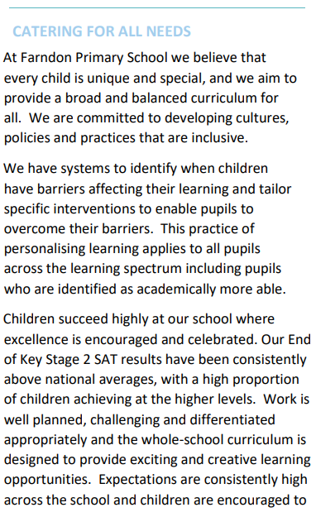

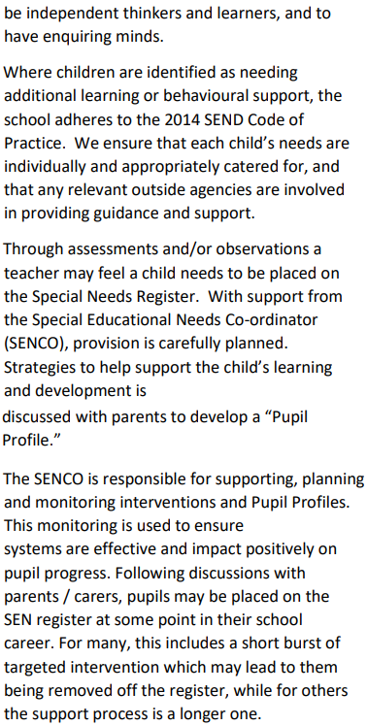
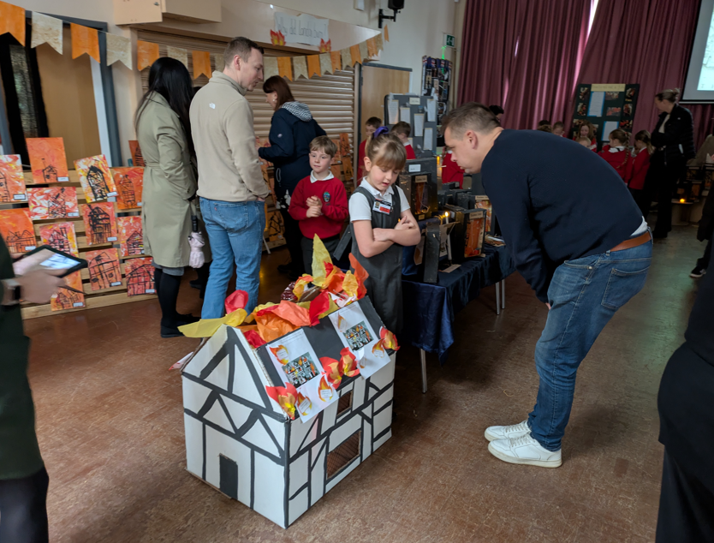
What did our parents say last year…….
In a recent questionnaire, 98% of parents said that their child makes good progress in our school and 62% of these parents strongly agreed.
One parent said, “My child continues to thrive and make good progress and generally doing well in all aspects of school. His love of learning is repeated everyday and he never fails to amaze us with his growing knowledge.”
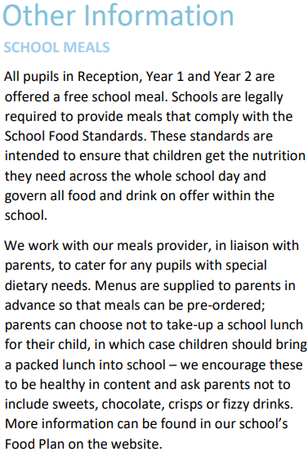

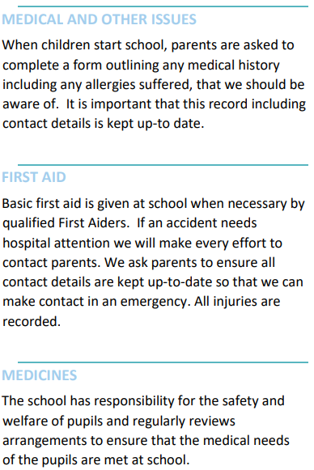
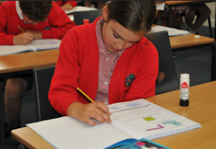
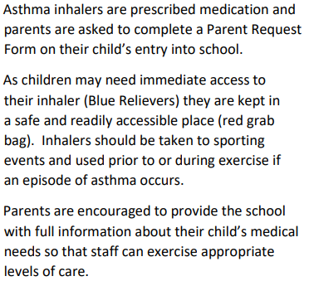
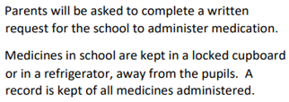
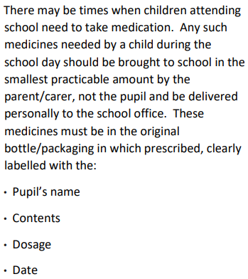

Essential School Information

TEACHING STAFF WITHIN SCHOOL

TEACHING STAFF
Name | Role | Responsibility
Mr A Walker | Headteacher | Assessment / Safeguarding / Technology
Mrs S Wakefield | Deputy Headteacher | Curriculum / Pastoral Leader / Literacy
Mrs N Pimparel | Year 2 Teacher | Inclusion Leader
Mrs S Water | Year 6 Teacher | Geography Leader
Mrs L Cooper | Year 5 / 6 Teacher | Maths Leader
Mrs L Wyllor (PT) | Year 5 Teacher | Computing Leader
Miss R Case (PT) | Year 5 Teacher
Mr A Bond (PT) | Year 4 Teacher | PE and MfL Leader
Mrs L Maclean (PT) | Year 4 Teacher | Music Leader
Miss P Jarrett | Year 3/4 Teacher | History Leader
Mrs R McCarthy (PT) | Year 3 Teacher | RE Leader
Mrs M Hardwick (PT) | Year 3 Teacher | Art and Design Leader
Mrs E Davies (PT) | Year 2 Teacher | Pupil Premium Leader
Mrs P Axon | Year 1/2 Teacher | Phonics Leader
Miss C Stephens | Year 1 Teacher | Science Leader
Mrs V Bayley | EYFS Teacher | Early Years Leader
Mrs P Chapman | EYFS Teacher | Speech and Language; EYFS Reading Leader
Mrs A Pomerantz | EYFS Teacher | Mental Health Leader
Miss Jackson | Pre School Teacher | SMSC Leader

Teaching Assistants
Name | Role | Responsibility
Mrs M Edmond | Teaching Assistant | Early Years Specialist
Miss E Baker | Teaching Assistant | Early Years Specialist
Miss L Brown | Teaching Assistant | ELSA Social and Emotional support
Mrs B Waters | Teaching Assistant | First Aid and Medicines
Mrs P Cook | Teaching Assistant | Phonics and Early Reading
Mrs K Barnes | Teaching Assistant | Newspaper; Safety Officers; ELSA
Mrs K Richards | Teaching Assistant | ELKLAN and Speech and Language
Mrs N Green | Special Needs TA | 1 to 1 Support
Mrs F Mitchell | Special Needs TA | 1 to 1 Support
Ms R Hillyer | Special Needs TA | 1 to 1 Support
Mrs K Credidio | Special Needs TA | 1 to 1 Support
Support Staff
Mrs S Ames | School Bursar | School finance and ordering
Miss J Diamond | School Admin | School Dinners; Attendance; Pre School
Mr M McCann | Site Manager | Health and Safety; Premises
FACE Before and After School Club
Mrs S Roderick | FACE | Bookings Manager
Miss S Gaskell | FACE | Before and After School Manager
Mrs D Lowe | FACE | Playleader
Mrs D Parry | FACE | Playleader
Mrs N Green | FACE | Playleader
Miss L Nicholas | FACE | Playleader
Mrs W Winnard | FACE | Playleader
Midday Assistants
Mrs N Green | Midday | Midday Supervisor
Mrs D Lowe | Midday | Midday Assistant
Mrs D Parry | Midday | Midday Assistant
Miss A Salmon | Midday | Midday Assistant
Mrs W Winnard | Midday | Midday Assistant

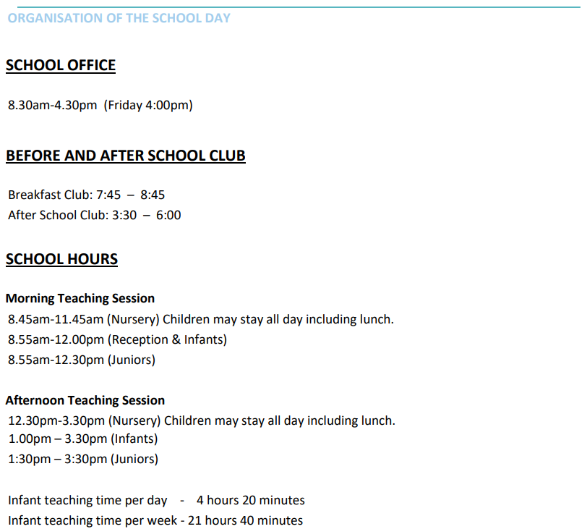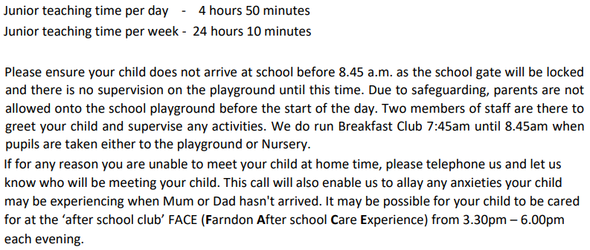

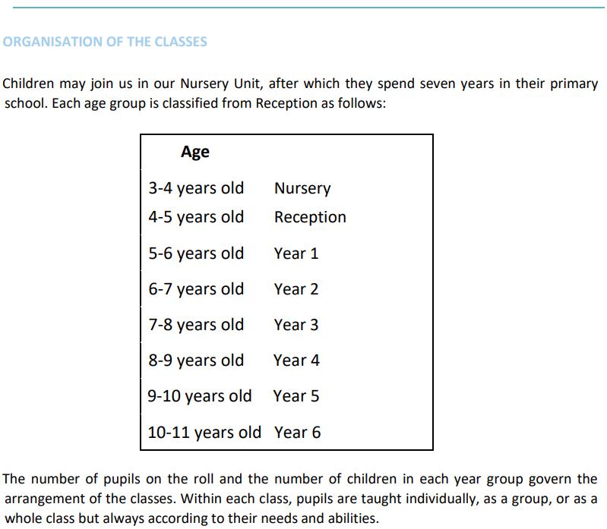
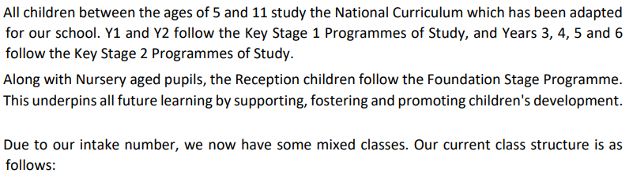
Acorns | EYFS: Pre School | Robins | Year 3
Ladybirds | EYFS: Reception | Ravens | Year 3 and 4
Caterpillars | EYFS: Reception | Wrens | Year 4
Foxes | Year 1 | Owls | Year 5
Squirrels | Year 1 and 2 | Kingfishers | Year 5 and 6
Hedgehogs | Year 2 | Kestrels | Year 6

Key Stage 2 2025 - 2026
Reading | EOKS1 | School  2026 | School 2025 | National  2026 | EOKS1 | School  2026 | School 2025 | National  2026
Reading | Expected+ | Exp | Exp | Exp | Exceeding | Higher Standard | Higher Standard | Higher Standard
104.93 | 74% | 68% | 70% | 75% | 35% | 32% | 33% | 33%

Maths | EOKS1 | School  2026 | School 2025 | National  2026 | EOKS1 | School  2026 | School 2025 | National  2026
Maths | Expected+ | Exp | Exp | Exp | Exceeding | Higher Standard | Higher Standard | Higher Standard
103.76 | 74% | 64% | 80% | 75% | 24% | 30% | 23% | 26%

Writing | EOKS1 | School  2026 | School 2025 | National  2026 | EOKS1 | School  2026 | School 2025 | National  2026
Writing | Expected+ | Exp | Exp | Exp | Exceeding | Higher Standard | Higher Standard | Higher Standard
Writing | 59% | 68% | 65% | 73% | 18% | 7% | 8% | 13%

Grammar | EOKS1 | School  2026 | School 2025 | National  2026 | EOKS1 | School  2026 | School 2025 | National  2026
Grammar | Expected+ | Exp | Exp | Exp | Exceeding | Higher Standard | Higher Standard | Higher Standard
104.1 |  | 73% | 80% | 74% |  | 21% | 23% | 23%

Combined Reading, Writing and Maths
Expected School | Expected National | Higher Standard School | Higher Standard National
55.4% | 63% | 6.8% | 8%

Achievement in Year 4 Multiplication Check 2026
Multiplication Test Check (MTC) 2026
Average score out of 25 | All | National (25) |  | Boys |  | Girls |  | FSM (6)
Average score out of 25 | 21.0 | 21.0 |  | 20.95 |  | 15.24 |  | 21.0
% Full Marks | 33% | 37% |  | 40% |  | 27% |  | 33%
Amount of pupils in each range
Below 10 | 10-15 |  | 15-19 |  | 20-24 |  | 25
0 | 5 |  | 8 |  | 18 |  | 15

Achievement in Year 1 Phonics Check 2026
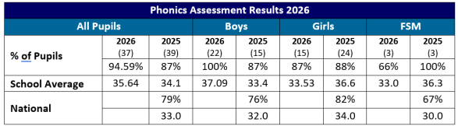

Achievement in Reception 2026

Listening and Attention | Speaking | Self Regulation | Managing Self | Building Relationships | Gross Motor Skills | Fine Motor Skills | Comprehension | Word Reading | Writing | Number | Numerical Patters | Good Level of Development
100% | 95% | 89% | 100% | 100% | 98% | 93% | 89% | 73% | 82% | 71% | 71% | 70%


School Visits:
- Jodrell Bank
- Beeston Castle
- Liverpool Theatre
- New Brighton Theatre for Panto
- Threapwood
- Young Voices Co-Op Arena
- Nantwich Museum
- Chester Zoo
- Burton Mere
- British Museum Experience
- Bridgewater Hall: Strings concert
- Abbey Gate singing performance

School Project Based Learning Showcase Events:
- Dungeons and Dragons Museum in School (Yr 3/4)
- Space Exhibition to the public (Yr 5/6)
- Video created for Octonauts for life in the sea (Yr 1/2)
- Dear Zoo show (Pre School)
- Birds Presentations to public (Rec)
- Fire of London Museum (Yr 1/2)
- Interactive Map for Village Tour (Yr 3/4)
- Horrible Histories Ancient Egyptian Movie (Yr 5/6)
- Deeside Marathon (Yr 3/4)
- Songs through the decades (Yr 1/2)
- Community Litter Campaign (Rec)
Residentials:
- Year 4 Bala – Swimming; Outdoor Activities; Team building; Viriata
- Year 5 Robinwood – Rafting; Kayaking; Climbing; Team building
- Year 6 London – Cultural trip of capital city
Special Events:
- Soap Box Derby (Fund raising for Hospice)
- Gladiator Visit to School - Steel
- Macmillan Coffee Morning (Fund raising for Cancer)
- Harvest Assembly in St Chads Church (Fund raising Food bank)
- Anti-Bullying Week
- Christmas Shoe Box Appeal (Fund raising)
- Christmas Market Carol Singing
- Heber Science Fair
- SPOTacular Day for Comic Relief
- Pre School Halloween Disco
- Birds of Prey talk
- Visit by local historian
- Fire of London themed day
- PTA Halloween Disco
- Taylor Swift Concert by PTA
- Odd Socks Day for Anti Bullying Week
- Practical Science Workshops PTA
- Bright Day
- Infant Nativity performances
- Valentine’s Day bake sale
- Easter sponsored bunny hop
- Wellies for Well-being
- Local Councillor visited Rec for their Litter campaign
- Sports Day
- Swimming pool at school
- World Book Day
- PTA Auction of Promises
- Heber Arts Festival
- Bikeability
- PTA Summer Festival
- Rushbearing Dance in Community
- Olympics Day

Sporting Success in Academic Year 2025 - 26:
- Yr 3/4 Heber Indoor Athletics Champions
- Yr 5/6 Heber Rugby Tournament Runners Up
- Yr 3/4 Heber Rugby Tournament Runners Up
- Yr 5/6 Heber Hockey Tournament Runners Up
- Under 11s Girls Football Chester Tournament Bronze Medal
- Yr 5/6 County SSP Indoor Athletics Runners Up
- Yr 5/6 Heber Handball Tournament Runners Up
- Yr 5/6 Heber Netball Tournament Champions
- Cheshire Cross Country: 2 Golds medals; 3 Bronze medals
- Under 9s Girls Football Chester Tournament Bronze Medal
- Under 11s Boys CWAC Football League Runners Up
- Yr 1 Chester SSP Football Tournament Champions
- Yr 3/4 Heber Football Tournament Champions
- Yr 1/2 Heber Football Tournament Champions
- Yr 5/6 County SSP Rounders Tournament Runners Up
- Yr 5/6 County SSP (B) Netball tournament Champions
- Cheshire District Athletics: 1 Gold; 1 Silver; 2 Bronze

