 Unlocking the potential…
Achievement Report Academic Year 2025 - 2026

-Year 1 Phonics Screening Check

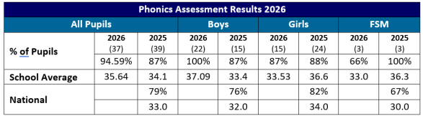

Year 4 Multiplication Test Check

Multiplication Test Check (MTC) 2026
Average score out of 25 | All | National (25) |  | Boys |  | Girls |  | FSM (6)
Average score out of 25 | 21.0 | 21.0 |  | 20.95 |  | 15.24 |  | 21.0
% Full Marks | 33% | 37% |  | 40% |  | 27% |  | 33%
Amount of pupils in each range
Below 10 | 10-15 |  | 15-19 |  | 20-24 |  | 25
0 | 5 |  | 8 |  | 18 |  | 15

Year 6 Standardised Assessment Tests (SATs)

Reading | EOKS1 | School  2026 | School 2025 | National  2026 | EOKS1 | School  2026 | School 2025 | National  2026
Reading | Expected+ | Exp | Exp | Exp | Exceeding | Higher Standard | Higher Standard | Higher Standard
104.93 | 74% | 68% | 70% | 75% | 35% | 32% | 33% | 33%

Maths | EOKS1 | School  2026 | School 2025 | National  2026 | EOKS1 | School  2026 | School 2025 | National  2026
Maths | Expected+ | Exp | Exp | Exp | Exceeding | Higher Standard | Higher Standard | Higher Standard
103.76 | 74% | 64% | 80% | 75% | 24% | 30% | 23% | 26%

Writing | EOKS1 | School  2026 | School 2025 | National  2026 | EOKS1 | School  2026 | School 2025 | National  2026
Writing | Expected+ | Exp | Exp | Exp | Exceeding | Higher Standard | Higher Standard | Higher Standard
Writing | 59% | 68% | 65% | 73% | 18% | 7% | 8% | 13%

Grammar | EOKS1 | School  2026 | School 2025 | National  2026 | EOKS1 | School  2026 | School 2025 | National  2026
Grammar | Expected+ | Exp | Exp | Exp | Exceeding | Higher Standard | Higher Standard | Higher Standard
104.1 |  | 73% | 80% | 74% |  | 21% | 23% | 23%

Combined Reading, Writing and Maths
Expected School | Expected National | Higher Standard School | Higher Standard National
55.4% | 63% | 6.8% | 8%

