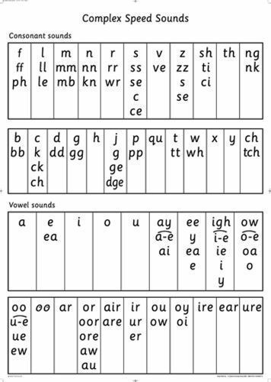
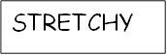
BOUNCY
STRETCHY

