

School Uniform Policy

Updated: March 2025
To be reviewed: September 2027
Author: Andy Walker

Farndon Primary School

EQUALITY SCHEME
EQUALITY IMPACT ASSESSMENT FOR
SCHOOL UNIFORM POLICY

Staff / Committee involved in development: |  | Leadership and Management Committee  Headteacher
For use by: |  | Staff, Governors and Parent/Carers
This policy relates to statutory guidance: |  | Education Act 2011  Human Rights Act 1998  Equality Act 2010  The General Data Protection Regulation  Data Protection Act 2018  DfE (2014) ‘School Admissions Code’  DfE (2024) ‘School Uniform’
Key related Farndon Policies: |  | Behaviour Policy  Complaints Policy  Safeguarding Policy  Home School Agreement
Equality Impact Assessment: Does this document impact on any of the following groups? If YES, state positive or negative impact, and complete an Equality Impact Assessment Form or action plan, and attach.
Groups: | Yes/ No |  | Positive/Negative impact
Disability | No
Race | No
Gender | No
Age | No
Sexual Orientation | Yes |  | The uniform is not split into gender
Religious and Belief | Yes |  | The school does not discriminate against any religion.
Gender Reassignment | No
Marriage & Civil Partnership | No
Pregnancy & Maternity | No
Other | No
Reviewed by |  | Headteacher
Agreed by |  | L+M Governors
Next Policy review date |  | September 2027
A copy of this form, and any related impact assessment form or action plan must be sent to the school office

Contents

Statement of Intent
Legal Framework
Key Personnel in Relation to this Policy
Roles and Responsibilities
Governing Board
Head Teacher
Teaching and support staff Parents/carers
Pupils
Cost and Availability
Religious Clothing
Equality
Complaints and Challenges
School Uniform Supplier
Compliance
Our Uniform
Our PE Kit
Jewellery
School Bag
Water Bottle
Hair Styles
Make-Up
Adverse Weather
Hot Weather
Cold Weather
Labelling

Statement of Intent

Farndon Primary School is committed to promoting equality and value for money and to ensuring that no child is discriminated against due to their religion or belief, economic circumstances or social and cultural background. This policy contains provisions to meet these objectives and has been created with health and safety, value for money and practicality at its heart. Additionally, it is important that our pupils feel a sense of belonging to our school. We believe that wearing a smart and practical uniform allows all children, regardless of their backgrounds, to feel equal to their peers and confident in their appearance. We also believe it is important for children to wear clothing that is conducive to a successful learning environment, including activity-appropriate clothing, such as sports attire.

Roles and Responsibilities

The Governing Board is responsible for:

- In consultation with the Head Teacher and school community, establishing a practical and smart school uniform that accurately reflects the school’s vision and values.
- Ensuring that equal opportunities are considered regarding the school’s uniform and that no person is discriminated against.
- Listening to the opinions and wishes of parents/carers, pupils and the wider school community regarding changes to the school’s uniform.
- Ensuring that the school’s uniform is accessible, affordable and durable.
- Ensure that the school keeps branded items to a minimum.
- Ensure that second-hand uniforms are available for parents to acquire. This information should be clear for parents of current and prospective pupils and published on the school’s website

The Head Teacher is responsible for:

- Enforcing the school’s uniform on a day-to-day basis.
- Ensuring that school staff understand this policy and know what to do if a pupil is in breach of the policy.
- Listening to the opinions and wishes of the school community regarding the school’s uniform and making appropriate recommendations to the Governing Board.
- Providing pupils with exemptions as appropriate e.g. for a pupil who has a broken arm and requires a loose-fitting top.

Teaching and support staff are responsible for:

- Ensuring that pupils dress in accordance with this policy at all times.
- Taking appropriate action when pupils are in breach of this policy.
- Ensuring that pupils understand why having a consistent and practical school uniform is important e.g. to establish school identity.

Parents/carers are responsible for:

- Providing their children with the correct school uniform as detailed in this policy.
- Informing the Head Teacher if their child requires a more relaxed uniform policy for a period of time, including why.
- Ensuring that their child’s uniform is clean, presentable and the correct size.

Pupils are responsible for:

- Wearing the correct uniform at all times, unless the Head Teacher has granted an exemption.
- Looking after their uniform as appropriate.
- Respecting why a school uniform is important to the school e.g. to develop a sense of belonging.

Cost and Availability

In accordance with the DfE’s Developing School Uniform Policy, Farndon Primary School ensures that our Policy does not discourage parents/carers from applying for a place for their child.

The school is committed to meeting the DfE’s recommendations on costs and value for money. Every care is taken to ensure that our uniforms are affordable for all current and prospective pupils, and that the best value for money is secured through reputable suppliers.

Our school uses Uniformity to obtain the best value for money and to ensure our uniform costs are reasonable and affordable. Through the tendering process, we believe that the garments provided by Uniformity are also high quality and very durable. Any savings negotiated are passed to parents where possible. The school does not amend uniform requirements regularly and takes the views of parents/carers and pupils into account when considering changes to school uniforms. Where changes are required, the school ensures that assistance is provided to parents/carers struggling to meet the associated costs.

Religious Clothing / Ceremonial Wear

Some religions and beliefs require their members to conform to a specific dress code. The school does not discriminate against any religion or belief; however, the school weighs the needs and rights of individual pupils against the health and safety concerns of the entire school community. Farndon Primary School endeavours to allow religious requirements to be met, wherever possible. Governors have adopted a policy for the wearing of Ceremonial Wear. We ask parents to make an appointment with the Head / Deputy to discuss the policy and to make any requests for Ceremonial wear to be worn in school. Parents’/carers’ concerns and requests regarding religious clothing are dealt with on a case-by-case basis by the Head Teacher and Governing Board. This is always conducted in accordance with the school’s Complaints Policy.

Equality

The school is required to ensure that this policy does not discriminate unlawfully. Every step has been taken to ensure that the cost of similar uniform items, for example, trousers versus skirts, are not disproportionate. The school endeavours to ensure that our uniform is as gender neutral and inclusive as possible. We do not insist that children of any sex must wear specific items of clothing.

Complaints and Challenges

The school endeavours to resolve all uniform complaints and challenges locally and informally, in accordance with the school’s Complaints Policy. To make a complaint, parents/carers should refer to the Complaints Policy and follow the stipulations outlined.

When a complaint is received, the school works with parents/carers to arrive at a mutually acceptable outcome. Governors are willing to consider reasonable requests for flexibility to allow a pupil to accommodate particular social and cultural circumstances.

Non-Compliance

If a child breaches the school uniform or P.E uniform policy, a member of staff will discreetly talk to them to find out why they are not in uniform and to remind them of the need to wear one. Should it happen again, teachers will send home a letter that reminds parents about the school’s uniform policy.

If the breeches of the school uniform policy continue, the Class Teacher and / or Head Teacher may deem it necessary to contact parents/carers. The school will endeavour to establish the reasons for non-compliance and will be sensitive if parents are in financial difficulty. The school may give missing items of uniform, if available, to ensure that children do not feel discriminated against should parents be unable or unwilling to provide them with the required items of uniform.

If a child forgets their PE kit, the school will endeavour to contact parents/carers to bring some into school. Failing that, the child will do P.E. in their school uniform. Missing a P.E. lesson is not an option. If a child forgets their swimming kit, school will attempt to contact parents/ carers to bring a swimming kit to school immediately. We understand that there may be some exceptional and unavoidable situations where children may have to come to school without a part of their school or P.E uniform (e.g. if it has been lost or damaged). If this is the case, we ask parents to contact us on the day to confirm the reason. No child will be disciplined for non-compliance because of their particular cultural, race or religious dress code.

Inclusion

The school welcomes children from all backgrounds and faith communities. All children have equal access to wearing school uniform regardless of their race, religion, gender, disability or ability. If there are serious reasons, for example religious objections, why parents want their child to wear clothes that differ from the school uniform, the school will look sympathetically at such requests. Similarly, should an item of school uniform prove problematic for a child with disabilities then parents are invited to draw this to the attention of the Headteacher. The school will not treat children with disabilities unfavourably. Farndon Primary School is committed to creating a positive climate that will enable everyone to work free from racial intimidation, discrimination and harassment and to achieve their full potential

Our School Uniform

Items that are available to buy will be on the Uniformity website (https://www.uniformityschools.com/collections/farndon-primary-school) and all of them will include the School's embroidered badge: As a minimum, we ask that all pupils have the embroidered badge logo for the Jumper / Cardigan.

Red jumper.
Red cardigan.
White polo shirt.

Below is the full School Uniform list for our pupils (available on Uniformity website). Parents may also wish to buy these from other outlets.

grey skirt / pinafore dress
grey trousers / grey shorts
grey or white socks
grey, black or red tights
red and white summer dress
black polishable shoes

Our PE Kit

Children are asked to come into school on the day of their PE lesson wearing their PE kit. They can wear it for the full school day. Parents/carers are responsible for ensuring their child is dressed appropriately for PE.

As a minimum, we ask that all pupils have the embroidered badge logo for the Red Cool PE top; and Black PE sports top. The PE kit available at Uniformity is as follows:

- Plain cool red PE T-shirt (with school logo)
- Black ¼ zip PE Sports top (with school logo)

Below is the full School Uniform list for our pupils (available on Uniformity website). Parents may also wish to buy these from other outlets.

- Black jogging pants
- Black shorts shadow black
- Primary Skort Black
- Black plimsolls (for indoor).
- Plain, suitable trainers

Jewellery
Jewellery rings, necklaces, bracelets and earrings can pose a hazard in school:
- Wearing of jewellery can result in tearing or piercing of flesh;
- There is a potential for injury to the wearer due to inadvertent contact of jewellery with other people, clothing etc;
- There is a risk to other people especially at playtimes and PE lessons where injury could occur due to contact with jewellery worn by another person;
- There is a risk of injury to the wearer from removing tape used to cover jewellery if the tape pulls the jewellery as it is removed.
We do of course recognise exceptional circumstances. Jewellery may be worn if required for medical reasons, e.g. a medical bracelet.
At Farndon Primary School we ask that children do not wear unnecessary and possibly expensive jewellery. Children are able to wear watches and they may choose to wear a single plain gold or silver, stud earring (for each ear). Where children come into school with jewellery that doesn’t follow this policy, staff will ask them to remove it and it will be kept safe in a box within the classroom cupboard.
For pupils who are participating in P.E., swimming, sports clubs and /or physical activities we ask that they do not come to school wearing earrings on those days. If they do, pupils will be asked to remove earrings and to store them in the classroom cupboard. Staff are not permitted to remove or insert earrings on health and safety grounds.
If your child wishes to have his/her ears pierced, then please ensure that this is done at the beginning of the 6 week summer break to allow plenty of time for wounds to heal. If a child has had their ears pierced and they are still within the 6 weeks healing period where they cannot take them out, they will be unable to do PE.

School Bag

Pupils must use an appropriately sized waterproof bag to carry their books and equipment. It should hold children’s books and reading diaries comfortably without causing any damage. Large bags / large rucksacks are discouraged for day-to-day lessons due to space on children’s pegs. School bags featuring inappropriate images, slogans or phrases are not permitted. The school encourages pupils to bring non-valuable bags to school. The school will not be liable for lost or damaged school bags. Additional book bags can also be purchased from the Uniformity website.

Water Bottle

All children are encouraged to bring a water bottle into school every day: this can be refilled by children whenever necessary during the day. Water bottles must be labelled with the pupil’s name. Water fountains are available in both buildings.

Hair Styles
Hairstyles should be reasonable and appropriate for being in a learning environment at school. Long hair (below shoulder length) should be tied back. Hair accessories should be minimal, plain and if possible in school colours. Hair should be kept out of children’s eyes using headbands, clips and slides; again plain using school colours.
During term-time pupils are asked not to have fashion hairstyles which include the following: shaved very short, dyed or streaked hair, patterns, mohawks, lines and tramlines. Hair braids, tinsels and feathers should also not be worn.
Where ‘lines’ have been cut into their hair during a holiday period, these should be allowed to grow out/ be cut out for the return to school.
Inclusion for Hair Styles
The school welcomes children and families from all backgrounds and faith communities. All children have equal access to our policies regardless of their race, religion, gender, disability or ability. If there are serious reasons, for example religious or cultural objections, why parents want their child to wear their hair that differ from the school policy, the school will look sympathetically at such requests

Make-Up

Makeup and cosmetics are not considered appropriate or consistent with our school uniform and therefore should not be worn. Nail varnish, Gel nails or false nails should not be worn in school.

Adverse Weather

Hot Weather

Everyone working at/attending the school during hot weather conditions is required to wear sun-safe clothing that covers as much of their skin as possible.

This includes wearing:

- Loose fitting tops with collars or covered necklines
- Tops that cover the shoulder area
- Grey or black shorts or red and white summer dresses of an appropriate length (if families wish to)
- Sun-safe hats
- Sunglasses with UV protection
- Sunscreen (Parents are encouraged to apply before school starts. Children must be able to apply this themselves and it must be labelled and handed to the child’s class teacher)

During hot weather, lightweight clothing is required to reduce the risk of overheating. Pupils are not required to wear their jumpers/cardigans during heatwaves. This also applies to members of staff.

If outside during break and lunch times, pupils not wearing sun-safe clothing/sunscreen are advised to stay in an area protected from the sun.

Cold Weather

During cold weather, pupils are required to wear scarves, gloves, coats and hats when they are outside. Additional layers underneath the usual school uniform are accepted. Where possible, pupils not wearing warm clothing are provided with spare clothing if going outside during break and lunch times.

In the event of snow, pupils without wellington boots or other forms of suitable footwear will not be allowed outside.

Labelling

School staff encourage good organisation of clothing and footwear, for example, designated spaces for children to keep belongings in and checking of labels. However, all pupils’ clothing and footwear must be clearly labelled with their name. Clothing labels are available on the Uniformity website. Clothing and footwear are the responsibility of the pupil and not the school. If a child goes home in another child’s clothing by accident, for example, their jumper, parents/carers should send the clothing not belonging to them back into school to their child’s class teacher. Any lost clothing which isn’t clearly labelled is to be taken to the lost property box. All lost property is retained for a term and then recycled into use via the school’s PTA.

Winter | Summer | Physical Education
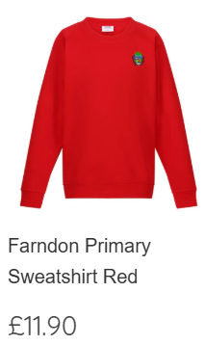  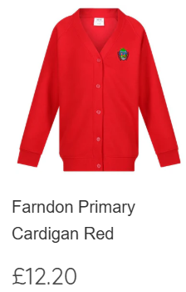  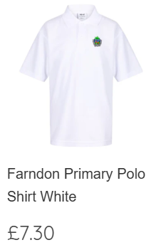  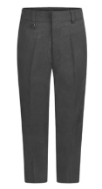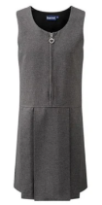  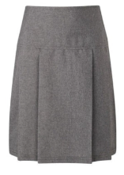 | 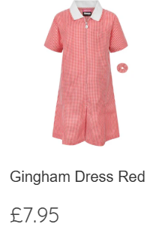  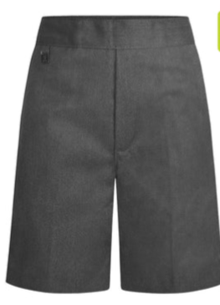 | 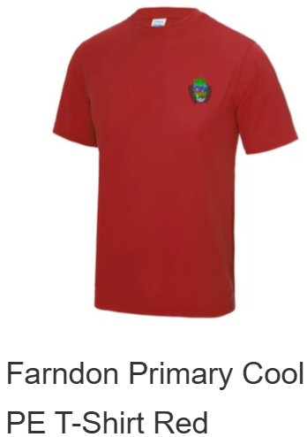  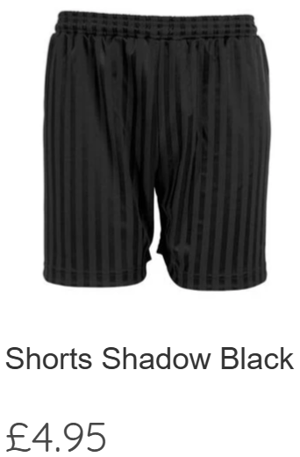  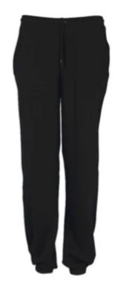  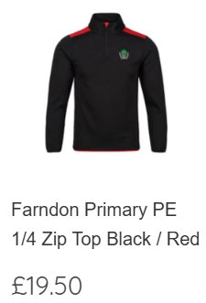

Other “Optional” Items available through Uniformity
