What’s been going on and how much have we raised to date?

Halloween disco  £433 raised   | End of month treats x2  £110 raised  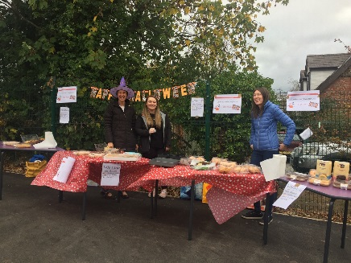 | Christmas Fair and Cards  £2,500 raised  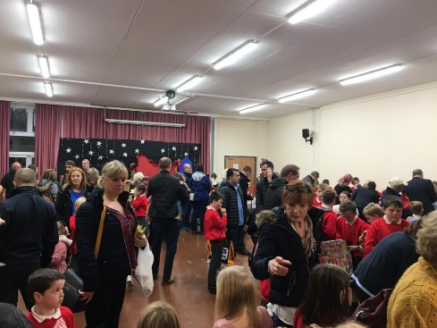
A massive thankyou to you all for supporting the PTA initiatives.
We had our most profitable Christmas fair ever!


With the money raised to date, we have been able to contribute:

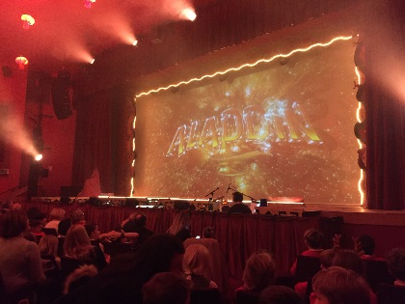 |  | 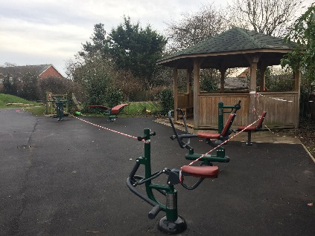
£800 to cover the transport to the Panto | £300 for early years resources for Reception | £11,000 to outdoor equipment which will be finished this half term

Dates for the diary – Events

Friday 8th March  @ 2pm | March PTA Meeting  (all welcome)
Friday 15th March | Non-Uniform Day  (£1 or Easter Egg donation please)
Thursday 28th March  (Doors open 5pm  Eyes down @ 5.30pm) | Easter Bingo @ Farndon Community Centre
Friday 29th March  (and every Half Term) | Tuckshop

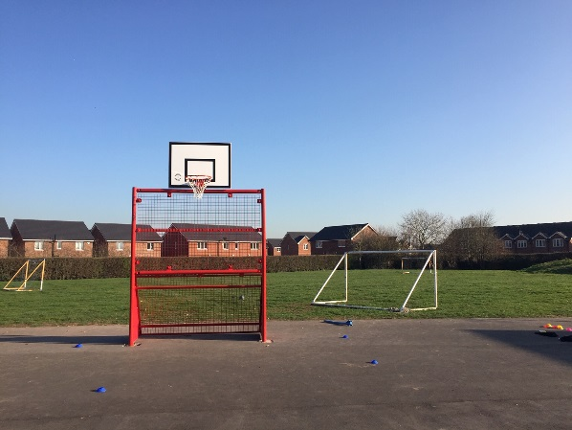 | 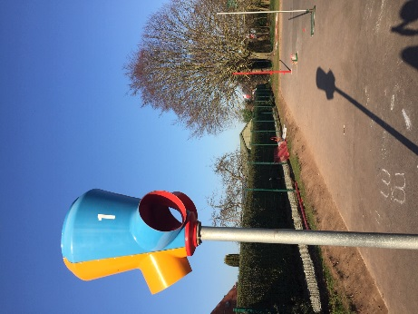

We would like to continue to support our Children at Farndon School, by raising more PTA funds through fun events. WE NEED YOUR HELP to enable us to achieve this. If you would like to help, please come along to the next PTA meeting or contact Portia Clarke or Fiona Moulding through the school office or via the Facebook page.

