The Autism Service
Transition to High School Online Event
(Via Microsoft Teams)
Date: 11.2.25 Time: 10am– 2pm

We are inviting all parents, carers and professionals supporting children in years 4, 5 and 6 to attend.

What’s happening?

There will be opportunities to attend workshops via Microsoft Teams and these will be delivered by The Autism Service Teachers. Workshops will include:

- Supporting organisation and independence
- Developing strategies to address emotional well-being
- Supporting the communication needs of the young person

There will also be information provided by High school and Primary school SENCOs focusing on effective joint parent/school working. There will be regular breaks throughout the day.

Following the event you will receive a copy of The Autism Service Transition to High School Pack, and this will be a useful tool to use with the child you are supporting.

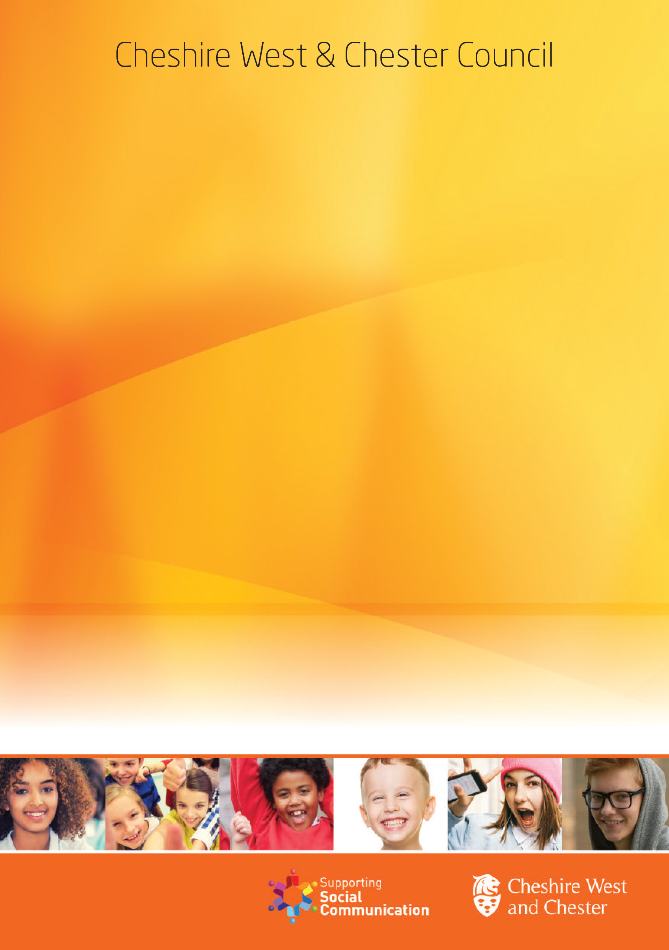
https://www.smartsurvey.co.uk/s/tranhigh1102/
To apply please click on the link below OR scan the QR code to complete the short application form.
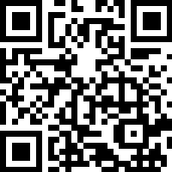
Please note that the closing date for applications will be Tuesday 4th February You will receive your link and any visual pre course information by Friday 7th February 2025.

