KEY STAGE 1 | Addition and subtraction | Multiplication and division
Year 1 | The principal focus of mathematics teaching in key stage 1 is to ensure that pupils develop confidence and mental fluency with whole numbers, counting and place value.
Statutory | - count to and across 100, forwards and backwards, beginning with 0 or 1, or from any given number  - given a number, identify one more and one less  - represent and use number bonds and related subtraction facts within 20  - add and subtract one-digit and two-digit numbers to 20, including zero  - solve one-step problems that involve addition and subtraction, using concrete objects and pictorial representations, and missing number problems such as 7 = □ - 9. | - count in multiples of twos, fives and tens  - recognise, find and name a half as one of two equal parts of an object, shape or quantity  - recognise, find and name a quarter as one of four equal  parts of an object, shape or quantity  - solve one-step problems involving multiplication and division, by calculating the answer using concrete objects, pictorial representations and arrays with the support of the teacher.  - find half of an object, shape or quantity  - find a quarter of an object, shape or quantity
Non-statutory guidance | - pupils memorise and reason with number bonds to 10 and 20 in several forms (e.g. 9 + 7 = 16; 16 - 7 = 9; 7 = 16 - 9). They should realise the effect of adding or subtracting zero. This establishes  addition and subtraction as related operations.  - pupils combine and increase numbers, counting forwards and backwards. | - doubling numbers and quantities  - finding simple fractions of objects, numbers and quantities.
Exemplification and suggested ideas/resources  Exemplification and suggested ideas/resources | e.g. 4 + 6 = 5 + 5, 3 + □ = 12  12 + 4, 18 – 9, 10 + 10  equivalence, pattern  use of balance scales, Numicon, bead strings/double bead-bar unifix, coat-hanger and pegs, number track, counting stick, hundred square      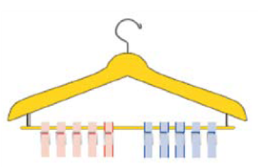   =  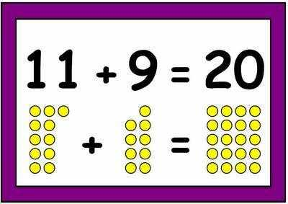  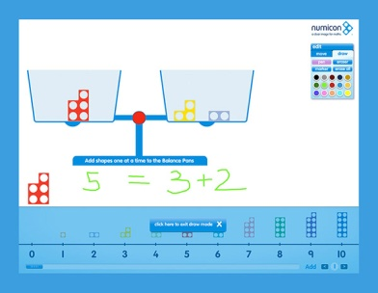  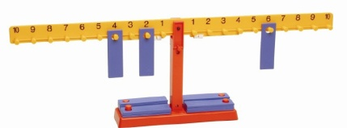  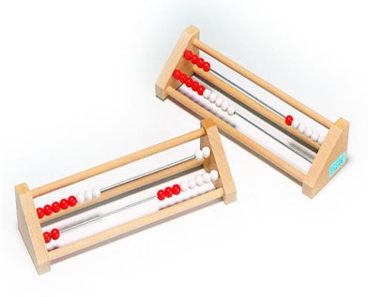 | e.g. double 6, double 9  ½ of 10, ¼ of 8  patterns in the number system and arrays, odd and even  counting stick, hundred square, multiplication square, Numicon, unifix, comparing tower, multi-link, counters, function machines  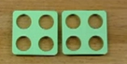  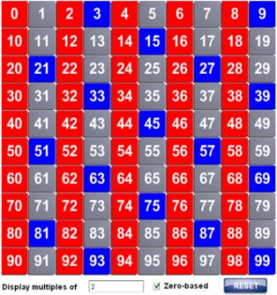  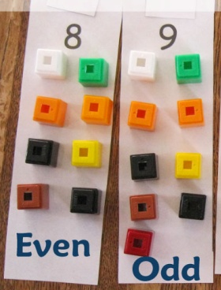  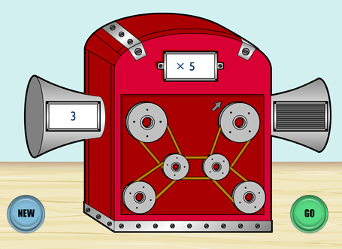  

KEY STAGE 1 | Addition and subtraction | Multiplication and division
Year 2 | By the end of year 2, pupils should know the number bonds to 20 and be precise in using and understanding place value. An emphasis on practice at this early stage will aid fluency.
Statutory | - recall and use addition and subtraction facts to 20 fluently, and derive and use related facts up to 100  - add and subtract numbers using concrete objects, pictorial representations, and mentally, including:  ▪ a two-digit number and ones  ▪ a two-digit number and tens  ▪ two two-digit numbers  ▪ adding three one-digit numbers  - solve problems with addition and subtraction:  - using concrete objects and pictorial representations, including those involving numbers, quantities and measures  ▪ applying their increasing knowledge of mental and written methods | - count in steps of 2, 3, and 5 from 0, and in tens from any number, forward or backward  - recall and use multiplication and division facts for the 2, 5 and 10 multiplication tables, including recognising odd and even numbers  - solve problems involving multiplication and division, using materials, arrays, repeated addition, mental methods, and multiplication and division facts, including problems in contexts.  - recognise, find, name and write fractions 1/3, ¼, 2/4, ¾ and of a length, shape, set of objects or quantity
Non-statutory guidance | - pupils check their calculations, including by adding to check subtraction and adding numbers in a different order to check addition (e.g. 5 + 2 + 1 = 1 + 5 + 2 = 1 + 2 + 5).  - pupils should partition numbers in different ways (e.g. 23 = 20 + 3 and 23 = 10 + 13) to support subtraction.  - pupils extend their understanding of the language of addition and subtraction to include sum and difference. | - they count in multiples of three to support their later understanding of a third.  - they begin to use other multiplication tables and recall multiplication facts, including using related division facts to perform written and mental calculations.  - pupils should count in fractions up to 10, starting from any number and using the ¹/₂ and ²/₄ equivalence on the number line (e.g. 1¹/₄, 1²/₄ (or 1¹/₂), 1³/₄, 2).
Exemplification and suggested ideas/resources  Exemplification and suggested ideas/resources | e.g. use 3 + 7 = 10, 10 - 7 = 3 and 7 = 10 - 3 to calculate 30 + 70 = 100, 100 - 70 = 30 and 70 = 100 - 30  commutative (a+b) = (b+a)and associate law (a+b)+c = a+(b+c) for addition, equivalence, pattern, partitioning, landmark numbers, bridging, inverse operations,  subtraction: take-away and comparison (finding the difference)  balance scales, Numicon, Dienes (base 10), Number line, unifix towers, counters, bead strings, place value counters/cards  Difference ITP  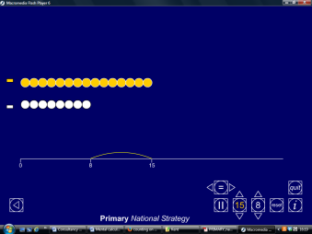  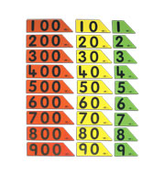  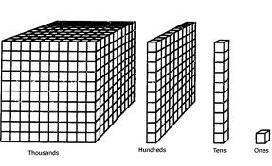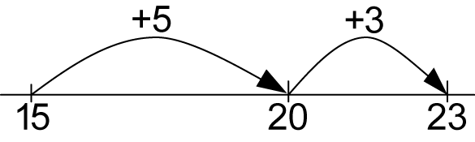  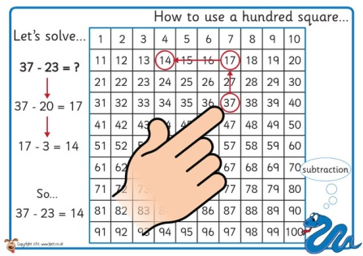   | arrays, number patterns, repeated addition, making connections to other aspects of the curriculum e.g. 5x table (time) 10x table (place value) division as sharing and grouping  counting stick, hundred square, number line, counters, multi-line, Numicon,Cuisenaire  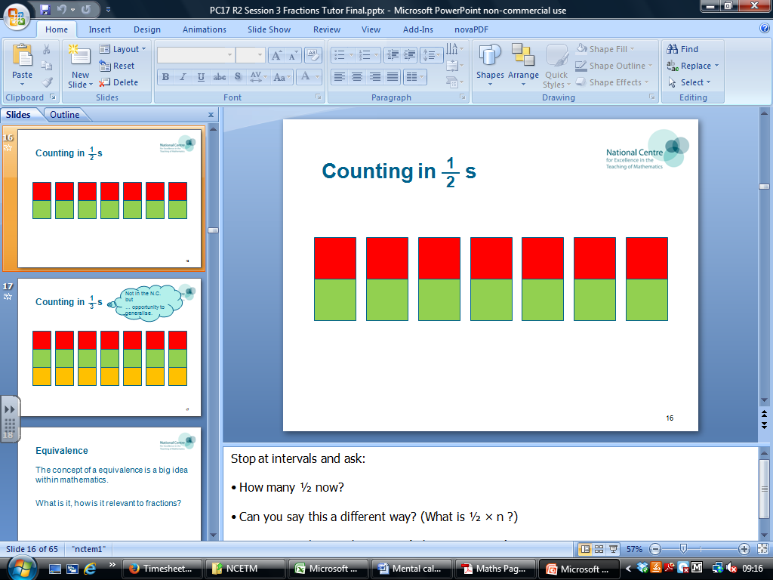  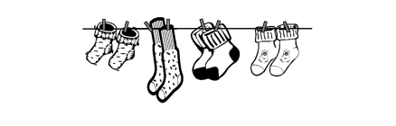  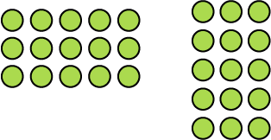    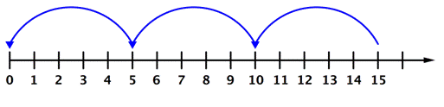  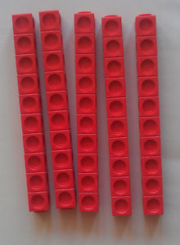  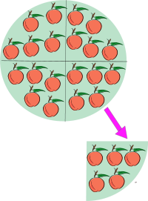

LOWER KEYSTAGE 2 | Addition and subtraction | Multiplication and division
Year 3 | The principal focus of mathematics teaching in lower key stage 2 is to ensure that pupils become increasingly fluent with whole numbers and the four operations, including number facts and the concept of place value.
Statutory | - find 10 or 100 more or less than a given number  - add and subtract numbers mentally, including:  - a three-digit number and ones  - a three-digit number and tens  - a three-digit number and hundreds  - solve problems, including missing number problems, using number facts, place value, and more complex addition and subtraction.  - count up and down in tenths  - add and subtract fractions with the same denominator within one whole (e.g. ⁵/₇ + ¹/₇ = ⁶/₇) | - count from 0 in multiples of 4, 8, 50 and 100  - recall and use multiplication and division facts for the 3, 4 and 8 multiplication tables  - write and calculate mathematical statements for multiplication and division using the multiplication tables that they know, including for two-digit numbers times one-digit numbers, using mental methods  - solve problems, including missing number problems, involving multiplication and division including positive integer scaling problems and correspondence problems in which n objects are connected to m objects  - recognise, find and write fractions of a discrete set of objects: unit fractions and non-unit fractions with small denominators
Non-statutory guidance | - pupils practise solving varied addition and subtraction questions. For mental calculations with two-digit numbers, the answers could exceed 100.  - pupils practise adding and subtracting fractions with the same denominator through a variety of increasingly complex problems to improve fluency. | - pupils now use multiples of 2, 3, 4, 5, 8, 10, 50 and 100.  - pupils continue to count in ones, tens and hundreds  - through doubling, they connect the 2, 4 and 8 multiplication tables.  - Pupils develop efficient mental methods, for example, using commutativity and associativity (for example, 4 × 12 × 5 = 4 × 5 × 12 = 20 × 12 = 240) and multiplication and division facts (for example, using 3 × 2 = 6, 6 ÷ 3 = 2 and 2 = 6 ÷ 3) to derive related facts (for example, 30 × 2 = 60, 60 ÷ 3 = 20 and 20 = 60 ÷ 3).  - Pupils solve simple problems in contexts, deciding which of the four operations to use and why. These include measuring and scaling contexts, (for example, four times as high, eight times as long etc.) and correspondence problems in which m objects are connected to n objects (for example, 3 hats and 4 coats, how many different outfits?; 12 sweets shared equally between 4 children; 4 cakes shared equally between 8 children).
Exemplification and suggested ideas/resources | e.g. 34 + 100, 65 + 47, 432 + 20, 320 - 200 Bridging, compensation, partitioning, landmark numbers  100 square, Dienes base 10, place value cards, number-line, bead string, Cuisenaire  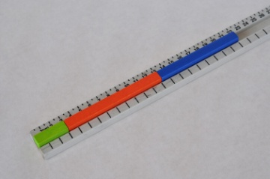  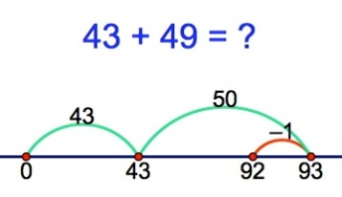  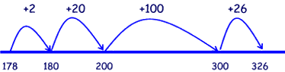  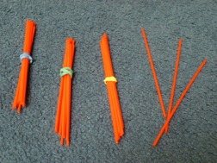  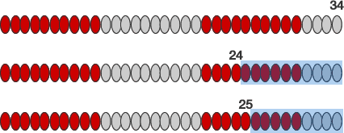  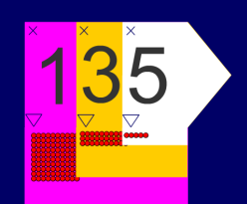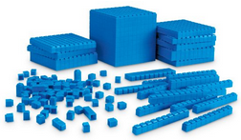  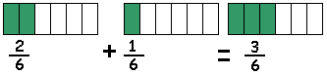  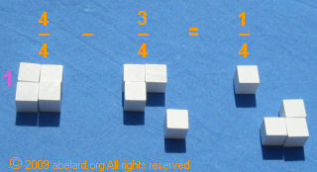 | e.g. 8 x 6, 3 x 11, 15 x 4,  commutative law, associative law, arrays, scaling  counting stick, multiplication square, Numicon, counters, multi-link  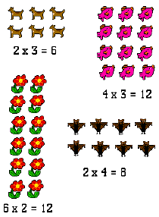    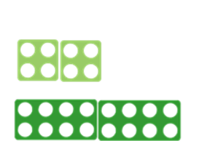  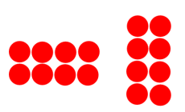  Commutative law: a x b = b x a  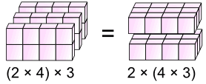  Associative law:  (a x b) x c = a x (b x c)  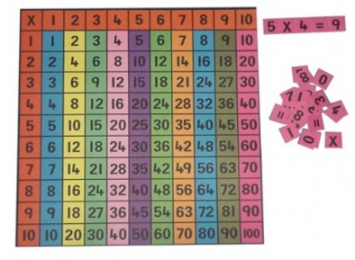  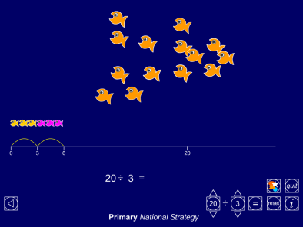  Grouping ITP

LOWER KEYSTAGE 2 | Addition and subtraction | Multiplication and division
Year 4 | By the end of year 4, pupils should have memorised their multiplication tables up to and including the 12 multiplication table and show precision and fluency in their work.
Statutory | - find 1000 more or less than a given number  - count backwards through zero to include negative numbers  - solve addition and subtraction two-step problems in contexts, deciding which operations and methods to use and why.  - count up and down in hundredths  - add and subtract fractions with the same denominator | - count in multiples of 6, 7, 9, 25 and 1000  - recall multiplication and division facts for multiplication tables up to 12 × 12  - use place value, known and derived facts to multiply and divide mentally, including: multiplying by 0 and 1; dividing by 1; multiplying together three numbers  - recognise and use factor pairs and commutativity in mental calculations  - solve problems involving multiplying and adding, including using the distributive law to multiply two digit numbers by one digit, integer scaling problems and harder correspondence problems such as n objects are connected to m objects.  - solve problems involving increasingly harder fractions  to calculate quantities, and fractions to divide quantities, including non-unit fractions where the answer is a whole number  - find the effect of dividing a one- or two-digit number by 10 and 100, identifying the value of the digits in the answer as units, tenths and hundredths
Non-statutory guidance | - pupils continue to practise mental methods for addition and subtraction with increasingly large numbers to aid fluency  - they practise counting using simple fractions and decimal fractions, both forwards and backwards. | - pupils practise mental methods and extend this to three-digit numbers to derive facts, (for example 600 ÷ 3 = 200 can be derived from 2 x 3 = 6).  - pupils write statements about the equality of expressions (e.g. use the distributive law 39 × 7 = 30 × 7 + 9 × 7 and associative law (2 × 3) × 4 = 2 × (3 × 4)). They combine their knowledge of number  facts and rules of arithmetic to solve mental and written calculations e.g. 2 x 6 x 5 = 10 x 6 = 60.  - pupils solve two-step problems in contexts, choosing the appropriate operation, working with increasingly harder numbers.
Exemplification and suggested ideas/resources | place value flip cards, counting stick, number-lines, Cuisenaire.  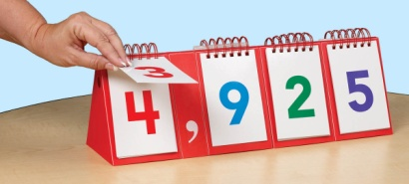  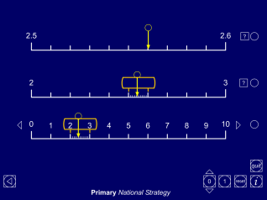  Decimal number line ITP  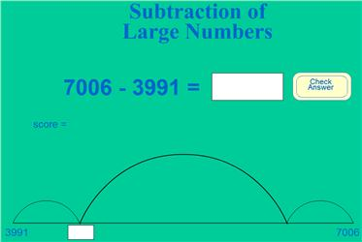  Mathszone  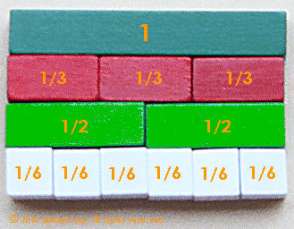  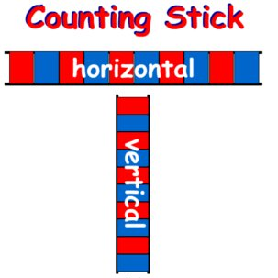 | commutative, associative and distributive laws, array, scaling, factors  Numicon, Cuisenaire, Place value cards/slider, multi-link  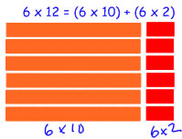  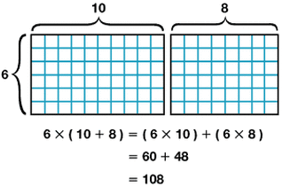  Distributive law: (a + b) x c = (a x c) + (b x c)  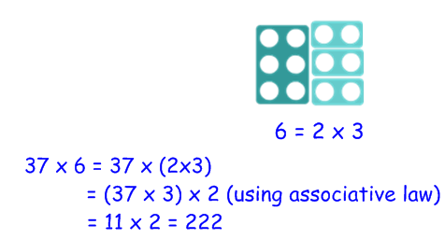  Using factor pairs  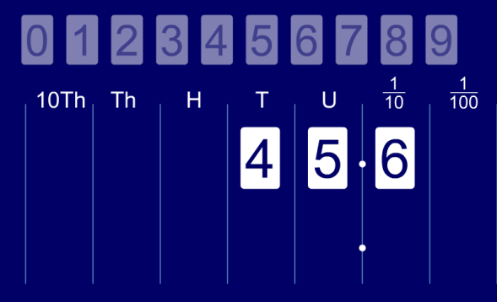  Moving digits ITP

UPPER KEYSTAGE 2 | Addition and subtraction | Multiplication and division
Year 5 | At this stage, pupils should develop their ability to solve a wider range of problems, including increasingly complex properties of numbers and arithmetic, and problems demanding efficient written and mental methods of calculation. With this foundation in arithmetic, pupils are introduced to the language of algebra as a means for solving a variety of problems.
Statutory | - count forwards and backwards with positive and negative whole numbers, including through zero  - add and subtract numbers mentally with increasingly large numbers  - solve addition and subtraction multi-step problems in contexts, deciding which operations and methods to use and why.  - solve problems involving addition, subtraction, multiplication and division and a combination of these, including understanding the meaning of the equals sign  - add and subtract fractions with the same denominator and denominators that are multiples of the same number | - count forwards or backwards in steps of powers of 10 for any given number up to  1 000 000  - identify multiples and factors, including finding all factor pairs of a number, and common factors of two numbers.  - recognise and use square numbers and cube numbers, and the notation for squared (²) and cubed (³)  - establish whether a number up to 100 is prime and recall prime numbers up to 19  - multiply and divide numbers mentally drawing upon known facts  - multiply and divide whole numbers and those involving decimals by 10, 100 and 1000  - solve problems involving addition, subtraction, multiplication and division and a combination of these, including understanding the meaning of the equals sign  - solve problems involving multiplication and division, including scaling by simple fractions and problems involving simple rates.  - multiply proper fractions and mixed numbers by whole numbers, supported by materials and diagrams  - solve problems which require knowing percentage and decimal equivalents of ¹/₂, ¹/₄, ¹/₅, ²/₅, ⁴/₅ and those with a denominator of a multiple of 10 or 25.
Non-statutory guidance | - they practise mental calculations with increasingly large numbers to aid fluency (e.g. 12 462 – 2 300 = 10 162).  - pupils extend counting from year 4, using decimals and fractions including bridging zero, for example on a number line.  - they mentally add and subtract tenths, and one-digit whole  numbers and tenths.  - they practise adding and subtracting decimals, including a mix of whole numbers and decimals, decimals with different numbers of decimal places, and complements of 1 (e.g. 0.83 + 0.17 = 1). | - they apply all the multiplication tables and related division facts frequently, commit them to memory and use them confidently to make larger calculations.
Exemplification and suggested ideas/resources | decimal notation, links to fractions, working with larger numbers  place value counters, number line, bead-bar, straws, Diene’s (base 10)decimal place value cards  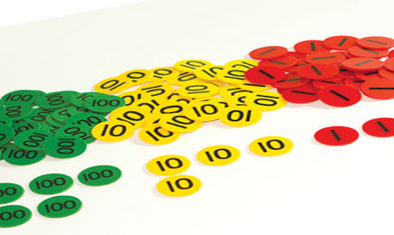  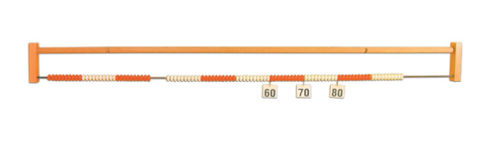  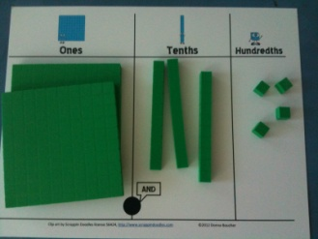  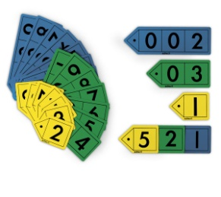  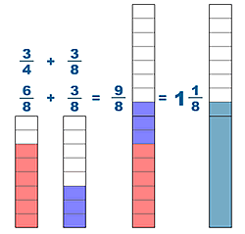 | algebra, balance scales, factors, multiples, proportional reasoning, decimal place value, equivalence  Cuisenaire, Numicon, multi-link, place value sliders  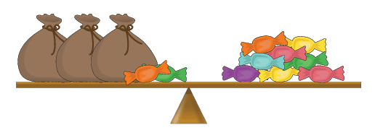  3x + 2 = 8    Factors of 8    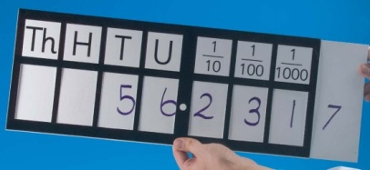  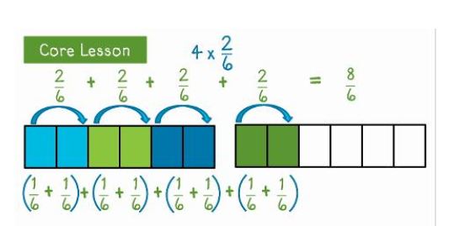

UPPER KEYSTAGE 2 | Addition and subtraction | Multiplication and division
Year 6
Statutory | - perform mental calculations, including with mixed operations and large numbers.  - solve addition and subtraction multi-step problems in contexts, deciding which operations and methods to use and why  - add and subtract fractions with different denominators and mixed numbers, using the concept of equivalent fractions | - identify common factors, common multiples and prime numbers  - use their knowledge of the order of operations to carry out calculations involving the four operations  - solve problems involving addition, subtraction, multiplication and division  - multiply simple pairs of proper fractions, writing the answer in its simplest form (e.g. ¹/₄ × ¹/₂ = ¹/₈)  - divide proper fractions by whole numbers (e.g. ¹/₃ ÷ 2 = ¹/₆ )  - recall and use equivalences between simple fractions, decimals and percentages, including in different contexts.
Non-statutory guidance | - they undertake mental calculations with increasingly large numbers and more complex calculations. | - pupils continue to use all the multiplication tables to calculate mathematical statements in order to maintain their fluency.  - pupils use their understanding of the relationship between unit fractions and division to work backwards by multiplying a quantity that represents a unit fraction to find the whole quantity (e.g. if ¹/₄ of a length is 36cm, then the whole length is 36 × 4 = 144cm).
Exemplification and suggested ideas/resources | algebra, equivalent fractions, calculations with larger numbers  place value cards, balance scales (algebra),Cuisenaire  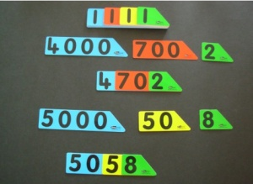  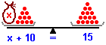  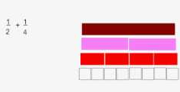 | multiplicative relationships, calculating with fractions, arrays.  Cuisenaire, Numicon, double-sided counters, paper strip, arrays    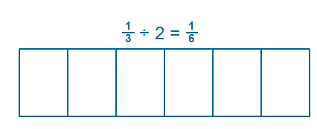

Notes:

Non-statutory – not all included – only that which I deemed particularly helpful or omitted from statutory e.g. doubles.

Have not repeated models and images in different year groups – would expect teachers to look at other years for further ideas and exemplification. E.g. associative law – represented once only (where it first appears).

