
Nursery Snack Menu
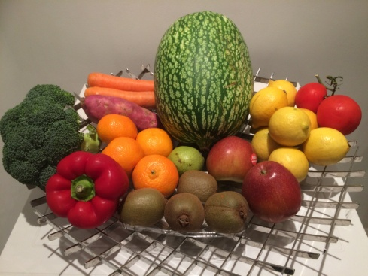
- Snacks consist of a variety of fresh fruit, vegetables and a range of healthy options to ensure that the children are provided with a well balanced and nutritious snack.
- Snack gives the children an opportunity to gain social skills, independence, communication and language skills and physical development when using equipment to prepare their snacks.
- Children have their own individual water bottles but they also have the option of pouring themselves a drink of milk or water.
- Vegetarians and any special diets can be catered for on request.

Snack costs 30p per session. This is 60p per full day. Staff will send out an invoice termly.

