Progression in Use of the Bar Model – Written by the Oxfordshire Maths Team – July 2014

The bar model was introduced in Singapore in the 1980s alongside an increased emphasis on problem solving in the curriculum. A new curriculum was devised based heavily on the Cockcroft report (1982) and ‘Agenda in Action’ (1989) – with the latter being an American report. It fits a maths mastery model, which involves spending more time on a topic. This allows students opportunities to explore maths in-depth. Such a concept has also been stressed by Jane Jones; lead HMI for mathematics, when she talks about ‘milking the maths.’

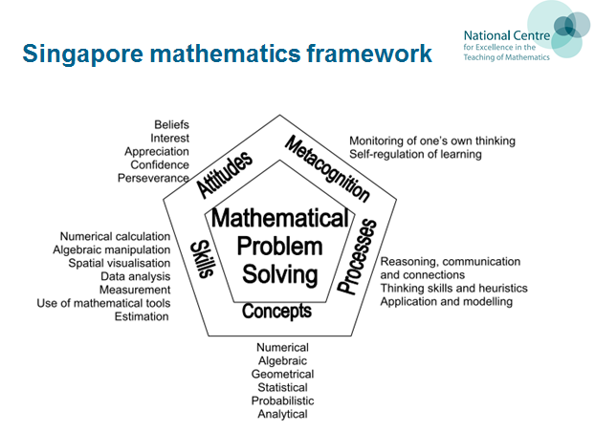
The Singapore and Shanghai curriculums have problem solving at the heart of them. Arguably, this is why they are so successful. This model also reflects strong teaching in this country, as noted in OfSTED’s ‘Made to Measure’ report. (2012)
The purpose of this document is to illustrate progression within the bar model and is the Oxfordshire maths team’s attempt to show where it could fit within the new national curriculum. It could become part of a school’s calculation policy. Please note that use of the bar model is not statutory and is designed to help children visualise maths problems, rather than do the maths for them. We have drawn heavily on various NCETM resources in order to write this document.

What does the bar model look like?

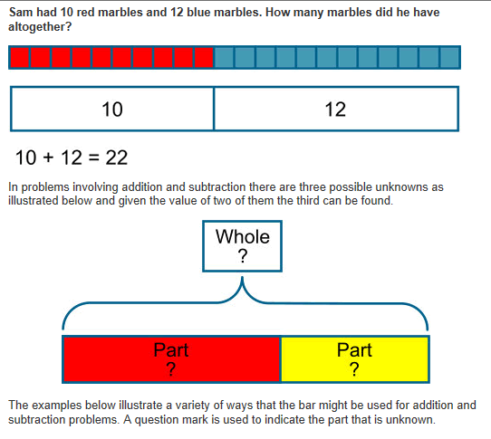
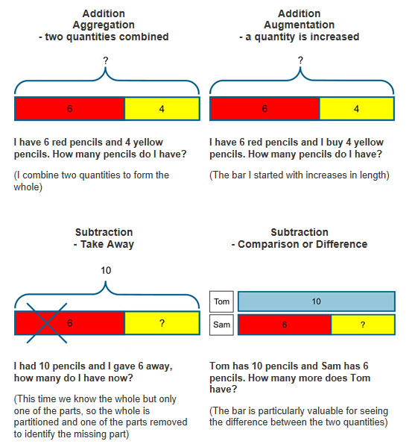
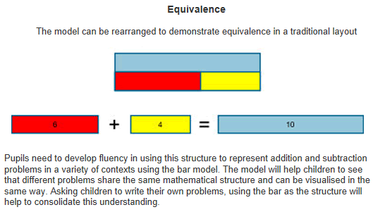

Milking the maths: using the bar model flexibly across all year groups:
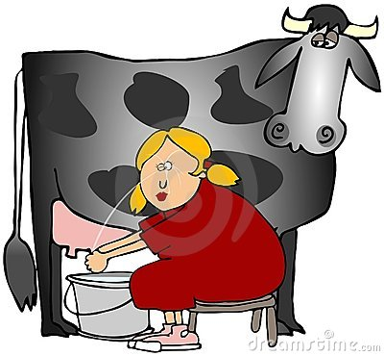
What could this bar model be showing?

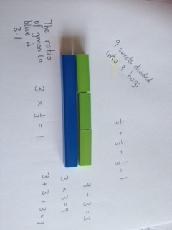

Playing with algebra

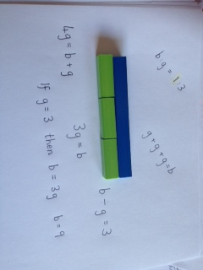
Can you design questions that fit the bar model?
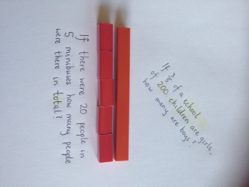

Years 1 and 2:

The maths team feel that Cuisenaire should be used by children at this stage, so that the gap is bridged between using concrete objects and drawing symbolic representations of objects. We would expect children to be working practically with Cuisenaire and talking about relations, so that they are then ready to start drawing bar model representations in lower Key-Stage 2.
National Curriculum Objectives: Rapid Recall
Year 1: represent and use number bonds and related subtraction facts within 20
Year 2: recall and use addition and subtraction facts to 20 fluently, and derive and use related facts up to 100
National Curriculum Objectives: Addition and Subtraction
Year 2: show that addition of two numbers can be done in any order (commutative) and subtraction of one number from another cannot
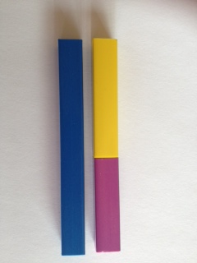
Focus on verbalising thinking:
e.g.
‘five add four is equal to nine’
‘four add five is equal to nine’
‘nine take-away four equals five’
‘nine take away five equals four’

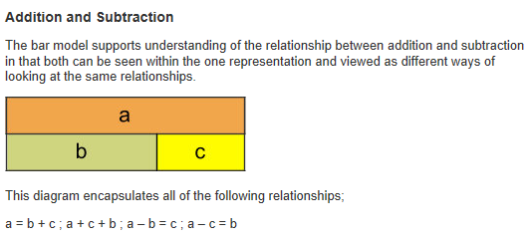
For teacher’s understanding, children would not be expected to write the above algebraic notations.
National Curriculum Objectives: Multiplication and Division
Year 1: solve one-step problems involving multiplication and division, by calculating the answer using concrete objects, pictorial representations and arrays with the support of the teacher.
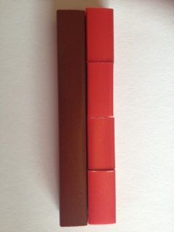
Focus on verbalising thinking:
e.g.
‘eight is two taken four times’
‘two taken four times is eight’
‘eight equals four times two’
‘there are four twos in eight’
Year 2: solve problems involving multiplication and division, using materials, arrays, repeated addition, mental methods, and multiplication and division facts, including problems in contexts.
[Photograph of Cuisenaire being used as a bar model and arrays.]
National Curriculum Objectives: Fractions
Year 1: recognise, find and name a half as one of two equal parts of an object, shape or quantity
recognise, find and name a quarter as one of four equal parts of an object, shape or quantity.
Year 2: recognise, find, name and write fractions ¹/₃, ¹/₄, ²/₄ and ³/₄ of a length, shape, set of objects or quantity
write simple fractions e.g. ¹/₂ of 6 = 3 and recognise the equivalence of ²/₄ and ¹/₂.
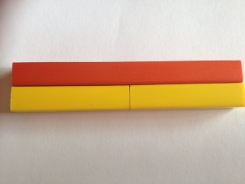
e.g.
What fractions can you see?
What fraction of the orange is each yellow piece?
If the value of the orange rod is ten, what is the value of each yellow rod?
Extension: What if the value of the orange rod is 6? 100? Etc.
National Curriculum Objectives: Problem Solving
Year 1: solve one-step problems that involve addition and subtraction, using concrete objects and pictorial representations, and missing number problems such as 7 = □ - 9.
Year 2: solve problems with addition and subtraction:
  - using concrete objects and pictorial representations, including those involving numbers, quantities and measures
  - applying their increasing knowledge of mental and written methods
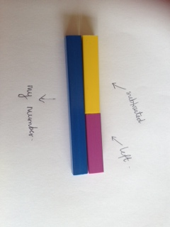
e.g.
I think of a number. I subtract 5. The answer is 4. What is my number?

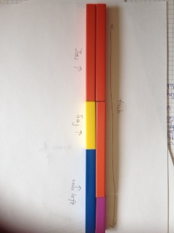
e.g.
A tub contains 24 coins. Saj takes 5 coins. Joss takes 10 coins. How many coins are left in the tub?

Courtesy of the NCETM:
These problems have been tried and tested in a school for the year groups specified; however you may wish to use them more flexibly for different aged children than that specified. Please note that schools can decide in which year group to use each of the problems, as some are challenging.

Year 1 Problems
- 1. Ebony has 5p and Daniel has 8p. How much do they have altogether?
- 2. A lolly costs 6p. Amrit paid with a 10p coin. How much change does he get?
- 3. Michael says that 16 + 5 = 21. Is he correct?
- 4. I think of a number. I subtract 5. The answer is 4. What was my number?
- 5. How many gloves are there altogether in 6 pairs of gloves?
- 6. Twelve people are split into two groups. How any are in each group?
- 7. Mrs Morton puts five 5p coins into her purse. How much is in her purse altogether?

Year 2 Problems
- 1. Dylan has 37 coloured pencils and he buys 30 more. How many does he have now?
- 2. Janie has 40 beads. She loses 25 of them. How many does she have left?
- 3. What is the difference between seventy six and thirty five?
- 4. I think of a number. I subtract 5. The answer is 4. What was my number?
- 5. Last week Ellie got £1.00 pocket money. She spent half of it. How much has she got left?
- 6. A tub contains 24 coins. Saj takes 5 coins. Joss takes 10 coins. How many coins are left in the tub?
- 7. Amelia writes the calculation below as a multiplication calculation? What might she write?
3 + 3 + 3 + 3 + 3 = 15
- 8. Mr Siddique shares £18 equally between his three sons. How much does each son get?
- 9. Charlotte-May had to find a 14 of a number. Her answer was 4. What number did she start with?
- 10. Danny cuts his pizza into 8 equal slices. He eats 3/4 of the pizza and gives the rest to his dog, Gruff. How many pieces does Danny eat?

Years 3 and 4:

The maths team feel that children should now be ready to start drawing bar model representations. For the purpose of this progression document, we have modelled ‘before’ and ‘after’ representations of problems. It may, however, be that schools instead choose to use a model whereby the first representation is developed.
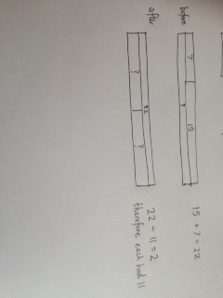
e.g.
Aiden has seven marbles and Harvey has fifteen. They decide to share them equally between them. How many do they get each?
National Curriculum Objectives: Problem Solving in Addition and Subtraction
Year 3: solve problems, including missing number problems, using number facts, place value, and more complex addition and subtraction.
Year 4: solve addition and subtraction two-step problems in contexts, deciding which operations and methods to use and why.
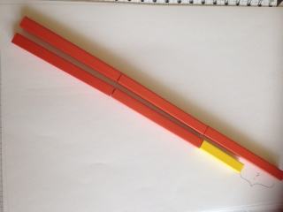
- e.g. one-step problem
- Sally has 40 football cards. She gives 25 of them away. How many does she give away?
National Curriculum Objectives: Problem Solving in Multiplication and Division
Year 3: solve problems, including missing number problems, involving multiplication and division, including integer scaling problems and correspondence problems in which n objects are connected to m objects.
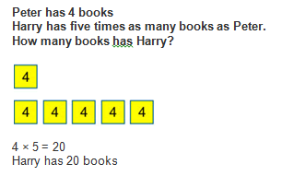
This is an example of integer scaling.
Year 4: solve problems involving multiplying and adding, including using the distributive law to multiply two digit numbers by one digit, integer scaling problems and harder correspondence problems such as n objects are connected to m objects.
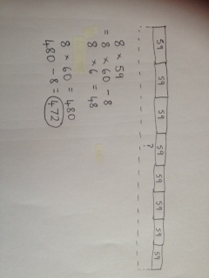
e.g. 8 children each download 59 songs to play on their iPod. How many songs do they have altogether?
National Curriculum Objectives: Fractions
Year 3: solve problems that involve (unit fractions and fractions with the same denominator)
Year 4: solve problems involving increasingly harder fractions to calculate quantities, and fractions to divide quantities, including non-unit fractions where the answer is a whole number
Year 4: solve simple measure and money problems involving fractions and decimals to two decimal places, including decimals
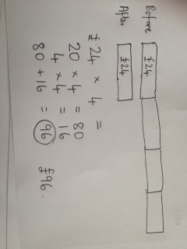
e.g. A computer game is £24 in the sale. This is one quarter of its original price. How much did it cost before the sale?

Courtesy of the NCETM:
These problems have been tried and tested in a school for the year groups specified; however you may wish to use them more flexibly for different aged children than that specified.

Year 3 Problems
- 1. There are 334 children at Springfield School and 75 at Holy Trinity Nursery. How many children are there altogether?
- 2. Gemma collected 293 badges but she gave 45 of them to her friend, Rebecca. How many badges did she have left?
- 3. Aiden has seven marbles and Harvey has fifteen. They decide to share them equally between them. How many do they get each?
- 4. Seven people each put five pens into a pot. Carmen then takes out fifteen pens. How many pens are left?
- 5. If you spend 61p at the corner shop, how much change do you get from £1.00?
- 6. If five apples cost fifty pence, how much would two apples cost?
- 7. Emma buys seven markers for 30p each. How much change does she get from £3.00?
- 8. A bookcase in the library holds 5 shelves with 46 books on each shelf. How many books are there in the bookcase altogether?
- 9. How many 5p stickers can Alexis buy with his 55p pocket money?
- 10. Which is the larger amount, one third of £60 or one quarter of £88?
- 11. A computer game is £24 in the sale. This is one quarter of its original price. How much did it cost before the sale?

Year 4 Problems
- 1. Martin has saved £6.78 and spends £4.69. How much does he have left?
- 2. Sally has 40 football cards. She gives 2 fifths of them away. How many does she give away?
- 3. Sally has 30 football cards. She gives 2 fifths of them to her friend. How many does she have left?
- 4. 8 children each download 59 songs to play on their iPod. How many songs do they have altogether?
- 5. Calculate how many fives there are in 85?
- 6. At the dressmakers, Debbie buys buttons weighing 3 grams each. If she has 81 grams of buttons, how many buttons does she buy?
- 7. Kelly buys four fifths of the shop’s oranges. If the shop had 20 oranges, how many does she have?

Years 5 and 6:

The maths team feel that Cuisenaire and double-sided counters are still valuable resources to use alongside drawn representations of problems. They should all be used flexibly according to the stage that children have reached in their learning.
National Curriculum Objectives: Problem Solving in Addition and Subtraction
Year 5: solve addition and subtraction multi-step problems in contexts, deciding which operations and methods to use and why
Year 6: solve addition and subtraction multi-step problems in contexts, deciding which operations and methods to use and why
National Curriculum Objectives: Problem Solving in Multiplication and Division
Year 5: solve problems involving multiplication and division, including scaling by simple fractions and problems involving simple rates
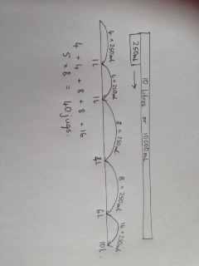
e.g. How many jugs with a capacity of 250ml could you fill with 10 litres of water?

National Curriculum Objectives: Fractions
Year 5: solve problems which require knowing percentage and decimal equivalents of ¹/₂, ¹/₄, ¹/₅, ²/₅, ⁴/₅ and those with a denominator of a multiple of 10 or 25, including decimals and percentages
Year 6: solve problems which require answers to be rounded to specified degrees of accuracy, including decimals and percentages

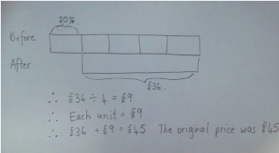
e.g. There is 20% off in a sale. The reduced price of the jeans is £36. What was the original price?

The bar model can also be linked beautifully with ratio and proportion, for example, in the following context:
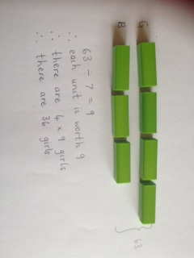
e.g. At a dance there are 4 girls to every 3 boys. There are 63 children altogether? How many girls are there?

Courtesy of the NCETM:
These problems have been tried and tested in a school for the year groups specified; however you may wish to use them more flexibly for different aged children than that specified.

Year 5 Problems
- 1. Every day for 4 days Helen scored 7.5 in a test. On the fifth day she scored 8. What was her total score?
- 2. I cut 60 cm from 3.3m of string and shared the rest between 3 friends. How much string did they get each?
- 3. How many jugs with a capacity of 250ml could you fill with 10 litres of water?
- 4. All the children in the school are going on a residential trip to the outdoor activity centre. They will be divided into 6 equal groups If there are 246 children in the school how many will be in each group?
- 5. Robert calculated 25% of 600. What answer does he get?
- 6. Sam calculated 40% of 120. What answer does he get?
- 7. Rita worked out that one sixth of a number was 12. What was the number she started with?
Year 6 Problems
- 1. Three quarters of a number is 54. What is the number?
- 2. Which is more; five ninths of 252 or four sevenths of 238?
- 3. There are 36 packets of biscuits. One half are chocolate, a ninth are digestive and a third are wafer biscuits. The rest are ginger nuts. How many biscuits are ginger nuts?
- 4. There is 20% off in a sale. How much would a track suit cost, if the normal price was £44.50?
- 5. There is 20% off in a sale. The reduced price of the jeans is £36. What was the original price?
- 6. At a dance there are 4 girls to every 3 boys. There are 63 children altogether? How many girls are there?
- 7. Seven in every nine packets of crisps in a box are salt and vinegar. The rest are plain. There are 63 packets of salt and vinegar crisps. How many packets of plain crisps are there?

Key Stage 3 Problems
- 1. Ralph posts 40 letters, some of which are first class, and some of which are second class.
He posts four times as many second class letters as first.
How many of each class of letter does he post? (This question appeared on a GCSE higher tier paper.)
- 2. A computer game was reduced in a sale by 20% and it now costs £55. What was the original cost?
- 3. A computer game was reduced in a sale by 30% and it now costs £77. What was the original cost?
- 4. Sally had a bag of marbles. She gave one-third of them to Rebecca, and then one quarter of the remaining marbles to John. Sally then had 24 marbles left in the bag. How many marbles were in the bag to start with?
- 5. Peter is playing Space Explorer on his computer. He finished 13 of the levels last week and 25 of the remaining levels this week. He has 12 more levels to complete. How many levels does Space Explorer have?
- 6. Sam bakes a variety of biscuits.
one third are peanut, half are raisin, the remaining 12 were oat. How many biscuits are baked?
- 7. Tom spent 30% of his pocket money and put away 45% into his savings. He was left with £2.50. How much pocket money did he receive?
- 8. Two numbers are in the ratio 4:5. They both sum to 135. Identify both numbers.
- 9. Two numbers are in the ratio 6:7. They both sum to 169. Identify both numbers.
- 10. A herbal skin treatment uses yoghurt and honey in the ratio 5:3. How much yoghurt is needed to mix with 130 g of yoghurt?

