 Unlocking the potential…

Welcome

Dear Parent
I would like to welcome you and your child to Farndon Primary. May I take this opportunity to thank you for choosing our school.

Farndon is a small friendly village school with high aspirations for its learning community. We thrive very much on our family ethos, cultivating good manners and successful, motivated pupils. We strive to create a curriculum that equips our children with the skills and confidence that will unlock their potential and take them onto Lifelong Learning.

We want your child to settle quickly into a happy, productive school life. We hope this booklet offers you an insight into what we do and how you can support your child’s learning through that vital Home School partnership.

There are a number forms of which you are asked to complete and return to school as soon as possible so that we can keep our records up to date.
Starting a new school is a big change for all involved and we hope that this will be the start of a fruitful partnership between home and school. We aim to be forward thinking and encourage everyone to have a go at new learning and innovative ideas. Further information about Farndon Primary can be found on our School website: http://www.farndon.cheshire.sch.uk/

Yours sincerely
Mr A. J. Walker BEd (hons) NPQH
Headteacher

STARTING SCHOOL


If you haven’t already, we always recommend visiting the school for a tour with a member of staff. We also encourage new pupils to visit the school where they receive a tour from one of Year 6 House Captains.
On the first day, we ask parents to come to the School’s main entrance where you will meet the class teacher. New pupils will be assigned a class buddy for the first week to help them settle in and familiarise themselves with their new surroundings and routines. We do all we can to ensure new pupils settle quickly in what is an anxious time for many.

THE SCHOOL DAY

We ask Parents to drop off their child at the School gate, where you will be met by a member of staff. The school is open from 8.45am and the teachers are responsible for the children from 8.45am onwards on the School playground. If for any reason you need to speak with the class teacher before the start of the day, then please phone the School Office, or come to main entrance where a meeting can be arranged wherever possible.
Please ensure that your child is in school by 8.55am as this is when the gate is locked. Late arrivals must sign in at the School Office. We are obliged to mark a pupil late if they arrive in the classroom after 8:55 and absent if they arrive after the close of register at 9:10 am.
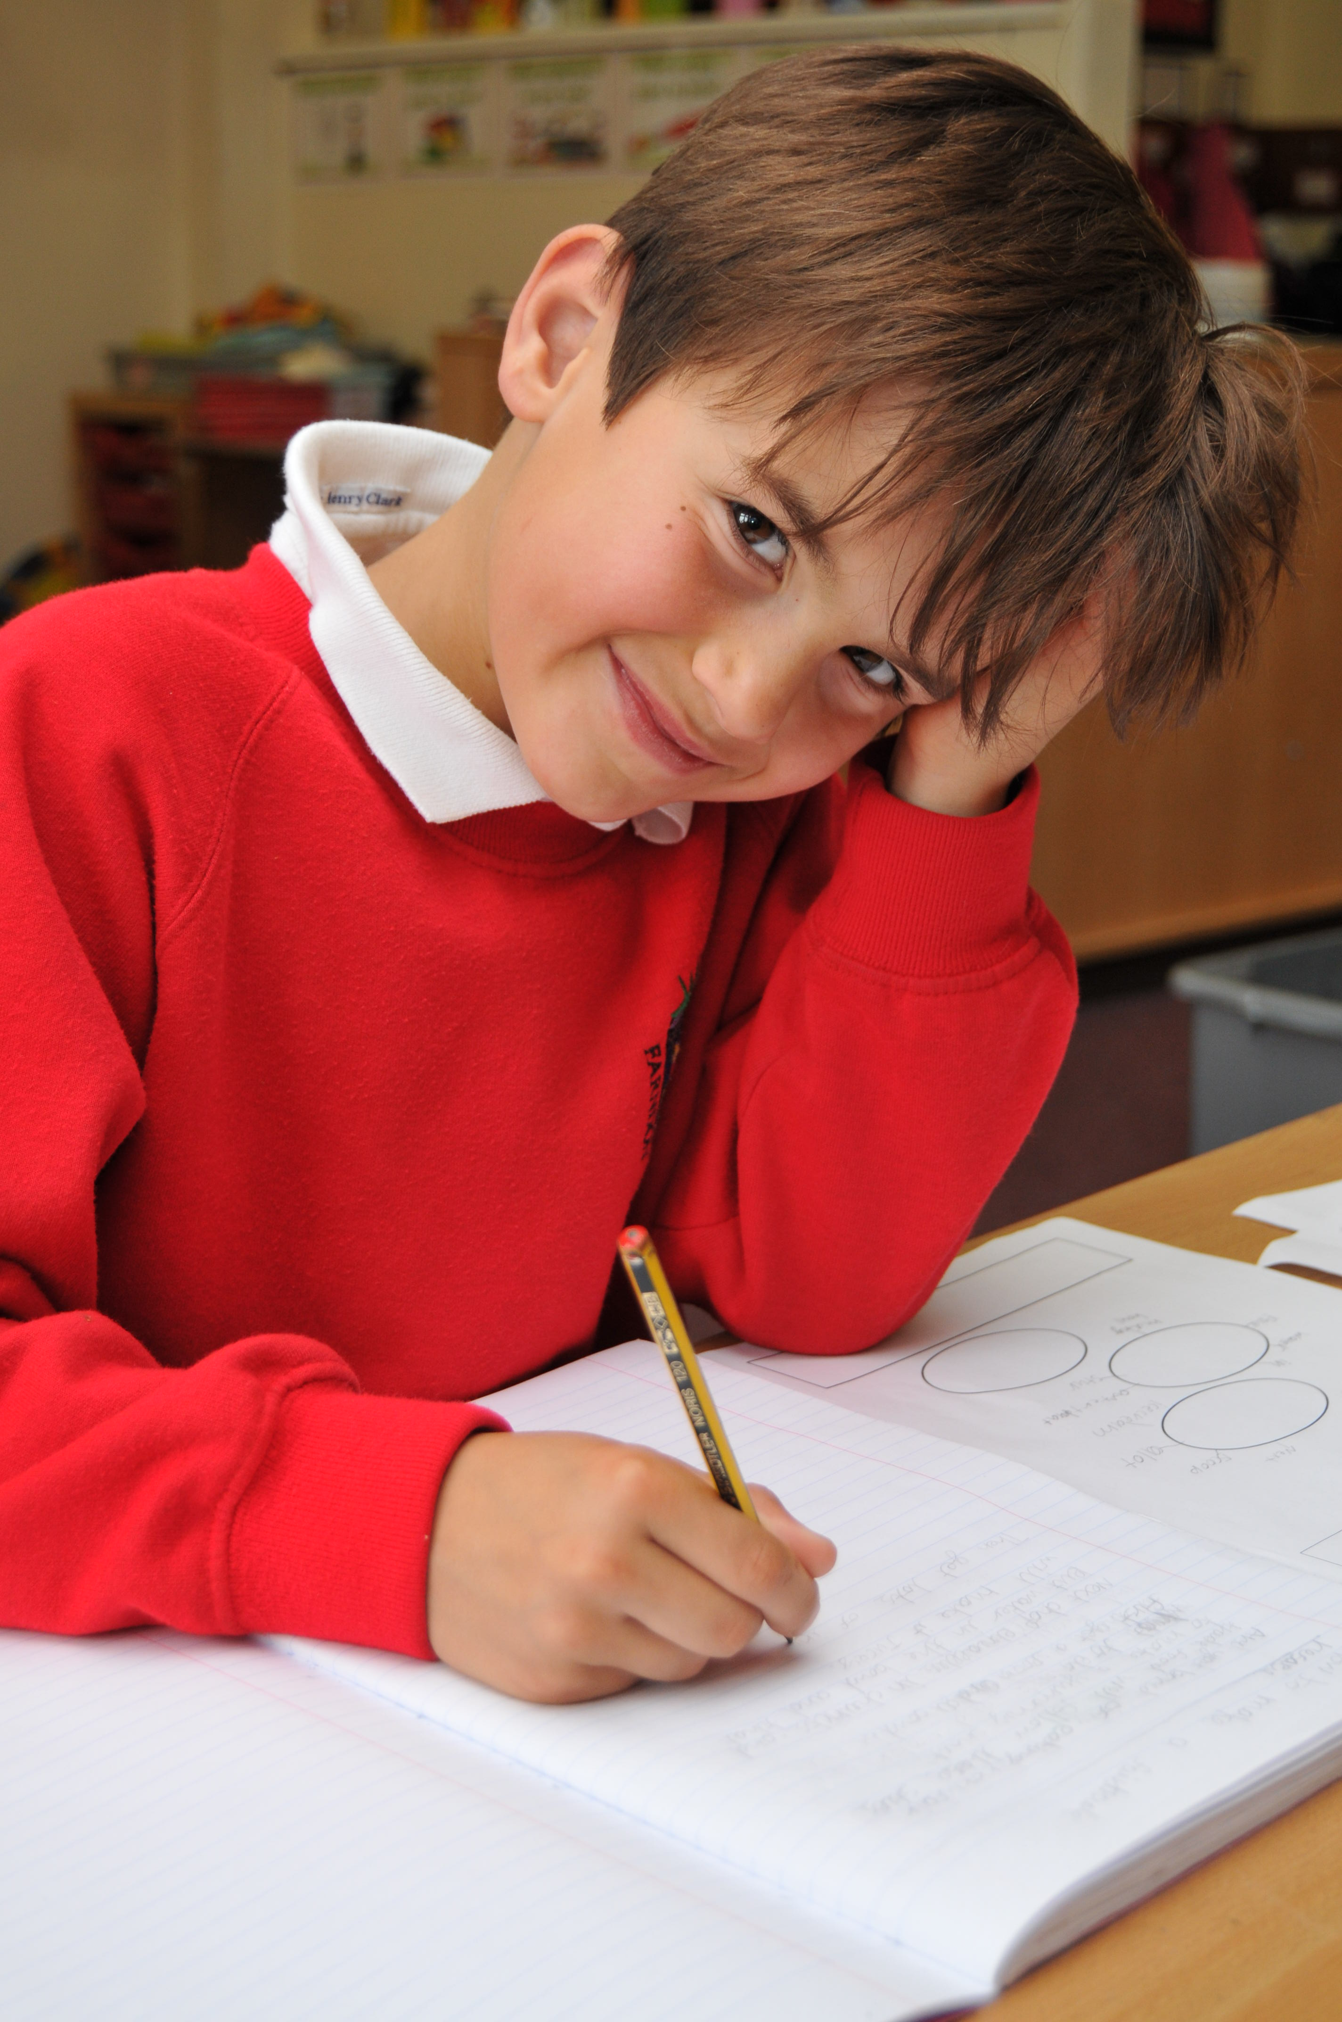
At the end of the day, the class teacher ensures the child has been collected in person. We ask children not to go out until they have seen the person collecting them. If there is a problem collecting, or if you make arrangements with another adult, please tell us or telephone the School Office.

FOOD IN SCHOOL

We are a healthy eating school. Each day the children in the Infants have a fruit snack and up until 5 years old in Reception they have free milk. Pupils can bring in something to eat for break times but this has to be a healthy snack: raisins, cereal bars, bread sticks etc.
Water is available for the children to help themselves to throughout the day, but they can also bring in their own drinks bottles.
Snack can also be bought from the school kitchen. It sells a variety of foods including toast, crumpets, bagels and fruit.
SCHOOL LUNCHES

School meals are freshly prepared each day at Farndon. The caterers adopt a healthy eating policy and the catering supervisor will be pleased to discuss any queries regarding your child’s meal or personal dietary requirements. The weekly menus are available on the School’s website under Virtual Office. Presently the price of a Primary School meal is £2.15
In September 2014, there was a change in legislation. All pupils in Key Stage 1 now have the opportunity to have a healthy, hot school meal free of charge. Parents can obviously opt out of this option and have a packed lunch. Once your child enters Year 3, all meals are chargeable.
Parents are asked to help the school kitchen staff by giving at least one week's written notice if they want to change their meal arrangement in any way.

When in the Juniors, a school meal can only be provided if
payment is received. We encourage parents to pay for school meals on a weekly basis or half termly in advance. Your cheque should be sent to school on a Monday morning, in a
sealed envelope with your child’s name on.

SCHOOL UNIFORM

The school colours are red, grey and white and the children are expected to come to school dressed in any combination of these colours as listed below.
School uniform is available all year round from the School Website under Virtual Office from Andrew Hyde. Each term, there will be order points to purchase more sweatshirts, cardigans, polo shirts and t-shirts with the school logo
Girls
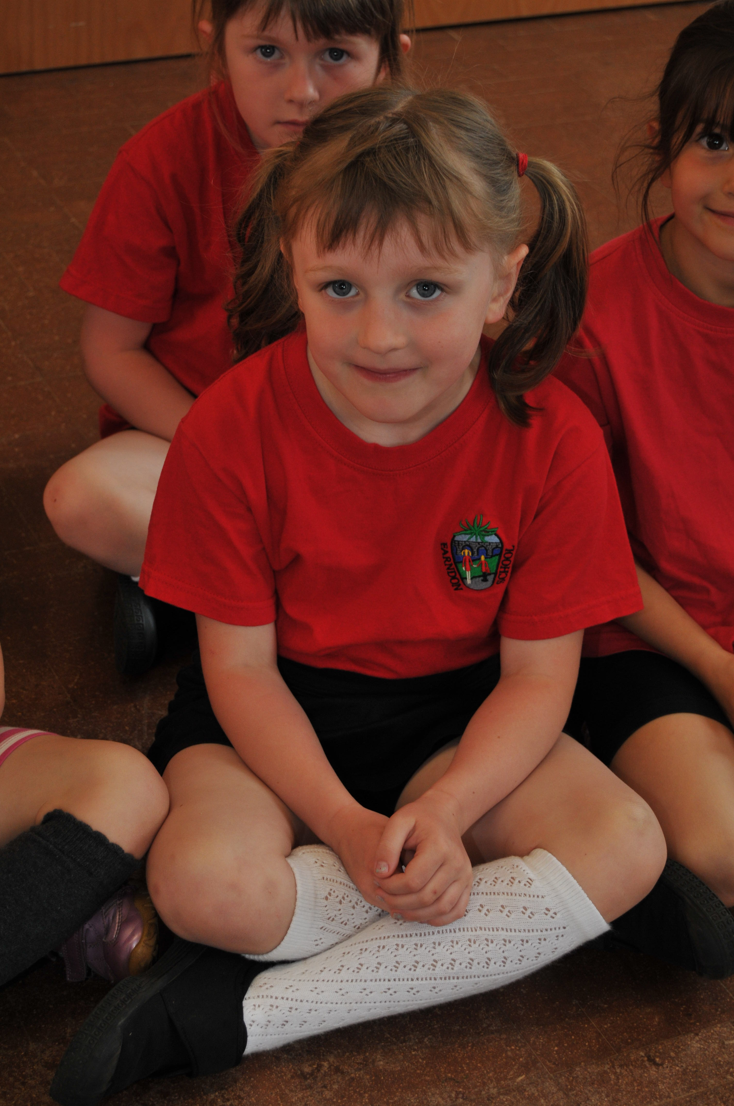
- grey skirt / pinafore dress / trousers
- school white logo polo shirt / white polo shirt
- school logo sweatshirt / school logo cardigan
- grey or white socks / tights
- red and white summer dress
- black shoes
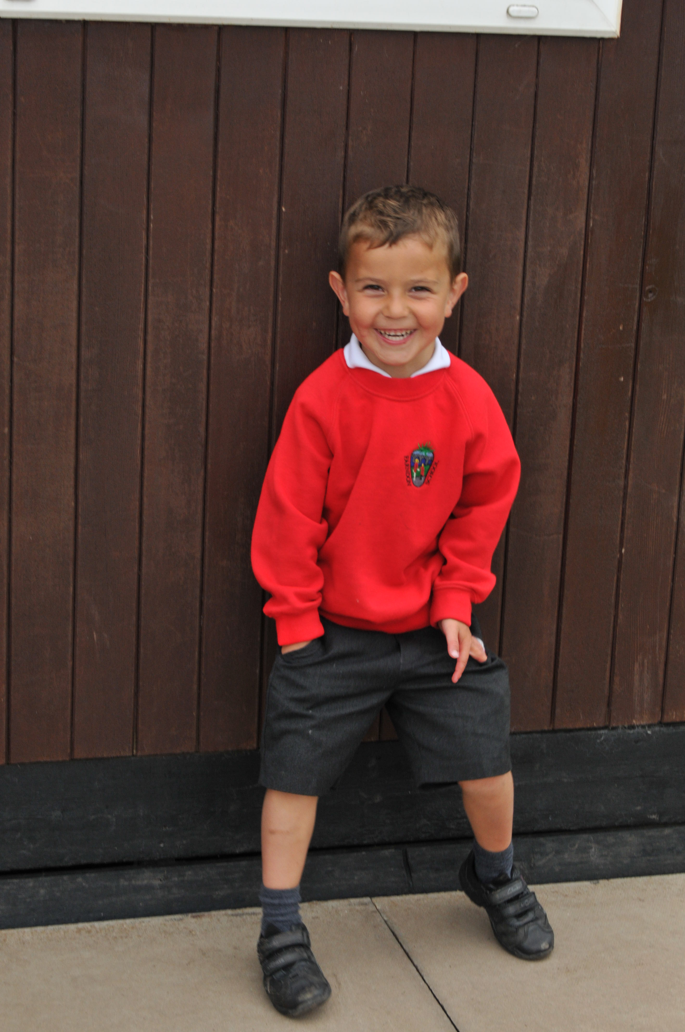

Boys
- grey trousers / shorts
- school logo polo shirt / plain white polo shirt
- school logo red sweatshirt
- grey socks
- black shoes

P.E : A fabric drawstring bag ( or zipped backpack )should be provided to store PE kit

Indoor Kit : Black shorts, logo red t- shirt / plain red T-shirt / black pumps
PLEASE ENSURE THAT ALL ITEMS OF CLOTHING ARE CLEARLY NAMED.
Jewellery
In the interests of health and safety, pupils are not allowed to wear jewellery, which could injure the child concerned, or other children. It is best kept for home and weekend wear.
HEALTH AND WELFARE

Absence due to illness
If your child is ill from school for medical reasons, please contact the Office as soon as possible on 01244 981280 and press 1 to leave a message. For a prolonged leave of absence ( up to or over 5 days ) on return to school we ask for a letter from the Parent stating the reasons for absence for our school records.

If your child becomes ill in school hours
We will contact you at once. Please ensure that we have up to date details of your home and work telephone numbers plus details of someone we can contact if you are unavailable. If your child receives a bump to the head, you will be contacted by a member of staff. We will also give the child a letter to take home.

Hospital, Doctor and Dental Appointments
Please let the School Office or class teacher know in advance, if your child will be out of school. Children must be collected and returned to school and signed out at the front entrance.
Medication
Parents should provide the Headteacher with full information about their child’s medical needs so that we can make appropriate provision.
Wherever possible parents should accept the administration of medicines as their own responsibility. If it is unavoidable that a child should take medicine in school, then these rules must apply, which follow the School’s Medicine / Health and Safety policy available on the website; Parents are responsible for the provision of the medication in the original container as dispensed by the pharmacy bearing a clear label showing:
- the name of the medication
- the name of the patient
- the dosage
- specific directions for the administration
- precautions relating to the medication storage requirements
- the name of the dispensing pharmacist/doctor
- the date the issue and the expiry date
Parents must bring medicines into the office and complete an authorisation form.

LEAVE OF ABSENCE REQUEST

We at Farndon Primary School and Cheshire West and Chester Local Authority believe that attendance at school is important and that poor absence can lead to a lack of progress.
We do need to inform you that the government has introduced Penalty Notice fines for parents whose children are out of school without the school’s authorisation.
- The law says that parents/carers do not have the right to take their children out of school for a holiday in term time.
- Headteachers will take into account individual circumstances such as the attendance record of the child, whether the child would miss exams or any exceptional circumstances.
Any requests must be made in advance on the official form obtainable from the school. A formal application must be completed and returned to the school as far in advance as possible and at least 7 days before the first date of the period of absence being requested. The Headteacher will provide a written response.
FORMS ARE AVAILABLE FROM THE SCHOOL OFFICE or WEBSITE
If an absence is not agreed and the pupil goes on holiday, the absence will go down as unauthorised. Parents are at risk of receiving a Fixed Penalty Notice where the leave of absence is more than 5 consecutive days.
Taking a holiday in term time means that children miss important school time. We would therefore request the cooperation of parents in considering the effect on their child’s education before making requests for leave of absence in term time.

HOME SCHOOL LIAISON

Education is a three way process between children, parents and the school. In order to achieve the maximum success for your child, the full co-operation and support of the parents and the school is needed. A Home-School Agreement is issued to each child on entry and will be kept on file until the child leaves the school. Regular newsletters are placed on the school website to inform parents of forthcoming events and other relevant information. This can be accessed under the Virtual Office tab.
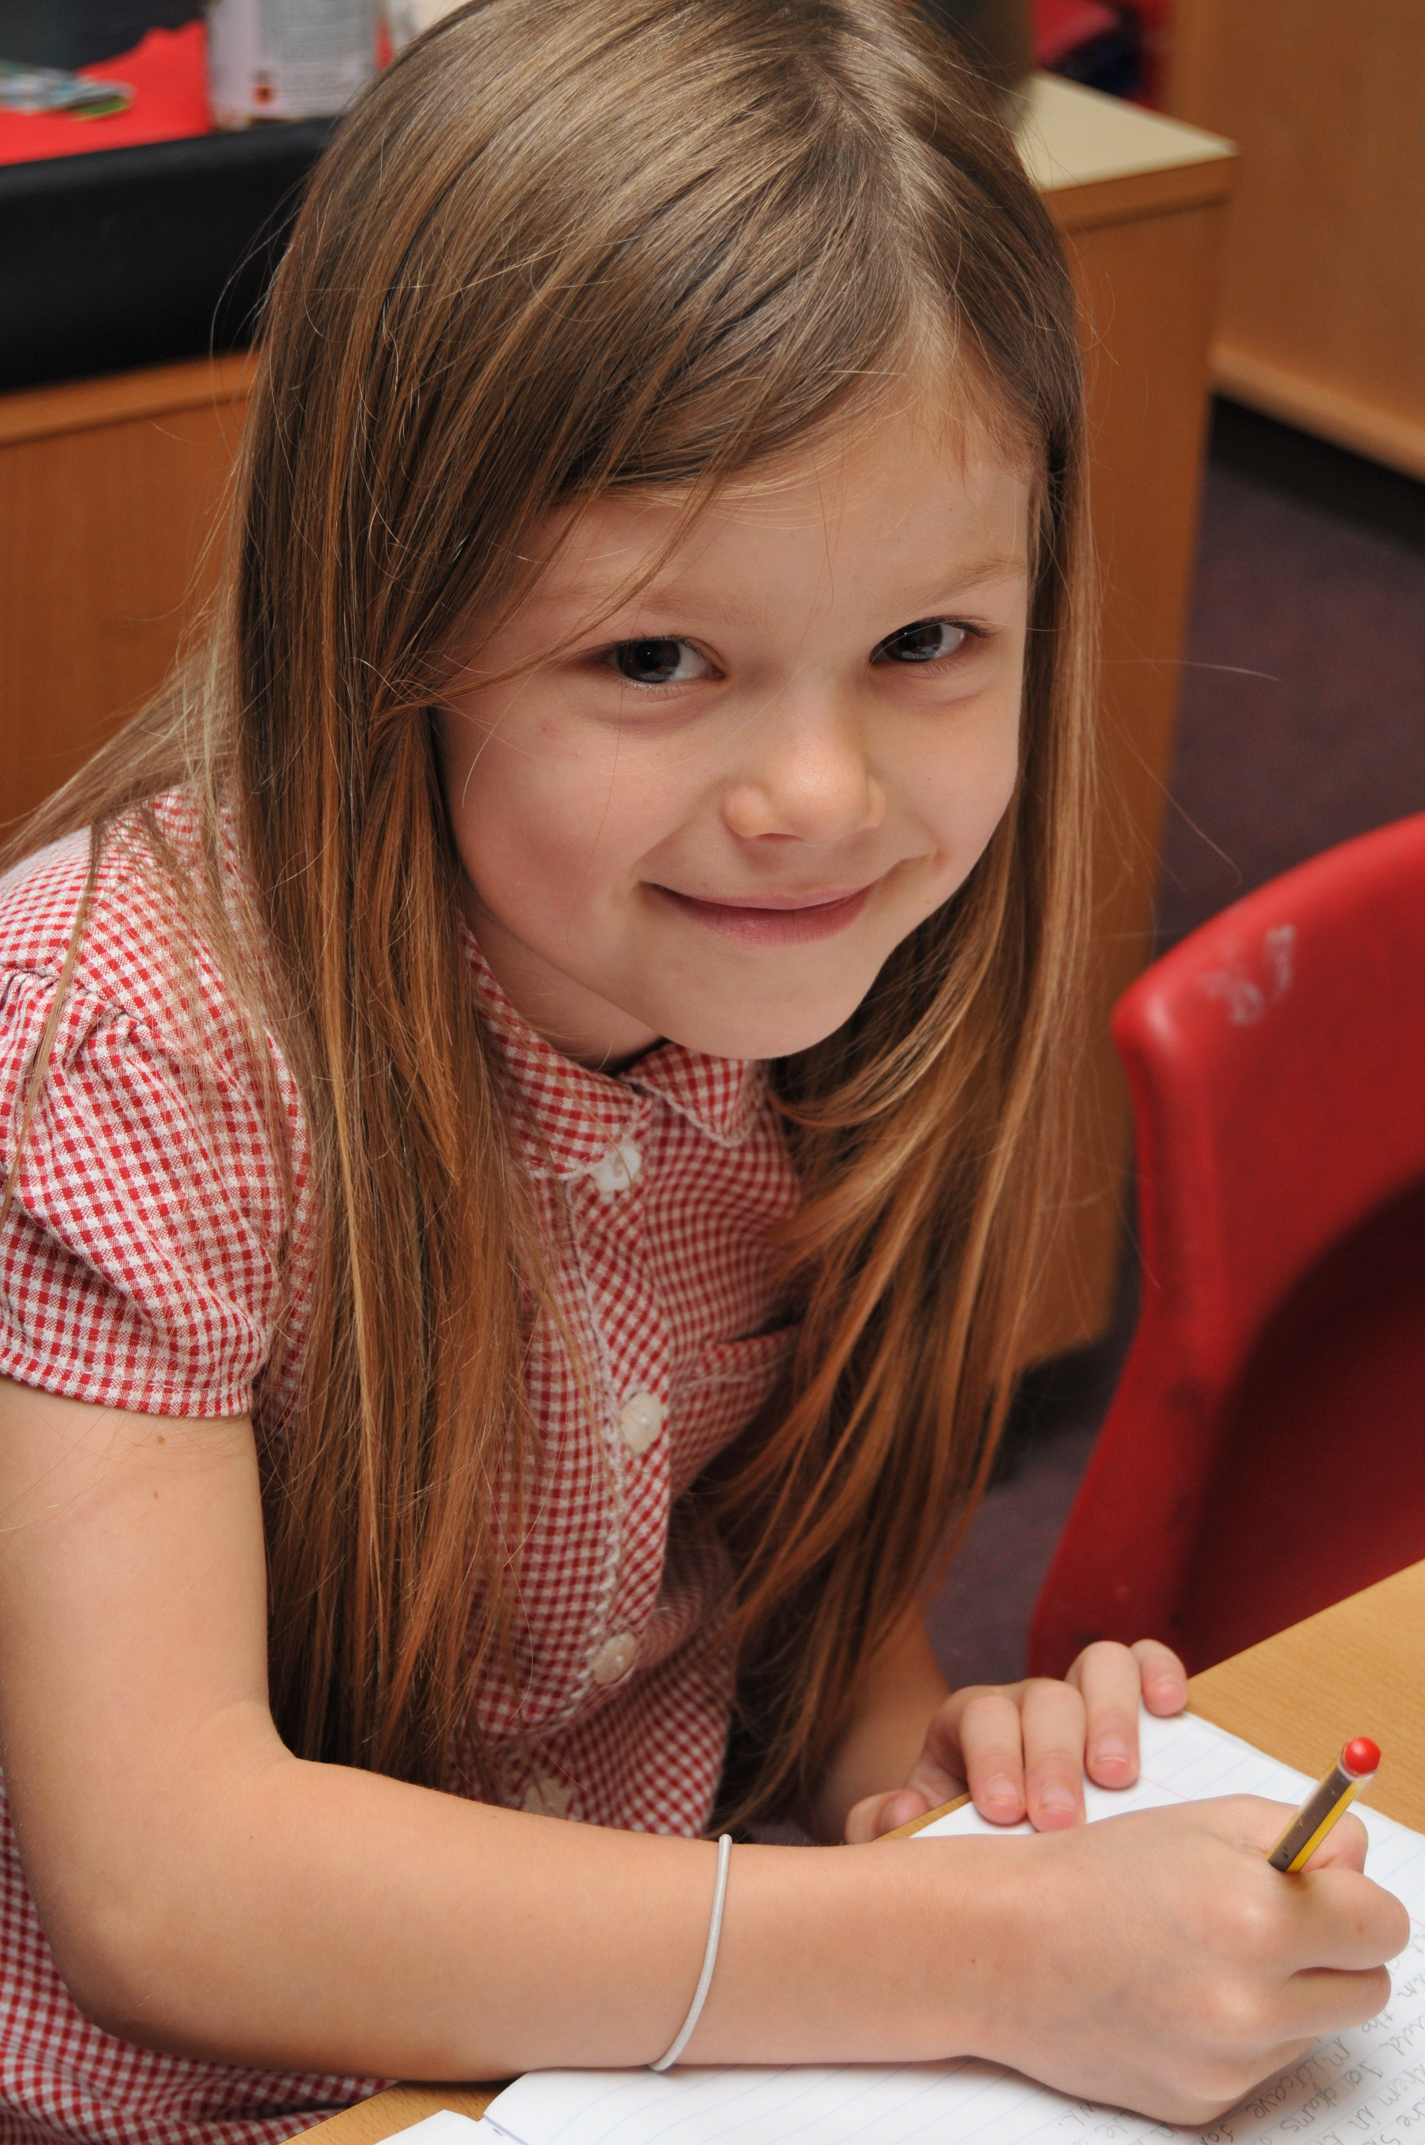

Another way of strengthening those links with School and home, is through the school’s virtual learning platform. Pupils can take part in additional homework tasks on MyMaths and enter in discussions, create scrapbooks or write a “wiki”. Parents can log into the parent area and take part in discussion on school improvement areas.

HOMEWORK

We expect you to read with your child everyday. We send home a book and a reading log where you sign to show you have read with your child. Spellings are also sent home and we expect children to learn their times tables. The amount of homework given varies depending on the year group. For more information on what work is given, please consult our policy which can be found on our website. Also, more details can be accessed on the Class pages on our website.
VISITING THE SCHOOL

The staff are usually available at the end of the school day. If you have a concern about your child, do not hesitate to ask to speak with the class teacher. Also, it is possible to e-mail the School Office or the Headteacher directly from the website. Please keep us informed of anything that happens at home which may affect your child as soon as possible.
There will be opportunities for more formal meetings during the year to enable parents to meet the teachers to discuss their child's work and progress. At the end of the year there will be a written report on each child's progress.

FORMS NEEDED TO BE COMPLETED

Please complete the forms contained within this pack and return to School as soon as possible to help us update our records.

- Home School Agreement
- Permission for Digital Learning Journey
- Permission for using images
- Data collection form
- Pupil consent for the local area
- School Dinner letter
- Privacy Notice
- Language and ethnicity notice sheet
We hope that you have found the information in our Admission Pack useful. Please do not hesitate to ask if you need any further information or are concerned about anything.

Unlocking the potential…

New Starter Details and Log-in passwords

Your child’s House is: _____________________________________

Your child’s MyMaths log in details: https://www.mymaths.co.uk/
School username: farndon School password: fifth
Pupil user name: ________________ Pupil Password: ____________________

Your child’s Virtual Learning Environment details
http://www.farndon.cheshire.sch.uk/ Then go to student log in.
Pupil Username: ______________________ Pupil Password: ____________________

Your parent Virtual Learning Environment log in details:
http://www.farndon.cheshire.sch.uk/ Then go to Parent log in
Parent Username: ______________________ Parent Password: ____________________

Farndon Primary School’s
Home School Agreement
Farndon Primary School -
Unlocking the potential…
Our aims are to provide creative opportunities through an
exciting and stimulating curriculum
We will….
Inspire a love for life long learning
Work in partnership
Be aspirational and supportive
Prepare pupils to be successful, responsible and considerate citizens
Ensure our children are safe and well cared for

By working together, with trust and mutual respect, we can achieve our aims

Agreement: We have read, understood and are in agreement with the promises made
Headteacher Chair of Governors Parent Child

School’s promises - We will:
Provide a safe and stimulating learning environment for all children.
Ensure that your child achieves well and is a valued member of the school community;
Achieve high standards of work and behaviour through building good relationships and developing a sense of responsibility;
Provide an interesting and enriched curriculum to develop and sustain a love of learning for life;
Keep parents informed about the teaching planned for the term for their child through curriculum updates;
Provide homework in line with the school’s homework policy;
Provide regular newsletters, website updates and blogs to inform and involve parents in school life;
Keep parents informed of their child’s progress and liaise with them promptly regarding any concerns;
Be open, welcoming and offer opportunities for parents and the community to become involved with school;
Care for and care about your child.
Parent’s and carers promises – I / We will
Make sure that my child gets to school on time;
Make sure that my child attends regularly and that the school is informed of the reason for any absence preferably by telephone or letter on the first day of absence;
Ensure that I give school up-to-date contact information;
Make sure that the school is kept informed of any change of circumstances or concerns that may have an effect upon my child’s behaviour and/or progress;
Attend consultation evenings to discuss my child’s progress;
Support the school in implementing their approach to good behaviour;
Be aware of and support my child in his/her homework, including reading;
Ensure that my child has everything s/he needs in school for that day, in particular PE Kit and stationery.
Make sure that my child is dressed appropriately for school and the weather and make sure their belongings are clearly labelled;
Ensure that my child is only sent to school on those days when s/he is physically fit.
Children’s promises – I / We will
Abide by the school rules;
1) Always do my best and encourage others to do so.
2) Always listen carefully, take turns to speak and respond politely.
3) Always care for others, their belongings and the school environment.
4) Always keep safe, help others and act sensibly.
5) Always follow instructions first time.
6) Always treat others as you want to be treated yourself.
Share any concerns with an adult in school;
Take responsibility for delivering letters and money to and from school;
Dress appropriately and will take responsibility for my clothing and school equipment; help my parents get me to school on time;
Complete my homework to the best of my ability and hand it in on time
Represent Farndon School well at all times.

