
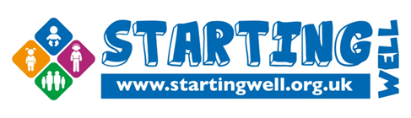

Starting Well 0-19 Service


Subject Register for the Parent Portal to Access Your Child's School Health Information

Dear Parent/Carer,

We are pleased to invite you to register for the School Screener Parent Portal, a secure and convenient way to receive important information from the Starting Well 0-19 Service about your child's health.

Why Register?
The Parent Portal gives you secure, 24-hour access to important information, including:
- Vision and hearing screening results
- National Child Measurement Programme (NCMP) results
- Referral information and health communications
- Secure letters and documents that can be viewed or downloaded at any time

All information is stored securely in one place and can be accessed on your smartphone, tablet or computer whenever it is convenient for you.

Please register within two weeks to ensure that you do not miss crucial communications regarding upcoming health services, please create your account today

Click here to register your secure Parent Portal account: https://cnw045.schoolscreener.com/Portal/#/cwp/g/CWP


Please note: Parent Portal is for receiving and viewing information securely. If you wish to formally opt your child out of an upcoming service, please contact the Starting Well service on our dedicated opt out email: cwp.ncmphearingvisionscreeningoptout@nhs.net

We are committed to making your experience convenient and secure. Thank you for registering promptly.

Kind Regards,
Starting Well 0-19 Service

