Dear Parents,
As SAT’s week begins on Monday 11th May, we’d like to help our wonderful Year 6 pupils start each day feeling calm, confident, and a little bit special.
To do this, we are inviting them to arrive early each morning (Monday to Thursday) at 8:30am, where they will be welcomed with toast and juice - just as previous Year 6 classes have enjoyed.
In addition, children may:
- Bring a small ‘treat’ snack for their morning break (for their own consumption only, due to allergies)
- Bring a small lucky mascot to keep on their desk during the tests
Before and after school clubs will continue as normal. Children attending a before-school club may wish to leave slightly earlier to join the rest of the class for breakfast at 8:30am.
We’re really looking forward to supporting the children through this important week and making it as positive an experience as possible.
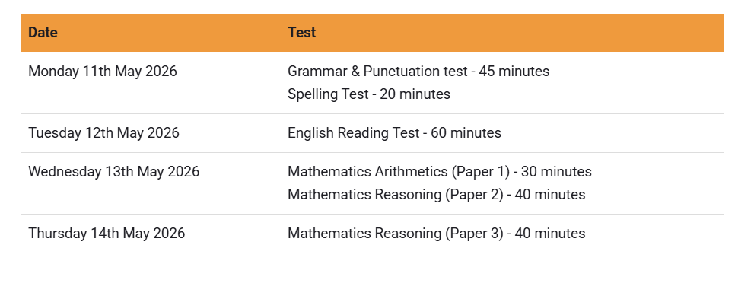
The SATS timetable is as follows:

The children have worked incredibly hard this year and we know that they are going to do just brilliantly in these forthcoming assessments. Each and every one of them are a credit to you and you should be very proud of what fabulous children you all have.
Kind regards

Year 6 Team

