First Name: | Last Name: |  | Class:
Why do you want to be a Junior Librarian?

Why do you think you would be good at this role? Can you think of examples of things you have done that show you are the sort of person who would make a good Junior Librarian?

Why is reading so important?

What is your favourite book and why? |  | 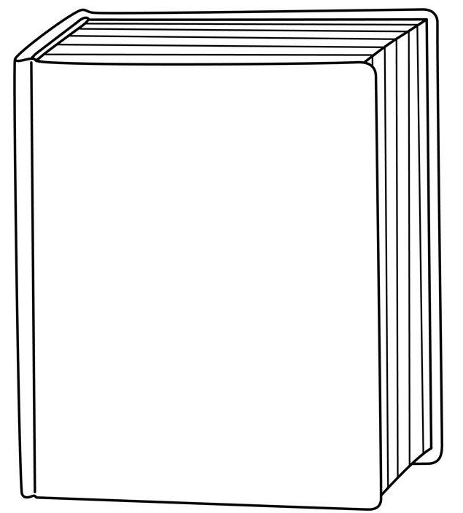  A drawing of the cover of your favourite book:
Librarian Application Form (YEAR 6 ONLY)


Please give your form to the office by Friday 26th September

