Art & Design Technology:
This half term we will be:
- Designing devices using electrical systems
- Using simple circuits and switches in our designs
Food Technology:
- Using ingredients that would be available in the Stone Age to create Oat Bread

Spanish:
This half term we will be:
- Learning to give directions
- Using language to describe hobbies

Computing:
This half term in Computing we will be:
- Identifying that sound can be recorded
- Explaining that audio recordings can be edited
- Applying audio editing skills independently
- Evaluating effective use of audio

English:
In English this half term we will be:
- Reading quality texts such as The Iron Man by Ted Hughes
- Reading dramatically to create suspense and acting out scenes from the text to show our understanding
- Writing news reports using ambitious vocabulary and organising our writing using paragraphs
- Exploring non-fiction texts focussing on the Stone Age
- Drafting and rewriting work
- reading work aloud to a group with confidence

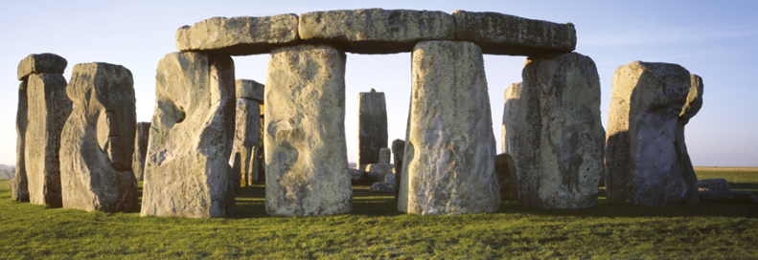
Humanities:
In humanities this half term we will be:
- Learning about how humans survived the Stone Age
- Ordering events in chronological order
- Understanding that sources can contradict each other
- Using historic terms for the period of study, such as; Palaeolithic, Mesolithic and Neolithic

We will be attending a virtual author visit as part of the Literacy Festival

Year 4 Spring 1
Savage Stone Age
Science (Electricity):
In science this half term we will be:
- Exploring what a circuit is and what makes it complete or incomplete
- Learning the symbols for the different parts of a circuit in order to draw our own electrical circuits

Maths:
In maths this half term we will be:
- Recalling multiplication facts
- Learning about factor pairs
- Multiplying and dividing three-digit numbers by one-digit numbers using the column method
- Calculating the perimeter of shapes
- Exploring improper fractions
- Exploring mixed number fractions

PSHE:
Through the Jigsaw programme we will:
- Discover what is meant by dreams and goals
- Focus on positive and happy experiences to counteract disappointment

Music:
In music this half term we will be:
- Learning, singing and performing Spanish songs
- Developing an understanding of what beat and pitch are

RE:
In RE this half term our unit is: What do Sikhs believe?
We will be:
- Exploring what Sikhs believe about God, including the meaning of Ik Onkar
- Learning why equality is important in Sikhism and how this belief shapes everyday life
- Finding out about key Sikh figures and texts, such as Guru Nanak and the Guru Granth Sahib
- Understanding the importance of the Amrit ceremony and serving others within the Sikh community

PE:
In PE this half term we will be:
- Learning and practising netball skills
- Learning a variety of passes and focusing on using space
- Applying our skills in matches

