Art & Design:
- We will be learning about the history of weaving around the world and Anglo Saxon textiles
- We will be developing the skill of weaving and creating our own woven pieces in the way Anglo Saxons did!
Food Technology:
- We will be planning and making Anglo-Saxon soup.

English:
Our class text this half term is Beowulf- a retelling of the Anglo-Saxon legend. We will be:
- Focussing on using adverbials to sequence and conjunctions to extend our sentences
- Rehearsing our sentences verbally before writing
- Focusing on editing and improving our work independently, thinking about audience and purpose
- Retelling a known legend in our own words
- Continuing to work on punctuating speech accurately

Humanities:
We will learn about:
- Who the Anglo-Saxons were, where they came from and why they came to Britain
- The significance of Alfred the Great
- What life was like in Anglo Saxon Britain – how people lived and what they believed

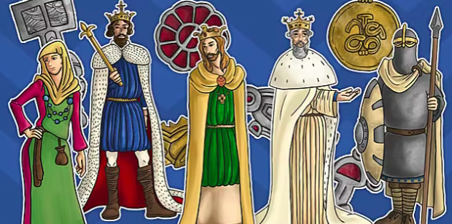
Maths:
We will be:
- Continuing to use our 3,4- and 8-times tables
- Comparing statements, learning related calculations and multiplying 2-digit numbers by 1-digit numbers
- Learning about length and perimeter

Computing: Creating Media – Desktop Publishing
During this unit, we will become familiar with the terms ‘text’ and ‘images’ and understand that they can be used to communicate messages. We will use desktop publishing software and consider careful choices of font size, colour and type to edit and improve premade documents.

Music:
In music for this half term, we will be looking at pitch and beat.
The children will be exploring the pentatonic scale and developing their understanding of beat, metre and rhythm.

PE:
We will be practising our throwing and catching skills and invasion game tactics through the sport of netball. We will also be looking at balancing and points in gymnastics.

We will be visiting the British Museum to immerse ourselves in the Anglo-Saxon period.

RE: What does it mean to be a Hindu in Britain today?
We will learn:
- Some key beliefs / concepts for Hindus and how these beliefs / concepts are expressed
- To describe how Hindus’ show their faith within their families in Britain today
- To make links between Hindu practices and the idea that Hindu Dharma is a whole ‘way of life’

Year 3 Spring 1
Invaders and Settlers!
PSHE:
Dreams and Goals
We will:
- Learn about a person who has experienced a challenge
- Identify our own goals and ambitions, and the challenges we will need to overcome to achieve them.

Spanish:
We will be building on our learning from Autumn 2 and learning to talk about ourselves and the things we like to do.

Science: Forces and Magnets
We will learn:
- What magnets are and how they work
- What things are magnetic and non-magnetic
- How magnets are used in everyday life

