

Autumn Term
Facebook - @OLSSCP Twitter - @OLSSTweets
Friday 9th October 2026



Date and Times | Event | Class
21/10/2026 | Whole School finish for half term | Whole school
16/11/2026 | Anti-bullying Week
02/12/2026 | Breakfast with Santa | Whole School
03/12/2026 | Christmas Panto | Year 1 – 6
09/12/2026- 8:45am | Christmas Craft Morning | Whole School
11/12/2026 | Christmas Bonanza and Christmas Jumper Day | Whole School
15/12/2026 | Christmas Lunch | Whole School
16/12/2026 -3:00pm | Christmas Bingo | Whole School
18/12/2026 | Christmas Party Day - Party Clothes | Whole School
18/12/2026 | Children finish for Christmas. | Whole School

Prayer & liturgy Dates
Year 4 - 07/10/26
Year 3 - 14/10/26

A message from Mrs Allen..
To ensure every child receives the right support at the right time, we follow a clear graduated approach.
Your child’s class teacher is the first point of contact and will put initial strategies in place. Mrs Allen oversees this process and becomes more directly involved where needed, including reviewing Individual Plans. Referrals to external agencies must follow this graduated process.
Appointments with Mrs Allen should be made via the school office

This week, we have been reflecting on the Gospel of the Ten Lepers (Luke 17:11–19), which reminds us of the importance of gratitude and taking time to thank God for the blessings in our lives. Jesus teaches us that even the smallest act of thankfulness can make a big difference. We have encouraged the children to think about the many things they are grateful for and how they can show their appreciation through their words and actions. On Thursday, our Year 3 and 4 children attended Mass, providing a wonderful opportunity to come together in prayer, deepen their faith and celebrate as part of our parish community. As we continue through the week, we pray that we may all have grateful hearts and follow Jesus' example by showing kindness, love and compassion to others.
Please join us in prayer.

Dear Lord,
Thank You for all the wonderful blessings You give us each day. Help us to remember to be grateful for our families, friends, teachers and the love we share. Just as the thankful leper returned to Jesus, may we always take time to say thank You. Guide us to show kindness, love and compassion to everyone we meet, and help us to grow closer to You through our words and actions.
Amen.

Catholic Life
Dates for your diary


OLSS Target-97%
Whole School Attendance – 93.34 %
97%+
90%-96.9%
Below 90%
Attendance
Reception | 80.48%
Year 1 | 96.19%
Year 2 | 95.56%
Year 3 | 96.82%
Year 4 | 95.19%
Year 5 | 92.86%
Year 6 | 94.8%
ARC | 90.91%



Arriving late can affect your child’s attendance!
Every minute counts!
As few as 19 missed days over the school year reduces your child’s chances of success.

Lateness = lost learning (Figures below are calculated over a school year)
5 minutes late each day 3 days lost!
10 minutes late each day 6.5 days lost!
15 minutes late each day 10 days lost!
20 minutes late each day 13 days lost!
30 minutes late each day 19 days lost!

Don’t let your child miss out! What you can do:
• Have a regular routine for the start of each day.
• Help your child get their clothes and equipment ready before they go to bed.
• Set a reasonable bedtime to make sure they get enough sleep. Get your child to school on time. If they are late, they have a bad start to the day.
If your child arrives late for class:
• They miss Phonics
• They miss out on important learning, which could affect their achievement.
• They don’t have the social time to settle into class.
• It can be embarrassing for them.
• They may disrupt the learning of the rest of the class.





Around School
Stars of the Week
Nursery | Reign
Reception
Year 1 | Brodie
Year 2 | Frankie
Year 3 | Olivia
Year 4 | Maria
Year 5 | Amellia
Year 6
ARC (S) | Esme
ARC (D) | Olivia
Well Done to all our amazing Stars of the Week!

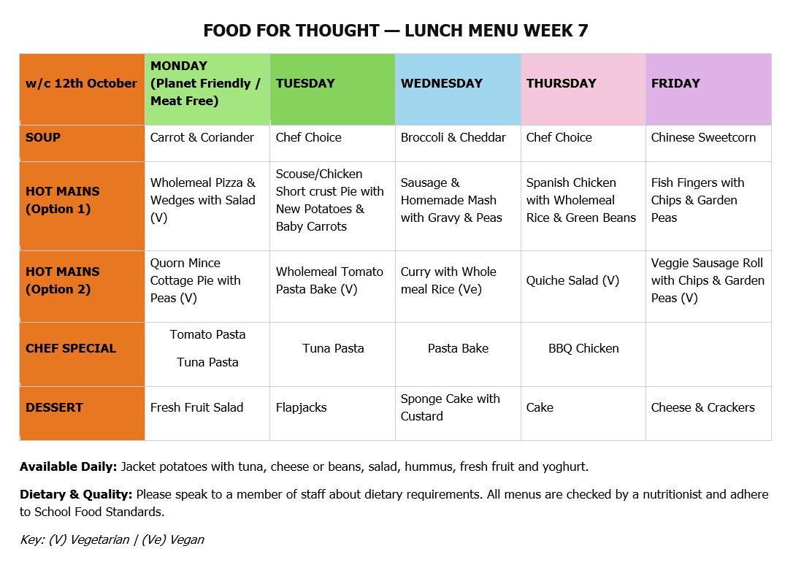





A healthy packed lunch gives children the energy and nutrients they need to learn, play and stay focused throughout the afternoon. Aim to include a variety of foods such as fruit or vegetables, a wholegrain sandwich/wrap or other starchy food, a protein-rich food such as cheese, eggs or yoghurt, and a drink of water. Try to keep sugary snacks, sweets, chocolate and fizzy drinks as occasional treats rather than everyday lunchbox choices. A colourful, balanced lunch helps children develop healthy eating habits and supports their wellbeing..

Healthy Lunches
Any children needing to use fidget toys will be provided with one from school to use during the school day to help them focus during lessons. Child are NOT allowed to bring in their own fidget toys. If you require any further information, please contact our SENDCo on the above email address.
Sensory Toys

Reception and Year 7 admissions 2027 Reception closes 15/1/2027, Year 7 closes 31/10/2026 -any problems or help needed submitting contact the office.
Parent Teacher Consultations are now live on Arbor 11/11/2026 slots from 1pm to 4.50 pm, any problems or need help to access, contact the office.

Nursery – 8:45am-2:55pm
Reception – 8:45am-3:05pm
Year 1 & 2 – 8:45am-3:10pm
Year 3, 4, 5 & 6 – 8:45am-3:10pm
ARC – 8:45am-3:05pm
School Start Times
Rec & Year 7

REMINDERS
Parents are asked to download the new ARBOR Parent App and follow all instructions for gaining access to your account, Office staff are here to help if needed.

School dinner money must be paid on a Monday for the week

We currently have uniform available in most sizes. Once this stock has been sold, we will no longer be selling uniform in school due to storage issues

After School clubs are all live on ARBOR and must be booked through the APP

PARENTPAY: Activation letters have been sent out, please activate your account for payments for trips, meals etc.

Nursery Places available for children who are 3+

Our Lady and St Swithin’s is a NUT FREE School

Please remember to CUT all grapes in your children’s packed lunches

.









