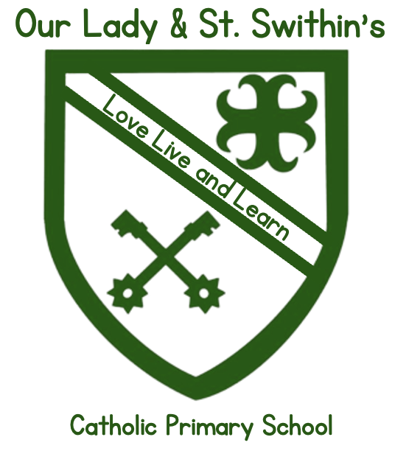
Love, Live and Learn

Food in Schools Policy
2026/2027
Headteacher:____________________
Chair of Governors:____________________
Date:______________

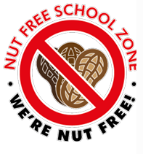


Food in School Policy
Snacks, Packed Lunches and Nut-Free Provision
September 2026
1. Introduction
Our Lady and St Swithin's is committed to promoting the health, wellbeing and
safety of all pupils. We recognise that healthy eating plays a vital role in supporting children’s
physical development, emotional wellbeing, behaviour, concentration and learning, and that
schools have an important responsibility in shaping positive lifelong habits.
This policy sets out the school’s expectations and procedures relating to food brought into school,
including snacks and packed lunches, and confirms the school’s position as a nut-free setting. It
also outlines how food safety, allergy management and choking prevention are addressed,
ensuring a consistent, inclusive and safe approach for all members of the school community.

2. Aims
The aims of this policy are to:
- promote healthy eating habits across the school day
- protect pupils and staff with food allergies, particularly those at risk of anaphylaxis
- reduce the risk of choking and food-related illness
- ensure clarity and consistency for parents, pupils and staff
- support safeguarding and medical needs in line with statutory guidance
- encourage partnership between home and school in supporting children’s safety, health and wellbeing
3. Statutory Responsibilities and Key Guidance
This policy supports the school’s statutory duties relating to safeguarding, health, wellbeing
and medical needs, and reflects current national guidance and best practice.
In particular, this policy aligns with and is informed by:
- Keeping Children Safe in Education (DfE) - ensuring pupils’ health and safety,
- including those with medical needs and allergies
- Early Years Foundation Stage (EYFS) Framework - including requirements relating to
- food safety, supervision, choking prevention and children’s wellbeing
- School Food Standards (DfE) - promoting healthy eating and balanced nutrition across
- the school day
- Children and Families Act 2014 - supporting pupils with medical conditions in school
- NHS and UK Health Security Agency guidance - promoting healthy eating, dental
- health and allergy awareness
- Allergy UK and Anaphylaxis Campaign guidance - supporting best practice in allergy risk management
Food in School Policy - April 2026
While this policy is non-statutory, it plays an important role in helping the school meet its
statutory responsibilities and in providing a clear, consistent and safe approach to food provision for all pupils.
4. Packed Lunches
This section sets out clear expectations for packed lunches to ensure they are balanced, nutritious and safe, while also supporting the school’s nut-free requirement.
Packed lunches should provide a balanced meal and include:
- a main item such as a sandwich, wrap, roll, pasta or rice-based dish
- at least one portion of fruit or vegetables
- a dairy item or suitable dairy alternative (e.g. yoghurt, cheese)
- water as the preferred drink (but juice is also acceptable)
- a healthy treat/dessert
Packed Lunches Must Not Include
- any nuts or nut-containing products (including spreads, snacks and cereal bars)
- chocolate bars or sweets
- fizzy drinks or energy drinks
- large cakes, pastries or sugary desserts
Packed lunches are eaten under staff supervision. Where packed lunches regularly do not meet
expectations, or where there are concerns linked to allergies or safeguarding, the school may
contact parents to discuss the appropriate next steps.

Please see Appendix A - What Does a Healthy Packed Lunch Look Like? - for guidance,
ideas, tips and hints.

5. Healthy Snacks in School
The purpose of this section is to ensure that snacks consumed during the school day are nutritious, safe and appropriate, supporting children’s energy levels and ability to learn. Children may bring one healthy snack to school for morning break (and afternoon break where applicable). Acceptable snacks include: fresh fruit (whole or appropriately prepared) vegetables (e.g. carrot sticks, cucumber, peppers) plain breadsticks or rice cakes healthy cereal bars
The following snacks are not allowed in school:
- chocolate, sweets or confectionery
- crisps
- cakes, biscuits or pastries
- sugary cereal bars or desserts
- fizzy drinks or energy drinks
- These items do not support healthy eating, can negatively impact concentration and behaviour,
- and increase the risk of dental decay.

Please see Appendix B - Healthy Snack Choices - for guidance, ideas, tips and hints.
6. Nut-Free Provision
This section exists to protect pupils and staff with severe nut allergies, where exposure can result in life-threatening reactions. Our Lady and St Swithin's is a nut-free school. This means: no nuts or nut-containing products are permitted on site this applies to snacks, packed lunches, food brought in for events and celebrations parents and carers must check ingredient labels carefully. This approach significantly reduces risk and supports a safe environment for all.
7. Food Safety and Choking Prevention
At Our Lady and St Swithin's, we are committed to ensuring that food consumed in school is safe and age-appropriate, and that risks are minimised. Following this approach significantly reduces risk and supports a safe environment for all.
We ask that:
- Grapes, olives and other higher-risk foods must only be brought into school if they are appropriately prepared to reduce choking risk. This includes cutting grapes and olives lengthways and into smaller pieces, and preparing hard foods so they are soft, grated or cut into thin strips appropriate to the child’s age.
- Parents prepare food before it comes into school, rather than relying on children to manage this themselves
We ensure that:
- Children are supervised while eating and staff support children to eat safely and calmly.
- Food is stored and handled safely
- EYFS provision follows enhanced guidance on food preparation and supervision
- Staff hold paediatric first aid training
8. Allergies and Medical Needs
To ensure pupils with medical conditions and allergies are identified, supported and kept safe, we
ensure that:
- Allergies and medical needs are recorded and shared appropriately
- Individual Medical Care Plans are in place where required
- Staff are trained to recognise allergic reactions and administer medication (including
- EpiPens)
- Parents are encouraged to inform school immediately of any new or changed allergies.
9. Breakfast Club Provision
Our Lady and St Swithin's recognises the importance of children starting the day
nourished, settled and ready to learn. As part of our commitment to wellbeing and inclusion, the
school provides toast and fruit to children attending Breakfast Club, supporting a healthy and
positive start to the day.
Our Breakfast Club provision:
includes toast and fresh fruit promotes calm routines and positive social interaction
supports children who may not have had breakfast at home
is managed in line with food safety, allergy and hygiene procedures
All food provided at Breakfast Club complies with the school’s nut-free policy and allergy
management arrangements. Staff supervising Breakfast Club are trained to support children
appropriately and ensure food is eaten safely.

10.Free Breakfast for All
To promote consistency in healthy eating across all school provision, Our Lady and St Swithin's Community
Primary School provides a free breakfast to all pupils, in line with School Food Standards. Any
changes to food provision are risk-assessed, communicated clearly and monitored for impact on pupils and staffing arrangements.
Free Breakfast Toast and Fruit Provision
Our school is committed to ensuring that all children have access to healthy food during the school day, regardless of circumstance, and recognises the important link between nutrition, wellbeing and readiness to learn.
Our Lady and St Swithin's provides toast free of charge to every child each morning. This provision is available to support pupils who may not have had breakfast at home and to ensure that all children begin the school day settled, nourished and ready to learn.
Our toast provision is:
- inclusive and open to all pupils who need it
- offered without stigma
- managed in line with food safety, allergy and hygiene procedures
- This approach reflects the school’s commitment to equity, care and wellbeing.
Fruit at Break time
In addition to the free morning toast provision, our school provides fresh fruit for pupils to access at break time. This supports healthy snacking, promotes positive eating habits and ensures that children have access to nutritious food during the school day.
Our fruit provision:
- is available to all pupils
- complements, rather than replaces, expectations around healthy snacks from home
- supports the School Food Standards and NHS healthy eating guidance
12.Our Curriculum - Supporting Healthy Food Choices
Our school’s cultural capital curriculum supports and reinforces the expectations set out in this
policy, ensuring that pupils not only follow the guidance around food in school, but helps them
understand why it matters.
Our Lady and St Swithin's recognises that developing pupils’ understanding of
health, wellbeing and safety is a key part of preparing them for life beyond school. Through our
PSHE and RSE/RSHE curriculum, pupils are explicitly taught the knowledge, skills and attitudes
that underpin the expectations within this policy.
Teaching is age-appropriate and builds progressively, ensuring that pupils develop a secure
understanding over time.

As part of Science, Design Technology, PSHE and RSE/RSHE lessons, pupils learn about:
- Healthy eating and nutrition, including the importance of balanced meals, healthy snacks and hydration
- Food choices and wellbeing, understanding how what we eat can affect our energy levels, mood, concentration and physical health
- Allergies and medical needs, learning why some foods are not allowed in school and how rules such as being a nut-free school help keep everyone safe
- Risk awareness and safety, including choking risks and why certain foods must be prepared in specific ways
- Responsibility and respect, understanding that individual choices can impact others within a shared community
- Equity and inclusion, recognising that schools provide food such as toast and fruit to ensure all children can access what they need to be ready to learn

Through these curriculum opportunities, pupils develop the knowledge, language and
understanding needed to make informed choices about food and health, both in school and
Food in School Policy – September 2026 beyond. This contributes to pupils’ cultural capital by equipping them with practical life skills, social
awareness and an understanding of how to navigate shared environments responsibly.
Our curriculum reinforces consistent messages across school life, helping pupils to understand that expectations around food are not arbitrary rules, but part of a wider commitment to health, safety, kindness and community responsibility.
13.Celebrations and Special Events
In order to ensure food used for celebrations remains safe, inclusive and aligned with the school’s healthy approach and policies, our school:
- ensures that allergies and dietary needs are considered
- non-food rewards are promoted, wherever possible
- parents/carers ensure that food provided, for event such as class parties, adhere to this
- policy and our ‘nut-free school’ stance
- external providers are aware of what is set out in this policy
14.Roles and Responsibilities
Parents and Carers
- provide healthy, nut-free snacks and packed lunches
- inform school of allergies and medical needs
- support the school’s healthy eating messages and this policy

Staff
- model positive attitudes to food and healthy eating
- supervise eating safely
- follow allergy and food safety procedures
School Leadership and Governors
- monitor the implementation of this policy
- ensure appropriate training is provided to empower staff
- review and update this policy
15.Monitoring and Review
This policy will be:
- monitored by senior leaders
- reviewed every two years or sooner if guidance changes
- updated in response to medical, safeguarding or operational needs
Any questions or concerns about this policy should be raised with the school office or a member of the Senior Leadership Team.

Appendix A
What Does a Healthy Packed Lunch Look Like?
This section is intended to support parents and carers in making positive, practical choices when preparing packed lunches for primary-aged children. A healthy packed lunch helps children to maintain energy levels, concentrate in lessons and develop lifelong healthy eating habits.
Good practice guidance recommends that packed lunches include a balance of starchy foods, fruit and vegetables, protein and dairy, while limiting foods high in sugar, salt and saturated fat.
The ‘Perfect’ Packed Lunch - A Balanced Approach
A healthy packed lunch should include the following components:
1. A Starchy Main Item (Energy for Learning)
Starchy foods provide children with the energy they need to get through the school day.
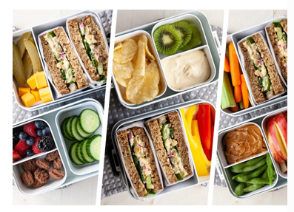
Examples include:
- wholemeal or brown bread sandwich or wrap
- pasta salad with vegetables
- rice or couscous dish
- bagel or roll (wholegrain encouraged)
Filling ideas (nut-free):
- cheese
- egg
- tuna
- chicken or turkey
- hummus (nut-free)
2. Fruit and/or Vegetables (Vitamins and Fibre)
At least one portion of fruit or vegetables should be included every day. Including both is encouraged where possible.
Examples include:
- apple slices, pear slices or orange segments
- berries or melon (appropriately prepared)
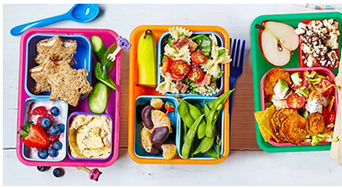
- carrot sticks, cucumber, peppers
- cherry tomatoes (cut appropriately)
These support digestion, immunity and overall health.
3. Protein-Rich Foods (Growth and Development)
Protein supports children’s growth and helps them feel full for longer.

Examples include:
- lean meats (chicken, turkey, ham)
- eggs
- cheese or yoghurt
- pulses such as lentils or chickpeas
4. Dairy or Dairy Alternatives (Calcium for Strong Bones)
Calcium is important for bone and tooth development.
Examples include:
- yoghurt
- cheese portion
- fromage frais
- dairy-free alternatives (where appropriate)
5. A Healthy Drink
- Water is the recommended drink for school.
- Milk is also appropriate and can be provided, at a cost, by our school
- Fizzy drinks and energy drinks are not suitable for school.
6. Healthy Treats
Packed lunches do not need to be completely ‘treat-free’, but treats should be small.
Healthier alternatives include:
- plain flapjack
- malt loaf
- small homemade cake
- plain biscuit
Chocolate bars, sweets and high-sugar desserts are not allowed.
Important Safety Reminders
- Our school is a nut-free environment - nuts and nut products must not be included
- Grapes, olives and similar foods must be cut lengthways
- Food should be age-appropriate and safely prepared
7. Supporting our Families
At Our Lady and St Swithin's, we recognise that families have different routines, preferences and circumstances. These examples are intended as guidance, not judgement, and we are always happy to support families with questions or concerns.
By working together, we can help children develop healthy habits, confidence around food and a positive relationship with eating.

Appendix B - Healthy Snack Choices
This appendix provides clear guidance for parents, carers and staff on appropriate healthy snack choices for school. Healthy snacks help maintain children’s energy levels, support concentration and promote positive eating habits. This guidance reflects national good practice and supports the school’s commitment to health, wellbeing and safety.
School-Provided Snacks
Our Lady and St Swithin's provides fresh fruit for pupils to access at break time.
This ensures that all children have access to a healthy snack during the school day and supports equity and inclusion. Parents may choose to provide an additional snack from home; however, this must align with the guidance below.
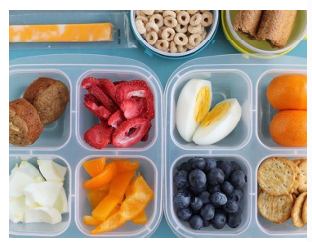
Permitted Healthy Snacks
The following snacks are appropriate for school:
- Fresh fruit (whole or appropriately prepared)
- e.g. apples, bananas, pears, oranges, berries
- Fresh vegetables
- e.g. carrot sticks, cucumber, peppers
- Plain breadsticks
- Plain rice cakes
- Healthy cereal bars
These snacks are:
- low in sugar and salt
- supportive of dental health
- recommended by NHS and School Food Standards guidance
Snacks That Are Not Permitted
The following snacks should not be brought into school:
- Chocolate bars
- Sweets
- Crisps
- Cakes, biscuits or pastries
- Sugary cereal bars
- Fizzy drinks or energy drinks
These items are high in sugar, salt or fat and do not support children’s health, wellbeing or
readiness to learn.
Nut-Free Requirement
Our Lady and St Swithin's is a nut-free school.
- Nuts and nut-containing products must not be brought into school
- This includes peanuts, nut spreads and cereal bars containing nuts
- Parents and carers are asked to check ingredient labels carefully
This requirement is in place to protect pupils and staff with severe allergies.

