Working at the expected standard:
I can write for a range of purposes and audiences:
I can compose and sequence sentences to form short narratives
I can compose and sequence sentences to form short non-fiction texts e.g. instructions, recounts, poems information texts
I can use familiar plots for opening, middle and end of stories and use formulaic phrases (once upon a time, one day, after that, later, in the end)
I can join words and clauses using ‘and
I can join words and clauses using ‘but’ and ‘or’
I can use the capital letters for people, places, days of the week and ‘I’
I can use mostly correctly: | capital letters
I can use mostly correctly: | full stops
I can make correct use of: | question marks
I can make correct use of: | exclamation marks
I can spell most words correctly (Year 1)
I can form lower case letters in the correct direction, starting and finishing in the right place, going the right way round and correctly orientated
I can use clear ascenders and decenders
I can form capital letters correctly

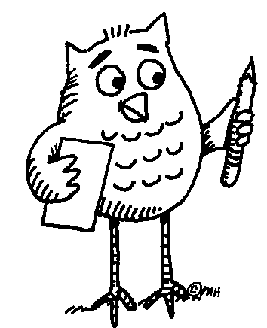
Key Learning in Writing Year 1

