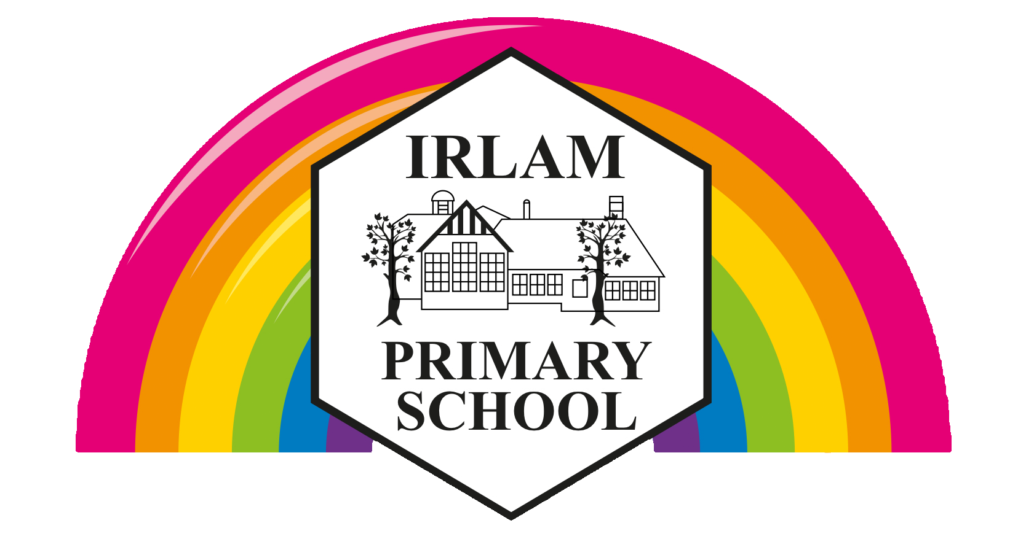

EYFS Acceptable Use Agreement

- I ask before I use a tablet, computer or camera.

- I tap or click on things I have been shown.

- I check if I can tap/click on things I haven’t seen before.

- I tell a grown-up if something upsets me.

Class:
Date:
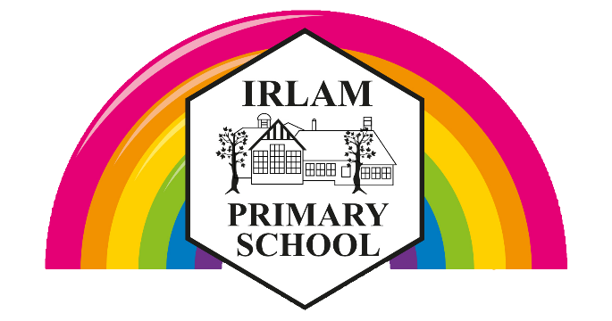

KS1 Acceptable Use Agreement

- I always ask a teacher or adult if I want to use the computers, tablets or cameras.
- I only open activities that an adult has told or allowed me to use.
- I know that I must tell an adult if I see something on a screen that upsets me, or I am unsure of.
- I keep my passwords safe and will never use someone else’s.
- I know personal information such as my address and birthday should never be shared online.
- I know I must never communicate with strangers online.
- I am always polite when I use communication tools.

Class:
Date:

KS2 Acceptable Use Agreement

- I will only access computing equipment when a trusted adult has given me permission and is present.
- I will not deliberately look for, save or send anything that could make others upset.
- I will immediately inform an adult if I see something that worries me, or I know is inappropriate.
- I will keep my usernames and passwords secure; this includes not sharing it with others.
- I understand what personal information is and will never share my own or others’ personal information such as phone numbers, home addresses and names.
- I will always use my own usernames and passwords to access my school accounts.
- In order to help keep me and others safe, I know that the school checks my files and the online sites I visit. They will contact my parents/carers if an adult at school is concerned about me.
- I will respect computing equipment and will immediately notify an adult if I notice something isn’t working correctly or is damaged.
- I will use all communication tools carefully. I will notify an adult immediately if I notice that someone who isn’t approved by the teacher is messaging.
- Before I share, post or reply to anything online, I will T.H.I.N.K.
T = is it TRUE?
H = is it HELPFUL?
I = is it INSPRING?
N = is it NECESSARY?
K = is it KIND?
- I understand that if I behave negatively whilst using technology towards other members of school, my parents/carers will be informed and appropriate actions taken.

Class:
Date:

Acceptable Use Agreement for Parents/Carers

We ask parents and carers to support us by:
- Sharing good online behaviours with your child.
- Emphasisng the importance of the Acceptable Use Statements your child has agreed to.
- Highlighting the importance of accessing only age-appropriate content and sites along with the pitfalls of social media.
- Explaining how to keep an appropriate digital footprint.
- Discussing what is and isn’t appropriate to share online.
- Emphasising never to meet anyone online nor trust that everyone has good intentions.
- Reporting any concerns you have whether home or school based.
- Stressing the importance of openness when being online and that no one should ever be too ashamed or embarrassed to tell a trusted adult if they have seen/shared anything concerning or have had inappropriate online contact.
- Drawing up an agreement of online safety rules for outside of school that are applicable even when your child is at a friend’s house.
- Avoiding posting or replying to any comments about the school on social media that may have a negative impact. Any concerns or worries should be reported to the school in the first instance.

Permission Access
By signing below, you agree to allowing your child access to the school’s internet and ICT systems. This also includes any educational subscription services. You are also aware that your child has signed/agreed to the school’s Acceptable Use Agreement for pupils.

Your Child(ren)’s Name(s):
Class(es):
Parent/Carer Signature:
Date:

Acceptable Use Agreement for Staff

By signing this agreement, you will have access to the school’s systems and acknowledge that you agree to all the statements below. Additionally, that you have read and understand school policies which have a bearing on this agreement.

- I will demonstrate the value of the use of digital technologies in improving the outcomes for children in my care.
- I will educate children in my care about the safe use of digital technologies, acting on any online safety issues in accordance with the school’s policies.
- I understand my use of the school’s ICT systems/networks and internet are monitored.
- I recognise that whether within school or out of school, I must abide by the rules/statements set out in this document when using systems, accessing/transferring data that relate to the school or impact on my role within the school and wider community.
- I know what GDPR is and how this has a bearing on how I access, share, store and create data.
- Any data that I have access to away from school premises must be kept secure and used with specific purpose. As outlined in the school’s data protection policy, it is my responsibility to ensure when accessing data remotely that I take every bit of reasonable care to ensure the integrity and security of the data is maintained.
- I understand that I am fully responsible for my behaviours both in and out of school and as such recognise that my digital communications, subscriptions and content I access can have a bearing on my professional role.
- I recognise that my social media activity can have a damaging impact on the school and children in my care at school if I fail to uphold my professional integrity at all times whilst using it.
- If I am contributing to the school’s social media account(s) or website(s), including ClassDojo, I will follow all guidelines given to me, with particular care given to what images/video imagery and details can be uploaded.
- I will never upload images/video imagery of staff/pupils or other stakeholders to my personal social media accounts unless there is significant reason to and that permission has been granted by the headteacher in writing for each occurrence.
- I will inform the school at the earliest opportunity of any infringement both on and off site by myself. Furthermore, if I am concerned about others’ behaviour/conduct, I will notify the school at the earliest opportunity.
- I will never deliberately access, upload or download illegal, inflammatory, obscene or inappropriate content that may cause harm or upset to others.
- I will never download or install software unless permission has been given by the appropriate contact at school.
- I shall keep all usernames and passwords safe and never share them. Writing down usernames and passwords, including storing them electronically, constitutes a breach to our data protection and safeguarding policy.
- I will never leave equipment unattended which could leave data and information vulnerable; this extends to accessing data/services/content remotely.
- Any personal devices I own shall not be used to access school systems/data/services/content remotely unless I have adequate virus protection and permission from the school.
- I understand that mobile devices, including smart watches, shall not be used, nor in my possession, during times of contact with children. These devices will be securely locked away (or out of sight) with adequate password protection on them should they be accessed by an unauthorised person. This excludes the use of a mobile phone camera for taking photos used in school or being shared with parents/carers, with the photos (or any other data) being immediately deleted afterwards.
- I will only use my own devices to make contact with parents/carers if using agreed communication platforms such as ClassDojo or email.

Staff Name:
Signature:
Date:

