Key Vocabulary | Key Knowledge | Key Knowledge
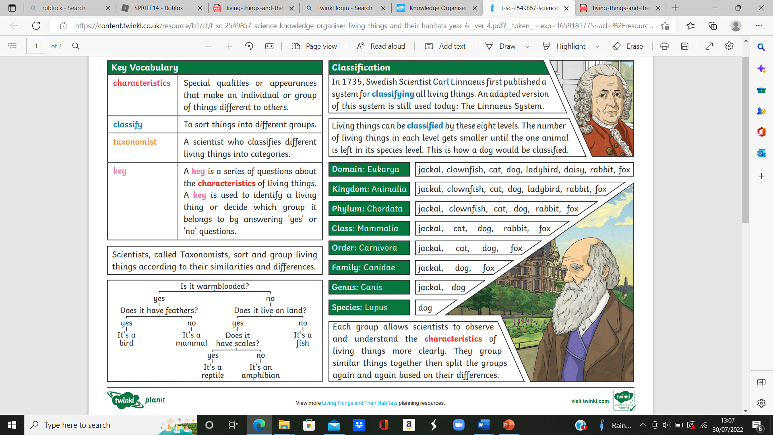 |  | 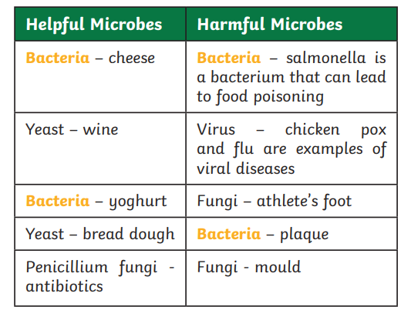  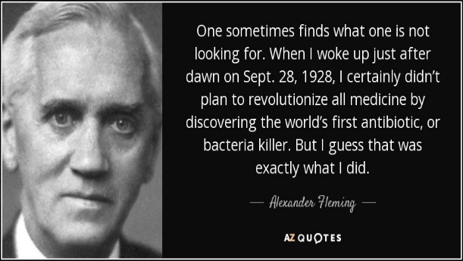
  characteristics | Special qualities or appearances that make an individual or group of things different to others.
  Classify | To sort things into different groups.
  key | A key is a series of questions about the characteristics of living things. A key is used to identify a living thing or decide which group it belongs to by answering ‘yes’ or ‘no’ questions.
  species | A group of animals that can reproduce to produce fertile offspring.
  bacteria | A single-celled microorganism.
  microorganism | An organism that can only be seen using a microscope, e.g. bacteria, mould and yeast. Some animals (dust mites) and plants (phytoplankton) are also microorganisms.
Living Things and Their Habitats - Year 6 