Key Vocabulary | Key Knowledge | Key Knowledge
Isaac Newton shone a light through a transparent prism, separating out light into the colours of the rainbow (red, orange, yellow, green, blue, indigo and violet) - the colours of the spectrum. All the colours together merge and make visible light.  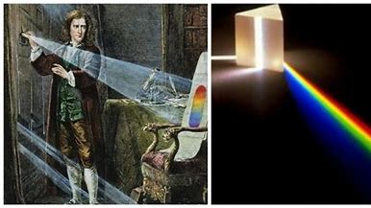 | The spoon in this water looks as if it is bent. This is because light bends when it moves from air to water. When light bends in this way, it is called refraction.  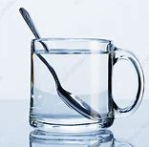  A shadow is always the same shape as the object that casts it. This is because when an opaque object is in the path of light travelling from a light source, it will block the light rays that hit it, while the rest of the light can continue travelling.  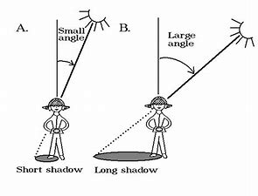  Shadows can also be elongated or shortened depending on the angle of the light source. A shadow is also larger when the object is closer to the light source. This is because it blocks more of the light. | We need light to be able to see things. Light waves travel out from sources of light in straight lines. These lines are often called rays or beams of light. Light from the sun travels in a straight line and hits the flower. The light ray is then reflected off the flower and travels in a straight line to the person’s eye, enabling them to see the chair.  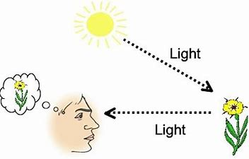  Reflection is a ray of light that has bounced back after hitting a surface. The law of reflection states that the angle of the incident ray is equal to the angle of the reflected ray.  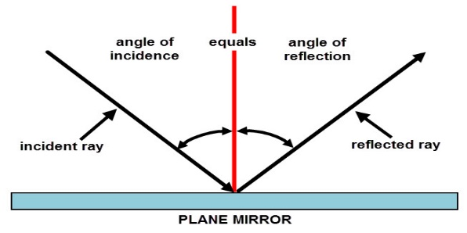
  light | A form of energy that travels in a wave from a source.
  light source | An object that makes its own light.
  incident ray | A ray of light that hits a surface.
  reflected ray | A ray of light that has bounced back after hitting a surface.
  shadow | An area of darkness where light has been blocked.
  visible spectrum | Light that is visible to the human eye. It is made up of a colour spectrum.
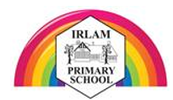
Light- Year 6

