Key Vocabulary
Evolution | Adaption over a very long time.
Offspring | The young animal or plant that is produced by the reproduction of that species.
Characteristics | The distinguishing features or qualities that are specific to a species.
Inheritance | This is when characteristics are passed on to offspring from their parents.
Variations | The difference between individuals within a species.
Natural Selection | The process where organisms that are better adapted to their environment tend to survive and produce more offspring.
Adaption | An adaptation is a trait (or characteristic) changing to increase a living thing’s chances of surviving and reproducing.
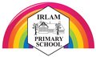
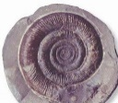
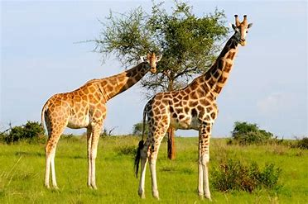
Fossils are the preserved remains, or partial remains, of ancient animals and plants. Fossils let scientists know how plants and animals used to look millions of years ago. This is proof that living things have evolved over time.

Evolution and Inheritance Year 6

Fossils of giraffes from millions of years ago show that they used to have shorter necks. They have gradually evolved through natural selection to have longer necks so that they can reach the top of taller trees.
An example of how a camel has adapted to its habitat.
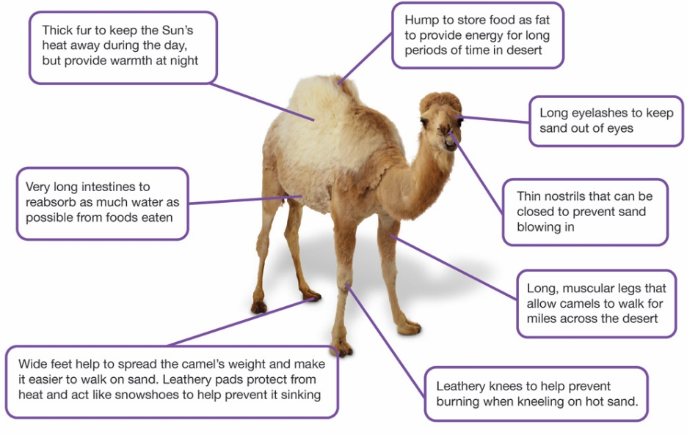
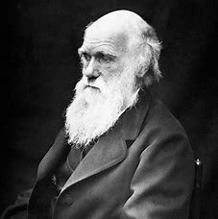
Charles Darwin (1809-1882) was an English scientist best known for his theory of evolution. He was a geologist who travelled across the world in 1831 on the HMS Beagle. He studied many animals and plants on his travels and came up with the idea of natural selection (the strongest survive and evolve). His book ‘On the Origin of Species’ was very controversial at the time because it went against the creation story in the Bible. His studied finches and tortoises living across the Galapagos islands.

