Key Vocabulary  Animals Including Humans - Year 6 | Key Knowledge |   Key Knowledge
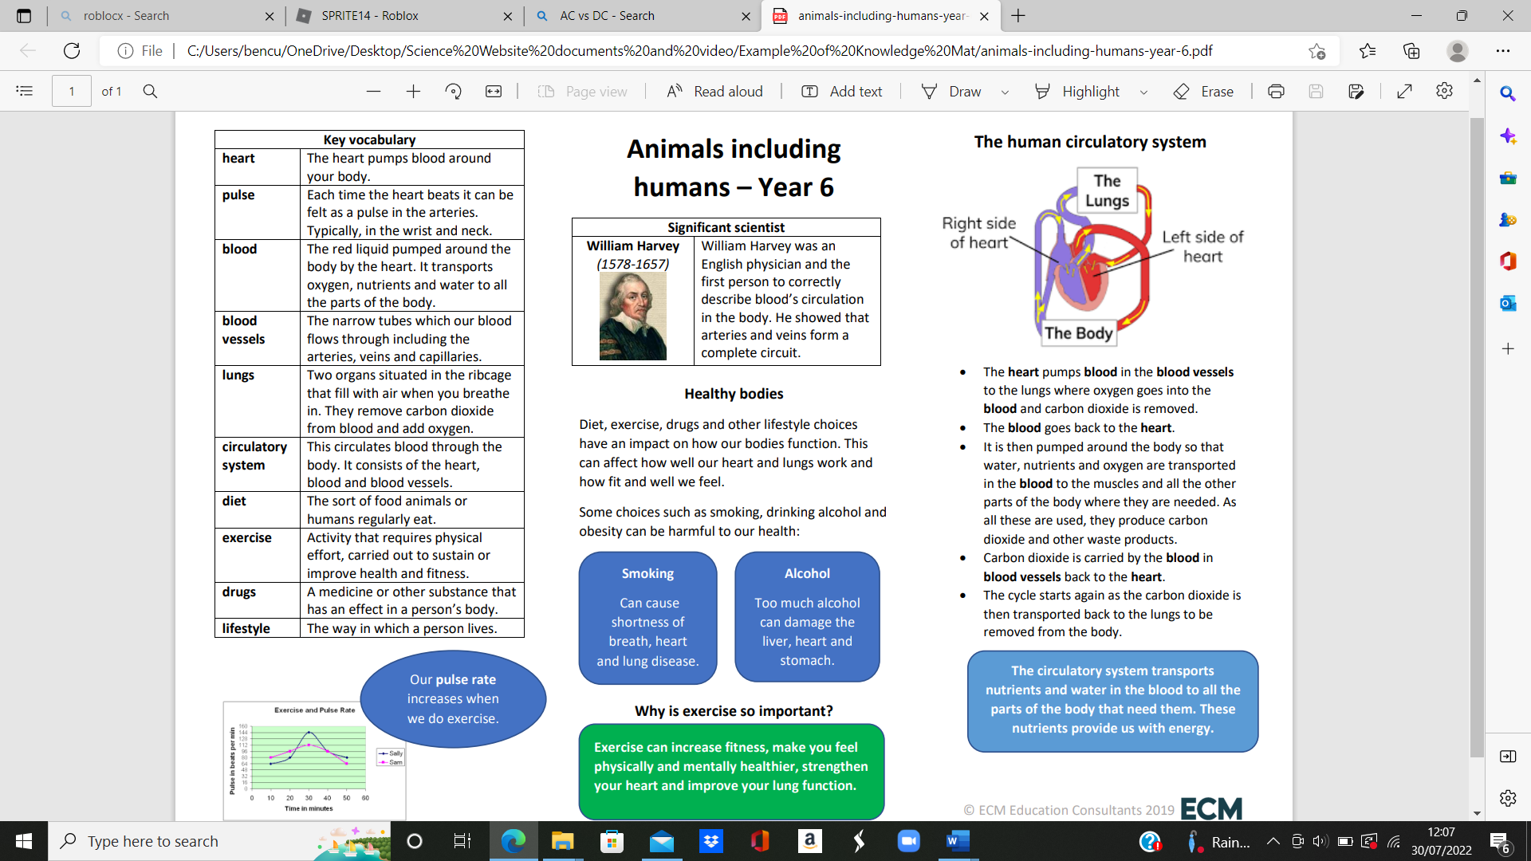  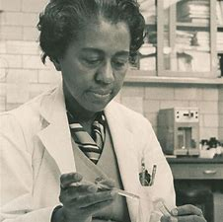  Marie Maynard Daly studied how cholesterol and sugar affect the human body, particularly the heart and circulatory system. | 