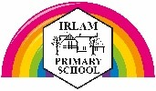
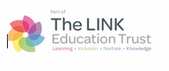
Science Policy
Updated February 2026
Intent
At Irlam Primary School, we have a stimulating Science curriculum which encourages the children to explore the world around them. We will encourage the children to develop a sense of curiosity. By asking questions and seeking answers the children will have a deeper understanding of the world we live in. We will look for opportunities to engage the children through awe and wonder. We aim to develop children’s working scientifically skills as they progress through the school. We offer the children plenty of opportunities to use scientific equipment to conduct experiments. We will extend the use of scientific vocabulary through questioning, predicting and drawing conclusions. We believe science encompasses an acquisition of knowledge, concepts, skills and positive attitudes. Through Science, we aim to give the children the confidence and the skills to be life-long learners who will explore the world around them. The children will be taught the skills to become ‘INSPIRED ENQUIRERS’.

Implementation
The acquisition of key scientific knowledge is an integral part of our science lessons. Linked knowledge organisers enable the children to learn and retain the important, useful and powerful vocabulary and knowledge contained within each unit. The progression for skills working scientifically are developed through the year groups and scientific enquiry skills are of key importance within lessons. The progression of these skills is set out in the science provision map each lesson has a clear focus. Scientific knowledge and enquiry skills are developed with increasing depth and challenge as children move through the year groups. They complete investigations and hands-on activities while gaining the scientific knowledge for each unit. Interwoven into the teaching sequence are key assessment questions, identified in green on lesson plans. These allow teachers to assess children's levels of understanding at various points in the lesson. They also enable opportunities to recap concepts when necessary. The sequence of lessons helps to embed scientific knowledge and skills, with each lesson building on previous learning. There is also the opportunity to regularly review and evaluate children's understanding. Activities are effectively adapted so that all children have an appropriate level of support and challenge. The detailed lesson plans include adult guidance to ensure that teachers are equipped with secure scientific subject knowledge, enabling them to deliver high-quality teaching and learning opportunities while making them aware of possible scientific misconceptions. The teaching of Scientists and Inventors is embedded throughout the units of science taught. We have close links with the community and the feeder high Schools.

Science in the Early Years
Children in the EYFS follow the Understanding of the World strand of the EYFS Statutory Framework. Children in the EYFS will find out and learn about the world they live in. At Irlam Primary School, we understand the importance of building strong foundations in the EYFS and building on this throughout their learning journey as they progress to Year 6 and beyond.
At Irlam Primary School, we have a wonderful indoor and outdoor EYFS environment where the children explore, investigate, discover and have fun whilst they are learning about the world they live in.
Children will:
Nursery
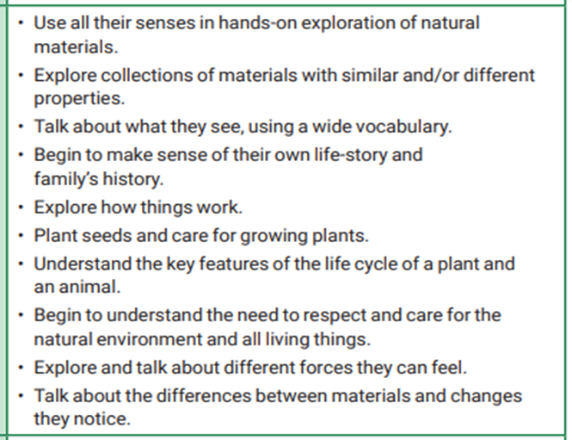
Reception
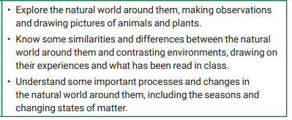
At the end of Reception, a ‘snapshot’ of where the children are in their learning journey is taken by assessing them against a set of Early Learning Goals under the Understanding the World umbrella. End of Key Stage information is recorded and sent to the LEA in the summer term.

Impact
Progress is measured through a child's ability to know more, remember more and explain more. This can be measured in different ways in the science units. The use of the green questions ensures opportunities are built into the lesson for ongoing assessment. Other assessment opportunities include: observing children at work, individually, in pairs, in a group, and in classes, questioning, talking and listening to children, considering work/materials / investigations produced by children together with discussion about this with them and of topic quizzes or assessment activities. We also use RRR (Revisit, Recap and Remember) in each lesson. There are also reasoning cards available for each unit. The Irlam Primary Science Progression Document provides detailed information about prior, current and future learning in each area of the Science curriculum. The impact of using the full range of resources included in the science unit will also be seen across the school with an increase in the profile of science. The learning environment across the school will be consistent with science technical vocabulary displayed, spoken and used by all learners. Whole-school and parental engagement is done through Science Days, the school website, science competitions and shared use of knowledge organisers. Children who feel confident in their science knowledge and enquiry skills will be excited about science, show that they are actively curious to learn more and will see the relevance of what they learn in school in science lessons to real-life situations and also the importance of science in the real world.
Assessment
Assessment in Science aligns fully with the school’s Assessment & Feedback Policy and reflects our whole-school approach to high-quality teaching, pupil progress and professional judgement.
Formative Assessment
Assessment takes place primarily during lessons and informs immediate teaching decisions.
Teachers assess pupils through:
• questioning and discussion
• observation of independent work
• live marking and conferencing
• modelling and re-teaching
• practical application (where appropriate)
• retrieval practice and low-stakes checks

Feedback is prioritised over marking. Assessment is responsive and takes place “in the flow” of teaching wherever possible.
There is no expectation that formative assessment is recorded separately or retrospectively.
Summative Assessment
Summative assessment supports teacher judgement and whole-school tracking but does not replace ongoing formative assessment.
In Science, this may include:
• end-of-unit tasks
• application activities
• practical outcomes
• low-stakes quizzes
• teacher assessment based on work over time

Insight is used to record professional judgement where appropriate. Children’s progress is continually monitored and tracked throughout their time at Irlam Primary School. INSIGHT is the assessment tool we use for assessment and tracking. Teacher assessments are put on the system regularly each half term that a topic is taught. We also record the TA on INSIGHT for Science during the Assessment Weeks.
Evidence Over Time
Pupils’ books, outcomes and practical work provide evidence of learning and progress across a sequence of lessons.
Evidence of assessment may include:
• live marking or teacher modelling
• pupil response to feedback
• whole-class feedback
• retrieval tasks
• discussion

The absence of written marking on a specific piece of work does not indicate the absence of assessment.
Impact is seen through pupils’ developing understanding, knowledge retention and application over time.
Reports to parents are made verbally twice a year at Parent’s Evenings and written once a year. These written reports describe each child’s attitude to science. End of KS2 data is submitted to the LEA in June.

Inclusion and Equity
Assessment in Science is inclusive by design. In school we aim to meet the needs of all our children through adaptive teaching ensuring a variety of approaches and tasks are appropriate to the various ability levels. This will enable children with learning and/or physical difficulties to take an active part in scientific learning and practical activities and investigations and to achieve the goals they have been set. We are an inclusive school and acknowledge that children are visual, kinesthetic or audio learners. Some children will require closer supervision and more adult support to allow them to progress whilst more able children will be extended through deeper level questioning. By being asked higher level questions or being given enhancing and enriching activities, more able children will be able to progress to a higher level of knowledge and understanding appropriate to their abilities. Teachers adapt questioning, scaffolding and feedback to support pupils with SEND and those who are disadvantaged, while maintaining high expectations for all. Assessment focuses on progress over time rather than volume of written work. At Irlam Primary School we are committed to providing all children with an equal entitlement to scientific activities and opportunities regardless of race, gender, culture or class.

Health and Safety:

In regard to science work in school all teachers will be familiar with the "Be Safe" safety booklet. Where appropriate reminders will be given to children about potential hazards and care of the equipment they are using. We are a member of CLEAPSS and have access up to date information.
Any trips should have been planned with due regard to the school policy on taking children on outings. Extra guidance should be considered on trips involving farms etc.
Review date: February 2027
Carol Barnes

